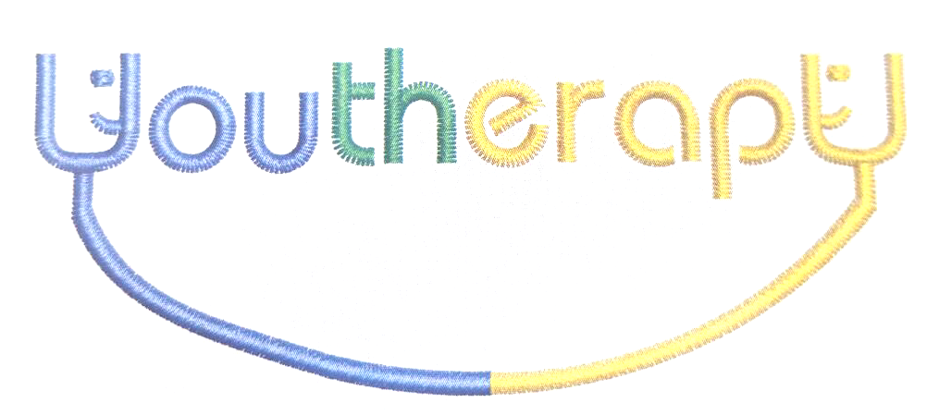

YOUTHERAPY SUPPORT TO CLIENTS AND FAMILIES DURING THE COVID 19 OUTBREAK
Telephone 01253 955858 between 9am and 5pm and leave a message if we are unable to answer your call or you are ringing outside these times. We will try to call you back as soon as we can.
We want to keep you and your families as safe as possible
- If you or a member of your household have a high temperature, a sudden cough, or any other symptoms, look on the NHS 111 website to check whether these might be Coronavirus and self-isolate in line with government guidelines
- YoutherapY are able to offer mainly telephone appointments but a few face to face contacts may be able to be offered for clients with no symptoms of Coronavirus
- We will try to continue with our drop-in appointments at Talbot and Brunswick Children’s Centre on Wednesday afternoons, between 3 p.m. and 5 p.m., but please ring first to check staff are available to see you
- Please try to limit yourself to have only one parent or carer with you and no other children and young people, so that we can ensure social distancing requirements are kept, as our waiting area is not a big one
- New client appointments will be booked as telephone appointments rather than seeing you in person
- If you are worried about your own, or someone else’s safety, or if your mental health is making you unwell, please phone us on the number above or ring one of the contact numbers below

Childline: 0800 1111
Wellbeing Mental Health Helpline: 0800 915 4640
Samaritans: 116 123
Domestic Abuse Helpline: 0808 2000 247
Young Minds: Text YM to 85258 for urgent support 24 a day

