Children and young people’s primary mental health care message in support of COVID-19
Keeping you and your child’s physical and mental health well, over the next coming weeks is so important to help manage the COVID-19 virus. We hope that you are following the public health guidelines as they update regularly to best manage your health and take care of you and your family. Alongside the COVID-19 government guidelines and restrictions, we acknowledge that this may have an impact upon your child’s emotional wellbeing and that access to support and everyday things that keep us well may be restricted. We therefore felt it important to signpost you to simple strategies, useful helplines & digital resources that maybe useful at this moment. Please read the below and we hope you keep you and your family well. 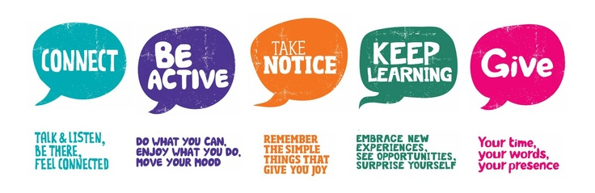
The 5 ways to wellbeing are key principles to keeping ourselves well; connect, be active, take notice, learn and give – the simple concepts are key to keeping us emotionally healthy in everyday life. Given the current circumstances and restrictions COVID19 places upon us, as parents/caregivers we are recommending that you consider & follow the 5 ways to wellbeing at home and for you to be creative with the resources you have to meet them in your family home.
Connect - It is important to stay connected to friends and family whilst the “physical” social distancing is recommended; to tackle this we can use social media, facetime, text, group chats, whatsapp etc… every day all day!
Be active - Activity and exercise is key to feeling good so go for a walk, jog, cycle, dance, put the music on, make some exercises up around the home, play games, do some gardening, bake, cook, interact as a family together and have fun.
Take notice - Take notice of your feelings and thoughts and practice some mindfulness strategies at home to help you manage and relax – see resources below for help on this.
Learn - Stimulate the mind, create opportunities to learn new things, read a book, learn how to sew, stich, a new game, access on line learning resources, complete school work, revision, work books.
Give - Give yourself personal space and time to look after yourself – ensure you eat a healthy diet, exercise, stick to some routine and sleep well. Give your patience, time, smile and be kind.
Remember children learn and observe adults behaviours and emotions for cues on how to manage their own emotions during difficult times! TEAM – Together Everyone Achieves More
Helpline numbers
*You can contact the below numbers if you have concerns over your child’s mental health
CAMHS - Children’s mental health services available for telephone support & face to face if required
*Monday – Friday 9am – 5pm *Fylde & Wyre Tel 01253 957166 *Blackpool 01253 957160
CASHER - Out of hours – Children’s mental health support team available for telephone support and face to face if required.
*Monday – Friday 5pm – 10pm Sat & Sun 10am – 8pm Tel 07810 696 565
Samaritans - 116 123
Hopeline UK – suicide prevention helpline for children - 0800 068 4141 text 07860039967
Childline - 0800 1111
Youngminds - Crisis messenger - if urgent text YM to 85258

Useful websites
www.kooth.com Online counselling service age 11-16yrs, children can also access education and general advice on mental health
www.youngminds.org.uk Children & parents can access education, advice& support on mental health issues.
www.nhs.uk Children & parents can access education, advice& support on mental health issues.
www.healthyyoungmindslsc.co.uk Children & parents can access education, advice& support on mental health issues.

Useful apps
Headspace – meditation app
Calm – mediation and sleep app
7 cups - anxiety and stress chat
Smiling mind –mediation app

