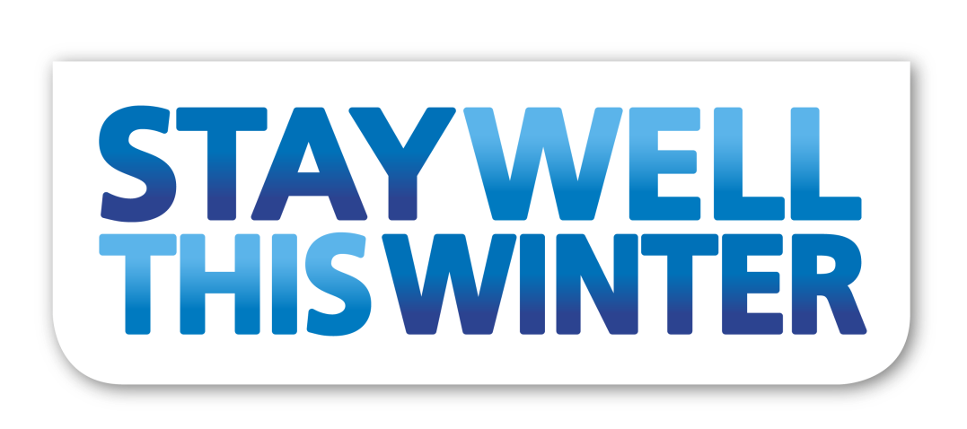

Taking care with Diabetes (type 1 or type 2 on insulin)
When you have a long-term condition, it’s important to take care of yourself and follow the advice of your GP practice and consultants so you can prevent your condition from worsening or getting complications. This guide will help you to know what you should be doing, and what to do if you start feeling worse. Our aim is to ensure that you get the care you need, when you need it. We want you to be able to look after yourself and know your warning signs, so that you don’t end up in an emergency situation.

Treatment
Living with type 1 diabetes means that you have to manage your health very carefully to avoid complications. You need to ensure that you’re taking your insulin and other medication as advised by your diabetes care team.

Being diabetic puts you at much higher risk from getting the flu. It is really important that you get your flu vaccination before the start of winter.

Your diabetes team can also help you set a target HbA1c level to aim for you to keep your blood glucose levels healthy.

If your blood glucose levels become too high or too low, this could lead to hyperglycaemia or hypoglycaemia respectively (high or low blood sugar levels) which can both cause severe symptoms and complications, so it’s important to keep up with taking insulin and monitoring blood glucose levels as you have been advised.

You should also aim to eat a healthy balanced diet and take regular exercise. Giving up smoking can benefit you a lot as diabetes means that your risk of heart attack and stroke is greater, and smoking increases this risk. Limit alcohol and keep up with your vaccinations. Get regular eye tests and look after your feet - regularly check your feet for cuts, blisters or grazes as you may not be able to feel them if the nerves in your feet are damaged.

When to get medical advice
As type 1 diabetes is a long-term condition you'll be in regular contact with your diabetes care team. Your GP or diabetes care team will also need to check your eyes, feet and nerves regularly because they can also be affected by diabetes.
You should also be seen regularly – at least once a year – to check how well your diabetes is being controlled over the long term.

See your GP if you have a minor foot injury that doesn't start to heal within a few days.

You should have had advice about how to look after yourself when you are ill – known as your “sick day rules”. If you haven’t been given these, contact your GP or care team.

Remember you can access GP services 24 hours a day, seven days per week. If you need to speak to a GP out of hours, then phone NHS 111 and they will arrange for you to speak to a professional.

