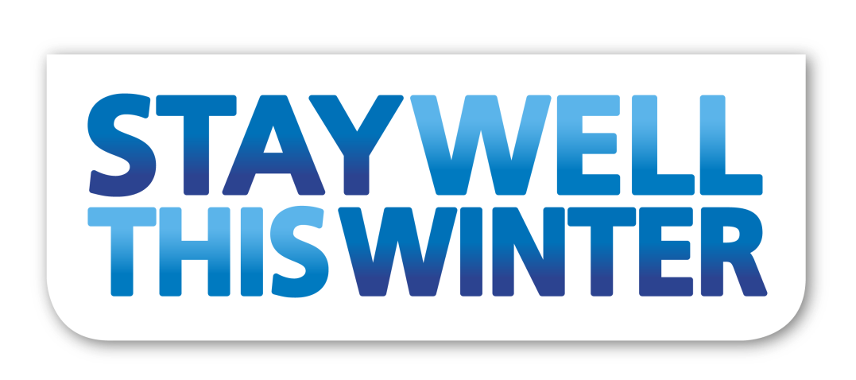

Taking care with Chronic Obstructive Pulmonary Disease (COPD)
When you have a long-term condition it’s important to take care of yourself and follow the advice of your GP practice and consultants so you can prevent your condition from worsening or getting complications.
This guide will help you to know what you should be doing, and what to do if you start feeling worse. Our aim is to ensure that you get the care you need, when you need it. We want you to be able to look after yourself and know your warning signs, so that you don’t end up in an emergency situation.

Treatment
Treatment can help to slow the progression and control the symptoms of COPD. The most important thing you can do is stop smoking if you are a smoker. You may also be prescribed inhalers and medications, and pulmonary rehabilitation. Follow your care team’s advice, including taking any medication prescribed, to make sure your health is in its best possible condition.

Please consider the following;
- Book an early review with your practice/COPD nurse prior to winter
- Receive the flu vaccination before winter
- If you notice an increase in sputum, particularly if it is coloured or if you are getting increasingly short of breath, you should contact your GP or COPD nurse for advice
- If you symptoms are getting worse, and you have been prescribed rescue medication, please considering using this as well as contacting a health professional

Only attend A&E if you are having significant difficulty breathing and your reliever inhalers are not working.

Remember you can access GP services 24 hours a day, seven days per week. If you need to speak to a GP out of hours, then phone NHS 111 and they will arrange for you to speak to a professional.

YOUR COPD NURSE IS ___________________________________

