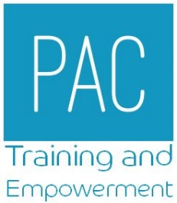

COURSE BOOKING FORM

Course Name |  |  |  | Course Dates
Attendee Details
Name
Contact Number (mobile)
Email address
We will use this email address to confirm the booking and communicate with you about the course. Please ensure this it is typed clearly without errors.

By returning this booking form you give permission for PAC to securely store and use the information you provide about yourself (and others) in order to access this training course. You also give permission for PAC to share this information with our funders, trainers, venues and awarding bodies in order to provide this training course.
We will contact you 6 months after the course date with a survey to ask if and how you have found the training helpful. Your feedback will be used to improve the training provided. Information you give will be held securely. You have the right to remove your consent for us to hold and process this information at any point. If you do remove consent to share your information then PAC may not be able to provide a service to you. To remove your consent you must contact the project manager in writing at info@p-a-c.org.uk. You can find out more about how PAC processes your information on our website www.p-a-c.org.uk/privacy.

Job Title
School / College Name
School / College Address
Managers name
Managers email address
Please be aware all applications must have line managers approval, and details provided above in order to be processed.
Please be aware that due to the way the courses are funding all attendees must work within the Lancashire county area. We are unable to accept bookings from attendees based in Blackpool or Blackburn.

I confirm that I work in a school or college in the LCC area.
Please note that cancellations made less than 10 days before the course start date will be invoiced at £50 per place.
Email for Invoicing
Please email this completed form to training@P-A-C.org.uk. We will contact you to confirm your place.

