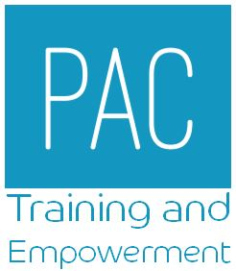

COURSE BOOKING FORM

Course Name |  |  |  |  | Course Dates
Attendee Details
Name
Contact Number (mobile)
Email address
WE WILL USE THIS EMAIL ADDRESS TO CONFIRM THE BOOKING AND COMMUNICATE WITH YOU ABOUT THE COURSE. PLEASE ENSURE THIS IT IS TYPED CLEARLY WITHOUT ERRORS.

Job Title
Organisation Name
Work Address
Organisation Type
PLEASE BE AWARE THAT DUE TO THE WAY THE COURSES ARE FUNDING ALL ATTENDEES MUST LIVE OR WORK WITHIN THE LANCASHIRE COUNTY AREA. WE ARE UNABLE TO ACCEPT BOOKINGS FROM ATTENDEES BASED IN BLACKPOOL OR BLACKBURN.

I confirm that I live/ work in the LCC area.
Are you a Student?
PLEASE NOTE THAT CANCELLATIONS MADE LESS THAN 10 DAYS BEFORE THE COURSE START DATE WILL BE INVOICED AT £50 PER PLACE.

Email for Invoicing
Authorisation from Manager Given |  | Yes / No / NA
Manager Name |  |  |  |  | Email

THESE DETAILS WILL BE MADE AVAILABLE TO THE COURSE TRAINER TO ALLOW THEM TO CONTACT YOU IN RELATION TO THE TRAINING.

WE WILL CONTACT YOU 3 MONTHS AFTER THE COURSE DATE WITH A SURVEY TO ASK IF AND HOW YOU HAVE FOUND THE TRAINING HELPFUL. YOUR FEEDBACK WILL BE USED TO IMPROVE THE TRAINING PROVIDED.

PLEASE EMAIL THIS COMPLETED FORM TO TRAINING@P-A-C.ORG.UK

