Anticoagulant services review
Listening to communities report
June 2026
Dan Clough
dan.clough@nhs.net

Contents

Introduction 2
Executive summary 2
Who have we heard from? 3
What did we hear? (Face-to-face) 6
South Shore Primary Care Centre, 11 May 2026 6
Moor Park Primary Care Centre, 12 May 2026 7
Lytham Primary Care Centre, 14 May 2026 7
Great Eccleston Health Centre, 20 May 2026 8
What did we hear? (Survey) 8
In general, how often do you attend anticoagulant clinics? 8
How do you currently travel to your appointments? 9
How far from your home (in terms of time taken to travel) would you be willing/able to travel to access clinics? 9
Have you considered self-testing your INR (international normalised ratio) at home? 10
If you have considered self-testing but chosen not to, what has stopped you? 10

Introduction

An anticoagulation clinic is a specialised healthcare service that monitors and manages patients taking anticoagulant (blood-thinning) medications. The clinic aims to ensure medication is at a safe and effective level to prevent blood clots while minimising the risk of excessive bleeding.

Anticoagulants are prescribed to treat or prevent conditions like deep vein thrombosis, pulmonary embolism, atrial fibrillation, and to protect patients with mechanical heart valves. While some modern blood thinners require no monitoring, medications like Warfarin are highly sensitive to diet, alcohol, and other drugs, necessitating close medical oversight.

NHS Lancashire and South Cumbria Integrated Care Board is currently looking at the model of delivering anticoagulation clinics across the region. This has been partly driven by the changing landscape, with more patients now receiving direct oral anticoagulants (DOACs) which don’t require the usual monitoring service provided by anticoagulation clinics, many GP practices have chosen to stop providing the clinic service that was very common some years ago. Some clinics are provided by secondary care providers in community or hospital settings, or on a primary care network footprint.

In order to support the development of a new model, it is important to understand the experiences of patients using current services. To achieve this, the ICB produced a survey with officers attending clinics in parts of the region to support patients to complete the online questionnaire while attending their appointments. The survey was also distributed electronically in an effort to reach as many patients as possible.

The following is a report of the key findings from the survey and conversations that took place.

Executive summary

A total of 117 completed survey responses were received, alongside face-to-face conversations with 37 patients attending clinics on the Fylde Coast. Feedback was gathered from people using a range of clinic locations, although response levels varied across localities. In particular, fewer responses were received from West Lancashire and Morecambe Bay due to limitations in access to local clinic settings and reliance on electronic survey distribution in those areas.

Overall, patients spoke positively about the quality of care provided by anticoagulation clinic staff. Staff were consistently described as kind, capable, efficient, respectful and reassuring. Clinics were generally viewed as well organised, with patients valuing familiar local services where staff know them and can respond to individual needs.

However, access and travel emerged as significant considerations for future service design. Many patients attend clinics frequently, so even modest increases in travel time, cost or complexity could have a disproportionate impact, particularly for older patients, people with physical health issues, those reliant on lifts or taxis, and those for whom public transport is unsuitable or requires multiple journeys.

Most respondents prefer to access care close to home and commonly indicated that travelling more than around 15 to 20 minutes would be difficult or undesirable. Parking was also raised repeatedly as a practical barrier, particularly at busy clinic sites where disabled bays are limited or patients are unclear about parking arrangements. For some patients, taxi costs and the availability of family support were important factors influencing whether they could attend appointments.

Feedback also highlighted opportunities to improve patient experience and choice. Suggestions included appointment reminder text messages, clearer information about parking, consideration of drive-through clinic models where appropriate, and clearer communication about whether home INR self-testing is available, suitable and supported.

Some patients were unaware self-testing was an option, while others felt it would not be appropriate for them due to confidence, age, health or a preference for professional support.

In developing any future model, the ICB should balance service sustainability with the need to maintain accessible, local provision for patients who require frequent monitoring. The feedback suggests that any changes should be supported by clear communications, consideration of transport and parking impacts, and a flexible approach that recognises differing patient needs, including those who may benefit from self-testing and those who continue to need face-to-face clinical support.


Who have we heard from?

117 completed responses to the survey were received. Respondents came from the following areas:

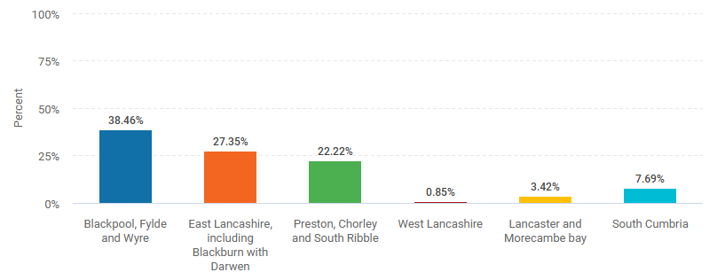
Under-representation in some areas

It is recognised that a small number of responses were received from people living in West Lancashire and the Morecambe Bay areas. Unfortunately, the team was advised by the main provider of anticoagulation clinics in Morecambe Bay – University Hospitals of Morecambe Bay NHS Foundation Trust – that due to the configuration of the clinics, it was not possible to host engagement officers as patients using the waiting rooms could be attending the trust for a range of different services. Therefore it was not possible to capture just anticoagulation patients at one time. This meant we relied solely on responses via the electronic survey for this area. Similarly, West Lancashire patients do not attend a secondary care trust in the ICB’s footprint, and GP practices in the area did not respond to requests to attend clinics, therefore only electronic survey responses could be used for that area.

Fylde Coast sessions

The officer who spoke to patients on the Fylde Coast did not utilise the survey system and so feedback is reported separately. The officer attended anticoagulation clinics at South Shore Primary Care Centre on 11 May, Moor Park Primary Care Centre on 12 May, Lytham Primary Care Centre on 14 May, and Great Eccleston Health Centre on 20 May. In total, 37 people were spoken to.

As part of the survey, demographic data was captured. All but three respondents agreed to provide this data. The responses, detailing who responded to the survey, are below:

Age
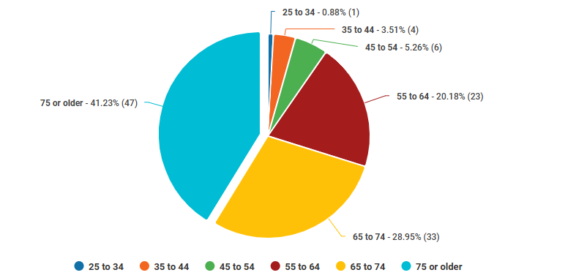
Gender
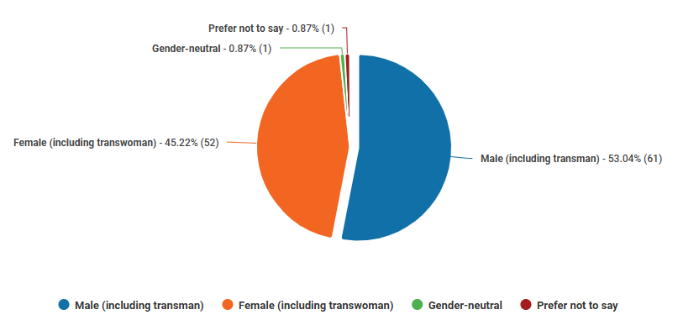

Ethnicity
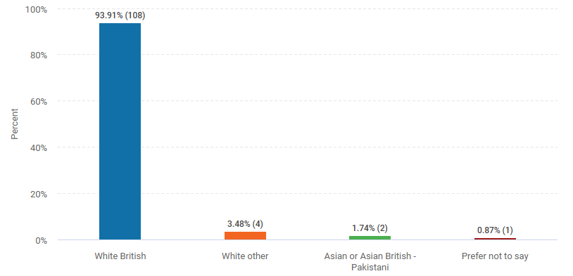
Disability
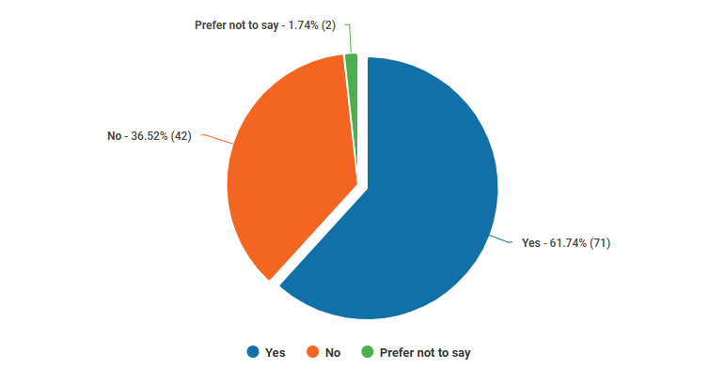

Carer
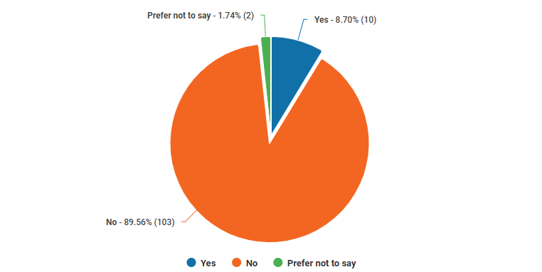


What did we hear? (Face-to-face)

South Shore Primary Care Centre, 11 May 2026

- Most people are fairly local to clinic; some had to travel around 20 minutes.
- Most would travel up to 20 minutes if they absolutely had to.
- Most people attend anticoagulant clinics weekly - some less often. This can be variable and sometimes unpredictable depending on the person’s health.
- Many people drive to clinics; some get lifts from family members, some get taxis. Few use public transport due to health, although they are aware of the possibility.
- The clinic is convenient and easy to get to by car or bus.
- Parking can be an issue, especially earlier in the day.
- Staff are kind, capable, attentive, and accommodate individual needs wherever possible.
- Clinics are well organised and well run, with a pleasant atmosphere.
- Most people wouldn’t want to travel further or for longer. Many felt their health would not permit them to travel greater distances.
- One patient was unhappy they had to travel past Blackpool Victoria Hospital to get to South Shore. With support it turned out staff were able to arrange for them to be seen at the hospital instead. Patient left very happy that issue was resolved.
- Other considerations:
  - Could patients be sent a reminder text message before appointments? It can be hard to remember if the appointments aren’t weekly or change frequency.
  - Will there be a clinic at Whitegate Drive health centre? It was mentioned some time ago but doesn’t seem to have materialised.

Moor Park Primary Care Centre, 12 May 2026

- Most patients live nearby or at least fewer than 20 minutes away.
- Majority attend the clinic weekly. Can be unpredictable depending on health.
- Some had been going to clinic in Fleetwood, which is hard to get to by public transport and very expensive by taxi. It was somewhat better for people who could drive, but still took at least 30 minutes from Bispham.
- Majority drive to appointments or get a lift from someone else. Some use public transport.
- Good public transport links for people who are local. Harder to get to for anyone having to travel across Blackpool or Over Wyre, as they have to get at least two buses and it can take over an hour one way.
- Parking is often very difficult and there are a limited number of disabled bays. Patients very concerned about parking fines and some not sure if they have to pay for parking. It is not very clear. Sometimes people have to park on the street.
- Majority did not want to have to travel more than 20 minutes to clinics as they have to attend so frequently - cost implication, time implication, impact on health - several stated they would not be able to travel further away due to their health.
- Clinics are efficient and run very well. Patients rarely have to wait more than 10 minutes.
- Staff are very kind, respectful, get to know the patients, make them feel cared for and comfortable.
- Other considerations:
  - Several people mentioned the ‘drive-through’ clinics during COVID-19 and said they had preferred this as it was faster and more convenient. They preferred waiting in their own car than a waiting room. They would welcome the return of this option.

Lytham Primary Care Centre, 14 May 2026

- Patients slightly older overall than other clinics - mostly in their 70s and 80s.
- Majority attend clinic in a car, either driving themselves or getting a lift from someone else.
- Several get taxis due to unsuitability of other options (physical health or distance make public transport difficult) and noted that cost is becoming more of a worry as the price of petrol goes up.
- Most people are fairly local to the clinic - within 10 minutes travel by car.
- Majority would not want to travel further for care - most had travelled 10 to 15 minutes. One person was happy to go to whichever clinic they were physically closest to and didn’t have a set preference.
- Staff are very highly thought of - kind, competent, efficient, thoughtful.
- Several patients commented that the clinics have a ‘pleasant atmosphere’, which is down to the staff.
- Those who had travelled by car commented on the difficulty of getting a parking space. Some had a disabled blue badge which makes it easier, some ended up parking on the street outside the health centre.
- Other considerations:
  - One patient had recently moved to the area from Greater Manchester, where they had an at-home machine to monitor INR levels. They wondered if that would be happening in Lancashire and South Cumbria.

Great Eccleston Health Centre, 20 May 2026

- Majority live within five to 10 minutes’ drive of the health centre. Some had previously been to the clinic at Blackpool Victoria Hospital, so were glad there was an option so close to home.
- Majority were on weekly visits - some said this depended on their INR reading and could fluctuate.
- Most were over 70 and were given a lift to the clinic due to their physical health issues. Some people drove themselves and one person walked, as they lived very close (less than two minutes’ walk).
- All preferred to come to the Great Eccleston clinic rather than travel to another clinic. Some said that their health would make it hard to go more than 15 to 20 minutes away from home.
- Staff were seen very favourably - efficient, kind, compassionate, and knew their stuff.

- Parking is very difficult due to the tiny car park, most park on the street.

What did we hear? (Survey)

In general, how often do you attend anticoagulant clinics?

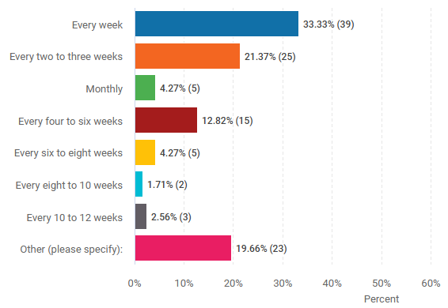
The majority of those who selected ‘other’ stated the time between appointments can vary, sometimes dependent on INR results.

How do you currently travel to your appointments?

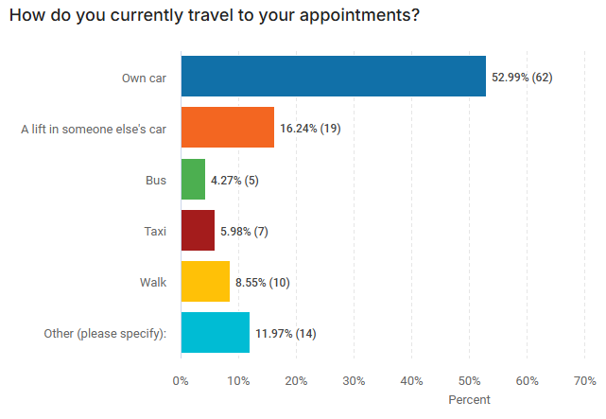
Although 14 respondents selected ‘other’, they all stated one of the above options.

How far from your home (in terms of time taken to travel) would you be willing/able to travel to access clinics?

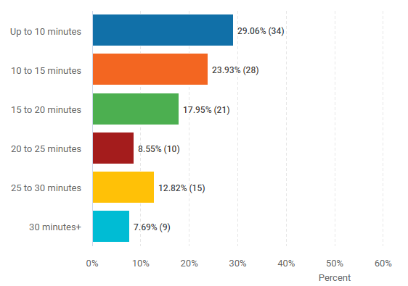

Have you considered self-testing your INR (international normalised ratio) at home?

The service lead on the Fylde Coast asked for this question not to be posed to patients in that area, so only 73 respondents answered this question.

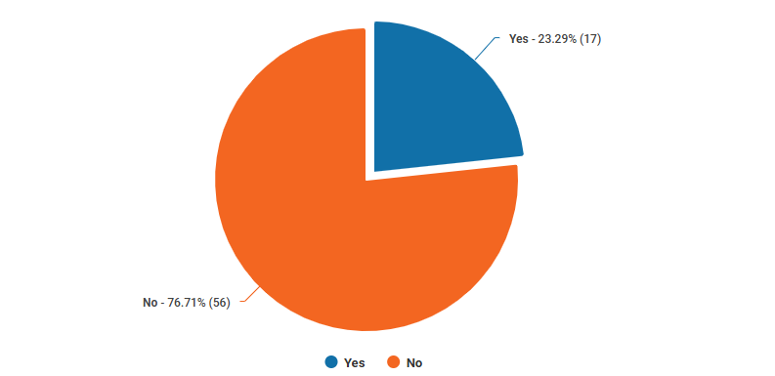

If you have considered self-testing but chosen not to, what has stopped you?
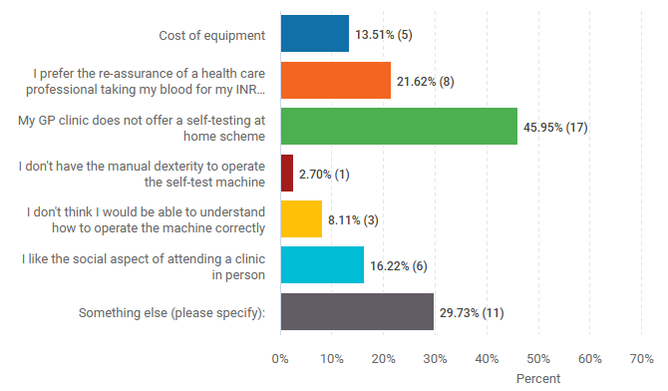
Of those who selected ‘something else’, six were unaware this was an option. One stated that professionals have enough trouble with theirs, so they would not know how to do it at home, another stated they are 91 and would like someone to do it for them, and another stated they were on apixaban.

