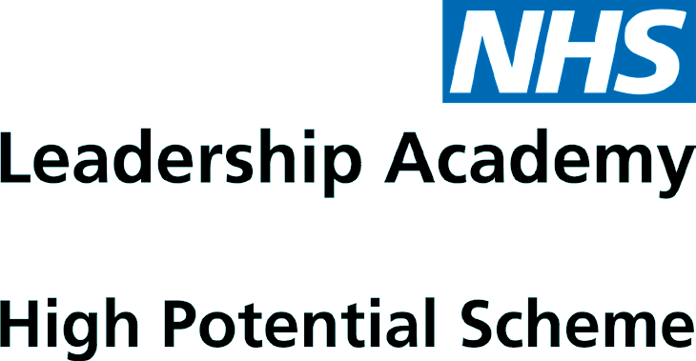

Career Stage Self-Assessment

For applicants

Career Stage Self-Assessment
In support of your application onto the High Potential Scheme, please complete and upload this career stage self-assessment to your application. This will help you decide which development stream is right for you, as well as helping the assessors review your eligibility for the Scheme.

Please read the following statements and select the statement which most closely reflects your level of skill in this area. There are no right or wrong answers. If you are confident in your skills for Questions 1 to 9, then development stream 2 could be right for you.

No | Experience | “I do not feel that this is a skill that I can easily draw upon just yet” | “I have started to build this skill, but it requires further development” | “I am confident and skilled in doing this”
1 | I have successfully led a small team, creating a team culture and environment that enables all team members to perform well
2 | I have successfully improved poor performance (people or service performance) and enabled my team to achieve or exceed expectations
3 | I have improved the work environment or experience of staff working in my team, or colleagues within my specialism
4 | I have addressed inequality in my area of work, improving access or the experience of others
5 | I have translated wider vision and policies to help my team to understand organisational and team aims in order to perform to expectations
6 | I understand how the work of my team connects into the work of other teams and I’ve delivered work in collaboration with others outside of my team/specialism
7 | I connect with stakeholders outside of my team/specialism, looking to understand their priorities and needs, adjusting the work of my team where appropriate to help other teams to achieve their aims
8 | I allocate work appropriately within my team
9 | I make good use of resources, making decisions in the best interests of the service
10 | I have successfully led a service area and have been responsible for its financial resources, assets, people and performance
11 | I have successfully led and co-ordinated the work of multiple teams
12 | I have spoken out against inequality or advocated for equality or inclusion
13 | I have successfully engaged my team with a new idea or vision, demonstrably gaining support and commitment to achieving the goal which has improved the service/area
14 | I have developed and led the implementation of policies within my area of expertise
15 | I am experienced in medium term planning – setting objectives and developing plans for my service area which contribute towards strategic goals
16 | I have built successful collaborations across the organisation / system which have improved service delivery / patient outcomes
17 | I have successfully researched external practice and applied lessons learned to improve service delivery
18 | I have successfully developed and managed budgets / resource plans to make most efficient and effective use of resources
19 | I understand organisational resourcing and how resourcing decisions are made

Please indicate how many years until you anticipate being in a senior executive role i.e. a board or governing body level role:

0 to 12 months
12 months to 24 months
24 months to 3 years
3 to 5 years
5 or more years

If you feel ready for an executive director level role within the next two years, an alternative development scheme maybe right for you. Please contact the team on highpotentialscheme@leadershipacademy.nhs.uk or call 0113 322 5635.

If appointed to the scheme, the responses you provide will help you access tailored support to enable your career progression. We recommended reviewing this with your line manager or sponsor to gain an additional perspective. Your responses may be explored through the interview process. Thanks for completing this self-assessment, please don’t forget to upload it with your application.l
Please

