Clinical Trials Summary for out of hours
Important Reference

Acronym study title | Keynote 992 (MK3475-992)
Study Details | A Phase 3, Randomized, Double-blind, Placebo-controlled Clinical Trial to Study the Efficacy and Safety of Pembrolizumab (MK-3475) in Combination With Chemoradiotherapy (CRT) versus CRT Alone in Participants with Muscle-invasive Bladder Cancer (MIBC) (KEYNOTE-992)
Principal Investigator PI  Sub PI’s | Dr Omi Parikh  Dr Natalie Charnley
Research Nurse Team | Amanda Cook
Drug therapy | 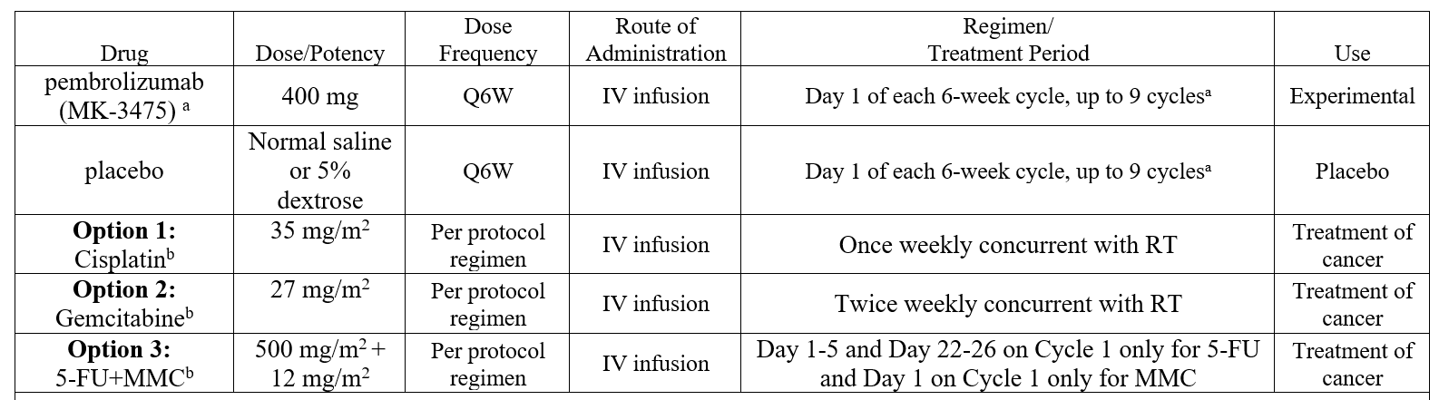
In the event that a patient calls this hotline for advise | Refer to SoC protocol for additional information regarding SoC treatment.  Advise patient to seek medical assistance via nearest available healthcare provider depending upon severity of symptoms.  Advise patient to keep all relevant trial paperwork with them for review by treating clinician.  Patients requiring admission may be reviewed by the on-call Oncology SpR/Consultant.  Day time contact number:  Principal Investigator:  Omi Parikh Tel: Tel: 01772 52 4574 / 3191 (Sec)  Research Nurse:  Amanda Cook Tel:01772 52 8475  If out of hours escalation is required, please alert PI/Co-I on the above details.  Treatment interruption/modification may be required.

