Respiratory communications toolkit: Winter 2023-24
Intranets/Newsletters

Helping patients with respiratory conditions this winter

As part of our public messaging campaign this winter, we have been working with fellow Trusts and the Lancashire and South Cumbria Integrated Care Board to ensure our local communities are receiving the most up-to-date and consistent advice.

Our latest toolkit features messaging around the importance of managing respiratory conditions for both adults and children.

Respiratory disease affects one in five people and is the third biggest cause of death in England after cancer and cardiovascular disease.

For many, the winter period can be a source of concern and worry. People with respiratory diseases, such as chronic obstructive pulmonary disease (COPD) or asthma, can be particularly susceptible to the effects of cold weather, finding themselves shorter of breath and coughing more than usual. In addition, the risk of catching COVID-19 and flu this winter remains significant.

Trusts across the region are advising patients with respiratory conditions to ‘protect their lungs’ this winter, to ensure the local community are aware of steps they can take to avoid GP visits or hospital admission. Professor Mohammed Munavvar, Consultant Chest Physician at Lancashire Teaching Hospitals NHS Foundation Trust, has given advice to the local population about what they can do to stay well, including keeping warm, staying active and planning ahead with medication.

Our messages have been shared with Primary Care and across the wider place featuring information on our websites [include link to your website piece] and social media platforms.

Please feel free to share these important messages across your networks to help them stay well this winter.

Press release (and for websites)
Lancashire respiratory consultant gives advice to ‘protect your lungs’ this winter
A leading Lancashire and South Cumbria-based respiratory consultant has advised people with respiratory conditions such as chronic obstructive pulmonary disease (COPD) or asthma to be extra vigilant this winter and ‘protect their lungs’.
Professor Mohammed Munavvar, who works at Royal Preston Hospital as a consultant chest physician, has seen an increase in patients with respiratory conditions over previous winter periods, so he wants to ensure the local community are aware of steps they can take to avoid GP visits or hospital admission.
If you have long-term respiratory conditions like COPD or asthma, winter can worsen your symptoms, often leading to shortness of breath or more coughing than usual. To manage your symptoms, you must be ‘weather-wise’. Being weather-wise means:
- Knowing why it is important to manage your condition more carefully during winter
- Having information to manage your condition during the winter months
- Making changes to your lifestyle to prevent your condition from getting worse
Professor Munavvar, said: “For many, the winter period can be a source of concern and worry. People with respiratory diseases, such as chronic obstructive pulmonary disease (COPD) or asthma, can be particularly susceptible to the effects of cold weather, finding themselves short of breath and coughing more than usual. In addition, the risk of catching COVID-19 and flu this winter remains significant – with cases and hospital admissions rising across the region.
“There are plenty of things which those with respiratory conditions can do to ensure that they remain well this winter, such as keeping warm, staying active and planning ahead with medications. It is important to keep warm by wearing layers of clothing when it’s cold. If you need to leave the house, check the weather forecast for the rest of the day to minimise your chances of getting caught in sudden downpours or strong, icy winds.
“Staying active and exercising can also be helpful, by keeping the blood circulating and the body warm. If you have a lung condition, your doctor will be able to advise you of a suitable level of exercise for you.”
He added: “Those on medication should ensure that they have an adequate supply, carry it with them, and people who have been prescribed bronchodilators should use them as directed before leaving the house, to prevent the cold weather causing a sudden tightening of the airways when they are out.”
It is important that those eligible should seek to have their COVID-19 and flu jabs as soon as they are made available to help protect themselves, their families and their loved ones.
All eligible adults can book their COVID-19 and flu vaccinations by visiting www.nhs.uk/seasonalvaccinations, on the NHS App or by calling 119.
Some pharmacies and other vaccine services offer walk-in clinics and people can search for their nearest location on the NHS website.
Respiratory disease affects one in five people and is the third biggest cause of death in England after cancer and cardiovascular disease. Emphysema/COPD and asthma are the most common conditions.
For more information, visit the NHS website here.

Press release (and for websites)

Advice on respiratory illnesses in children this winter
Local health experts are asking parents and carers to be aware of the signs of respiratory illnesses in children as temperatures drop.
Respiratory syncytial virus (RSV) is a common virus that causes coughs and colds in winter and is the most common cause of bronchiolitis (a common chest infection) in children under two.
Joanne Connolly, divisional nursing director for women and children at Lancashire Teaching Hospitals NHS Foundation Trust, said: "Respiratory illnesses in children are very common, especially in winter. The spread of illnesses such as RSV and flu is back to pre-pandemic levels and in some cases higher due to people being comparatively sheltered over the past couple of years.
"We understand that respiratory illnesses in children can be very concerning for families, however, for the majority of children these illnesses will not be serious, and care can be provided at home with simple measures such as paracetamol, ibuprofen, and fluids to help relieve symptoms."
Early symptoms of bronchiolitis are similar to a cold, such as sneezing, a runny or blocked nose, a cough and a slightly high temperature of 38C. It may cause a reduction in appetite and more noticeable effort in breathing.

Most cases of bronchiolitis will usually get better on their own, but parents should contact their GP Practice or contact NHS 111 if:

- Your child is feeding or eating less than normal
- Your child has had a dry nappy for 12 hours or more, or shows other signs of dehydration
- Your baby is under 3 months and has a temperature of 38C, or is older than 3 months and has a temperature of 39C or higher
- Your baby feels hotter than usual when you touch their back or chest, or feels sweaty
- Your child is very tired or irritable

Children under 8 weeks old, those born prematurely, and those with underlying health conditions are at a higher risk of severe bronchiolitis, and parents should consider accessing health advice earlier.

Parents and carers are advised to dial 999 or attend an Emergency Department if:

- Your child is having difficulty breathing – you may notice grunting noises or their tummy sucking under their ribs
- There are pauses when your child breathes
- Your child's skin, tongue or lips are blue
- Your child is floppy and will not wake up or stay awake

There are some things you can do to lower the chances of your child getting bronchiolitis such as:
- wash your hands and your child's hands often
- wash or wipe down toys and clean surfaces regularly
- use disposable tissues and throw them away as soon as you've used them
- keep newborn babies away from anyone with a cold or the flu – especially if they're under 2 months old or were premature
Joanne added: "We would ask all patients and visitors to adhere to the safety measures in place at your local healthcare facility – including good hand hygiene, and not visiting patients if you’re unwell. This will help to keep our patients, colleagues and yourselves safe."
Find out more about the symptoms of bronchiolitis and what to do on the NHS website.
Digital screen slides

(See separate attachments)

Videos (downloads available on links below)

Professor Mohammed Munavvar

- COVID-19 and Flu Vaccine: https://vimeo.com/894469833?share=copy
- Advice for managing respiratory conditions: https://vimeo.com/894446589/4d0bf19a28?share=copy
- Advice for managing respiratory conditions: https://vimeo.com/894446770/1af5ecf214?share=copy

Joanne Connolly

- When to seek medical advice and contact your GP: https://vimeo.com/894543193/f29747b2ed
- When to call 999 or attend ED: https://vimeo.com/894543568/cbaf6cab6a?share=copy
- General advice: https://vimeo.com/894543432/506ff9b382?share=copy
- Keeping children off school with illness: https://vimeo.com/894543371/62aca6437a?share=copy
- Immunisations: https://vimeo.com/894543507/b9e14c6e5d?share=copy
- Scarlet Fever: https://vimeo.com/894543761/56890ba90f?share=copy
- Common illnesses and RSV: https://vimeo.com/894544021/dd2993f8cb?share=copy

Social media – ‘Protect your Lungs’

Topic | Video link | Post | Image to be used
General advice – respiratory conditions over winter | https://vimeo.com/894446589/4d0bf19a28?share=copy | For many, the winter period can be a source of concern and worry. People with respiratory diseases, such as chronic obstructive pulmonary disease (COPD) or asthma, can be particularly susceptible to the effects of cold weather, finding themselves shorter of breath and coughing more than usual.  Watch a video from Professor Munavvar, a Consultant Chest Physician working in Lancashire and South Cumbria, about how you can keep yourself well this winter. | N/A – VIDEO TO BE USED
General advice – respiratory conditions over winter | https://vimeo.com/894446770/1af5ecf214?share=copy | Lancashire and South Cumbria is supporting people to stay warm, safe and well this winter. People with respiratory diseases, such as chronic obstructive pulmonary disease (COPD) or asthma, can be particularly susceptible to the effects of cold weather, finding themselves shorter of breath and coughing more than usual.  You can find out more about advice on how to stay well over winter here (LINK TO PRESS RELEASE)
COVID-19 and flu vaccine | https://vimeo.com/894469833?share=copy | For some, flu or COVID-19 can be very dangerous and even life-threatening. Flu and COVID-19 vaccines reduce the risk of serious illness in colder months.  Find out if you’re eligible and book now at http://nhs.uk/wintervaccinations or on the NHS App. | N/A – VIDEO TO BE USED
Keeping warm | N/A | Do you have a respiratory condition? Make sure you keep warm over winter by wearing layers and keeping your home warm to avoid getting ill.  For more information visit (LINK TO PRESS RELEASE) | 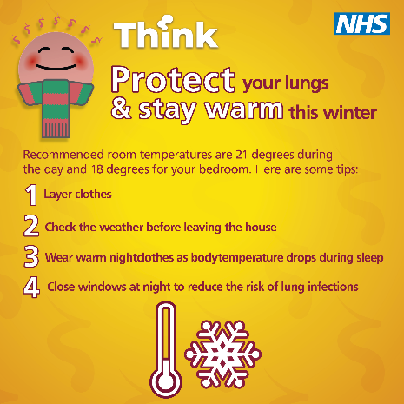
Staying active |  | If you have a respiratory condition, it’s important to stay active over winter to keep your body warm.  Exercise is generally good for strengthening lung health at any time of year – if you have a lung condition, your doctor will be able to advise you of a suitable level of exercise for you.  For more information, visit (LINK TO PRESS RELEASE) | 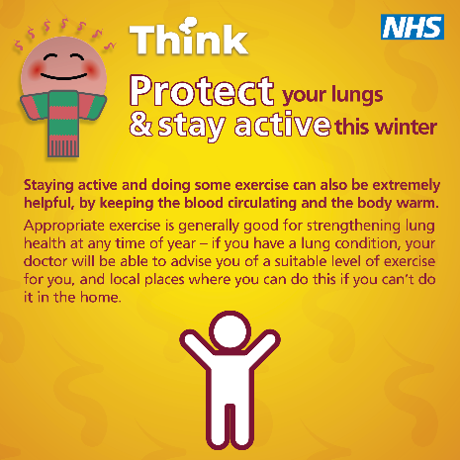
Planning medication |  | If you have a respiratory condition, it’s important to plan ahead with medications over winter.  You can also protect yourself through:  - Winter vaccinations  - Pneumonia vaccines  - Avoiding people with respiratory infections  For more information, visit (LINK TO PRESS RELEASE) | 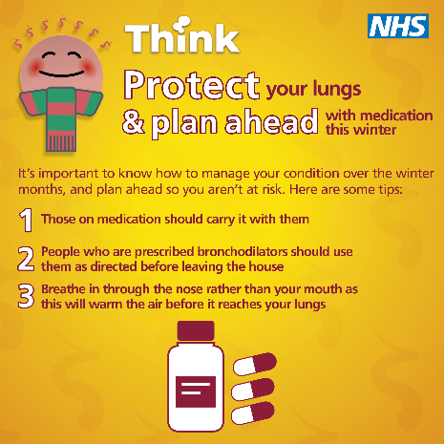

Social media – Children’s respiratory

Topic | Video link | Post | Image to be used
General advice | https://vimeo.com/894543432/506ff9b382?share=copy | There are several common infections that your child might pick up over the winter period, such as flu or RSV.  Find out more from Joanne Connolly, Divisional Director for Women’s and Children’s at Lancashire Teaching Hospitals in the video below about how to keep your children well this winter. | N/A – VIDEO TO BE USED
Common illnesses and RSV | https://vimeo.com/894544021/dd2993f8cb?share=copy | There are several common infections that your child might pick up over the winter period, such as flu or RSV.  By making sure you understand the signs and symptoms, you can help protect your little ones this winter by knowing when to care for them at home, or when they might need a trip to hospital. | N/A – VIDEO TO BE USED
Scarlet fever | https://vimeo.com/894543761/56890ba90f?share=copy | Scarlet fever is a contagious infection often seen during winter that mostly affects young children. It's easily treated with antibiotics.  The first signs of scarlet fever can be flu-like symptoms, with a rash appearing 1248 hours later.  Visit the NHS website here to find out more https://www.nhs.uk/conditions/scarlet-fever/. | N/A – VIDEO TO BE USED
Immunisations | https://vimeo.com/894543507/b9e14c6e5d?share=copy | Immunisation is the best defence for children against severe illnesses.  Make sure you check their NHS vaccination records via the NHS app or contact your health visitor, or GP Practice.  Find out more from Joanne Connolly, Divisional Director for Women’s and Children’s at Lancashire Teaching Hospitals in the video below. | N/A – VIDEO TO BE USED
When to contact your GP | https://vimeo.com/894543193/f29747b2ed | There are several common infections that your child might pick up over the winter period, some of which may need advice or antibiotics prescribed by your GP or Pharmacist.  Watch the video below to find out the signs and symptoms to look out for, and when to contact your GP Practice. | N/A – VIDEO TO BE USED
When to call 999 or visit ED | https://vimeo.com/894543568/cbaf6cab6a?share=copy | Although most common illnesses in children over winter can be treated at home, it’s important you know what to look out for when your child may need urgent medical attention.  Watch the video below to make sure you know what to look out for, and when it’s best to ring 999 or visit your local Emergency Department. | N/A – VIDEO TO BE USED
Keeping children off school | https://vimeo.com/894543371/62aca6437a?share=copy | Keeping your child away from school or nursery when they are infectious this winter will help in stopping the spread of any common illnesses.  If your child has common symptoms like a cough or sore throat, they should continue to attend, but if they are infectious there is a risk they could pass it onto others. | N/A – VIDEO TO BE USED
Keeping up to date with immunisations | N/A | Immunisation is the best defence for children against severe illnesses.  Make sure you check their NHS vaccination records via the NHS app or contact your health visitor, or GP Practice. | 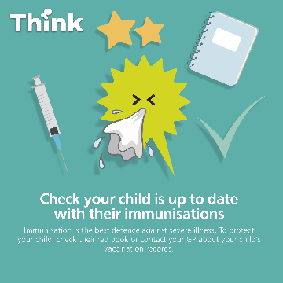
Hand hygiene | N/A | By teaching your child how to wash their hands properly this winter, we can all help prevent the spread of infections which are more common during the colder periods.  Knowledge of hand hygiene will help your little ones reduce the risk of picking up or spreading infections, to keep illnesses to a minimum this winter. | 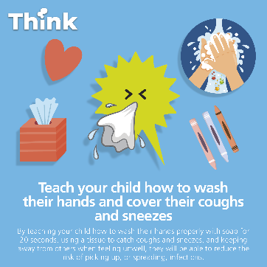
Symptoms and what to do if things get worse | N/A | There are several common infections which we see more of during the winter period, including RSV, scarlet fever and flu.  In most cases, these infections will be mild and can be treated at home, but it’s important to know when you might need medical help.  Click here to find out more (LINK TO CHILDREN’S PRESS RELEASE) | 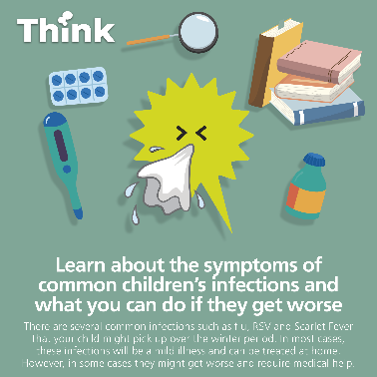
Keeping children off school/nursery when infectious | N/A | Keeping your child away from school or nursery when they are infectious this winter will really help in stopping the spread of any common illnesses.  If your child has common symptoms like a cough or sore throat, they should continue to attend, but if they are infectious there is a risk they could pass it onto others.  Click here to find out more (LINK TO CHILDREN’S PRESS RELEASE) | 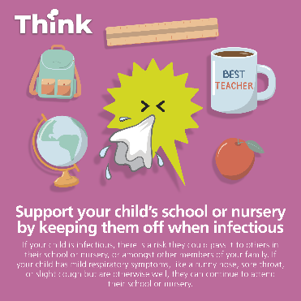

ENDS

