Winter toolkit – mental health

Social media posts and images

Facebook - Loneliness and social isolation

Date | Post Copy | Asset
December | POST 1  We are urging people to think about their own mental health this winter.  Pop in and see your neighbour for a cuppa, message a mate or give your family a ring.  POST 2  Winter can be a lonely time for some, we are encouraging us all to be considerate of others and open up conversations if we need help or believe others may be feeling lonely. | 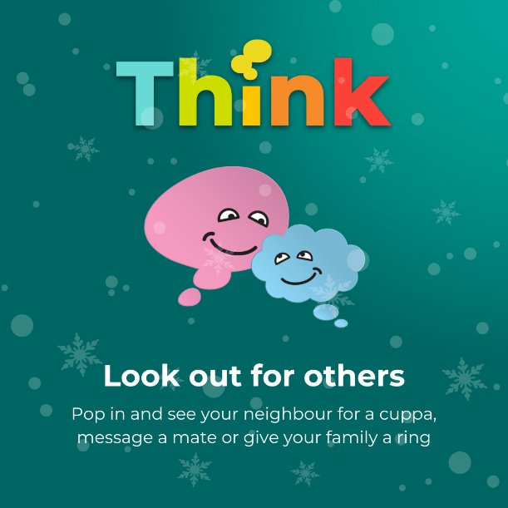
January | Winter can be a lonely time for some, we are encouraging us all to be considerate of others and open up conversations if we need help or believe others may be feeling lonely.  Sometimes, even when we are surrounded by others we can feel alone. Don't suffer in silence, reach out to organisations who are there to support you.  • South Cumbria - lancaster.gov.uk  • Preston - https://www.stcatherines.co.uk/resources/preston-social-support-groups/  • Blackburn - https://housingcare.org/service/list/s-22-companionship-befriending/l-240-blackburn-with-darwen#:~:text=Chatterbox%20Action%20Against%20Loneliness&text=Chatterbox%20is%20our%20award%2Dwinning,or%20alone%20in%20later%20life  • Blackpool - https://www.bfcct.co.uk/  Older people often experience loneliness. Age UK has the Silver Line on 0800 4708090. You can call for free seven days a week, 24 hours a day for a chat. | 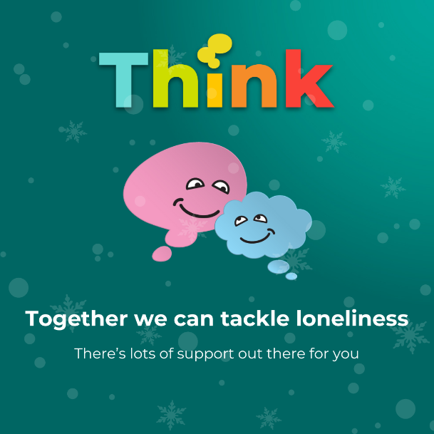
January | To be sent in the New Year – press release and social media around young people and loneliness
February | To be sent in the New Year - press release and social media around LGBTQ+ and loneliness

Twitter - Loneliness and social isolation

Date | Post copy | Asset
Throughout | We are urging people to think about their mental health this winter.  Think about checking in on your neighbours, having a cuppa, messaging a friend or going on a walk. | 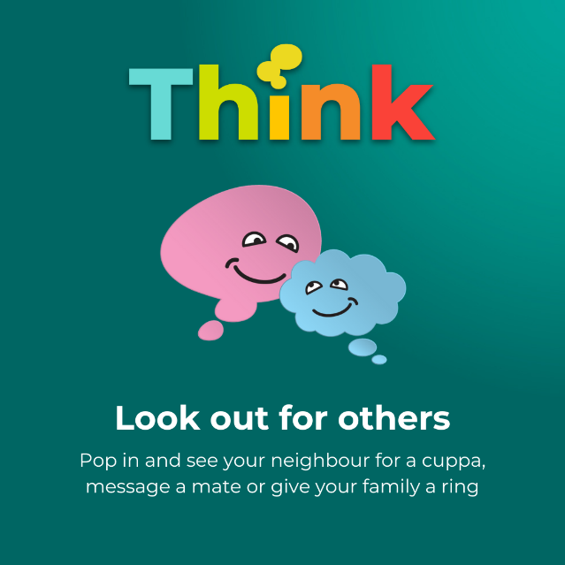

Facebook and Twitter – helpline messaging - crisis line, NHS talking therapies and wellbeing line

Date | Post copy | Asset
Throughout | We are here to support you this weekend if you are struggling and need urgent mental health support.  Our crisis line is available 24 hours a day, call 0800 953 0110 and speak to a trained medical professional 📞 | 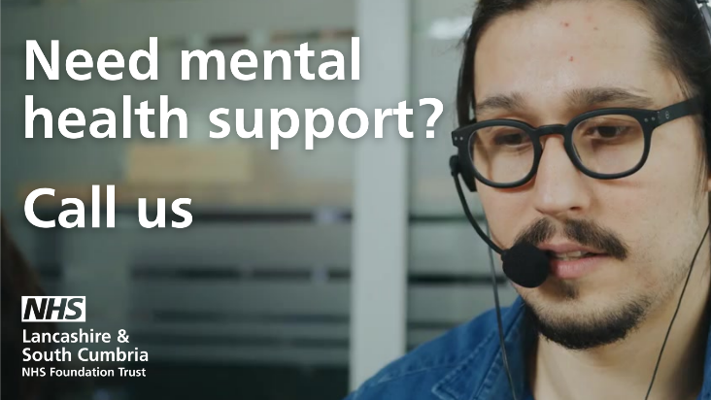
Throughout | The cold winter months can leave you feeling deflated 😔  As we continue to live through the cost of living crisis and a level of uncertainty talk to our mental health team on 0800 953 0110.
Throughout | Struggling to cope with feelings of anxiety or depression?  Refer yourself to NHS Talking Therapies to get the help you need ⬇️  www.lancashireandsouthcumbria.icb.nhs.uk/talkingtherapies
Throughout | Do you know someone who is struggling with anxiety or depression?  Rachel speaks about how NHS Talking Therapies have helped her:  “I was instantly reassured by my therapist, my sessions are with a senior CBT therapist who helps me rationalise my worries and teaches me coping mechanisms. They make me feel at ease, are always professional and nothing ever seems too much hard work. I know I’m in a safe space where I can talk openly and freely without any judgement and I even enjoy the homework element where I put their teachings into practise.”  NHS Talking Therapies are here to help.  You can self-refer here: https://bit.ly/3M5lW9Z | 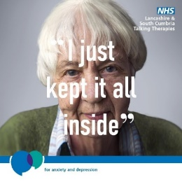
Feelings of anxiety and depression can affect us all.

If you need help with your mental health, refer yourself to NHS Talking Therapies ⬇️

www.lancashireandsouthcumbria.icb.nhs.uk/talkingtherapies
Middle of December | Christmas is just a few weeks away but we know not everyone will be excited for the countdown. For some, this time of year is difficult and it's important to know where to call for help when you need it. You can reach us on 0800 953 0110 📞
December | Are you feeling overwhelmed by Christmas?  We are urging people to reach out if they are struggling with their mental health this festive period.  Mental health support is available across Lancashire and South Cumbria. You can call the Crisis Line on 0800 953 0110 they are available 24 hours a day, seven days a week.
December | It’s normal to feel anxious, worried or down at times, especially during the festive season. There’s no shame if you're finding it’s too much.  We’re here to talk - our mental health wellbeing line and texting service is free.  Call 0800 915 4640 or Text 'Hello' to 07860 022846.
December | Christmas is just a few days away but we know not everyone will be excited for the countdown. For some, this time of year is difficult and it's important to know where to call for help when you need it. You can reach us on 0800 953 0110 24 hours a day, 7 days a week.

How to support your mental health – and others - throughout winter (Facebook and Twitter)

Date | Post copy | Asset
Beginning of December | The festive period can be stressful for families at the best of times, but potentially even more so this year with the rising cost of living. People often feel pressured to spend more money than they can afford on elaborate gifts and food during the festive period.  Think about seeking help for money issues this Christmas, we can help: LSC Integrated Care Board :: Cost of living support (icb.nhs.uk)  https://www.lancashireandsouthcumbria.icb.nhs.uk/news-and-media/latest-news/seek-help-money-worries-christmas | 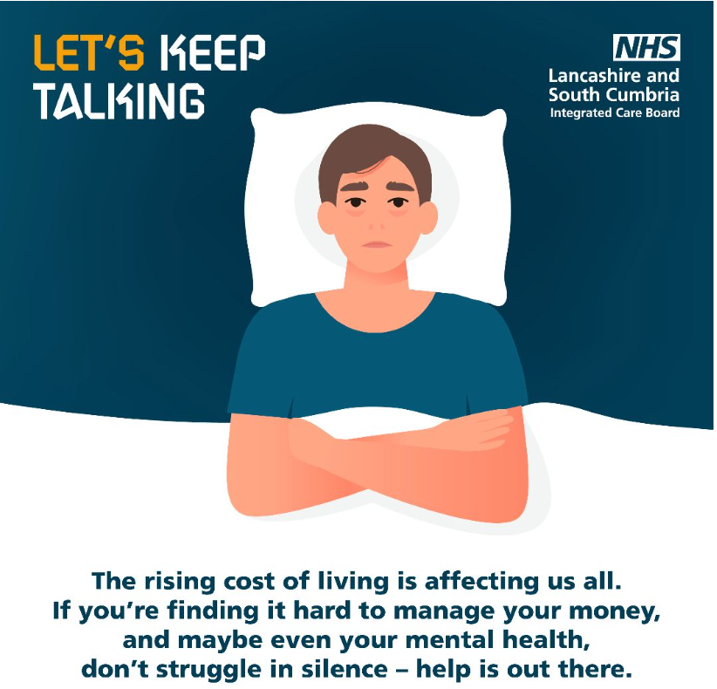
December | Christmas can be a struggle financially – if you’re worried about money, don’t suffer in silence, help is out there: LSC Integrated Care Board :: Cost of living support (icb.nhs.uk)
December | Think about checking in on others this winter. People can often be suffering with mental health issues without you knowing.  Is someone acting differently to usual?  Drop them a message, give them a call or pop round – it could make a huge difference. | 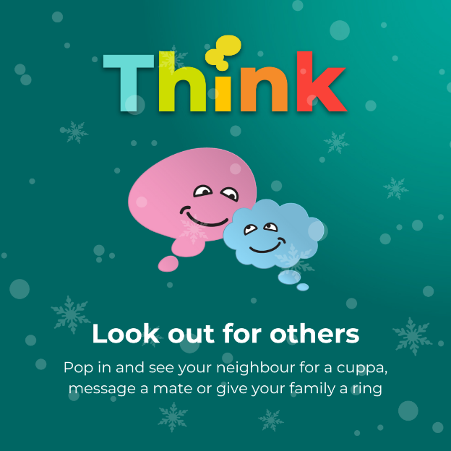
After Christmas | Back in October we shared some useful info for supporting your mental health during these dark winter nights. Here’s a reminder of our top tips Take your mental health forward when the clocks go back :: Lancashire and South Cumbria NHS Foundation Trust (lscft.nhs.uk) | Press release re clock change previously circulated
Middle of December | Feeling overwhelmed by the festive period? Your mental health and wellbeing are important than the ‘perfect’ Christmas. We are offering advice on how to cope as the celebration draws nearer, particularly after you start to see posts on Instagram and other social platforms.  Will also share Instagram story on our feed on – please repost if possible. | Use press release below - please add to websites
Middle of December  Facebook | We are reminding people that your mental health and wellbeing are more important than the ‘perfect’ Christmas’ as preparations for the festive period get underway.  We are offering advice on how to cope as the celebration draws nearer, with many people seeing an effect on their mental health in the quest for the best Christmas, particularly after seeing posts on Instagram and other social media from influencers and friends.  Here is some advice:  - Be kind to yourself and realistic on what you are physically able to attend and afford to buy. Try and manage your own and other’s expectations of what you can manage  - Remember that Christmas isn’t just about spending lots of money and overindulgence, plan your time doing what you would like to do, whether that is spending some time on your own or seeing loved ones. You may even decide to volunteer to help a local charity over the festive period to keep busy, give back and be around people who appreciate the gesture  - Christmas isn’t always a happy time for everyone; check in on those you know who might experience loneliness or are going through a tough time. A quick call, message or visit may help  - Make a list of services you may need and their Christmas opening times, booking appointments well in advance where necessary.
Dec/Jan | Think about supporting your mental health this winter by taking a walk outside during daylight hours - a break from your daily routine to experience some fresh air and natural day light will help
Dec/Jan | If you’re feeling a bit down, then think about talking to a friend about how you are both feeling as sharing your feelings will make you feel less alone.
December/ January | Coping with grief at Christmas can be an extremely difficult time, when you’re grieving, the thought of celebrating Christmas can be really daunting. It’s important to look after yourself and work out the best ways to cope throughout the season.  Don’t worry, there is help, support and information available to you either as a bereaved spouse, partner, carer, family member or friend.  Cruse Bereavement Support have some tips on how to support yourself over Christmas:  https://www.cruse.org.uk/understanding-grief/managing-grief/christmas/#:~:text=Consider%20different%20ways%20of%20celebrating&text=Or%2C%20you%20might%20find%20sticking,you're%20not%20comfortable%20with

Suicide awareness, prevention and bereavement

December | The festive season can be difficult if you have been bereaved by suicide. @AMPARO_LEM offer free practical and emotional support to anyone affected by suicide in Lancashire. If you’re struggling, reach out.  https://amparo.org.uk/
The festive season can be difficult if you have been bereaved by suicide. @Every_Life_Cumb are there to support you.

https://www.every-life-matters.org.uk/affected-by-suicide/
If you’re worried someone is thinking about suicide, ask them directly. Evidence shows asking someone if they're suicidal can protect them.

Get support to start the conversation today: https://www.healthierlsc.co.uk/suicide-1
 | If you are having thoughts of suicide or are worried about a friends of family member, you can talk to someone wearing an orange button. They’ve had the training to help you.  https://www.healthierlsc.co.uk/icb/orangebutton | 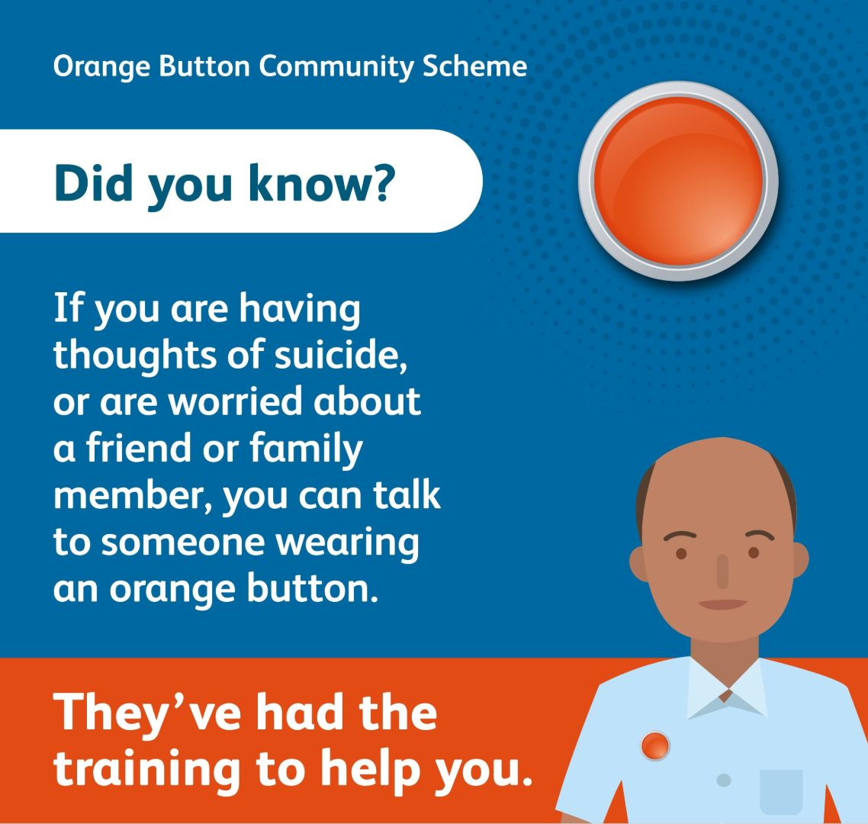
 | Young people can feel a lot of pressure at this time of year. @PAPYRUS_Charity are available 24/7 to offer free, confidential support via their #HOPELINE247. Call 0800 068 4141 | 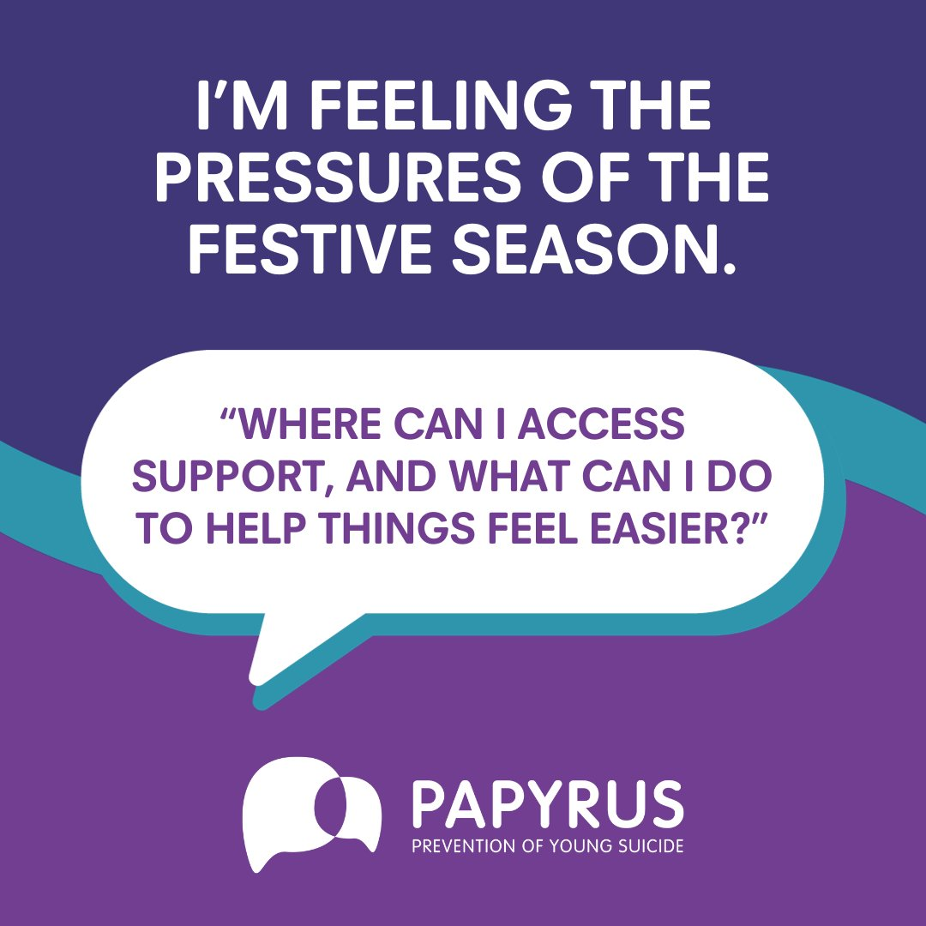
January | If you’ve been bereaved by suicide, starting the new year without a loved one can be really difficult. @Every_Life_Cumb are there to support you.  https://www.every-life-matters.org.uk/affected-by-suicide/
If you’ve been bereaved by suicide, starting the new year without a loved one can be really difficult. @AMPARO_LEM offer free practical and emotional support to anyone affected by suicide in Lancashire. If you’re struggling, reach out.

https://amparo.org.uk/

 | Are you starting the new year worried about money? There’s lots of support and advice available.  Most debt issues can be easily sorted out if you just reach out for help.  https://www.lancashireandsouthcumbria.icb.nhs.uk/our-work/mental-health/support/debt-advice-and-support/advice-and-support | 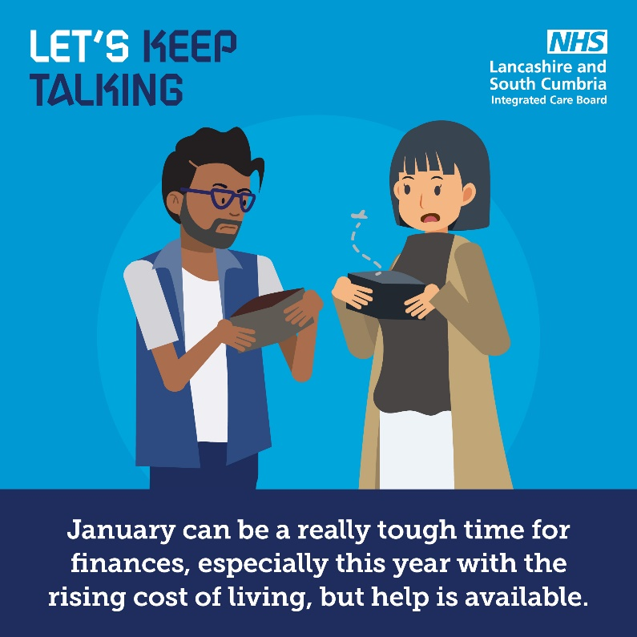
The new year doesn’t feel exciting to everyone. If you’re having thoughts of suicide, there’s people ready to listen.

Samaritans: 116 123
Papyrus: 0800 068 4141
Lancs + S.Cumbria crisis line: 0800 953 0110

The Healthy Young Minds website has lots of advice, guidance and support related to children and young people’s mental health and emotional wellbeing.

https://www.healthyyoungmindslsc.co.uk/

Press release – Christmas pressure (to be circulated by LSCft)
Mental health advice ahead of Christmas
‘Your wellbeing is more important than the ‘perfect’ Christmas’ is the reminder coming from a mental health Trust as preparations for the festive period get underway.
Lancashire and South Cumbria NHS Foundation Trust (LSCft) is also offering advice on how to cope as the celebration draws nearer, with many people seeing an effect on their mental health in the quest for the best Christmas, particularly after seeing posts on Instagram and other social media from influencers and friends.

Senior Psychological Wellbeing Practitioner, Nicola Scott, from LSCft’s Talking Therapies service “Christmas is a great time to celebrate and see family and friends, buy each other gifts and make plans, however, it’s for these reasons that it can also be particularly difficult and overwhelming for some too.
“Whether you’re partaking in the festivities or it’s happening around you, it adds extra pressure and can become a burden on many people; financially, emotionally or physically.
“It might be that you can’t afford to buy gifts for others or your budget won’t stretch to get everything your family ask for. It also can be a really busy time leaving you burning the candle at both ends and some may dread having to spend time with family they might not normally get along with, all the while seeing photos of people seemingly enjoying themselves in matching pyjamas, smiling round the dinner table or indulging in the sharing of lots of Christmas presents. It could even be that you don’t have many friends or family around you to share these moments with and Christmas reminds you of that.
“We often see an increase in referrals into our service this time of year and so it is vital to remind people the perfect Christmas doesn’t exist, your health and wellbeing are more important. Set yourself some boundaries and remember that it is okay to not spend lots of money or time doing festive activities if you can’t or don’t want to.”
Advice on how to cope includes:
- Be kind to yourself and realistic on what you are physically able to attend and afford to buy. Try and manage your own and other’s expectations of what you can manage
- Remember that Christmas isn’t just about spending lots of money and overindulgence, plan your time doing what you would like to do, whether that is spending some time on your own or seeing loved ones. You may even decide to volunteer to help a local charity over the festive period to keep busy, give back and be around people who appreciate the gesture
- Christmas isn’t always a happy time for everyone; check in on those you know who might experience loneliness or are going through a tough time. A quick call, message or visit may help
- Make a list of services you may need and their Christmas opening times, booking appointments well in advance where necessary

- Try to find something in common with people you normally struggle to speak to and if you are not comfortable, keep a sensible distance without cutting yourself off from everyone else you’re with
- Remember that there is no such thing as the perfect Christmas and images you see on social media are a snapshot in time and often aren’t ‘real’ because they portray what we want the world to see. Don’t assume that people in the photos are having a better time than you or that you are inferior to them. Try to enjoy your own experience
- If possible, do some exercise such as outdoor walking. It’s free and is a great way to get some fresh air while spending time with others
- Most importantly, let someone know if you are struggling. There is lots of help available and services who can help you.
LSCft is also letting people know that they will be there to listen and talk to over Christmas and afterwards, when people may start to feel a lull after the celebrations are over and life goes back to normal.
Nicola added: “We know that Christmas often becomes a distraction for people who are experiencing difficulties in their lives and then when it’s over they are hit with reality.
“We will be here for anyone who needs help over the festive period and beyond.”
Mental health support is available across Lancashire and South Cumbria through the Crisis Line on 0800 953 0110 which is available 24 hours a day, seven days a week.
For help with anxiety and depression, please visit Talking Therapies at lscft.nhs.uk/talkingtherapies where you will find more information and have the option make a self-referral into the service.
ENDS

Web copy (can also use full press release)
Mental health advice ahead of Christmas
‘Your wellbeing is more important than the ‘perfect’ Christmas’ is the reminder coming from a mental health Trust as preparations for the festive period get underway.
Lancashire and South Cumbria NHS Foundation Trust (LSCft) is also offering advice on how to cope as the celebration draws nearer, with many people seeing an effect on their mental health in the quest for the best Christmas, particularly after seeing posts on Instagram and other social media from influencers and friends
Senior Psychological Wellbeing Practitioner, Nicola Scott, from LSCft’s Talking Therapies service “Christmas is a great time to celebrate and see family and friends, buy each other gifts and make plans, however, it’s for these reasons that it can also be particularly difficult and overwhelming for some too.
“It might be that you can’t afford to buy gifts for others or your budget won’t stretch to get everything your family ask for. It also can be a really busy time leaving you burning the candle at both ends and some may dread having to spend time with family they might not normally get along with, all the while seeing photos of people seemingly enjoying themselves in matching pyjamas, smiling round the dinner table or indulging in the sharing of lots of Christmas presents. It could even be that you don’t have many friends or family around you to share these moments with and Christmas reminds you of that.
“We often see an increase in referrals into our service this time of year and so it is vital to remind people the perfect Christmas doesn’t exist, your health and wellbeing are more important. Set yourself some boundaries and remember that it is okay to not spend lots of money or time doing festive activities if you can’t or don’t want to.”
Advice on how to cope includes:
- Be kind to yourself and realistic on what you are physically able to attend and afford to buy. Try and manage your own and other’s expectations of what you can manage.

- Remember that Christmas isn’t just about spending lots of money and overindulgence, plan your time doing what you would like to do, whether that is spending some time on your own or seeing loved ones. You may even decide to volunteer to help a local charity over the festive period to keep busy, give back and be around people who appreciate the gesture.
- Christmas isn’t always a happy time for everyone; check in on those you know who might experience loneliness or are going through a tough time. A quick call, message or visit may help.
- Make a list of services you may need and their Christmas opening times, booking appointments well in advance where necessary.
- Try to find something in common with people you normally struggle to speak to and if you are not comfortable, keep a sensible distance without cutting yourself off from everyone else you’re with.
- Remember that there is no such thing as the perfect Christmas and images you see on social media are a snapshot in time and often aren’t ‘real’ because they portray what we want the world to see. Don’t assume that people in the photos are having a better time than you or that you are inferior to them. Try to enjoy your own experience.
- If possible, do some exercise such as outdoor walking. It’s free and is a great way to get some fresh air while spending time with others.
- Most importantly, let someone know if you are struggling. There is lots of help available and services who can help you.
LSCft is also letting people know that they will be there to listen and talk to over Christmas and afterwards, when people may start to feel a lull after the celebrations are over and life goes back to normal.
Mental health support is available across Lancashire and South Cumbria through the Crisis Line on 0800 953 0110 which is available 24 hours a day, seven days a week.
For help with anxiety and depression, please visit Talking Therapies at www.lancashireandsouthcumbria.icb.nhs.uk/talkingtherapies where you will find more information and have the option make a self-referral into the service.
Intranet copy

‘Your wellbeing is more important than the ‘perfect’ Christmas’. Lancashire and South Cumbria NHS Foundation Trust (LSCft) is offering advice on how to cope as the celebration draws nearer, with many people seeing an effect on their mental health in the quest for the best Christmas, particularly after seeing posts on Instagram and other social media from influencers and friends.
Advice on how to cope includes:
- Be kind to yourself and realistic on what you are physically able to attend and afford to buy. Try and manage your own and other’s expectations of what you can manage.
- Remember that Christmas isn’t just about spending lots of money and overindulgence, plan your time doing what you would like to do, whether that is spending some time on your own or seeing loved ones. You may even decide to volunteer to help a local charity over the festive period to keep busy, give back and be around people who appreciate the gesture.
- Christmas isn’t always a happy time for everyone; check in on those you know who might experience loneliness or are going through a tough time. A quick call, message or visit may help.
- Make a list of services you may need and their Christmas opening times, booking appointments well in advance where necessary.
- Try to find something in common with people you normally struggle to speak to and if you are not comfortable, keep a sensible distance without cutting yourself off from everyone else you’re with.
- Remember that there is no such thing as the perfect Christmas and images you see on social media are a snapshot in time and often aren’t ‘real’ because they portray what we want the world to see. Don’t assume that people in the photos are having a better time than you or that you are inferior to them. Try to enjoy your own experience.
- If possible, do some exercise such as outdoor walking. It’s free and is a great way to get some fresh air while spending time with others
- Most importantly, let someone know if you are struggling. There is lots of help available and services who can help you.
Mental health support is available across Lancashire and South Cumbria through the Crisis Line on 0800 953 0110 which is available 24 hours a day, seven days a week.
For help with anxiety and depression, please visit Talking Therapies at www.lancashireandsouthcumbria.icb.nhs.uk/talkingtherapies where you will find more information and have the option make a self-referral into the service.

