Bank holidays communications toolkit – Winter 2023-24

Social media

Topic | Post | Image to use
Medicine cabinet | It costs around £10 to stock your medicine cabinet with recommended medicines. Visit your local pharmacy for advice and get prepared now before you fall ill: www.healthierlsc.co.uk/winter. | 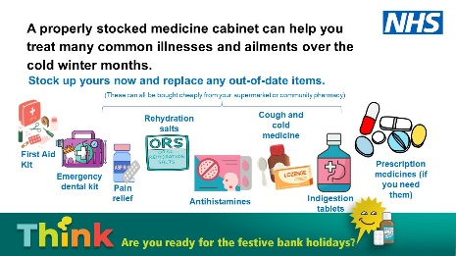
Medicine cabinet | A well-stocked medicine cabinet should have aspirin, paracetamol and ibuprofen, anti-diarrhoea tablets, oral rehydration salts, cough and cold medicine, antihistamines, indigestion medicine, an emergency dental kit and a first aid kit including a thermometer and ice and heat packs for pain. They’re all cheap and will help if you need them. www.healthierlsc.co.uk/winter.
Medicine cabinet | While out Christmas shopping, make sure you pick up any medicines you might need if you fall unwell this winter. You’ll thank yourself later. www.healthierlsc.co.uk/winter.
Medicine cabinet | Have you got a fully stocked medicine cabinet? When was the last time you checked everything in there was in date? Check them now and replace any out-of-date items. www.healthierlsc.co.uk/winter.
Repeat prescription | Don’t leave it too late to order your repeat prescriptions if you’re due to run out of medications over the festive bank holidays. www.healthierlsc.co.uk/winter. | 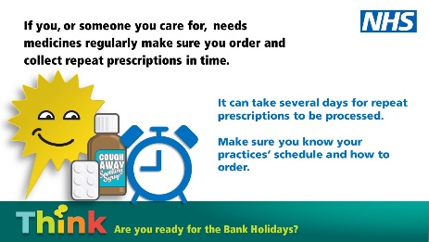
Repeat prescription | It can take a number of days to process repeat prescriptions and, with GPs and some pharmacies closed on bank holidays, there will be more people ordering them. You can order in advance from your GP or online or using the NHS app. www.healthierlsc.co.uk/winter.
Bank holiday opening | You can still access urgent health services over the festive season, but most GP practices will be closed on bank holidays. Health advice is available through 111.nhs.uk and you can find which pharmacies are open by visiting www.healthierlsc.co.uk/winter and selecting ‘Pharmacy’. | 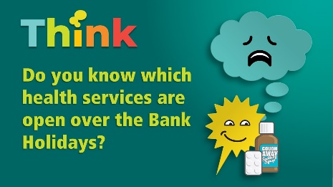
Vaccinations | Those eligible should also book flu and COVID-19 vaccinations – especially if attending parties or visiting family – rather than putting it off until the new year. To find out if you are eligible, and to book, visit www.healthierlsc.co.uk/getmyjab | 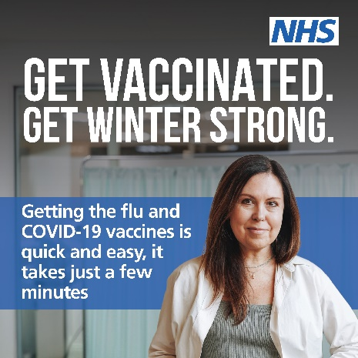
Dentistry | Most dentists will be closed over the festive bank holidays. If you need urgent dental treatment or advice when your usual dental practice is closed call the Dental Helpline - 0300 1234010 between 8am and 9pm Monday to Friday, 10am to 5pm weekends and bank holidays.  Outside of these hours, for urgent dental support call 111. Find out more at www.healthierlsc.co.uk/winter | 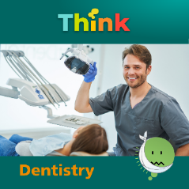

Digital screen slides

(See separate attachment.)

Intranets/Newsletters

With Christmas just around the corner, it’s a good time to stock up your medicine cabinet and make sure you order any repeat. Most GP practices, dentists, optometrists and pharmacies will be closed or have limited opening hours over the Christmas and New Year bank holidays, so making sure you have enough medication at home to cover the festive break is really important.

Planning ahead for ordering and collecting repeat prescriptions is essential at a time when services are likely to be busier than normal. By ordering medicines as soon as possible, it allows enough time for it to be processed and dispensed and helps avoid a last-minute rush.

Coughs and colds, as well as COVID-19, are extremely common at this time of year, so pain relief such as aspirin, paracetamol and ibuprofen is useful to keep at home to cope with aches, pains and high temperatures. Indigestion relief remedies, anti-diarrhoea tablets and oral rehydration salts are also good to have to hand, as well as a first aid kit, including a thermometer and ice and heat packs for pain – especially when slips and falls are more likely in frosty conditions.

Pharmacies will be open for their regular Saturday and Sunday hours on 23 and 24 December, but the majority will be closed for Christmas Day (Monday 25) and Boxing Day (Tuesday 26). Again, pharmacy availability will be extremely limited on New Year’s Day (Monday 1 January).
A list of the pharmacies that will be open across the region over the Christmas and New Year bank holidays can be found on our website at www.healthierlsc.co.uk/winter. You can also use the NHS find a pharmacy tool to find your nearest available pharmacy.

Most GP practices will also be closed over the bank holidays and it can sometimes take up to five working days for a practice to issue a repeat prescription and for a pharmacy to process and dispense the medication - so ordering as soon as possible is advisable. You can order repeat prescriptions online, through the NHS App or through your GP surgery.

The dental helpline is available should you need dental advice when your normal dentist is closed. Call 0300 1234010 between 8am and 9pm Monday to Friday, 10am to 5pm weekends and bank holidays. For advice outside of these times visit 111.nhs.uk or call 111.

Those eligible should also book flu and COVID-19 vaccinations – especially if you are attending parties or visiting family – rather than putting it off until the new year. To find out if you are eligible, and to book, visit www.healthierlsc.co.uk/getmyjab

Press release (and for websites)

Have you ordered your repeat prescription ahead of Christmas?
Tuesday 12 December 2023

With Christmas just around the corner, health professionals in Lancashire and South Cumbria are urging people to stock up their medicine cabinets and order repeat prescriptions in good time.

Most GP practices and pharmacies will be closed or have limited opening hours over the Christmas and New Year bank holidays, so making sure you have enough medication at home to cover the festive break is really important.

Dr Peter Gregory, associate medical director for Lancashire and South Cumbria Integrated Care Board (ICB), the organisation that plans and buys health services for the region, is urging people not to leave it too late to get your prescription orders in, and also to keep your medicine cabinet topped up with everyday essentials to help deal with the winter months ahead.

He said: “Planning ahead for ordering and collecting repeat prescriptions is essential at a time when services are likely to be busier than normal. By ordering medicines as soon as possible, it allows enough time for it to be processed and dispensed and helps avoid a last-minute rush.

“Make a note of your local pharmacy’s opening times over Christmas, and now is also a good time to stock up on home medicine basics so that you can make the most of the festive period.

“Coughs and colds, as well as COVID-19, are extremely common at this time of year, so pain relief such as aspirin, paracetamol and ibuprofen is useful to keep at home to cope with aches, pains and high temperatures. Indigestion relief remedies, anti-diarrhoea tablets and oral rehydration salts are also good to have to hand, as well as a first aid kit, including a thermometer and ice and heat packs for pain – especially when slips and falls are more likely in frosty conditions.”

Pharmacies will be open for their regular Saturday and Sunday hours on 23 and 24 December, but the majority will be closed for Christmas Day (Monday 25) and Boxing Day (Tuesday 26). Again, pharmacy availability will be extremely limited on New Year’s Day (Monday 1 January). A list of those that are opening will be made available on the Lancashire and South Cumbria Integrated Care Board (ICB) website.

You can order repeat prescriptions online, through the NHS App or through your GP surgery.

You can also use the NHS find a pharmacy tool to find your nearest available pharmacy.

Think ahead - make sure that you have enough medication to last when your GP surgery may be closed. Don’t use A&E or 111 as a back-up pharmacy; plan ahead. But if you do need emergency advice, community pharmacies can often help.

Most dentists will also be closed over the festive bank holidays. If your dental practice is closed and you need urgent dental treatment or advice contact the Lancashire and South Cumbria dental helpline which can also provide advice, support and an appointment where required. Call 0300 1234 010 between 8am and 9pm Monday to Friday, 10am to 5pm weekends and bank holidays. Outside of these hours, for urgent dental support and all urgent care needs, please visit 111.nhs.uk or call 111. NHS 111 will help direct you to the most appropriate service which could be a walk-in centre, pharmacy or an out-of-hours GP appointment. Always call 999 in the event of a life-threatening emergency.

Those eligible should also book flu and COVID-19 vaccinations – especially if you are attending parties or visiting family – rather than putting it off until the new year. To find out if you are eligible, and to book, visit healthierlsc.co.uk/getmyjab.

ENDS

