Self-care communications toolkit – Winter 2023-24

Social media – for use during Self Care Week (13-19 Nov 2023)

Topic | Video link | Post | Image to use
Social prescribing link workers | https://youtu.be/Ks5P-vBbuIk | This #selfcareweek we're taking the self out of self-care. If you want to improve your health and wellbeing there is lots of help and support available to you. Social prescribing link workers are available through your GP practice. #selfcaretogether #selfcareweek
Psychological practitioners | https://youtu.be/srkTM4rwOD4 | Self-care includes your mental health and getting to the bottom of issues that might be holding you back or affecting your motivation. Some GP practices have access to psychological practitioners that can help you. #selfcaretogether #selfcareweek
Pharmacy | https://youtu.be/8XOVfLYO874 | You'd be amazed at how much self-care advice you can get from your local pharmacist. They can offer all kinds of advice and support to you are not alone in looking after yourself. #selfcaretogether #selfcareweek | 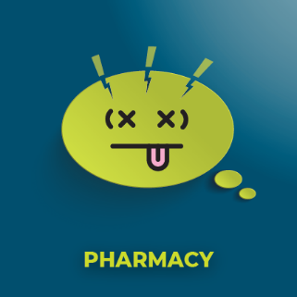
NDPP | https://youtu.be/Ni0WyBkk3hM | The National Diabetes Prevention Programme #NDPP is a great way to prevent type 2 diabetes and helps with weight loss and lifestyle changes. It's a way of guiding you through the self-care behaviours you need #selfcaretogether #selfcareweek  https://www.lancashireandsouthcumbria.icb.nhs.uk/our-work/diabetes/national-diabetes-prevention-programme

Social media – for use during all of winter

Topic | Video link | Post | Image to use
Athlete’s foot | https://youtu.be/z-LAqMN9iUI | Athlete’s foot is painful and can last several weeks but over the counter medicines will do the trick so you don’t always need to see a doctor. Making sure you wear fresh socks every day is a good way to help. Here's what else you need to know #SelfCare  Find more at www.healthierlsc.co.uk/winter
Back pain | https://youtu.be/2KeHACZ1ZX8 | Back pain is common and there are ways to treat the symptoms yourself at home. You only need to see a GP under certain circumstances or if it doesn’t ease off.  Try a hot bath or speak to your pharmacist for some advice on rub on painkillers.  See your GP if the pain doesn’t ease after 3 days, if it moves to your chest or if you also have a fever.  Seek urgent advice through NHS 111 you feel numb or get pins and needles or if you lose control of your bowels or urination.  #SelfCare  Find more at www.healthierlsc.co.uk/winter
Bites and stings | https://youtu.be/q2K5zIv2AS4 | Bites and stings are nothing to worry about usually. Soap and water will help. Just DON’T use vinegar or bicarbonate of soda like those old wives’ tales say. Here's what you need to know to be #SelfCare  Find more at www.healthierlsc.co.uk/winter
Chicken pox | https://youtu.be/JqvmCnmHreU | Chicken pox affects lots of children but the old at home remedies are often the best. Like wearing socks on hands at night to stop them scratching. Your pharmacist will have ointments to help with chicken pox. Here's what you need to know to be #SelfCare  Find more at www.healthierlsc.co.uk/winter
Colds | https://youtu.be/WnJQCxIb3RU | It's the time of year where colds are likely . There’s no need go to the doctor with a cold as you can treat it at home. Make sure you have lots of fluids and take cheap painkillers like paracetamol. Save yourself a long wait for a GP by following this simple advice. Be #SelfCare  Find more at www.healthierlsc.co.uk/winter
Conjunctivitis | https://youtu.be/crNViTKeKgw | Conjunctivitis affects the eyes and can last up to two weeks but can be treated with warm water. It’s rarely anything too serious. #SelfCare  Find more at www.healthierlsc.co.uk/winter
Constipation | https://youtu.be/f7B9VyMDD2c | Constipation can be painful but drinking plenty of water and eating more fruits and vegetables should help. Here's what you need to know for #SelfCare  Find more at www.healthierlsc.co.uk/winter
Coughs | https://youtu.be/xmuvVPShvn4 | It’s the time of year when coughs and colds are likely, but they will clear up after a few weeks. It’s only if a cough lasts longer that you need to seek medical help. #SelfCare  Find more at www.healthierlsc.co.uk/winter | 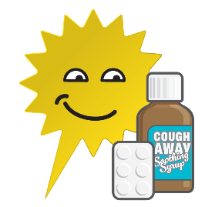
Cradle cap | https://youtu.be/SfQn_8vRong | Cradle cap is perfectly normal and very common. It will clear up on its own with regular washing with baby safe shampoo #SelfCare  Find more at www.healthierlsc.co.uk/winter
Ear infections | https://youtu.be/OMB2l03XJSw | Ear infections are very common and can be treated fairly easily at home.  Use painkillers and drink plenty of fluids. Check with children for signs of other illnesses  See the GP if you also have a temperature over 38C or if you have other symptoms such as sickness or dizziness  Seek emergency care if it's a child and they also have a rash that doesn’t fade with pressure.  #SelfCare  Find more at www.healthierlsc.co.uk/winter | 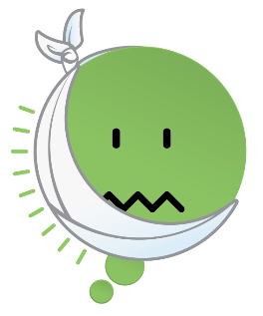
Ear wax | https://youtu.be/oaBiiQq9Vek | GPs don’t always see people to clear ear wax. Believe it or not a few drops of olive oil in your ear will help loosen ear wax. Just don’t stick cotton buds in there!  #SelfCare  Find more at www.healthierlsc.co.uk/winter
Fever | https://youtu.be/cwjh4OEqr7s | When should you and when shouldn’t you see a doctor when your child has a fever? Here's what you need to know #SelfCare  Find more at www.healthierlsc.co.uk/winter
Headaches | https://youtu.be/Z8BiMzJrrvs | A headache is rarely an emergency. Different types of headaches mean different ways to treat them, but it usually boils down to rest, drinking plenty of fluids and cheap painkillers #SelfCare  Find more at www.healthierlsc.co.uk/winter | 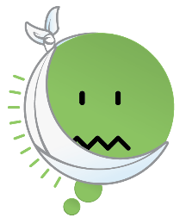
Heartburn and indigestion | https://youtu.be/8tyvt3U_RIk | It’s easy to mistake heartburn and indigestion with something more serious. Some people rush to emergency services when there’s no need. Here's what you need to know for #SelfCare  www.healthierlsc.co.uk/winter
Long term conditions | https://youtu.be/ZsRYGYP3rcs | Did you know that colder weather can make long-term respiratory conditions worse. If you have asthma or COPD here's what you need to know for #SelfCare  www.healthierlsc.co.uk/winter | 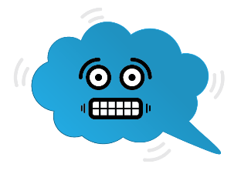
Sore throat | https://youtu.be/UtjEODJkZIM | Sore throats can be treated really easily at home or with help from a pharmacist. Here's what you need to know for #SelfCare  www.healthierlsc.co.uk/winter | 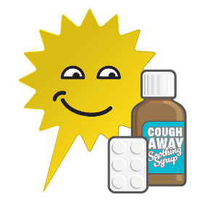
Sprains and strains | https://youtu.be/0nKp6oVnHps | If you sprain or strain a limb it might hurt but it isn't an emergency. They can often be treated yourself without the need for medical help.  Remember PRICE - Protect, Rest, Ice, Compression bandage, Elevate.  Seek medical advice if you can't move the limb at all, it's deformed or if you notice serious bruising.  #SelfCare  Find more at www.healthierlsc.co.uk/winter
Preventing falls | https://youtu.be/t_pNQhgqnWU | If you’re a little unsteady on your feet, falling can be common but it can lead to more serious health issues. Here’s some self-care advice to help prevent falls. #SelfCare  www.healthierlsc.co.uk/winter | 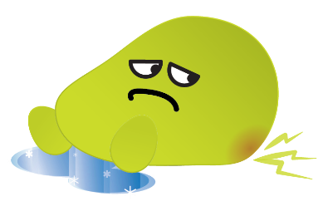

Digital screen slides

(See separate attachment.)

Intranets/Newsletters

Self-care is all about finding ways to improve your physical and mental health and wellbeing. This includes staying active, knowing how to prevent falls, checking your medication/stocking your medicine cabinet and knowing how to treat common illnesses and ailments yourself. All of these are little things we can do to prevent health and wellbeing issues getting to the point of needing medical help.

Here are some top tips for how to exercise self-care in your daily life:

- Take vitamin D supplements, especially if you’re unable to get outside regularly.
- Boost your natural immunity to colds and viruses with good nutrition and regular exercise.
- Support your mental wellness by keeping connected to friends and family.
- Note your daily achievements and celebrating the little things.
- Learn something new every day and take time to notice the world around you.
- Get plenty of fresh air.
- Speak to a local pharmacist to review your medication if you have a lot of medications.
- Adopt positive lifestyle choices.
- Understand how to manage minor and long-term health conditions.
Information videos about the most common illnesses and ailments that can be treated at home are available at www.healthierlsc.co.uk/winter

The advice includes taking hot baths and over-the-counter painkillers for colds, drinking honey and lemon in warm water for coughs, putting olive oil in your ears to help with the build-up of ear wax and exercises you can do to improve balance if you’re unsteady on your feet.

These videos also contain information about how long each illness/ailment may last and at what point you should consider seeking medical advice.

The benefits of exercising self-care go beyond not having to take time out of your day to see a healthcare professional. Very often, over-the-counter remedies can be much cheaper than getting them on prescription. Paracetamol, for example, costs as little as 34p and completely stocking your medicine cabinet with staple medicines and remedies can be done for under £15.

Anyone with a long-term health condition is at greater risk of becoming unwell during winter, as the colder weather makes some conditions worse. So, if you have a respiratory condition, like asthma or COPD, or even if you’re just a little unsteady on your feet, the videos on our webpage contain information that you will find useful.

Press release (and for websites)
Monday 13 November 2023

Put yourself first by hitting the self-care button this week

Take charge of your health – that is the message from NHS chiefs this Self Care Week.

Staying active, checking your medication and knowing how to treat common illnesses yourself are just some of the little things we can all do to prevent health and wellbeing issues getting to the point of needing medical help.

Self Care Week is a national event from 13-19 November 2023 and is the perfect time to think about how we live our lives and maybe make some small changes.

Peter Gregory, associate medical director with NHS Lancashire and South Cumbria Integrated Care Board (ICB), said: “We see a lot of people coming to GPs with conditions that would naturally get better in time on their own.

“It’s easy for people to assume the worst when they get ill and worry that their cold or sore throat is something worse, and we will always encourage people to make an appointment with their GP if they have real cause for concern.

“But very often it’s better to take control of the illness and a quick visit to a pharmacist for advice or simply getting plenty of rest and warm drinks is enough to get on top of things.”

As health services such as GPs, walk-in centres and A&E are busier than ever, the best way to avoid long waits is to prevent health and wellbeing issues getting to the point of needing urgent medical help.

Information videos about the most common illnesses and ailments that can be treated by self-care at home are available at www.healthierlsc.co.uk/winter. The list includes hot baths and over-the-counter painkillers for colds, honey and lemon in warm water for coughs, olive oil in the ears to help with build-up of ear wax and exercises on how to improve balance if you’re unsteady on your feet.

These videos also contain information about how long the illness may last and at what point you should consider seeking medical advice from your doctor.

The benefits of exercising self-care go beyond not having to take time out of your day to see a healthcare professional. Very often over-the-counter remedies can be much cheaper than getting them on prescription. Paracetamol, for example, costs as little as 34 pence and completely stocking your medicine cabinet with staple medicines and remedies can be done for under £15.

There are also benefits for mental and physical health, as good self-care includes getting more exercise, quitting smoking and maintaining a healthy weight. One of the simplest self-care behaviours is trying a new hobby which distracts the mind from day-to-day troubles and can give you a sense of achievement. Speaking to a social prescribing link worker could help find something for you.

Most GP practices have access to social prescribing link workers or health coaches. Their role is to establish what is affecting your health and wellbeing and explore ways to tackle those issues. They can guide you through the different options and support you into a service that best suits your needs. They will even go as far as going with you to a new group or service if you need it.

Local authorities have lots of people willing to offer advice on finding new services or hobbies for you. That could be in the form of a sports coach at one of the sports centres or even a librarian to help search for a new hobby or interest group.

Find more top tips around self-care on our website: www.healthierlsc.co.uk/winter

For more information on Self Care Week visit Self Care Week.

ENDS
Notes to editors:

Self Care Week, 13-19 November, is an annual national awareness week that focuses on embedding support for self-care across communities, families and generations. The campaign is about making improvements in your life to protect your physical health and mental wellbeing.

