Cumbria Health and Wellbeing Board

Submission to the Lancashire and Cumbria Health Equity Commission (HEC)
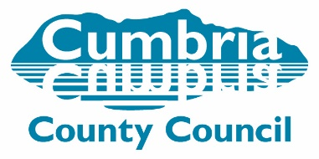


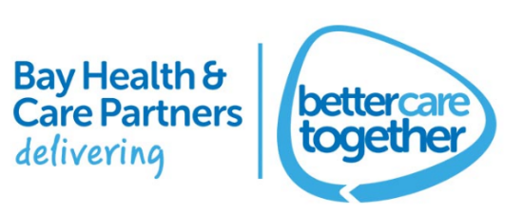
- Executive Summary
1.1 This report is the Cumbria Health and Wellbeing Board submission to the Lancashire and Cumbria Health Equity Commission. The Health Equity Commission is chaired by Professor Sir Michael Marmot, the commission affords the two counties a unique opportunity to highlight the health inequalities, in the wake of the worldwide Covid-19 pandemic. The Health Equity Commission is formed of a mix of independent experts and key influencers who will have a sustained role in the monitoring of its recommendations.
1.2 Health and Wellbeing Boards and their associated Directors of Public Health were asked to work across their local areas with their partners and local communities to paint a picture of the needs of local partners and their communities in relation to health inequalities which will be collated to evidence to inform the Commission. This report will be presented to Sir Michael’s panel on the 29th November 2021, by Cumbria’s Director of Public Health, Colin Cox.
1.3 The Health Equity Commission asked the HWWB to consult on 8 key questions:
- Identify the key health inequalities in your area. What would you like to emphasis or highlight?
- What are your localities priorities to reduce health inequality (up to 5)?
- What work/projects/strategies do you have locally that have had the most positive impacts on health inequalities?
- What support do you need to make a step change in addressing health inequalities?
- How would you strengthen partnerships with stakeholders who impact on health in our region e.g., businesses, the VCFS, public services and local authorities?
- What barriers have prevented you making the difference to your locality?
- How we can make health inequalities our number 1 priority?

1.4 The evidence presented in this report has been collated from a wide range of participants from organisations across Cumbria, including local authorities, NHS, Third and Voluntary Sector and local businesses. The outcomes of this Commission will help Cumbria shape its response to concerns raised through the Integrated Care System and will identify priorities to help address those health inequalities.
1.5 Cumbria is a county of contrasts, with a mix of deprivation and affluence: famed for its areas of outstanding natural beauty, there are also pockets of urban deprivation. Rural areas face challenges around accessing services, lack of public transport and fuel poverty, urban areas face the challenges brought by low air quality, limited employment opportunities and poverty.
1.6 The varying issues across Cumbria’s diverse communities means that solutions to tackle the wider determinants of health need to be tailored to different parts of the county. By directly seeking the views of the county’s multiple partner organisations as part of this work, it is hoped to get a complete picture of the issues, concerns and perhaps some emerging solutions, for Cumbria’s health inequalities.
1.7 The Commission process has involved partners being asked 8 key questions covering health inequalities, priorities, impacts of local work, resources and support needed to make a step change, how to strengthen partnerships and barriers to local change. Many respondents identified the same or similar issues, with key themes emerging across the 8 questions, which are summarised below.
1.8 It should be noted that many of the priorities identified by respondents are already reflected in local strategies which include: tackling poverty; building community resilience; tackling obesity; improving mental health and wellbeing; population health management plans; improving children’s mental wellbeing and improving adult mental wellbeing. However, the Covid-19 pandemic response work has meant that some actions plans and implementation strategies have been subject to delays.
1.9 A variety of key health inequalities were highlighted by respondents and an overarching theme was that, despite the best efforts of partners across the county, there has been no seismic shift in health inequalities in the county. There was frustration from respondents about this. The survey and consultation groups highlighted several issues for Cumbria which included:
  - a need for long-term funding, rather than the current piecemeal approach that saw short-term funding for short-term projects;
  - the need to improve partnership working in the county, specifically with reference to addressing the hierarchical approach and ensuring the involvement of front-line staff and people with ‘lived experience’;
  - the need to make the most of existing resources and to ensure that duplication of effort is avoided;
  - the complexities of some structures in the county, which was a barrier to meaningful and agile partnership working.
All of these concerns should be viewed against the background of issues around national and local policy (including the benefits system, low wage economy, zero hours contracts and, locally, transport infrastructure) and the impact of the Covid-19 pandemic. The complex structures governing healthcare and local government in Cumbria further complicates partnership working efforts.

1.10 Taking the issues of partnership working and structural complexities together, one big concern for respondents was the problems around data sharing across partners – particularly primary care, health and local government – with joined up systems better able to identify need. GDPR legislation was acknowledged as a practical barrier to this. Meanwhile, it was felt that having the resource, priority and scale needed to tackle health inequalities would allow partners to develop and implement a joint plan, encompassing a shared vision and co-produced principles to address health inequalities.
1.11 There was very strong feedback on the importance of the role of Community, Voluntary, Faith and Social Enterprise (CVFSE) partners and their impact in addressing inequalities. Uniquely placed to ensure that ‘lived experience’ plays a role in identifying local issues and need along with their understanding of what works and what does not, in tackling community issues. Appropriate and timely funding would ensure their efforts were more sustainable.
1.12 When asked what could foster a ‘step change’ in health inequalities, a number themes emerged around legislation, funding, data, planning, consistency and collaboration and the need to learn from pilot projects, ensuring information and data sharing across partners and the importance of lived experience and partnership working.
1.13 There was a shared view that collaborative partnership working is vital to reduce health inequalities, with strong collaboration not just through local partners but between national and local partners, all local government partners, the NHS, Third, Voluntary and Independent Sectors, community groups and local communities themselves.
1.14 A practical suggestion for a more consistent approach to collaborative partnership working could be achieved through ensuring that inequalities was a central priority in more organisations, with a common approach to identifying impacts on inequalities at the service-design stage, through the use of Equality Impact Assessments to inform planning, development and commissioning decisions. In addition, taking a ‘Health in All Policies’ approach would make health inequalities pivotal to the way organisations plan and work. Alongside this was the need to recognise the role that the wider determinants of health plays in health inequalities and give this the recognition that it needs.
1.15 The importance of sharing learning from projects and programmes was raised, with a joined-up approach to evaluating interventions that work well; not only would this create a more consistent approach to service design but would also help to avoiding duplication of effort and deployment of resources. This would also ensure that interventions could be better targeted and the most made of the limited resources available.
1.16 In conclusion, despite the best efforts of the Cumbria Health and Wellbeing Board and partners, people continue to experience multiple inequalities and this report acknowledges reducing these is a complex ambition. This report identifies key steps in order to do this. Change is needed in how policy development is approached, to address the structural causes of inequalities in relation to education, environment, housing, welfare provision and planning, with social and health inequalities considered at the planning stage of policy, service and programme development.
1.17 Early intervention, prioritising disadvantaged groups, developing regulatory policy and improving access to services are key. Building on community engagement via the ‘lived experience’ and working with communities is an important part of the approach needed, without the problems around identification and stigmatisation of people living in deprivation. Involving the community voice in strategic decisions and devolving more power to community partnerships is central, along with ensuring sustainable funding for CVFSE organisations and utilising their knowledge and standing in the community to develop and realise that greater community involvement.
1.18 From the evidence collated in this report, it is recommended that to meaningfully impact on inequalities in Cumbria we must:
- Agree joint system leadership, accountability and oversight across all partners.
- Be purposeful about creating the right conditions and culture with ensuring the right level of understanding, mindset, skills and behaviours for tackling the social determinants of health.
- Further develop and strengthen collaborative partnership working, including working with communities to ensure the voice of lived experience becomes embedded within governance, priority setting and decision making.
- Develop a shared set of priorities and outcomes, with an explicit emphasis on inequalities and agreed responsibility for delivery across the partnerships.
- Ensure data sharing protocols are in place to enable the development of integrated datasets. Identify gaps in data collection and develop solutions.
- Increase investment in prevention and allocate local funding based on social inequalities and health outcomes to increase funding to communities with the greatest need.
- Provide evidence of how to reduce health inequalities locally in the short, medium and long term.
- Agree a set of tools to be used across the system to ensure that a reduction in health inequalities is a golden thread in all decision making.

- Background
2.1 Lancashire and Cumbria have commissioned a Health Equity Commission (HEC) which is proposed to support and influence efforts to tackle health inequalities and promote greater healthy equity across Lancashire and Cumbria and to shape and inform both of the region’s renewals following COVID19.
2.2 The HEC, chaired by Professor Sir Michael Marmot, will bring Lancashire and Cumbria up to date. The HEC will be based on the latest evidence to demonstrate where our biggest health inequalities are and what works to reduce them following the pandemic. It will assess how best to provide leadership and support the formative structures of our Integrated Care System (ICS), investment and actions for better and more equitable health through priority actions in the short, medium and long term. The HEC will be formed of a mix of independent experts and key influencers and have a sustained role in the monitoring of its recommendations. As such, the HEC will:
- Be a catalyst for health equity transformation in both Regions, by helping to develop meaningful responses and action in key social determinants of health;
- Provide independent expert opinion, evidence and guidance as Lancashire and Cumbria’s communities, places and economy reshape post COVID19;
- Provide expertise, challenge, and support to lead the way, regionally and nationally in recognising and responding to the inequalities that traditionally exist and have emerged as a result of COVID19 and the circumstances arising from the pandemic.
2.3 Health and Wellbeing Boards and their associated Directors of Public Health have been asked to work across their local areas with their partners and local communities, to paint a picture of the needs of local partners and their communities in relation to health inequalities which will be collated to evidence to inform the Commission.
3.0 Cumbria
3.1 Cumbria is the third largest county in England by area, 6,768 km². It is bounded to the north-east by Northumberland, the east by County Durham, the south-east by North Yorkshire, the south by Lancashire, the west by the Irish Sea, the north-west by the Scottish council areas of Dumfries and Galloway, and the north by Scottish Borders. Cumbria is one of the most sparsely populated counties in England in mid-2020 Cumbria’s population was 499,781 persons.
Many parts of Cumbria have a natural environment second to none; however some of our urban areas suffer from poor air quality. There are clear pockets of deprivation linked to low income and skills, particularly in some urban areas, whereas it is often our more rural areas that have difficulty accessing goods and services.
Such differences in poverty, power and resources, exposure to health damaging environments, and opportunities in early life are the main drivers of health inequalities. Unhealthy behaviour such as smoking, inactivity, violence and poor diet is more common in communities that have less access to and control over these assets.
The correlation between deprivation and health can clearly be illustrated by comparing the geography of multiple deprivation in Cumbria with the geography of health deprivation and disability, as shown in the maps below.

Figure 1
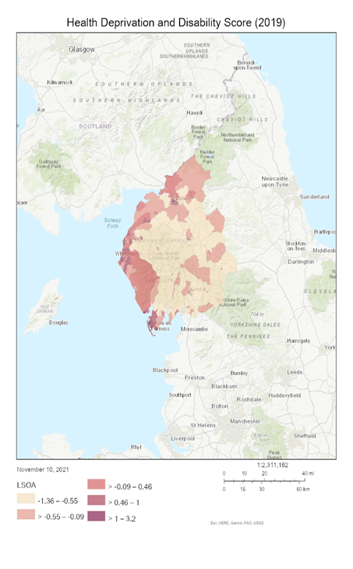 | 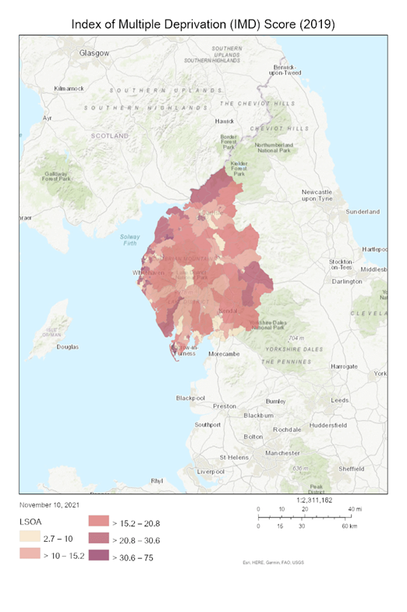
It is clear from the maps above that for many of the indicators that combine to create the Index of Multiple Deprivation (particularly those focused on income, employment and skills), Cumbria’s most challenged areas are urban and more generally along the west coast of the county.

However there are two important caveats to this statement. Firstly, the Index of Multiple Deprivation is more useful in looking at urban areas, where deprivation is more likely to be similar in any given location; in larger rural geographies there is more likely to be a mixture of relative deprivation and relative affluence leading to a more average score overall and potentially masking rural deprivation. Secondly, some of the indicators used tell a very different story: the maps below illustrate that for access to housing and services, and for the living environment domain (which is dominated by indicators of housing quality including whether houses are centrally heated), it is Cumbria’s rural areas that face the greatest challenges.

Figure 2
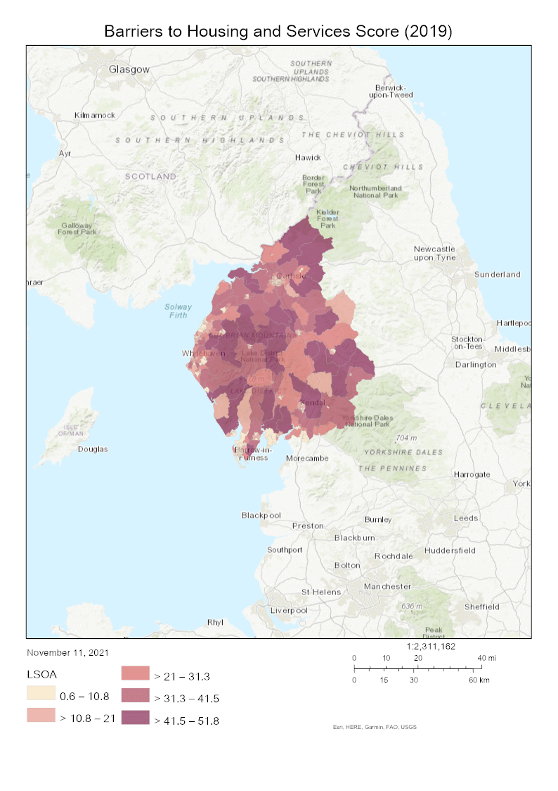 | 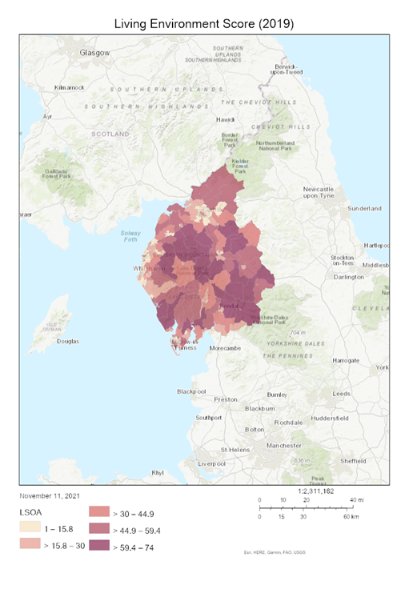
This significant variation across Cumbria indicates that the priorities for tackling the wider determinants of poor health and wellbeing will necessarily be different in different parts of the county .
4.0 Cumbria Health and Wellbeing Board (HWBB)
4.1 The Health and Wellbeing Board exists to provide strategic leadership and promote closer integration of health and care, through partners working together to ensure that everyone in Cumbria is able to benefit from improvements in health and wellbeing.
4.2 To achieve the purpose outlined above the functions of the Health and Wellbeing Board are (full details in appendix 1):
Leadership - to lead and direct the health and wellbeing system to ensure that partners improve services and make the best use of resources to deliver better outcomes for people.
Understanding - to identify and develop a shared understanding of the needs and opportunities for improving people's health and wellbeing in Cumbria and to lead the development of a Joint Strategic Needs Assessment.
Strategy - to prepare and publish a Joint Health and Wellbeing Strategy for Cumbria to ensure that the services required to meet the needs identified in the JSNA are delivered in a planned, coordinated and measurable way.
Assurance - to ensure a collective awareness of the major changes, pressures and risks across health and wellbeing services and provide opportunity to review, comment and consider the opportunities for collaborative approaches to address or manage these.
Accountability - to be assured that the decisions of the Board and partners, and their subsequent outcomes, are clearly focused on improving the health and wellbeing of people in Cumbria.
Partnership - to ensure there is effective dialogue, engagement and joint working between county and local health and wellbeing structures and partnerships and with other key strategic partnerships and networks.
Integration - to promote integration and partnership working between the NHS, social care, public health and other services.
4.3 Details of the membership of the Health and Wellbeing Board can be found in appendix 2.
5.0 Health and Wellbeing Board key strategies
5.1 The Health and Wellbeing Board covers the full geographic region of Cumbria. This includes the Districts of Allerdale, Barrow, Carlisle, Copeland, Eden, South Lakes and Cumbria County Council. The health footprint across Cumbria is split.
5.2 The North of Cumbria – covering Carlisle, Eden, Allerdale and the majority of Copeland Districts sits in the North East, North Cumbria (NENC) ICS, in which it is one of four ICPs. North Cumbria is split into 8 integrated care communities (ICCs), matching (though predating) the new primary care network (PCN) footprints and aiming to deliver place-based care through partnership working. Carlisle, Cumbria's capital and only city, is covered by two ICCs (Carlisle Healthcare, and Carlisle Network) for its urban area, and a third ICC (Brampton and Longtown) for the District's rural area. Workington, Cumbria's largest coastal town, has its own ICC. Whitehaven falls within Copeland ICC. The remaining ICCs are Maryport and Cockermouth, Keswick and Solway, and Eden. Several ICCs include a mix of deprived coastal and rural areas with more affluent areas within or close to the Lake District National Park.
5.3 The South of Cumbria sits in Lancashire and South Cumbria Integrated Care Partnership. Morecambe Bay Place Based Partnership (PBP) is one of five PBPs in Lancashire and South Cumbria ICP. There are eight ICCs in Morecambe Bay, which have been created to help bring together local health and care organisations and have an important local role in reducing health inequalities. The ICCs are Barrow and Millom, Bay (covering Heysham and Morecambe), Carnforth, East (covering Bentham, Kirkby Lonsdale and Sedbergh), Grange and Lakes (covering Ambleside, Grange-over-Sands and Windermere), Kendal, Lancaster and Mid Furness.
The ICCs are broadly co-terminus with the newer Primary Care Network (PCN) footprints, with some exceptions. PCNs are the building blocks for the delivery of the NHS Long Term Plan and have responsibilities in relation to reducing health inequalities as part of a Direct Enhanced Service. BHCP are working with PCNs and ICCs to maximise delivery to provide integration at a neighbourhood level and support communities to improve health outcomes.
The eight PCNs in Morecambe Bay were established in July 2019. They are Barrow and Millom PCN, Bay PCN (covering Heysham and Morecambe), Carnforth and Milnthorpe PCN, Grange and Lakes PCN (covering Ambleside, Grange-over-Sands and Windermere), Kendal PCN, Lancaster PCN, Mid Furness PCN and Western Dales PCN (covering Bentham, Kirkby Lonsdale and Sedbergh). The footprints of the PCNs are broadly co-terminus with those of the previously established Integrated Care Communities, although the Carnforth and Milnthorpe PCN overlaps with East ICC and the majority of the area covered by East ICC (excluding Milnthorpe and surrounds) is covered by the Western Dales PCN.
Morecambe Bay PBP spans two local authorities and some of these ICCs/PCNs are located within Lancashire Cumbria County and therefore Lancashire Health and Wellbeing Board.
5.4 The Health and Wellbeing Board has a number of key strategies to implement its work going forward, tackling inequalities is a key element in all of these strategies.

Figure 3 – Key Strategic Documents
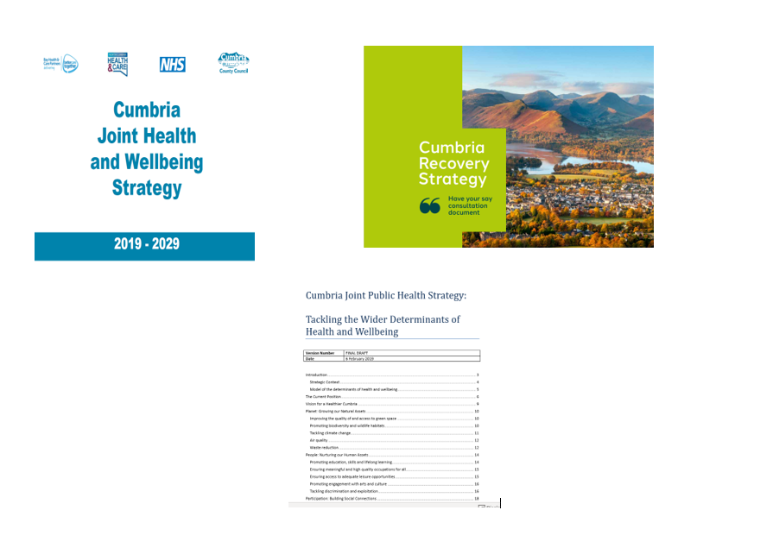
5.5 The Cumbria Joint Health and Wellbeing Strategy 2019 – 2029 sets out the vision and priorities that will shape how the Cumbria Health and Wellbeing Board will work together over the next ten years. The strategy underpins the Board’s ultimate aim to improve the overall health and wellbeing of the people of Cumbria and reduce health inequalities. The strategy development and delivery of the strategy is supported by the Cumbria Joint Strategic Needs Assessment (JSNA). Cumbria Observatory – JSNA
Social, economic and environmental inequalities and their effects are pervasive locally as well as nationally. The Cumbria Joint Strategic Needs Assessment has identified inequality as a recurrent theme throughout the county. Many indicators show persistent inequalities, with poorer health outcomes in people living in more disadvantaged situations: those living in poverty and those who have protected characteristics are significantly more likely to experience ill health and premature death than those living in advantaged circumstances.

Figure 4 - Cumbria Joint Health and Wellbeing Strategy 2019 – 2029 framework

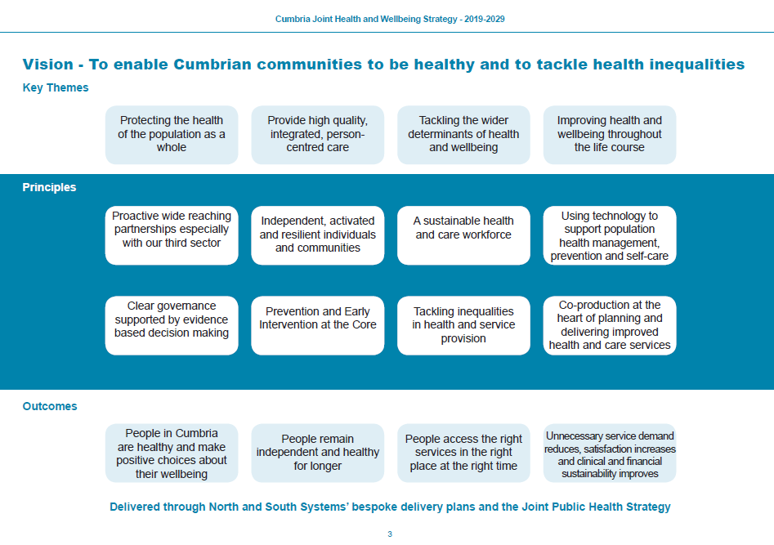

5.6 The Cumbria Joint Public Health Strategy: Tackling the Wider Determinants of Health and Wellbeing was developed by the Public Health Alliance. The strategy is to be supported by a range of action plans, developed and implemented at different levels (Figure 5).
Figure 5 – Implementation of the Joint Public Health Strategy

The strategy supports the implementation of the vison of the Cumbria Joint Health and Wellbeing Strategy ‘To enable Cumbrian communities to be healthy and to tackle health inequalities’. The strategy outlines the five key components to achieving a healthier Cumbria (figure 6).

Figure 6 – Joint Public Health Strategy five key components

5.7 The Cumbria Recovery Strategy (accompanying evidence, paper 3) was ratified in July 2021. The strategy was produced due to the impact on the County of the Covid-19 pandemic. The strategy aims to build a better place where people are healthy and safe and people want to visit, communities are connected and thriving and our economy is growing, sustainable and benefits everyone.
Figure 7 Cumbria Recovery Strategy Priorities
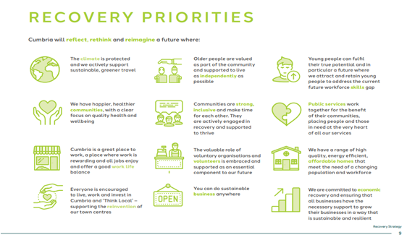
6.0 Health and Wellbeing Board Task and Finish Group – Recovery Priorities/Inequalities
6.1 A paper was submitted to the HWBB in July 2020 outlining the recovery structures that had been put in place in Cumbria in order start to rebuild after Covid (accompanying evidence, paper 4). It was agreed that the HWWB priorities for the next year would be:
Wellbeing:
Priority 1 Addressing the impact that Covid has had on the emotional and mental wellbeing of Children and young people.
Priority 2 Building on the community response to Covid - supporting people and communities in Cumbria to thrive.
Priority 3 Addressing the impact of Covid has had on the wider determinants of health. In particular, focussing on the impact that the economic downturn will have on individuals, families and communities.
Sustainability of Health and Care System:
Priority 1 Development of new service delivery models
Priority 2 Sustainability of the Regulated Care Market
6.2 In July 2021 a paper was presented to the Health and Wellbeing Board outlining the impact of Covid-19 on inequalities (accompanying evidence, paper 5). The paper aimed to construct a framework for a conversation at the Health and Wellbeing Board around what approach is required to:
- Mitigate further inequalities which may develop due to further possible measures that may be required to control the spread of COVID-19 which is currently still circulating in the population.
- Address inequalities as part of Cumbria’s stabilisation and recovery plans.
The paper described how the COVID-19 pandemic has highlighted existing inequalities with people living in our most deprived communities, males, people from Black, Asian and Minority Ethnic (BAME) backgrounds having higher rates of infection and sadly mortality from COVID-19. The highest mortality rate has been seen in London, followed by the North West and the North East. A greater negative impact on mental and financial wellbeing has been seen in the North of England than the rest of the country. The paper highlighted that allowing these inequalities to continue will result in poorer population health outcomes and a missed opportunity to learn from the experiences of the COVID-19 pandemic.
The paper also highlighted that deprivation-related inequalities in the mortality rate from COVID-19 follow a similar trajectory to inequalities in mortality from other causes, this suggests that the drivers of COVID-19 mortality are similar to the wider causes of inequalities in health.
To illustrate how the pandemic has potentially had multiple and complex impacts on inequalities this paper used the five key components in the vision from the Cumbria Joint Public Health Strategy and the Cumbria Recovery Strategy – Planet, People, Participation, Place, Prosperity to briefly describe some of the local impacts.
6.3 Following the presentation of the paper the HWBB recommended that a small task and finish group was established to take the outcomes from the discussion and bring forward a refresh of the Health and Wellbeing Board Recovery Priorities (TOR accompanying evidence, paper 6).
6.4 The role of the task and finish group is to bring together representatives from the Health and Wellbeing Board with colleagues from across the County. The aim of the group is to undertake a refresh of the Health and Wellbeing Board Recovery Priorities considering the potential impacts of COVID-19 on the existing inequalities faced by certain population groups within Cumbria.
6.5 Following the announcement of the HEC it was agreed that the task and finish group would lead on collating the evidence for the ‘HEC ASK’ on behalf of the HWBB.
7.0 Distribution of the HEC questions and information gathering
7.1 To collect responses from across the county to the questions raised by the HEC, e mails on behalf of the HWWB were circulated to partnership groups. There were also presentations at a number of partnership meetings e.g., the Public Health Alliance and the Poverty and Financial Hardship Working Group. Feedback was invited via e mail returns and responses to the questions on a survey monkey (full responses can be found in appendix 3).
7.2 To enable partners and individuals to participate in evidence gathering during meetings and in a less formal format, the questions were posted onto a retro board. The link to the retro board was also sent out to partners. The retro board allows people to add ‘virtual’ post it notes under the questions, other participants then have the option to like any comments posted (full responses can be found in appendix 4).
Figure 8 - Easy Retro Board
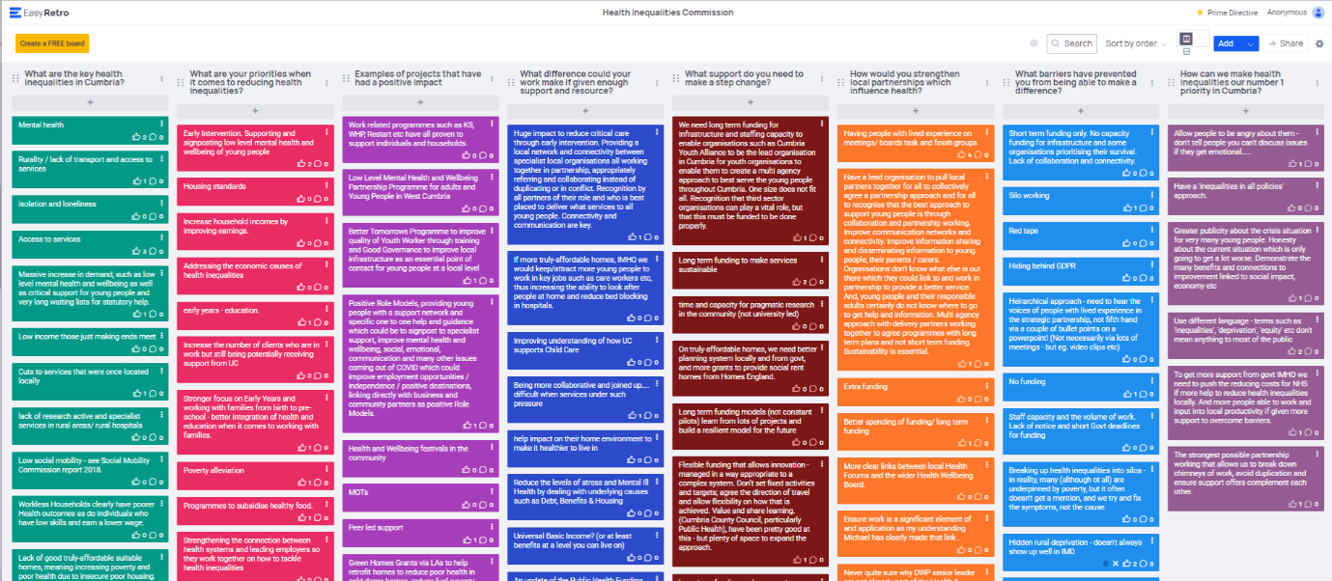

7.3 There has been feedback from partners regarding confusion as to what areas the HEC covered. The decision for North Cumbria to join the HEC was not finalised until October 2021. On the Institute of Health Equity webpage, it is still described as the Lancashire and South Cumbria Health Equity Commission, which some partners in the north have described as a barrier to them becoming involved. Other county wide partners have said they were unsure whether to feedback from a whole county perspective or just the south. There has also been feedback that not as many people from the north of Cumbria attended the HEC workshops because it was advertised as Lancashire and South Cumbria.
8.0 Responses to question 1 - Identify the key health inequalities in your area. What would you like to emphasis or highlight?
8.1 A number of respondents identified the same or similar issues in relation to the key health inequalities in Cumbria, these have been pulled together as themes (Figure 9). Many of these themes were cross cutting and could potentially have multiple impacts on people.
Examples of cross cutting responses:
“Lack of training opportunities outside the larger conurbations. The distance, difficulty, and cost of travelling to training centres prevents many young people having any ambition or motivation to improve their circumstances.”

“Addiction, poor housing options, lack of employment, culture issues, no real aspirations (due to lack of opportunity) to break out of poverty and benefits.”

“Our super aging population presents significant challenges, as does the lack of availability of staff within the health and social care sector, potentially reducing the quality of care available, preventing hospital discharge into the community.”
Figure 9 – Q1 Themes
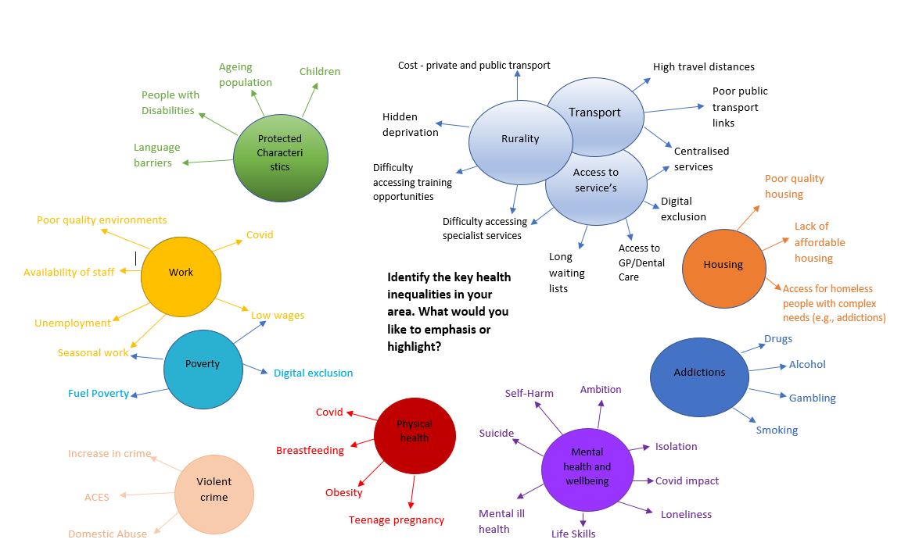

8.2 Inequalities across society are based on imbalances of power, income and wealth. Health inequalities occur as a result of these wider inequalities. As such, these wider inequalities need to be addressed if health inequalities are to be reduced. The themes that emerged from the consultation reflected this in that participants identified most of the wider determinants that contribute to health inequalities. Rurality, the large geographical area of Cumbria and the associated issues related to this was one of the main themes that participants identified, this included issues such as population spread, access to services and transport.
Figure 10 – Spread of the Cumbrian population
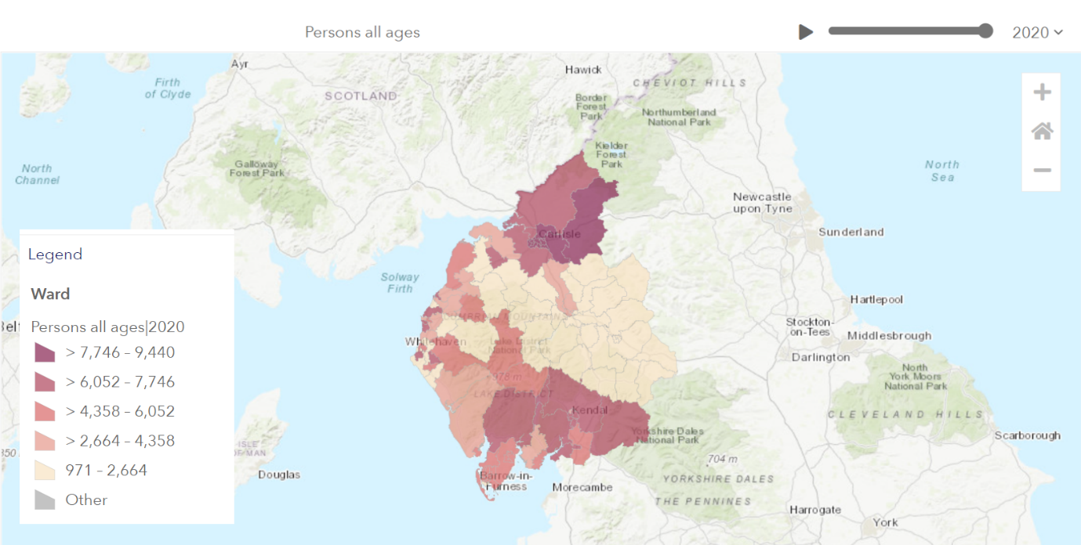

8.3 Having good public transport networks can also promote social cohesion and connectivity for people who are not able to drive. Unfortunately, public transport is a considerable challenge in Cumbria where the majority of the population live rurally in multiple small communities, and there has been a struggle to make rural routes financially viable.
8.4 Participants themes also identified some specific health inequalities in physical health and mental health and wellbeing, with some themes specific to contributing factors such as addictions.
8.5 Child Health – In Cumbria in Year 6, 19.2% (943) of children are classified as obese. The rate for alcohol-specific hospital admissions among those under 18 is 52*, worse than the average for England. This represents 48 admissions per year. Levels of GCSE attainment (average attainment 8 score), breastfeeding and smoking in pregnancy are worse than the England average (PHE fingertips).

8.6 Adult Health - the rate for alcohol-related harm hospital admissions in Cumbria is 658*. This represents 3,446 admissions per year. The rate for self-harm hospital admissions is 226*, worse than the average for England. This represents 1,005 admissions per year. The rates of new sexually transmitted infections and new cases of tuberculosis are better than the England average. The rate of killed and seriously injured on roads is worse than the England average. The rates of statutory homelessness, violent crime (hospital admissions for violence) and employment (aged 16-64) are better than the England average (PHE fingertips).
8.7 The large number of themes identified by participants highlighted the complexity of addressing inequalities in Cumbria. Several the theme’s participants identified are already included in the HWBB key strategies as priorities. However, these strategies are high level blueprints of the HWBB’s vision and desired outcomes. Due to the Covid-19 pandemic, work on developing some of the vital action plans to implement the strategies has been delayed.
Many priorities are however being taken forward including:
- Tackling Poverty;
- Building Community Resilience;
- Tackling Obesity;
- Improving Mental Health and Wellbeing;
- Population Health Management workplans;
- Improving children’s mental wellbeing;
- Improving adult mental wellbeing.
8.8 There were a small number of gaps in the themes that participants identified, this could have been due to the tight timeframe for the consultation and that some partners may not have received the questions or had the capacity to respond.
8.9 One of the gaps not highlighted by participants was the inequalities often faced by unpaid carers. The COVID-19 pandemic continues to have a monumental impact on unpaid carers’ lives – not only because of the increased amount of care that many are having to provide, but because of the far-reaching effect that providing this level of care is having on many aspects of their lives: their relationships, their mental and physical health, their paid work and finances, and their emotional wellbeing. It is estimated that overnight, an additional 4.5 million people became unpaid carers in March 2020, meaning 1 in 4 (26%) UK adults were providing unpaid care to an older, disabled or ill relative or friend at the height of the pandemic. Unpaid carers provide critical support for people with health and social care needs. The majority of recipients of unpaid care are older parents or spouses and partners. Evidence suggests that unpaid caring should be considered a social determinant of health. Carers experience poor physical and mental health, struggle to access services and are at risk of financial hardship.
9.0 Responses to question 2 - What are your priorities when it comes to reducing Health Inequalities?
9.1 As with question one, a number of respondents identified the same or similar priorities in relation to the reducing health inequalities in Cumbria. These have been pulled together as themes (Figure 11).
9.2 There were a couple of priorities identified that were specifically relevant to local initiatives:
“Integrate health inequalities into the Borderlands and the 70m infrastructure investment planned for Carlisle and other similar towns initiatives i.e. Barrow”.
“Ageing Population and supporting healthy years of life – making Cumbria an attractive place to live, work and invest for younger people. Promoting work as healthy and second/third careers in later life. Inclusive Growth- ensuring that investment in the county is deployed in a manner that closes income gaps, increases the GVA of the county and looking at circular economies.”
Figure 11 – Q2 Themes

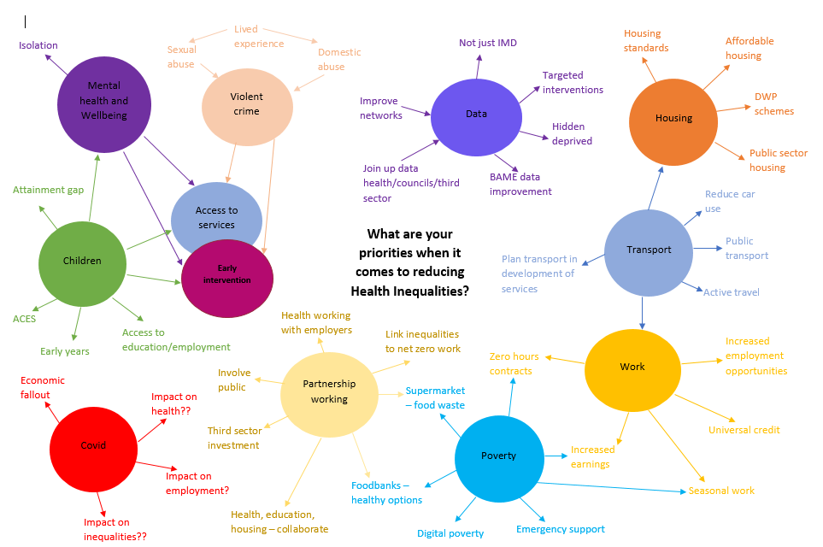
9.3 Two of the most common recurrent themes were partnership working and data issues.
“Partnership work and ensuring a joined-up collaborative, cross-sector approach to delivery. Third sector organisations play a vital role as they work at a community level but must be invested in.”
“Sort out the data sharing across primary care, health and the councils. Data is fragmented, systems should be able to talk to each other. Pulling together all the data will allow better identification of need.”
9.4 Many participants responded that generally partnership working across the county was good, with partners making a genuine effort to work collaboratively. It was acknowledged that the complexity of the health footprint across the county means that there are different structures, strategies, plans and priorities. It can also cause issues with partners needing to attend multiple meetings.
9.5 There was strong feedback that it is essential that all partners acknowledge the role of the Community, Voluntary and Faith and Social Enterprise partners and the impact they have in addressing inequalities. They are essential for involving communities and ensuring statutory partners listen to the bottom-up needs of communities, bringing lived experience voices to the table, they also have a wealth of experience in what has been tried before, what worked and what did not. It is essential that they are adequately funded to enable them to provide support to local communities. This funding needs to be of sufficient value and sustainable; the reliance of CVFSE on short term funding is destabilising, affecting staff, community trust and impact.
9.6 The analysis of the theme’s partners identified for question 1 and 2 showed that there was the expected overlap in what participants identified as what the key health inequalities in Cumbria are and what their priorities are when it comes to reducing Health Inequalities. However, there were a number of notable omissions in key inequalities identified in Q1 and the and priorities identified in Q2 these were:
- Protected characteristics;
- Physical health;
- Addictions and;
- Rurality;
There were also priorities in Q2 that had not been highlighted as issues in Q1 these were:
- Partnership working;
- Data;
- Early intervention;
- Covid (higher number of issues highlighted).
There could be several reasons for this difference including the consultation possibly not receiving submissions from partners who work specifically in these areas. Or that there are barriers to partners being able to prioritise all the issues identified due to funding or capacity issues.
9.7 A number of the priorities identified by partners are included in the HWBB key strategies as priorities. Following the COVID-19 pandemic, as part of its strategic recovery plans the HWWB developed the Cumbria Recovery Strategy. Within the strategy there are 20 broad priorities that sit under the HWWB, these include several that are specific to reducing inequalities including (accompanying evidence, paper 7):
- Reduce the inequalities in emotional well-being and mental health created and compounded by experiences of domestic abuse, substance misuse or isolation.
- Further develop equitable, person-centred, joined-up preventative services to reduce the risk factors for ill-health and Covid-19, including tobacco, alcohol and other substance misuse as well as healthier weight initiatives for all ages.
- Reduce inequalities for those people with additional needs who may have been further marginalised, excluded or de-skilled through the work of all our partnerships
- Ensure Cumbria has a thriving third sector, with sustainable and supported voluntary, community, faith and social enterprise organisations that are well connected to each other and to statutory sector organisations.
9.8 To ensure that the priorities in the HWBB key strategies are implemented it is vital that partners work together to identify what pieces of work are currently underway, to identify the gaps and develop the action plans to ensure the priorities are achieved.
10.0 Responses to question 3 - What work/projects/strategies do you have locally that have had the most positive impacts on health inequalities?
10.1 From the responses to question 3 (Figure 10) it is apparent that there are many excellent projects and programmes of work being undertaken across the county by multiple partners across all sectors. During some of the discussions at the meetings (where partners were encouraged to discuss in a less formal way) there was frustration expressed by partners that ‘we have been talking about and working on tackling inequalities for years and we are getting nowhere, in fact they are getting worse’.
10.2 The projects and programmes that were identified are varied, examples included Health and Wellbeing Coaches, Social Prescribing, and Community Development work. One recurring theme coming through in many of the projects was strong partnership working.
“Partnership work and ensuring a joined-up collaborative, cross-sector approach to delivery. Ensuring VCSE sector are invested to deliver services at a local level. The West Cumbria Mental Health Programme is a good example of this”.
10.3 Although it was apparent that there is excellent work being undertaken across the county, from the evidence submitted it was not clear if all the projects had an inequality focus. It was not evident if there were specific inequalities outcomes or if tools such as Health Inequality Impact Assessment had been used to inform decisions on planning, development, and commissioning. Or if data measurement tools were being used to measure impact and inform further investment or decommissioning.
10.4 From the evidence submitted it was also difficult to ascertain how partners shared information on the various projects that are being delivered across the county. This could lead to possible overlap and repetition with different partners delivering very similar projects. There is also a risk of not sharing learning from previous projects, what worked well and what did not. Reducing health inequalities cannot be achieved by numerous small stand-alone interventions, it requires multiple joined up interventions, targeting different components of health across the life-course. To achieve this there needs to be strategic oversight and coverage in terms of the need, geography and population, but also local focused to ensure that it makes a difference to people on the ground.
10.5 The key Health and Wellbeing Board Strategies and work of the task and finish group are described in section 3.0 and 4.0 above.

Figure 11 – Q3 Examples of work
Barrow! (All kinds of bits....).

MOT’s.

Properly funded holistic youth services.

Peer led support.

Work related programmes such as KS, WHP, Restart etc have all proven to support individuals and households.

The Cumbria Health and Wellbeing Coaches are an amazing resource.

Green Home grants via LA’s to reduce poor health in cold damp homes, reduce fuel poverty, and reduce carbon emissions.

Solway Views - work to articulate the reasons people find it hard to get into work was great, but we need to get better at using this information at a strategic level to influence policy.

The Well/3rd-sec organization is at the front line and needs investing in. We run food backs, to Social Supermarkets, but people need the basics, people’s mental health are at breaking point
Big local - long term, low key community development work (with funding for locally led projects).

Poverty Truth Commissions, Poverty-proofing, etc - using lived experience to inform services (and, for PTC, also building personal relationships between people with lived experience and decision makers).

With reference to the issues above (1) we have adopted a strategy of working with partners across health, third sector (a key player) and where appropriate local and county council (housing and infrastructure) - this has worked well in targeted areas notably in Barrow where we have significant drug abuse and crime.

Community based services and activities.

School Poverty Proofing - carried out by schools in partnership with Children North East.

Showing impact of social prescribing and link workers. Health support that isn’t medical.

In depth, local, personalised support to get people (slowly) into work – e.g. Building Better Opportunities.

Brathay Aspiring Leaders Programme (giving young people from a wide range of backgrounds the skills and confidence to lead).

CAB Money Advice Contract with the County Council.

CLEP has produced its Local Industrial Strategy and Restart, Reboot, Rethink Strategies, both of which have inclusive growth as one of three strategic touchstones, which guide all of our activities. CLEP can provide specific case study examples to exemplify any of the activities at 1 and 2, on request.

Anchor institutions can positively influence the social, economic and environmental conditions in the area to support healthy and prosperous people and communities see work in Morecambe Bay.

Big local, and similar long term, low key community development work.
CAB housing specialists operating in County Courts to prevent eviction as homelessness in a major cause of physical and mental ill health.

Positive Role Models, providing young people with a support network and specific one to one help and guidance which could be to signpost to specialist support, improve mental health and wellbeing, social, emotional, communication and many other issues coming out of COVID which could improve employment opportunities/independence/positive destinations, linking directly with business and community partners as positive Role Models.

Social Prescribing both NHS and Community.

Green Home grants via LA’s to reduce poor health in cold damp homes, reduce fuel poverty, and reduce carbon emissions.

Winter pressure funding (NHS England) to H&W team to reduce demand of acute mental health settings and primary care, working with individuals adopting coaching model to build resilience and quality of life.

Public Health funded Health and Wellbeing Coaches who provide practical and emotional support through coaching to individuals and local communities. Address health and wellbeing concerns such as weight management, smoking, mental health, substance abuse, anxiety, isolation and loneliness. Working alongside partners for those with more complex issues that includes domestic abuse, homelessness, safeguarding (adults).

Health and Wellbeing festivals in the community.

Low level Mental Health and Wellbeing Partnership Programme for adults and young people in West Cumbria.

Collaboration with UOC to develop bespoke postgraduate certificate in health coaching.

Redesign of local library offer to communities by providing direct access to H&W team for support, advice and guidance to improve health and wellbeing.

Perhaps not directly related to health inequalities (but not entirely disconnected), but in the community resilience structures I took a deliberate (and not universally popular) steps to flatten the hierarchy by including some of the larger community groups in the Cumbria-wide group as well as their local group. This has been invaluable in getting a feel for what's really going on, rather than what people would like to believe is going on (not with any malice, but the formal structures tend to only report the positives).

Partnership work and ensuring a joined-up collaborative, cross-sector approach to delivery. Ensuring VCSE sector are invested to deliver services at a local level. The West Cumbria Mental Health Programme is a good example of this.

Case studies available from CLEP regarding employer engagement in mental health and wellbeing. Looking to learn from and replicate the employer response to the pandemic to look at other health challenges, creating healthy workplaces that take a holistic approach to employee recruitment and retention.

Better Tomorrows Programme to improve the quality of Youth Workers through training and Good Governance to improve local infrastructure as an essential point of contact for young people at a local level.

11.0 Responses to question 4 - What difference your work could bring to health inequalities if you were given the resources/priority/scale required?
11.1 This question received the least number of responses of the eight questions posed. Unlike the other responses there were not as many recurring themes.
The main areas identified were:
- Long term funding would provide stability for projects to become established and then actually make a difference to inequalities.
- Focus on prevention and early intervention. Which would reduce the need for critical care.
- We could extend tested initiatives to support businesses and employers to address health challenges. Employers can see the benefits of a healthier engaged workforce and will often them mainstream the activity in BAU.
- A focus on inclusive growth and moving the county to full employment which would have significant benefits for health and wellbeing and would significantly reduce health inequalities.
- Allow us to scale up the work programme that we are developing to deliver inclusive growth and address chronic labour supply issues.
- Working with and empowering communities to take charge of their own wellbeing.
- Solid work on the ground, and the strategic connection able to make significant change.
- Affordable homes attracting people to live in the region and the knock-on effect that has on recruitment and the economy.
- Improved public transport – leading to better access to services.
- Improved health and wellbeing.
- Universal Basic Income? (or at least benefits at a level you can live on). Increased understanding and uptake of Universal Credit. Individuals on UC getting to keep more of what they earn.
- Increased capacity for the Public Health Team. Including the ability to fund projects.
- Being more collaborative and joined up. Better partnership working.
11.2 Some participants felt that addressing inequalities can be viewed as an unsurmountable task. Many of the partners who contributed to the consultation have been working to reduce health inequalities over many years. Given limited budgets and austerity measures there is a need to be clear on how best to spend our resources with the explicit aim of reducing inequalities and improving health outcomes.
11.3 Reducing inequalities requires action by central and local government, the NHS, the third and independent sectors, and community groups across a range of public policy areas. Having the resources/scale and priority required would enable the development and implementation of a joint strategic plan across all partners that encompasses a shared vision, co-produced principles that direct action to address health inequalities, shared outcomes (across the whole area – not differing by geography), shared data, shared methods of evaluation, shared impact assessments against which plans are evaluated.
12.0 Responses to question 5 - What support do you need to make a step change in addressing health inequalities?
12.1 As with question one and two, a number of respondents identified the same or similar priorities in relation to the reducing health inequalities in Cumbria. These have been pulled together as themes (Figure 12). Running through the themes as before was the need to address the wider determinants of health.

Figure 12 – Q5 Themes

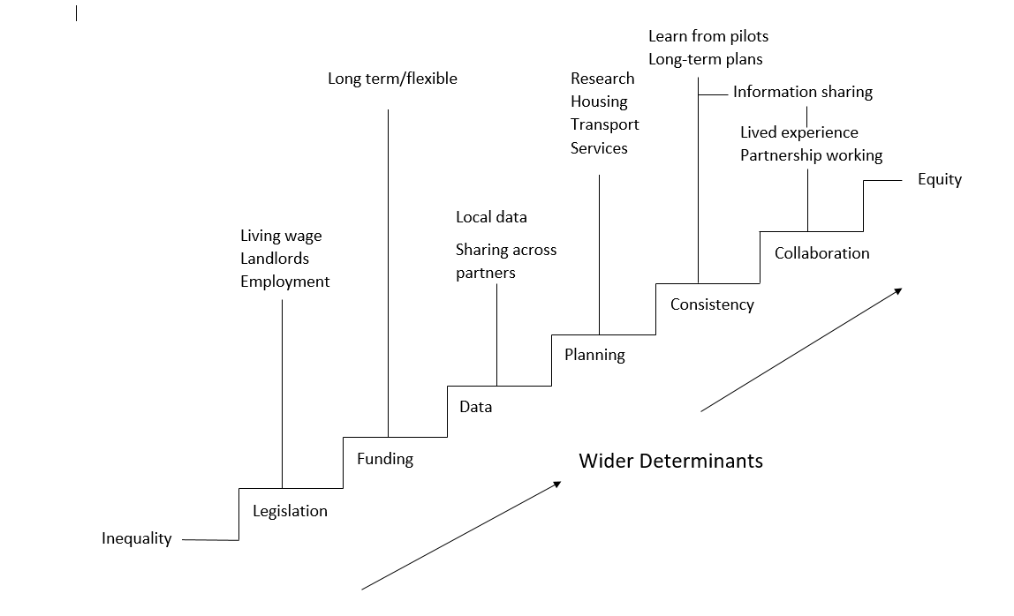

(Please note the diagram is not sequential, all steps can be taken in any order)

12.2 There was a call from participants for stronger legislation to help protect people living in disadvantaged circumstances, these included calls for a true living wage, banning zero hours contracts and protecting people in rental accommodation e.g. “Legislation to stop private landlords ripping off people with extortionate rent to live in substandard properties.”
12.3 A recurring theme in the feedback was the issue of funding. Participants called for more funding but also for changes in how funding is managed “Flexible funding that allows innovation – managed in a way appropriate to a complex system. Don’t set fixed activities and targets: agree the direction of travel and allow flexibility on how that is achieved.” Several responses called for long term sustainable funding to allow projects the time to deliver outcomes. There was discussion in the consultation meetings that allocation of budgets for projects which may not see outcomes for several years are often seen as a lower priority than the allocation of budgets required to relieve immediate pressures on services. Some expressed concerns that the Inverse Care Law is still evident in how services are delivered.
12.4 Data was a theme that has been voiced by participants in a few the questions. “Better data of the actual demographics of the region, we do not have a full understanding of our ethnic minority populations.” In discussion at the consultation meetings some statutory partners expressed concerns over the practicalities of data sharing such as GDPR, others felt that as data can inform needs-based funding allocation and support the evaluation of the impact of multiple interventions across the system it is essential that the perceived barriers are overcome.
12.5 Participants called for better planning, this included “more emphasis on pragmatic community-led research. A better planning system locally and from government to be able to provide affordable/comfortable homes and better planning when designing new services, putting them closer to where deprived people are, or ensuing transport has been considered in the early stages of the plans.”
12.6 There were a number of participants who felt that better consistency would help support them in addressing inequalities this included long term plans not short-term pilots and learning what did or did not work in pilots which would require better information sharing, e.g. “Long term funding and an acceptance that transport often needs to be subsidised, sometimes heavily, as in the South of England. Also, that being able to move around independently is good for people’s mental health. Not keep reinventing the wheel, but support what works and replicate what works elsewhere. Public transport needs stability. People take time to trust and rely on a transport service. If it keeps changing, then nobody uses it.”
12.7 Throughout all the questions in the consultation the importance of strong collaboration in reducing inequalities has been consistent. This includes better collaboration between national and local partners, collaboration between all partners in local government, the NHS, the third and independent sectors, and community groups and collaboration with communities and people with lived experience.
13.0 Responses to question 5 - How would you strengthen partnerships with stakeholders who impact on health in our region e.g. businesses, the VCFS, public services and local authorities?
13.1 No single agency alone can reduce inequalities. Partnership working across the Local Authorities, Health, the Third Sector, the Independent Sector and local communities is vital to addressing the inequalities that lead to health inequalities.
13.2 The responses to this question were very varied. A lot of the responses reflected the responses to other questions. These included:
- The complex health footprint – “The way that health is organised across the County is a major barrier. It is complex and confusing. There appears to be rivalry between the North and the South. South does not appear to want to be part of Cumbria. Often feels like a 2-tier system.”
- Barriers to participation – “CCG, ICP, ICS, PCN, CCC?? Why do you talk in acronyms? This is a barrier for third sector and community organisations to understand these systems and their functions.”
- Having the right people involved – “Having people with lived experience on meetings/boards/task and finish groups.”
- Strategic approaches – “Programmatic approaches allow expert panels and steering groups to convene to make joined up and informed decisions on funding direction and add a new impetus and determination of all to focus on step change.”
13.3 Ensuring action emerged as a new theme with a number of participants – “Expect the members to actually put into action any work agreed. Stop writing plans which are never implemented. Make the meetings a useful place to be” and “There are lots of very good strategies with no action plans and no one taking ownership of the work required.”
13.4 There were examples of good practice with recommendations for improvement – “The Safer Cumbria Partnership and associated subgroups includes membership from Criminal Justice Agencies, District and County Councils, Health, the Voluntary/Third Sector and we have worked with the Chamber of Commerce and local businesses on specific areas or work such as Modern Slavery and Domestic Abuse. While the Partnership has delivered successful outcomes in relation to amended process changes and working practices, it could be further strengthened by maximising joint commissioning opportunities across the partnership to meet the joint strategic needs and deliver improved outcomes for the people of Cumbria.”

14.0 Responses to question 7 - What barriers have prevented you making the difference to your locality?
14.1 This question received the second largest number of responses. The responses were quite broad but have been collated into broad overarching themes.
14.2 Funding – consistent with responses to other questions funding was reported as a major barrier to making a difference to inequalities. Participants highlighted the issues of short-term funding, unrealistic funding deadlines, unrealistic complex reporting for funding and that they felt there is inequality in how services in Cumbria are not fairly funded by the national formula.
14.3 Complex systems – participants felt that the complex health systems across the county and neighbouring counties was a real barrier to developing joined up working, with there being different structures, strategies, plans and priorities. Partners in the consultation meetings discussed how they often did not know who to contact from which organisations and that it can also cause issues with partners needing to attend multiple meetings. Participants also expressed concerns that the situation may be further complicated while the Local Government Reorganisation is underway. There was concern as to possible implications to how the health footprint would sit when the reform is finalised.
14.4 National and local policy – there were a number of responses that broadly fit under issues of national and local policy. These included:
- Lack of an adequate benefits system, low wage economy, zero hours contracts.
- Funding coming out with very short notice with unreal expectations on when it can be spent by.
- Why do we concentrate so much on the outcomes of inequality (obesity, smoking, sedentary behaviour), and not on the root causes of inequality?
- Breaking up health inequalities into silos – in reality many (although not all) are underpinned by poverty, but it often does not get a mention.
- Local Government reorganisation – possibly good in the long term, but whilst still busy with COVID-19 impact and other important issues, it is a block as staff going to be having to spend a lot of time to ensure future support to residents is going to be maintained/improved in the next 5 years.
- Many still fear UC which is understandable, but work is required to ensure clients and never worse off in work. Experience shows when that scenario is identified policy is quick to change ensuring resolution.
- No support from Local Government. Almost everyone identifying transport as a major issue, then going on to discuss other things. It is always in the ‘too difficult’ box. Also, in someone else’s box, never my problem. Surveys about passenger transport always asks the users of transport, never those who cannot use it for any reason.
14.5 Partnership working (or lack of) - although partnership working was seen in a positive light in several responses to other questions a number of participants raised this as a barrier to making a difference to inequalities. These included:
- Hierarchical approach – need to hear the voices of people with lived experience in the strategic partnerships, not fifth hand via a couple of bullet points on a Powerpoint!
- That lived experience and 3rd sector involvement seems to be tokenistic. Listen and take on the evidence of lived experience, nothing for us without us.
- Hierarchical structures, and only being willing to talk to the important people (e.g. you could learn a lot of about health inequalities by talking to the zero hours, contract cleaners who work in our hospitals, and how they were forced back into cleaning covid wards the day that shielding ended...).
14.6 The impact of Covid was also raised by a number of partners as being a major barrier to taking forward pieces of work that were already underway.
15.0 Responses to question eight - How we can make health inequalities our number 1 priority?
15.1 From the responses received and the discussions in the consultation meetings it is apparent that for the participants in this consultation tackling inequalities and health inequalities is a high priority. A lot of work over many years has been invested by individuals and organisations and there was a frustration that participants felt little has been achieved. There was a strong feeling that to tackle inequalities it must become a priority for many more individuals and organisations.
The responses have been categorised into a few broad themes:
15.2 Strategic approach:
- Inequalities in the wider determinants of health should be our priority as this is the only way to tackle health inequalities.
- Have a ‘inequalities in all policies’ approach.
- All partners to sign up to use the same approach and tools to identify possible impacts on inequalities when designing services, policies, projects etc. EIA of HIIA approach (but done properly).
- Help us make the case to business and view health inequality as not just a social problem but an economic one too.
- Early years provision; employability measures and equal access to health provision.
- Acknowledge it's complex, and ‘manage’ it in ways appropriate to facilitating change a complex system (rather than assuming we can command and control everything). Be comfortable with chaos, and value learning (as well as outcomes).
- Concentrate on the ‘mess in the middle’ – we are currently trying to mesh top down with bottom up, and that's always likely to be the case to some extent - but we often try and pretend there will not be a clash between the two.
- By continually and effectively evidencing what works and the impact to economy, health services and the quality of life of individuals and by securing the right levels of funding to achieve lasting change.
15.3 Engaging the community:
- Allow people to be angry about them – don’t tell people you can’t discuss issues if they get emotional.
- Greater publicity about the crisis situation for very many young people. Honesty about the current situation which is only going to get a lot worse. Demonstrate the many benefits and connections to improvement linked to social impact, economy etc.
- Use different language – terms such as ‘inequalities’, deprivation’ ‘equity’ etc don’t mean anything to most of the public.
- Engage community, work with local organization NHS cannot do this alone it needs to be a real partnership. commission local organisations.
- Allow people to get angry (and upset) about them! All too often conversations are closed down with "we can't continue if you're getting emotional" - back to giving people the skills they need. You clearly can have good conversations when people are emotional, clinicians in some specialities need to do this on a daily basis. Help (and support) public sector staff to accept that it's useful to listen to people's experience and acknowledge it even if it's uncomfortable and they can't immediately fix it.

  - Partnership working:
- The strongest possible partnership working that allows us to break down chimneys of work. Avoid duplication and ensure support offers complement each other.
- By working collaboratively with the existing partnerships within the county and in particular the Safer Cumbria Partnership we can review those health inequalities that can be best addressed by a partnership approach and work together for a successful outcome. We can share the issues impacting on criminal justice and community safety as outlined above and consider the most appropriate action. With the potential changes to the partnership landscape linked to the Local Government Reorganisation, Safer Cumbria will remain a constant through this process and will continue with its current governance structure.
16.0 Conclusion/Recommendations
16.1 It is apparent from the evidence in this paper that tackling inequalities and health inequalities is a priority for the HWWB and partners across the county. A lot of work is being undertaken across multiple partners with positive outcomes. However, there continue to be people experiencing multiple inequalities. Reducing inequalities is a complex ambition and needs different actions to be taken at all levels. Applying current inequalities theory systematically to planning can help to break down the required actions to the level of tasks that can be planned, implemented and reviewed in order to strengthen the collective contribution to reducing inequalities in Cumbria.
16.2 To be successful changes are required in the way policies are developed to address the structural causes of inequalities, including education, environment, housing, welfare provision and planning. Developing regulatory policies, improving access to services, prioritising disadvantaged groups and taking action early in the life cycle, are also key in improving health. Consequently, social and health inequalities must be considered in the planning stages of all policy, service and programme development, in order to maximise the potential for reducing inequalities.
16.3 There is a need to continue to learn from and grow with local communities. Community engagement and building a social movement for health are local priorities and are working well. However, there is a need to continue to progress this and to further build two-way conversations with communities, including greater representation from communities in strategic decision-making partnerships. This will require new ways of working to ensure that community members can be actively involved in conversations and decision-making processes.
16.4 There are difficulties inherent in attempting to target resources to deprived people (identification, definition and stigmatisation). This can cause difficulties for planners in identifying the most deprived members of the population of Cumbria. Partnership working (including working with communities and people with lived experience) is an example of an alternative way of targeting those people who are at greater risk of future ill health (and a variety of other problems).
16.5 More sustainable funding for CVFSE will reduce competition and the opportunity cost of time spent seeking funding to maintain grass roots support for communities. Continuing to work with the VCFSE to understand the experiences and needs of local communities, working towards authentic community voice in strategic decisions will devolve more power to community partnerships.
16.5 Funding needs to be fair and sustainable with realistic deadlines and achievable meaningful reporting.
16.6 All partners need to commit to the development and implementation of a joint strategic plan that encompasses a shared vision, co-produced principles that direct action to address health inequalities, shared outcomes (across the whole area – not differing by geography), shared data, shared methods of evaluation and shared impact assessments against which plans are evaluated. The use of similar processes and tools would make the process more streamlined and strengthen the partnership working.
16.7 It is recommended that to effectively impact on inequalities policies, strategies, action plans and projects shoul;d be:
    - Evidence-based;
    - Outcomes orientated;
    - Systematically applied;
    - Scaled up appropriately;
    - Appropriately resourced;
    - Sustainable.
16.8 It is recommended that to meaningfully impact on inequalities in Cumbria we must:
- Agree joint system leadership, accountability and oversight across all partners.
- Be purposeful about creating the right conditions and culture with ensuring the right level of understanding, mindset, skills and behaviours for tackling the social determinants of health.
- Further develop and strengthen collaborative partnership working, including working with communities to ensure the voice of lived experience becomes embedded within governance, priority setting and decision making.
- Develop a shared set of priorities and outcomes, with an explicit emphasis on inequalities and agreed responsibility for delivery across the partnerships.
- Ensure data sharing protocols are in place to enable the development of integrated datasets. Identify gaps in data collection and develop solutions.
- Increase investment in prevention and allocate local funding based on social inequalities and health outcomes to increase funding to communities with the greatest need.
- Provide evidence of how to reduce health inequalities locally in the short, medium and long term.
- Agree a set of tools to be used across the system to ensure that a reduction in health inequalities is a golden thread in all decision making.

Appendix 1

Purpose of the Cumbria Health and Wellbeing Board

To achieve the purpose outlined above the functions of the Health and Wellbeing Board are:
Leadership - To lead and direct the health and wellbeing system to ensure that partners improve services and make the best use of resources to deliver better outcomes for people. Specifically, the Board is responsible for:
- providing a structure for strategic local planning and accountability of health and wellbeing related services across a range of sectors and providers
- providing County-wide strategic leadership to public health, NHS, adults social care, children's social care and other relevant local authority commissioning - acting as a focal point for determining and agreeing health and wellbeing priorities and outcomes and resolving any related conflicts
- considering the draft strategic plans for healthcare, social care and public health to ensure that they deliver the Board's strategic priorities and outcomes and agreeing whether to recommend them to the relevant decision-making body(ies).

Understanding - To identify and develop a shared understanding of the needs and opportunities for improving people's health and wellbeing in Cumbria and to lead the development of a Joint Strategic Needs Assessment. Specifically, the Board is responsible for:
- assessing the needs of the local population and lead the statutory joint strategic needs assessment ('JSNA')
- ensuring that the JSNA is based on the best evidence and data available so that it is fit for purpose and reflects the needs of local people, users and stakeholders
- ensuring that the JSNA drives the development of the Health and Wellbeing Strategy and influences other key plans and strategies across the County
- ensuring that the Local Integrated Care Partnerships, Local Authorities, Clinical Commissioning Groups and NHS England demonstrate how the JSNA has driven decision making
- preparing a Pharmaceutical Needs Assessment for Cumbria.

Strategy - To prepare and publish a Joint Health and Wellbeing Strategy for Cumbria to ensure that the services required to meet the needs identified in the JSNA are delivered in a planned, coordinated and measurable way. Specifically, the Board is responsible for:
- developing an agreed set of strategic priorities to focus both collective effort and resources across Cumbria
- ensuring plans and priorities, within both individual organisations and for systems, are aligned and support the delivery of this Strategy.
Assurance - To ensure a collective awareness of the major changes, pressures and risks across health and wellbeing services and provide opportunity to review, comment and consider the opportunities for collaborative approaches to address or manage these. Specifically, the Board is responsible for:
- overseeing and reviewing performance in the delivery of the Health and Wellbeing Strategy
- receive regular reports on the implementation of respective health and care system plans
- monitoring health and wellbeing improvements and outcomes across the County and be accountable for the overall strategic performance management of agreed countywide health and wellbeing outcomes
- receiving updates on areas where performance needs to be addressed
- receiving assurance that improvements that are required as part of the regulatory regime are being delivered
- receiving reports from the Public Health Alliance to ensure that the Cumbria Public Health Strategy is being delivered.

Accountability - To be assured that the decisions of the Board and partners, and their subsequent outcomes, are clearly focused on improving the health and wellbeing of people in Cumbria. Specifically, the Board is responsible for:
- ensuring that appropriate structures and arrangements are in place to ensure the effective engagement and influence of local people and stakeholders
- improving the transparency and accountability to local people of services, organisations and decision making connected to health and wellbeing
- improving democratic accountability for health and wellbeing decision making
- responding to the NHS Commissioning Board when views are sought regarding the Clinical Commissioning Group ('CCG')
- representing Cumbria in relation to health and wellbeing issues across the sub regional and at national level.

Partnership - To ensure there is effective dialogue, engagement and joint working between county and local health and wellbeing structures and partnerships and with other key strategic partnerships and networks. Specifically, the Board is responsible for:
- supporting and encouraging strong partnership working between local organisations in Cumbria involved in health and wellbeing
- actively engaging with the other key partnerships to ensure achievement of outcomes in all agreed areas and to extend the reach of the Joint Health and Wellbeing Strategy by ensuring alignment with other strategies and plans
- receiving the Local Safeguarding Children's Board's and the Safeguarding Adult's Board Annual reports
- encouraging wide engagement of partners throughout the Health and Wellbeing partnership structure by ensuring involvement in consultations, stakeholder events, good practice sharing, and task and finish groups
- providing a forum for cross-system learning and support between North Cumbria and Morecambe Bay.

Integration - To promote integration and partnership working between the NHS, social care, public health and other services. Specifically, the Board is responsible for:
- supporting the development of integrated working with all partners in order to improve the outcome of local communities
- supporting the delivery of joined up care between providers in order to improve health and wellbeing outcomes and reduce health inequalities
- supporting the development of vibrant community places, linking local partners to address the wider determinants of health
- enabling collaboration between commissioners, joint commissioning and pooled budgets, where this provides better integrated service delivery and outcomes
- discharging all functions relating to the Better Care Fund that are required or permitted by law to be exercised by the Board including: Agreeing the Better Care Fund; and overseeing the delivery of the Better Care Fund and Improved Better Care Fund.

Appendix 2

The membership of the Health and Wellbeing Board comprises of:

- Leader of the County Council (Chair)
- The Chief Executive of Cumbria County Council
- County Council's Executive Director - People
- County Council's Director of Public Health
- County Council Cabinet member for Health and Care Services
- County Council Cabinet member for Children's Services
- County Council Cabinet member for Public Health and Communities
- County Council Cabinet Member for Schools and Learning
- The Chair of each of the CCGs (both of whom will be joint Vice Chair)
- The Executive Lead from both CCGs
- The Chair of the North Cumbria Integrated Care NHS Foundation Trust
- The Chief Executive of North Cumbria Integrated Care NHS Foundation Trust
- The Chair of the University Hospital Morecambe Bay NHS Foundation Trust
- The Chief Executive of University Hospital Morecambe Bay NHS Foundation Trust
- The Chair of Cumbria, Northumberland, Tyne and Wear NHS Foundation Trust
- The Chief Executive of Cumbria, Northumberland, Tyne and Wear NHS Foundation Trust
- The Chair of Lancashire and South Cumbria NHS Foundation Trust
- The Chief Executive of Lancashire and South Cumbria NHS Foundation Trust
- The Chief Constable of Cumbria Constabulary
- A representative from NHS England
- A representative of Healthwatch Cumbria
- A representative of the six District Councils
- A representative of the Voluntary and Community Sector

Appendix 3
HEALTH EQUITY COMMISSION QUESTIONNAIRE – Responses
Feedback collated from county wide partnerships and individuals which were received via e mail returns and responses to the questions on a survey monkey.

- Identify the key health inequalities in your area. What would you like to emphasis or highlight?
- As PCC and Chair of the Safer Cumbria Partnership and in the context of associated crime and ASB issues I believe that problems around addiction, primarily Drugs and Alcohol would be a major concern. These are obviously associated with other societal inequalities (not necessarily causal but rather contributory). My concern as PCC, with these are the link to crime drawing children and young adults into a potentially destructive lifestyle with impact on health (including mental health) and education outcomes and therefore long-lasting negative impact. In common with other areas we have seen a worrying increase in violent crime involving weapons (knives).

- The differing health outcomes and healthy years of life lived across Cumbria are well known and are documented in the Cumbria Observatory data. There is a strong read across to economic prosperity, hence why this work falls into the scope of the Cumbria Local Enterprise Partnership. Years of working life lost has a direct impact on not just individuals but also employers and businesses. Our super aging population presents significant challenges, as does the lack of availability of staff within the health and social care sector, potentially reducing the quality of care available, preventing hospital discharge into the community. Whilst highest levels of deprivation and corresponding poor health outcomes are clusters around the City of Carlisle and the communities of the West Coast, we also see pockets of deprivation in rural areas. Loneliness, isolation and poor mental health are also challenges in our rural communities.

- Cumbria LEP is an economic body and as such our focus is on creating the economic conditions that reduce health inequalities through supporting the creation of high-quality employment opportunities and promoting inclusive growth. We also encourage businesses to engage in the health-related issues on which they can have an impact. At this point, there is a heavy focus on creating COVID secure workplaces, given that this has disproportionately impacted on certain communities and individuals. Additionally, CLEP has promoted issues such as supporting good mental health and wellbeing, given the significant increase in the number of individuals facing mental wellbeing issues as a result of the pandemic, which will have serious implications on future productivity. I would like to emphasise the need to have a stronger and symbiotic relationship between health and the economy. The impact of the pandemic which resulted in economic restrictions has created further health impacts – reduced mental wellbeing; excess alcohol consumption; weight gain and more inactivity to name a few.

- Addiction, poor housing options, lack of employment, culture issues, no real aspirations (due to lack of opportunity) to break out of poverty and benefits.
- Lots are obvious, so a few to emphasis........
- Rural inequalities (not always fully evident in IMD - but various Is of Rural M have been suggested).
- Travel distances, limited access to public transport, and so restricted access to health services for some people.
- Poverty is intertwined many of the inequalities, but this often seems to be somewhat ignored, meaning we sometimes try and treat the symptom rather than the cause
- Digital exclusion (due to cost, lack of skills, or lack of infrastructure)
- Language/Ethnicity - I still come across an assumption that there are so few BAME people in Cumbria that we don't need to "worry" about them (e.g., recently in relation to flood warning) - and this lack of experience can sometimes lead to these people being disadvantaged when they use health services (e.g., NHS staff don't know how to access interpreters, whereas in a big city they'd be more familiar with the process).

- There are a number
- Stark differences in life expectancy and healthy life expectancy between wards. (Many other inequalities mirror ward deprivation levels).
- High rates of obesity particularly among children.
- Above national rates for smoking and teenage pregnancies
- High hospital admittance rates for alcohol – specific conditions in under 18’s
- Poor mental health, reflected by incidents of self-harm and male suicide exacerbated by Covid-19 – increased isolation, impact on CYP, financial pressures, increased addiction
- Ageing populations – exacerbated by Covid-19 and current health & care crisis
- Increased incidence of domestic abuse – Covid-19
- Potential beneficiaries need to be included in conversations, design and evaluation.

- What are your localities priorities to reduce health inequality (up to 5)?
Are there actions within the partnership action plan that aim to reduce health inequalities?
- Through both the Office of the Police & Crime Commissioner and the Safer Cumbria Partnership we have various actions/workstreams which consider the lived experiences of victims of sexual and domestic abuse with the aim to ensure a collaborative accountable and sustainable provision to aid victims to cope and recover as well as identifying barriers to access services. As outlined above (1) drugs and alcohol is a key driver in offending behaviours and we aim to consider the findings and recommendations contained withing Dame Carol Blacks review on Substance Misuse and Drug Treatment and Recovery to improve the picture in Cumbria. We are in the process of producing a Public Health Approach to Serious Violence to identify those areas which the Partnership including Health partners, can work collaboratively to address.

- Aging Population and supporting healthy years of life – making Cumbria an attractive place to live, work and invest for younger people. Promoting work as healthy and second/third careers in later life. Inclusive Growth- ensuring that investment in the county is deployed in a manner that closes income gaps, increases the GVA of the county and looking at circular economies.

- The focus for us is supporting those that face health challenges to enter or return to the workplace, given the challenges related to labour supply and our commitment to inclusive growth – ensuring that nobody is left behind. We also want to work with businesses and individuals to extend working life as this will help address labour issues but importantly improve health and wellbeing in later life, given the benefits of work. Finally, we will be using our Careers related programme to promote positive health, wellbeing and resilience to young people, given the decline in recent years. If not addressed this will present long term productivity challenges in the economy.

- Addiction, mental health, Housing employment, and Culture.

- Seeing people as a whole - many of the people suffering the greatest inequalities will have multiple challenges - and we're not likely to get to the root of these with separate stop smoking, healthy weight, safe drinking, healthy eating strategies. Involving the voices of lived experience at a strategic level, rather than filtered through many layers of management (not always directly or at every meeting - e.g., video can be a powerful starting point). Acknowledging that rural areas need different models of healthcare - specialism and centralisation can be very effective, but only if you're able to reach those specialist centres. We know people turn down more specialist care a long way from home and loved ones - and for services like A&E/Maternity, long travel times often simply aren't an option. Work around community cohesion? If people have a broader social circle, they're more likely to support policy that reduces inequalities, etc.

- Programmes that target life stages and offer holistic actions that wrap around communities and/or in high deprivation areas. Partnership work and ensuring a joined-up collaborative, cross-sector approach to delivery. Third sector organisations play a vital role as they work at a community level, but must be invested in.

- What work/projects/strategies do you have locally that have had the most positive impacts on health inequalities?
- With reference to the issues above (1) we have adopted a strategy of working with partners across health, third sector (a key player) and where appropriate local and county council (housing and infrastructure) - this has worked well in targeted areas notably in Barrow where we have significant drug abuse and crime.
- Case studies available from CLEP regarding employer engagement in mental health and wellbeing. Looking to learn from and replicate the employer response to the pandemic to look at other health challenges, creating healthy workplaces that take a holistic approach to employee recruitment and retention.

- CLEP has produced its Local Industrial Strategy and Restart, Reboot, Rethink Strategies, both of which have inclusive growth as one of three strategic touchstones, which guide all of our activities. CLEP can provide specific case study examples to exemplify any of the activities at 1 and 2, on request.

- The Well/3rd-sec organization is at the front line and needs investing in. We run food backs, to Social Supermarkets, but people need the basics, people’s mental health are at breaking point.

- There are a number –
- Big local - long term, low key community development work (with funding for locally led projects).
- Solway Views - work to articulate the reasons people find it hard to get into work was great, but we need to get better at using this information at a strategic level to influence policy.
- Poverty Truth Commissions, Poverty-proofing, etc - using lived experience to inform services (and, for PTC, also building personal relationships between people with lived experience and decision makers).
- Barrow! (All kinds of bits....).
- Brathay Aspiring Leaders Programme (giving young people from a wide range of backgrounds the skills and confidence to lead).
- Perhaps not directly related to health inequalities (but not entirely disconnected), but in the community resilience structures I took a deliberate (and not universally popular) steps to flatten the hierarchy by including some of the larger community groups in the Cumbria-wide group as well as their local group. This has been invaluable in getting a feel for what's really going on, rather than what people would like to believe is going on (not with any malice, but the formal structures tend to only report the positives).

- Partnership work and ensuring a joined-up collaborative, cross-sector approach to delivery. Ensuring VCSE sector are invested to deliver services at a local level. The West Cumbria Mental Health Programme is a good example of this.

- What difference your work could bring to health inequalities if you were given the resources/priority/scale required?

- Additional resource for support to victims of sexual violence and abuse (of all forms) would enable us to improve outcomes through the criminal justice system. We do have a successful Bridgeway Centre which is a great asset in this respect but funding is always precarious and short term, it faces constant threat of closure and reduction of service. Greater resource for addiction issues is always needed (in common with all other areas).

- Viewing health inequality through an economic lens and supporting businesses and employers to address health challenges provides a good sustainable route for investment. This helps focus on prevention and early escalation – and with relatively modest funding to extend tested initiatives, employers can see the benefits of a healthier engaged workforce and will often them mainstream the activity in BAU. This has certainly proved the case with some of our larger employers and it would be fantastic to look at how more SMEs can engage.

- As outlined above a focus on inclusive growth and moving the county to full employment would have significant benefits for health and wellbeing and would significantly reduce health inequalities. CLEP could play a significant role in addressing these issues with further funding, which would allow us to scale up the work programme that we are developing to deliver inclusive growth and address chronic labour supply issues.

- We would empower the community to take charge of their own wellbeing, we would help share and design a service around their needs and not our own. We would go to where people are at, not ask them to come where we are at. We would have a strategy that would change the current culture.

- I think this question should also include the "access/influence" required - one of our key bits of learning over the last few years is that we've only really been able to make significant change where we've had both really solid work on the ground, and the strategic connection/support to be able to remove the (often many) barriers. Did I mention "linking social capital" yet?

- As a funder we understand the communities and VCSE sector throughout Cumbria. We already fund many projects, organisations and individuals targeting health inequality and geography in Cumbria which adds to serve value to the work we do. We are well positioned to take programmatic approaches to specific geographies and/or demographic. Over the last 18 months we have managed a number of NHS funds in North Cumbria, which have addressed health inequalities by funding VCSE organisations to address community needs. We have also actively encouraged VCSE organisations to work in partnership.

- What support do you need to make a step change in addressing health inequalities?
- We continue to develop better inter agency collaboration, but data and information sharing is always challenging between Policing and Health - less so with education. Whilst issues of confidentiality are understood this is nonetheless a barrier to effective analysis of intelligence which could lead to more effective signposting to support as well as protecting vulnerable and at risk individuals. Additionally, looking at security of employment, removing in work poverty and increasing the number of living wage + employers in the county would be a welcome piece of work.

- For CLEP and the wider economy that it represents – quantifying and making the case to business that investment in employee health is money well spent.

- CLEP would like to see a better integrated funding system to allow the development of cohesive responses to addressing worklessness, extending working life and co-ordinating the business communities full engagement in workplace health.

- We need lived experience at every level, so we hear what people’s experiences are and that we are listening to them and make the plan around that lived experience evidence.

- Long term, low key investment in the infrastructure (community development staff) - with an acknowledgement that there won't be any quick wins, and there's little point trying to set 5 years’ worth of transactional KPIs. So a willingness to take a risk, and value things we can't easily measure? A voice at strategic level to argue for the above (and an acceptance that this isn't always the same thing as a VCS representative - the formal VCS has often become quite accepting of the need to do things the same way as we've always done them (at least during the New Public Management era). A Universal Basic Income?!

- Shared commitments and strong relationships between Enterprise, NHS, public health and charity partners with a continued understanding of planned action.

- How would you strengthen partnerships with stakeholders who impact on health in our region e.g. businesses, the VCFS, public services and local authorities?
How can the partnership work develop/widen partnership working to progress work?
- The Safer Cumbria Partnership and associated subgroups includes membership from Criminal Justice Agencies, District & County Councils, Health, the Voluntary/Third Sector and we have worked with the Chamber of Commerce and local businesses on specific areas or work such as Modern Slavery and Domestic Abuse. While the Partnership has delivered successful outcomes in relation to amended process changes and working practices, it could be further strengthened by maximising joint commissioning opportunities across the partnership to meet the joint strategic needs and deliver improved outcomes for the people of Cumbria.

- CLEP has convening power in this space and already has representation from all these stakeholders on the sector panels, providing a possible vehicle to take this work forward with a stronger focus on health inequality.

- CLEP has highly effective relationships with the business community, which could deliver greater benefits if there was funding to support specific initiatives, through for example the Shared Prosperity Funding. This would look not only at employment related initiatives but also mechanisms to increase the general health of the workforce through a programme of activity.

- Bring people together at the start, let them/us have a voice at each stage of the strategy to make and bring about change.

- Concentrate on identifying, building and selecting the skills needed for collaborative working - we're still (at times) putting the wrong people in key positions if we really want to make this work ("square who think they're blobs" can be very loudly persuasive at interview - but are often gatekeepers rather than connectors, and squash the people who can actually make this work)
Take active steps to challenge assumptions and rebalance power - if people assume, I don't have anything "important" to say because I work in the voluntary sector (and they still sometimes do), imagine what it's like for someone facing significant disadvantages. Fund the infrastructure (community development staff, community meeting spaces, etc). Involve a wider range of partners - most obviously DWP! But don't necessarily just create more meetings, the networks around them might be more useful.
- Programmatic approaches allow expert panels and steering groups to convene to make joined up and informed decisions on funding direction and add a new impetus and determination of all to focus on step change.

- What barriers have prevented you making the difference to your locality?
These can be local, regional or national barriers that have prevented work progressing.
- Substance Misuse and Mental Health are two of the key areas that impact across nearly all areas of the Safer Cumbria Partnerships priorities and areas of business, both from a victim and perpetrator perspective and in terms of community cohesion. While we have improving links in relation to substance misuse through the new addictions contract and with the newly formed Addictions Group reporting to Safer Cumbria, our links and workstreams in relation to Mental Health are not as developed. It is hoped that stronger links between mental health and the Safer Cumbria Partnership could start to deliver some key benefits for the county.

- The biggest barrier is the availability of discretionary funding to better knit together the system. The funding for employment and skills initiatives is overly complex and inhibits the issues being readily addressed, as they do not facilitate a comprehensive response to link employment opportunity and need (e,g. unemployed in one area and jobs in another with no effective transport links or affordable housing).

- Some silos continue to exist and the complexity of our 2 x health footprints with quite different population needs has served to amplify. Rural geography, relatively small population with some high need areas means that resources are scarce - delivery sometimes just costs more per capita.

- That lived experience and 3rd sec involvement seems to be tokenistic. Listen and take on the evidence of lived experience, nothing for us without us.

- There are a number
    - National policy?!
    - Lack of an adequate benefits system, low wage economy, zero hours contracts (when there's a significant power imbalance).
    - Inequalities in the Public Health funding formula?!
    - A lack of curiosity (I remember a senior NHS person repeatedly saying, "I'm very disappointed that the people of West Cumbria are willing to settle for second rate health services"; I eventually took to simply replying "And I'm disappointed you're not interested in understanding why......" [wanting decent local services, rather than "world class" services at a distant tertiary centre).
    - Evidence Based Medicine! Or at least an over-reliance on EBM, and a narrow definition of "evidence". An assumption that "experts" know best (which they might, but only within the often-narrow bounds of their expertise) - over extrapolating the evidence has been a common theme.
    - Short term-ism - sorry guys, we're not going to fix this in a single election cycle!
    - Hierarchical structures, and only being willing to talk to the important people (e.g., you could learn a lot of about health inequalities by talking to the zero hours, contract cleaners who work in our hospitals, and how they were forced back into cleaning covid wards the day that shielding ended.......).
    - A transactional approach, that sees relationships as dangerous.......

- Through disaster response funding and over two decades of funding we believe that we have had an impact on health inequality. However, as a funder whose aim is to address disadvantage throughout Cumbria we do not have unlimited funds and we do have limitations within some of the funds we manage. Moreover, action on health inequality must include collective action to be most effective and not lead to a cliff edge in funding.

- How we can make health inequalities our #1 priority?
If the Commission could do three things to support local action on health inequalities, then what would they be?
- By working collaboratively with the existing partnerships within the county and in particular the Safer Cumbria Partnership we can review those health inequalities that can be best addressed by a partnership approach and work together for a successful outcome. We can share the issues impacting on criminal justice and community safety as outlined above and consider the most appropriate action. With the potential changes to the partnership landscape linked to the Local Government Reorganisation, Safer Cumbria will remain a constant through this process and will continue with its current governance structure.

- Help us make the case to business and view health inequality as not just a social problem but an economic one too.

- Early years provision; employability measures and equal access to health provision.

- Engage community, work with local organization NHS cannot do this alone it needs to be a real partnership. commission local organisations.

- A number of ways - Talk about them! Build a movement......
- Make them everyone's problem - stop blaming those who live in poverty (etc) for the situation they find themselves in, and the heatlh inequalities they face, as that's very rarely the full picture.
- Allow people to get angry (and upset) about them! All too often conversations are closed down with "we can't continue if you're getting emotional") - back to giving people the skills they need. You clearly can have good conversations when people are emotional, clinicians in some specialities need to do this on a daily basis. Help (and support) public sector staff to accept that it's useful to listen to people's experience and acknowledge it even if it's uncomfortable and they can't immediately fix it.
- Acknowledge it's complex, and "manage" it in ways appropriate to facilitating change a complex system (rather than assuming we can command and control everything). Be comfortable with chaos, and value learning (as well as outcomes).
- Concentrate on the "mess in the middle" - we're currently trying to mesh top down with bottom up, and that's always likely to be the case to some extent - but we often try and pretend there won't be a clash between the two.
- Did I mention Blobs and Squares?!

- By continually and effectively evidencing what works and the impact to economy, health services and the quality of life of individuals and by securing the right levels of funding to achieve lasting change.

Any other thoughts?
- This will only work if you bring the people along with you at the start, move egos aside and listen to the people and communities we support. Have people with lived experience at every level and see them as professionals with lived experience.

- Not at the moment, but I'm sure I'll come up with more later.......

Appendix 4
HEALTH EQUITY COMMISSION QUESTIONNAIRE – Responses
Feedback collated from the easy retro board

1, What are the key health inequalities in Cumbria?
- Mental Health (2 likes).
- Massive increase in demand such as low levels of mental health and wellbeing as well as critical support for your people and very long waiting lists for statutory help (1 likes).
- Rurality/lack of transport and access to services (1 like).
- Isolation and loneliness.
- There is a definite inequality in people with disabilities in Cumbria compared to the rest of the country.
- Access to services (3 likes).
- Low income, those just making ends meet.
- Cuts to services that were once located locally (1 like).
- Lack of research active and specialist services in rural areas/rural hospitals.
- Low social mobility- see Social Mobility Report 2018.
- Workless households clearly have poorer health outcomes as do individuals who have low skills and earn a lower wage.
- Lack of good truly affordable homes, meaning increasing poverty and poor health due to insecure poor housing.
- Transport-to access health services, employment and education (1 like).
- Support for people with drug and alcohol problems.
- Gambling.
- Poor health caused by poor environment that people live and work in.
- Fuel poverty and poorly insulated homes (1 like).
- Cuts to health services meaning people in rural areas are poorly served.
- Drug and alcohol misuse.
- Poor employment prospects-young people moving away as a result (1 like).
- Obesity and the difficulties of accessing/affording good food and the ability to cook.
- Lack of training opportunities outside the larger conurbations. The distance, difficulty, and cost of travelling to training centres prevents many young people having any ambition or motivation to improve their circumstances.
- Access to responsive mental health support for people in crisis.
- Access to housing for homeless people with complex needs (MH, substances, DA and criminality).
- Impact of poverty on wellbeing – no disposable income, increase in living costs to enhance lifestyle.
- Access to primary care GP/Dental care.
- Appropriate treatment and interventions for alcohol dependency.

2, What are your priorities when it comes to reducing Health Inequalities?
- Early intervention supporting and signposting low level mental health and wellbeing of young people (2 likes).
- Housing standards.
- Affordable housing.
- Increase household incomes by improving earnings.
- Addressing the economic causes of health inequalities.
- Increase the number of clients who are in work but still potentially receiving support from UC.
- Addressing the educational attainment gap.
- Early years – education (1 like).
- Stronger focus on Early Years and working with families from birth to preschool. Better integration of health and education when it comes to working families (1 like).
- Poverty alleviation (1 like).
- Reduction of domestic abuse and ACES.
- Programmes to subsidise healthy food (1 like).
- Ensuring foodbanks can supply healthy options.
- Work with the supermarkets to eliminate the gross food waste and instead make it affordable to people in need.
- Zero hours contracts should not be allowed. The County has a lot of tourism with seasonal work leaving lots of people in a precarious financial situation.
- Strengthening the connection between health systems and leading employers so they work together on how to tackle inequalities.
- Increasing employment opportunities.
- Integrate health inequalities into the Borderlands and the 70m infrastructure investment planned for Carlisle and other similar towns initiatives i.e., Barrow.
- Better collaborative approach from health, education, housing – giving people the same message and picking them up no matter where they access services (the dream).
- Public sector, housing providers and key employees pooling funds to establish a long-term crisis fund for food, heating etc – the DWP schemes have demonstrated the viability of using vouchers at a large-scale level.
- Actually, focus on people living in deprived circumstances instead of relying on the ‘easy option’ using IMD to identify deprived areas. We have many people who are the ‘hidden’ deprived.
- Better data to reveal pocketed deprivation in rural areas – problem with data averaging out in Cumbria (1 like).
- Sort out the data sharing across primary care, health and the councils. Data is fragmented, systems should be able to talk to each other. Pulling together all the data will allow better identification of need.
- Better data of the actual demographics of the region, we do not have a full understanding of our ethnic minority populations.
- Protecting people in deprived circumstances from the health and economic fallout of COVID.
- We need to better understand the impact of long covid as evidence suggests it is more likely to have greater impact on people in more deprived neighbourhoods because they are more likely to have pre-existing health problems.
- Digital poverty.
- Involve the public in decision making.
- Linking the NET Zero agenda more tightly to health inequalities.
- Active travel reducing car use (1 like).
- Really planning how people are able to move around. Active travel, good proper funded passenger transport. Including how users can travel to services in the early planning of new or re-located services, not as an add on at the end! Be realistic about how people travel and get to the front of any offered services.
- Improving access to education and employment.
- Ensure that the review explicitly addresses protected characteristics under the Equality Act and makes recommendations.
- UC payments are currently increased at age 25. It would be much fairer to award the higher 25+ rate to 16-24 year olds for YP without parental support living independently such as Care Leavers.
- Identifying and addressing the impact of COVID on inequalities.
- Targeted support to those individuals residing in areas of high deprivation. Improve access to local services and support development of local networks. Improve individual’s overall health and wellbeing, giving individual choice, control and personal resilience.

3, Examples of projects that have had a positive impact.
- Work related programmes such as KS, WHP, Restart etc have all proven to support individuals and households.
- Low level Mental Health and Wellbeing Partnership Programme for adults and young people in West Cumbria.
- Better Tomorrows Programme to improve the quality of Youth Workers through training and Good Governance to improve local infrastructure as an essential point of contact for young people at a local level (1 like).
- Positive Role Models, providing young people with a support network and specific one to one help and guidance which could be to signpost to specialist support, improve mental health and wellbeing, social, emotional, communication and many other issues coming out of COVID which could improve employment opportunities/independence/positive destinations, linking directly with business and community partners as positive Role Models (1 like).
- Health and Wellbeing festivals in the community.
- MOT’s.
- Peer led support (1 like).
- Green Home grants via LA’s to reduce poor health in cold damp homes, reduce fuel poverty, and reduce carbon emissions.
- Community based services and activities.
- Social Prescribing both NHS and Community.
- School Poverty Proofing - carried out by schools in partnership with Children North East.
- Showing impact of social prescribing and link workers. Health support that isn’t medical.
- The Cumbria Health and Wellbeing Coaches are an amazing resource.
- Properly funded holistic youth services.
- CAB Money Advice Contract with the County Council.
- CAB housing specialists operating in County Courts to prevent eviction as homelessness in a major cause of physical and mental ill health.
- Big local, and similar long term, low key community development work.
- In depth, local, personalised support to get people (slowly0 into work – e.g. Building Better Opportunities.
- Anchor institutions can positively influence the social, economic and environmental conditions in the area to support healthy and prosperous people and communities see work in Morecambe Bay.
- Public Health funded Health and Wellbeing Coaches who provide practical and emotional support through coaching to individuals and local communities. Address health and wellbeing concerns such as weight management, smoking, mental health, substance abuse, anxiety, isolation and loneliness. Working alongside partners for those with more complex issues that includes domestic abuse, homelessness, safeguarding (adults).
- Winter pressure funding (NHS England) to H&W team to reduce demand of acute mental health settings and primary care, working with individuals adopting coaching model to build resilience and quality of life.
- Collaboration with UOC to develop bespoke postgraduate certificate in health coaching.
- Redesign of local library offer to communities by providing direct access to H&W team for support, advice and guidance to improve health and wellbeing.

4, What difference could your work make if given enough support and resource?
- Huge impact to reduce critical care through early intervention. Providing a local network and connectivity between specialist local organisations all working together in partnership, appropriately referring and collaborating instead of supplication or in conflict. Recognition by all partners of their role and who is best placed to deliver what services to all young people. Connectivity and communication are key (1 like).
- If more truly affordable homes, IMHO we would keep/attract more young people to work in key jobs such as care workers etc, thus increasing the ability to look after people at home and reduce bed blocking in hospitals.
- Improving understanding of how UC supports Childcare.
- Being more collaborative and joined up…..difficult when services under such pressure (1 like).
- Help impact on their home environment to make it healthier to live in.
- Reduce the levels of stress and mental ill health by dealing with the underlying cases such as Debt, Benefits and Housing.
- Universal Basic Income? (or at least benefits at a level you can live on).
- Update of the Public Health Funding Formula so Cumbria gets a fair share – not something based on what used to be spent historically (3 likes).
- I have never seen pressure brought to increase the UC tapper so individuals keep more of what they earn? The initial trial had greater in work incentives and their removal were a hug issue and were related to austerity (1 like).
- Better connections between transport providers and modes, so more people can access services at their own pace. Joined up transport, so passenger transport times are not twice as long as a personal car journey.
- Local and affordable

5, What support do you need to make a step change?
- We need long term funding for infrastructure and staffing capacity to enable organisations such as Cumbria Youth Alliance to be the lead organisation in Cumbria for youth organisations to enable them to create a multi-agency approach to best serve the young people throughout Cumbria. One size does not fit all. Recognition that the third sector organisations can play a vital role but that this must be funded to be done properly (1 like).
- Long term funding to make services sustainable (2 likes).
- Time and capacity for pragmatic research in the community (not university led).
- On truly affordable homes we need a better planning system locally and from govt, and more grants to provide social rent homes from Homes England.
- Legislation to stop private landlords ripping off people with extortionate rent to live in substandard properties.
- Long term funding models (not constant pilots) learn from lots of projects and build a resilient model for the future (1 like).
- Stop throwing the baby out with the bath water. Ministers chopping and changing ideas and priorities, short term funding, pilots that are successful then are just stopped and then the learning is lost. We need a consistent approach.
- Flexible funding that allows innovation – managed in a way appropriate to a complex system. Don’t set fixed activities and targets: agree the direction of travel and allow flexibility on how that is achieved. Value and share learning. Cumbria County Council, particularly Public health), have been pretty good at this – but plenty of space to expand the approach (2 likes).
- Stop just focusing on health inequalities, we will never reduce health inequalities until we address the wider determinants of health.
- Long term funding and an acceptance that transport often needs to be subsidised, sometimes heavily, as in the South of England. Also, that being able to move around independently is good for people’s mental health. Not keep reinventing the wheel, but support what works and replicate what works elsewhere. Public transport needs stability. People take time to trust and rely on a transport service. If it keeps changing, then nobody uses it.
- Put health services where the people are!
- Research into effectiveness of adopting a coaching model and the long term outcomes for individuals (all customer groups).
- Sort out the data sharing across primary care, health and the councils. Data is fragmented, systems should be able to talk to each other. Pulling together all the data will allow better identification of need.

6, How would you strengthen local partnerships which influence health?
- Having people with lived experience on meetings/boards/task and finish groups (4 likes).
- Have a lead organisation to pull local partners together for all to collectively agree a partnership approach and for all to recognise that the best approach to support young people is through collaboration and partnership working. Improve communication networks and connectivity. Improve information sharing and disseminating information to young people, their parents/carers. Organisations don’t know what else is other there which they could link to and work in partnership to provide a better service. And, young people and their responsible adults certainly do not know where to go to get help and information. Multi agency approach with delivery partners working together to agree programmes with long term plans and not short-term funding. Sustainability is essential (1 like).
- Extra funding.
- Better spending of funding/long term funding (1 like).
- More clear links between Local Health Forums and the wider Health and Wellbeing Board (1 like).
- Ensure work is a significant element of and application as my understanding is Michael has clearly made that link.
- Never quite sure why DWP senior leaders are not already part of the Health and Wellbeing Board? We have direct links to MfE and SoS. Sure we could find a senior leader to do so (1 like).
- The way that health is organised across the County is a major barrier. It is complex and confusing. There appears to be rivalry between the North and the South. South does not appear to want to be part of Cumbria. Often feels like a 2-tier system.
- Identify properly who needs to be at the partnerships. Expect the members to actually put into action any work agreed. Stop writing plans which are never implemented. Make the meetings a useful place to be.
- There are lots of very good strategies with no action plans and no one taking ownership of the work required.
- Support for JCP Youth Hubs would be excellent. The resource required can be as little as an hour a month for outreach from any partner organisation.
- CCG, ICP, ICS, PCN, CCC?? Why do you talk in acronyms? This is a barrier for third sector and community organisations to understand these systems and their functions (2 likes).

7, What barriers have prevented you from being able to make a difference?
- Short term funding only. No capacity funding for infrastructure and some organisations prioritising their survival. Lack of collaboration and connectivity.
- Silo working.
- Red tape.
- Covid.
- Hiding behind GDPR.
- Hierarchical approach – need to hear the voices of people with lived experience in the strategic partnerships, not fifth hand via a couple of bullet pints on a powerpoint! (Not necessarily via lots of meetings – but e.g., video clips etc).
- No funding.
- Staff capacity and the volume of work. Lack of notice and short Govt deadlines for funding (1 like).
- Funding coming out with very short notice with unreal expectations on when it can be spent by. Do not award funding in June and ask for a project to be set up and delivered by the end of the financial year. Government funding should be allowed to be carried forward.
- Breaking up health inequalities into silos – in reality many (although not all) are underpinned by poverty, but it often does not get a mention, and we try to fix the symptoms not the cause (1 like).
- Why do we concentrate so much on the outcomes of inequality (obesity, smoking, sedentary behaviour), and not on the root causes of inequality?
- Hidden rural deprivation doesn’t always show up well in IMD (2 likes).
- Loss of funding.
- Two tier governance – develop recommendations for the West and East Cumbria Councils when they are formed as shadow authorities in May 2022. Local Government Reform will be a major opportunity to address health inequalities if done up front.
- Just had a useful briefing on the Green Homes Grant and how it works well for some households but not many houses in rural areas of Cumbria as the system is too inflexible and the grant per property tool low for many of the complex traditional buildings in rural Cumbria. And the govt schemes are too short term to encourage local businesses to get trained up and involved in green retrofit work.
- Short termism – we have to accept these with take a long time to solve.
- Local Government reorganisation – possibly good in the long term, but whilst still busy with COVID-19 impact and other important issues, it is a block as staff going to be having to spend a lot of time to ensure future support to residents is going to be maintained/improved in the next 5 years.
- Many still fear UC which is understandable, but work is required to ensure clients and never worse off in work. Experience shows when that scenario is identified policy is quick to change ensuring resolution.
- No support from Local Government. Almost everyone identifying transport as a major issue, then going on to discuss other things. It is always in the ‘too difficult’ box. Also, in someone else’s box, never my problem. Surveys about passenger transport always asks the users of transport, never those who cannot use it for any reason (1 like).

8, How can we make Health Inequalities our number 1 priority in Cumbria?
- Inequalities in the wider determinants of health should be our priority as this is the only way to tackle health inequalities.
- Allow people to be angry about them – don’t tell people you can’t discuss issues if they get emotional (1 like).
- Have a ‘inequalities in all policies’ approach.
- All partners to sign up to use the same approach and tools to identify possible impacts on inequalities when designing services, policies, projects etc. EIA of HIIA approach (but done properly).
- Greater publicity about the crisis situation for very many young people. Honesty about the current situation which is only going to get a lot worse. Demonstrate the many benefits and connections to improvement linked to social impact, economy etc (1 like).
- Use different language – terms such as ‘inequalities’, deprivation’ ‘equity’ etc don’t mean anything to most of the public (2 likes).
- To get more support from government IMHO we need to push the reducing costs for the NHS if more help to reduce health inequalities locally. And more people able to work and input into local productivity if given more support to overcome barriers (1 like).
- The strongest possible partnership working that allows us to break down chimneys of work. Avoid duplication and ensure support offers compliment each other (1 like).

Cumbria Joint Public Health Strategy 2019-2029
Carers UK- State of Caring 2021
Public Health England- Caring as a Determinant of Health - 2021

