Let’s Keep Talking
Phase 10 – cost of living crisis communications toolkit
July-September 2022 – FINAL

Contents

LTK Phase 10 1
Press release 1
Newsletter copy (internal and wider stakeholders) 2
Web copy 2
Mental health support directory 3
Digital screen images 3
Posters 4
Email signature 6
Social media schedule 6

LTK Phase 10

Phase 10 of the Let’s Keep Talking suicide prevention campaign focuses on the cost-of-living crisis and encouraging people to seek support in relation to paying bills. We know that money worries can lead to people thinking about taking their own lives and we want to encourage people to get help before it reaches crisis point.

Press release

Please add the press release below to the news sections of your websites and use in stakeholder/public information updates/newsletters.

Cost of living crisis: don’t struggle in silence

Health leaders across Lancashire and South Cumbria are urging people to talk about their money worries as food, fuel and energy costs continue to rise.

The message comes as part of the latest phase of the local health and care partnership’s Let’s Keep Talking suicide prevention campaign.

The ‘cost of living crisis’ has been a frequent feature in the news over the past few weeks and months, with more and more people struggling to pay the bills and make ends meet.

Neil Smith, the mental health multi-agency strategic lead for the Lancashire and South Cumbria Health and Care Partnership, said: “We know that rising food, fuel and energy costs, to give a few examples, are having a big impact on so many people right now.

“We recognise that for some people, the day-to-day cost of living is starting to feel unmanageable. But it’s important people know help is out there – and more importantly they reach out for that help if they need it.”

Dealing with money issues can sometimes be off-putting, and many people can feel ashamed. But most debt and money issues can be sorted through the help of organisations such as Citizen’s Advice.

Emma Sylvester, debt services manager at Citizen’s Advice, said: “We are seeing an increase in people contacting our service who are struggling with the rising cost of living.

“We want people to know that they’re not alone and our advisors will be able to support them to find the best solution to their concerns and problems.

“We know that money worries can lead to people thinking about taking their own lives.

“But it doesn’t have to be this way. In my role as a debt services manager, I have never said to anyone ‘we can’t help you with that’, there’s always a way.”

Suicide rates across the region are the third highest in England and men are three times more likely to take their life by suicide than women.

For more information and help and support about debt and money visit Lancashire and South Cumbria Health and Care Partnership :: Cost of living crisis (healthierlsc.co.uk)

Newsletter copy (internal and wider stakeholders)

The latest phase of Lancashire and South Cumbria Health and Care Partnership’s Let’s Keep Talking suicide prevention campaign focuses on the cost-of-living crisis.

The rising costs of day-to-day living is rarely out of the news with more and more people struggling to pay the bills and make ends meet.

Sometimes when people are in debt, they can become so worried about it that they consider taking their own lives.

This campaign urges people to ‘keep talking’ about their money worries so they don’t reach that point.

A suite of new materials, which includes posters, videos, social media messages and radio adverts, has been developed which you will hopefully see and hear over the next few weeks.

For more information please visit Lancashire and South Cumbria Health and Care Partnership :: Cost of living crisis (healthierlsc.co.uk) or contact lyndsey.shorrock@nhs.net.

Web copy

You may wish to feature the campaign on your website beyond the news section, if so, please feel free to use/adapt the copy below.

The latest phase of Lancashire and South Cumbria Health and Care Partnership’s Let’s Keep Talking suicide prevention campaign focuses on the cost-of-living crisis.

The rising costs of day-to-day living is rarely out of the news with more and more people struggling to pay the bills and make ends meet.

Sometimes when people are in debt, they can become so worried about it that they consider taking their own lives.

This campaign urges people to ‘keep talking’ about their money worries so they don’t reach that point.
For more information please visit Lancashire and South Cumbria Health and Care Partnership :: Cost of living crisis (healthierlsc.co.uk) where you can also download a copy of the campaign toolkit.

Mental health support directory

We have created a new directory of resources to support mental health (not just in relation to debt).

If you would like hard copies, please contact lyndsey.shorrock@nhs.net.

You can access it as a digital page turner here: https://79c2075a.flowpaper.com/DBP034LSCHPMentalHealthLeafletLetsKeepTalking/#page=1
You can access it as a PDF here: DBP034_LSCHP_Mental_Health_Leaflet_A6_12pp_Concertina_SP.pdf (healthierlsc.co.uk)

Digital screen images

Please use the images below on screens in public waiting areas. Please use the links below the images to download the high-resolution files.

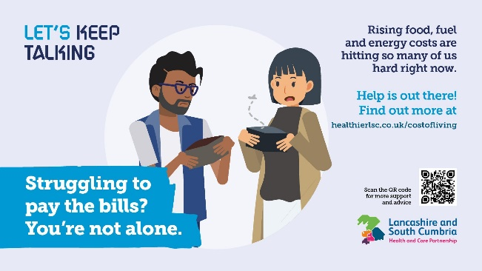  DBP372_LKT_Cost_of_Living_Ph10_Screen_Savers1.jpg (1920×1080) (healthierlsc.co.uk) | 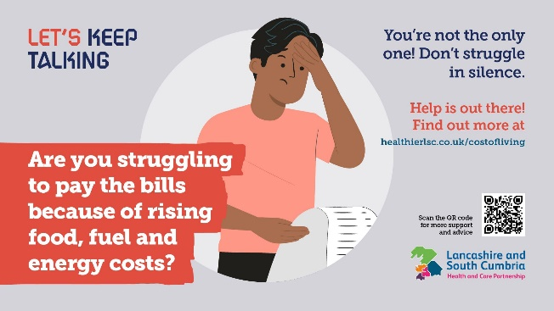  DBP372_LKT_Cost_of_Living_Ph10_Screen_Savers2.jpg (1920×1080) (healthierlsc.co.uk)
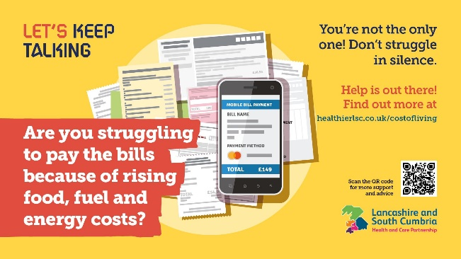  DBP372_LKT_Cost_of_Living_Ph10_Screen_Savers3.jpg (1920×1080) (healthierlsc.co.uk) | 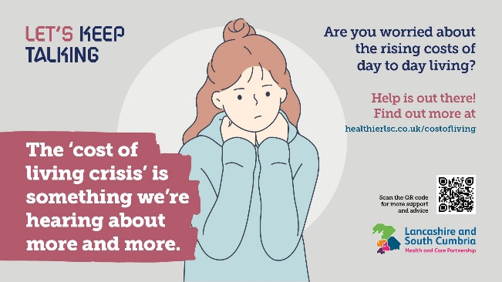  DBP372_LKT_Cost_of_Living_Ph10_Screen_Savers4.jpg (1920×1080) (healthierlsc.co.uk)
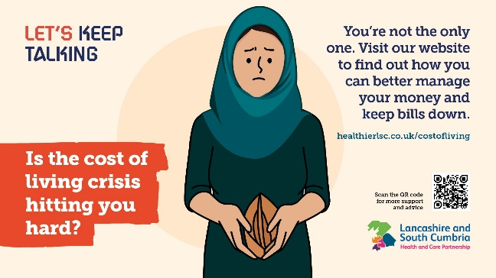  DBP372_LKT_Cost_of_Living_Ph10_Screen_Savers5.jpg (1920×1080) (healthierlsc.co.uk) | 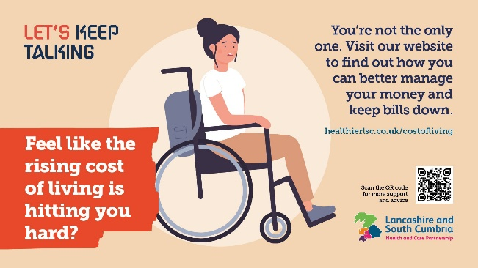  DBP372_LKT_Cost_of_Living_Ph10_Screen_Savers6.jpg (1920×1080) (healthierlsc.co.uk)

Posters

Please display any of the posters below in any public areas at your disposal. The images below are for illustrative purposes only. Please use the links below the images to download the high-resolution files.

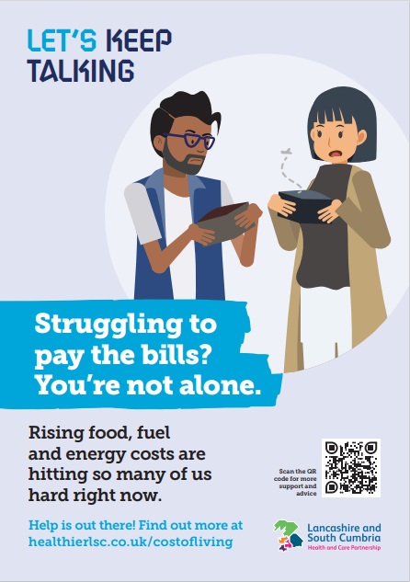  DBP370_LKT_Cost_of_Living_Ph10_A4_Posters_FINAL_1.pdf (healthierlsc.co.uk) | 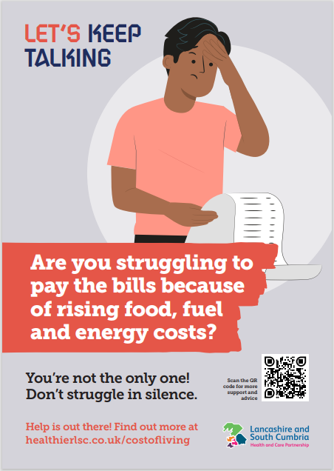  DBP370_LKT_Cost_of_Living_Ph10_A4_Posters_FINAL_2.pdf (healthierlsc.co.uk)
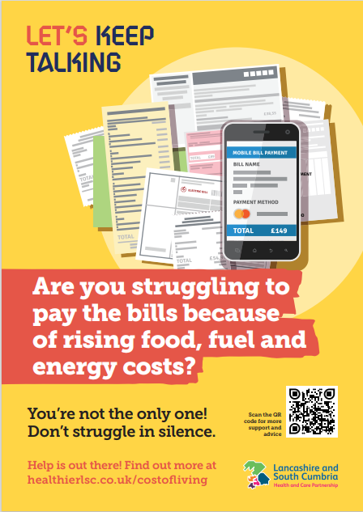  DBP370_LKT_Cost_of_Living_Ph10_A4_Posters_FINAL_3.pdf (healthierlsc.co.uk) | 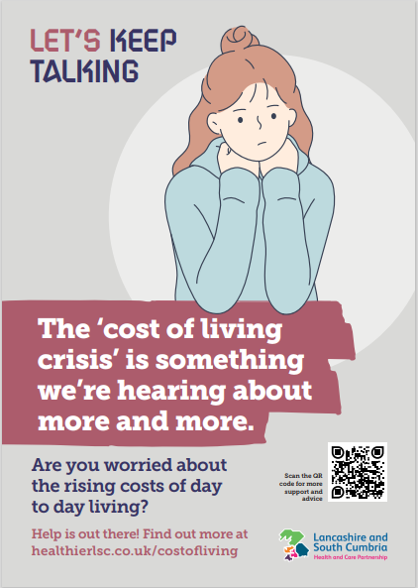  DBP370_LKT_Cost_of_Living_Ph10_A4_Posters_FINAL_4.pdf (healthierlsc.co.uk)
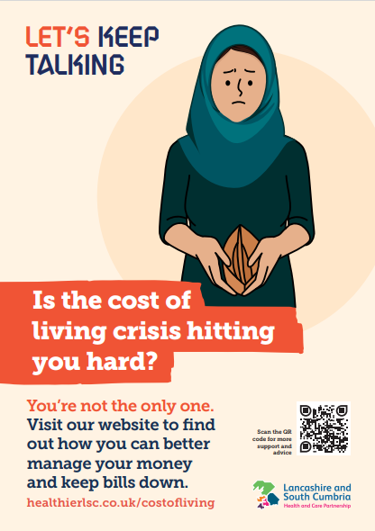  DBP370_LKT_Cost_of_Living_Ph10_A4_Posters_FINAL_5.pdf (healthierlsc.co.uk) | 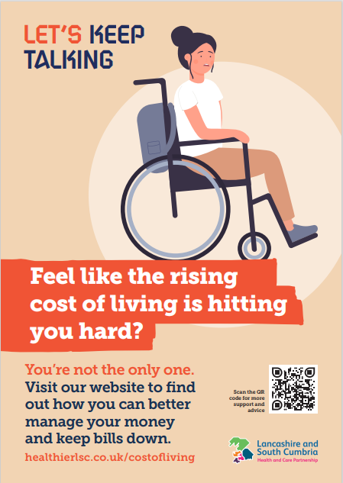  DBP370_LKT_Cost_of_Living_Ph10_A4_Posters_FINAL_6.pdf (healthierlsc.co.uk)

Email signature

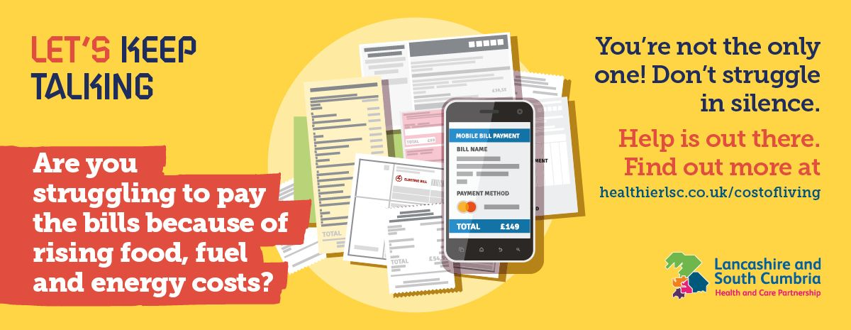

DBP373_LKT_Cost_of_Living_Ph10_Email_Signature.jpg (1200×465) (healthierlsc.co.uk)

Social media schedule

Below are some suggested social media posts to use or adapt for your channels. Please schedule two posts per week throughout the remainder of July, August and September.

The thumbnails below are for illustrative purposes only. Please download the high-resolution image by clicking on the link below the image.

Copy | Image thumbnail/asset
💷 Struggling to pay the bills? You’re not alone.  Rising food, fuel and energy costs are hitting so many of us hard right now.  But help is out there! Find out more ➡️ https://www.healthierlsc.co.uk/index.php?cID=10868 | 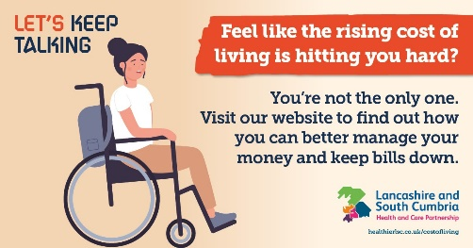  SM_COL_-_1.jpg (1200×628) (healthierlsc.co.uk)
💷 Rising energy, fuel and food costs is making life feel pretty tough right now.  Don’t suffer in silence!  Let’s keep talking about our money struggles – check out this advice ➡️ https://www.healthierlsc.co.uk/index.php?cID=10868 | 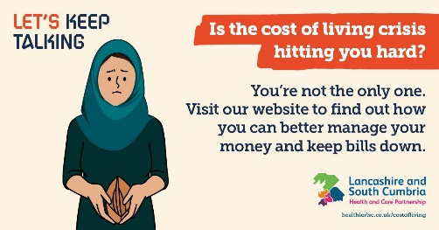  SM_COL_-_2.jpg (1200×628) (healthierlsc.co.uk)
💷😟 Are you struggling to pay the bills because of rising food, fuel and energy costs?  You’re not the only one! Don’t struggle in silence.  Help is out there ➡️ https://www.healthierlsc.co.uk/index.php?cID=10868 | 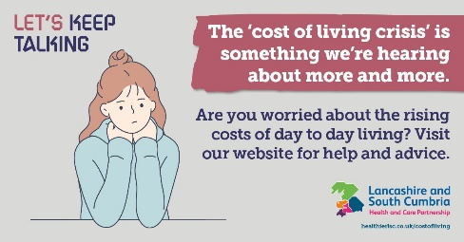  SM_COL_-_3.jpg (1200×628) (healthierlsc.co.uk)
💷 The ‘cost of living crisis’ is something we’re hearing about more and more.  Are you worried about the rising costs of day to day living?  Check out our website for help and advice ➡️ https://www.healthierlsc.co.uk/index.php?cID=10868 | 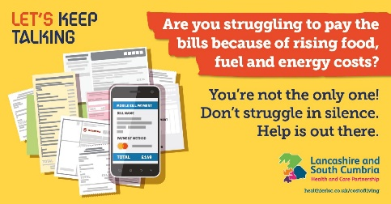  SM_COL_-_4.jpg (1200×628) (healthierlsc.co.uk)
💷 Feel like the rising cost of living is hitting you hard?  You’re not the only one.  Have a look at our website to find out how you can better manage your money and keep bills down ➡️ https://www.healthierlsc.co.uk/index.php?cID=10868 | 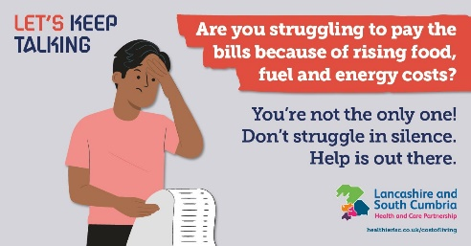  SM_COL_-_5.jpg (1200×628) (healthierlsc.co.uk)
💷 Worried about paying the bills?  Times are tough right now with what feels like ever increasing food, fuel and energy costs?  Help is out there. Check out our website for health and advice ➡️ https://www.healthierlsc.co.uk/index.php?cID=10868 | 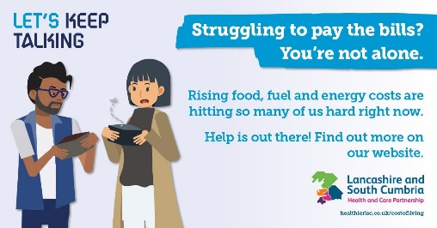  SM_COL_-_6.jpg (1200×628) (healthierlsc.co.uk)

