Let’s Keep Talking
Phase 8 – problem gambling communications toolkit
March-April 2022 – FINAL

Contents

LTK Phase 8 1
Press release 1
Newsletter copy (internal and wider stakeholders) 2
Posters 2
Videos 3
Digital screen images 3
Social media schedule 3

LTK Phase 8

Phase 8 of the Let’s Keep Talking suicide prevention campaign focuses on problem gambling. Once again, former professional footballer Clarke Carlisle is supporting the campaign by opening up about his own relationship with gambling and encouraging people who need help to reach out.

Press release

Ex-Premier League footballer opens up about problem gambling

Former Premier League footballer Clarke Carlisle has opened up about his relationship with gambling in a bid to help others deal with similar problems.

The 42-year-old is supporting the latest phase of Lancashire and South Cumbria Health and Care Partnership’s Let’s Keep Talking campaign which focuses on problem gambling.

Being a compulsive gambler can harm your health and relationships and leave you in serious debt.

The UK has one of the biggest gambling markets in the world. Problem gambling not only harms the individual, but their families, friends and wider society.

In 2018, 24.5 million people in England gambled (54% of the adult population, or 40% when you exclude the National Lottery).

The North West (4.4%) and North East (4.9%) had the highest prevalence of at-risk gamblers.

There is evidence that gambling can be successfully treated in the same way as other addictions. However, if left untreated it can lead to suicide.

The former Blackpool, Burnley and Preston North End defender has spoken openly about his problem gambling, his battle with depression and previous suicide attempts:

“Gambling’s always been my little secret and I don’t know why I coveted it so much. I’ve given up smoking and drinking in the past, but gambling was always the one that I kept.

“Gambling can very, very quickly spiral and affect many different areas of your life. It’s a never-ending chase of wins and losses: it becomes incredibly draining.

“I’ve been actively suicidal on five occasions in my life, and on four of those occasions gambling was a huge factor that took me to those depths. It becomes all consuming, don’t let it get there.

“There might not always be a quick solution but there is always a solution, let’s break that cycle. Help is out there, please reach out.”

The past two years have been a very difficult time for a lot of people. It is more important than ever for people to reach out if they are struggling with their mental health.

Neil Smith, the Mental Health Multi-Agency Strategic Lead for the Lancashire and South Cumbria Health and Care Partnership, said: “Once again, we’re extremely grateful to Clarke for getting behind our campaign. We know his personal experiences will resonate with so many other people – particularly young men.

“Nobody sets out to become a problem gambler, but as Clarke has said, we understand things can quickly spiral out of control for some people. We want people to know there is help out there and the sooner they reach out, the sooner they can start to turn things around.”

For help and support with problem gambling visit www.healthierlsc.co.uk/gambling.

Newsletter copy (internal and wider stakeholders)

Former Premier League footballer Clarke Carlisle is once again supporting Lancashire and South Cumbria Health and Care Partnership’s Let’s Keep Talking suicide prevention campaign.

The 42-year-old has opened up about problem gambling in a bid to help others deal with similar problems.

Being a compulsive gambler can harm your health and relationships and leave you in serious debt, and in some cases can lead to suicide.

A suite of new materials, which includes posters, videos, social media messages and radio adverts, has been developed which you will hopefully see and hear over the next few weeks.

For more information and to download a copy of the toolkit please visit www.healthierlsc.co.uk/gambling or contact lyndsey.shorrock@nhs.net.

Videos

Please find a link below to two videos (a short and long version) featuring Clarke Carlisle speaking about his own struggle with gambling and encouraging people in a similar position to get help.

Long version: https://youtu.be/TWm-wynJjf8
Short version: https://youtu.be/6ebMXMl53yQ

Digital screen images

The images below are for illustrative purposes only. Please use the links below the images to download the high-resolution files. Please display these in places such as public waiting areas.

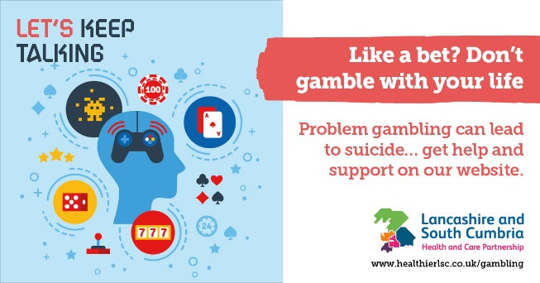  DBP001_HLSC_Keep_Talking_Gambling_SM_Ads_AWK.jpg (1200×628) (healthierlsc.co.uk) | DBP001_HLSC_Keep_Talking_Gambling_SM_Ads_AWK2.jpg (1200×628) (healthierlsc.co.uk)
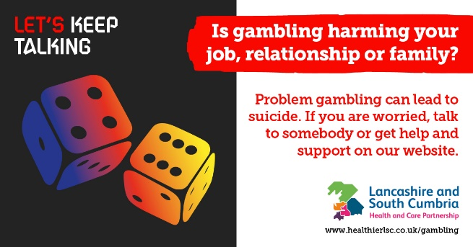  DBP001_HLSC_Keep_Talking_Gambling_SM_Ads_AWK3.jpg (1200×628) (healthierlsc.co.uk) | 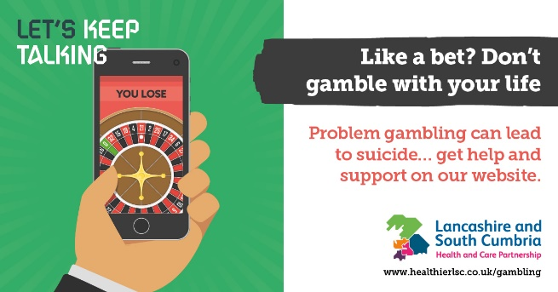  DBP001_HLSC_Keep_Talking_Gambling_SM_Ads_AWK4.jpg (1200×628) (healthierlsc.co.uk)
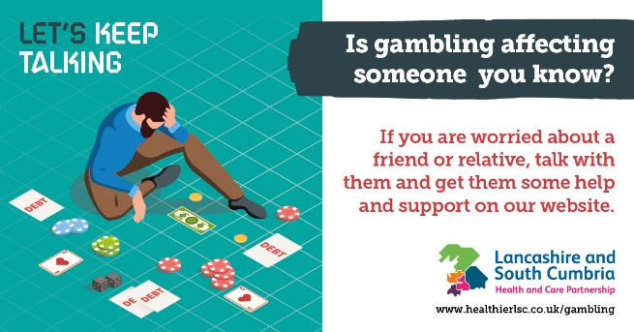  DBP001_HLSC_Keep_Talking_Gambling_SM_Ads_AWK5.jpg (1200×628) (healthierlsc.co.uk) | 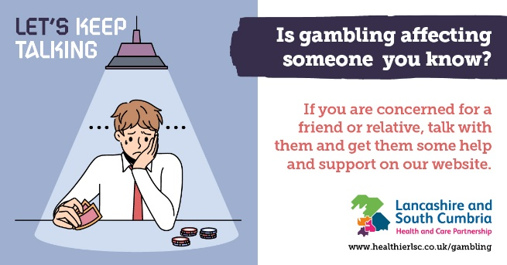  DBP001_HLSC_Keep_Talking_Gambling_SM_Ads_AWK6.jpg (1200×628) (healthierlsc.co.uk)

Social media schedule

Below are some suggested social media posts to use or adapt for your channels. Please schedule two posts per week throughout March and April.

Depending on the social media management systems you use, if you have the ability, please create a campaign for evaluation purposes.

The hashtag for the campaign is: #StartTheConversation, other relevant hashtags include: #SuicidePrevention #MentalHealth #AntiStigma #GamblingAddiction #ProblemGambling

The thumbnails below are for illustrative purposes only. Please download the high-resolution image by clicking on the link below the image.

Copy – Clarke Carlisle specific for Facebook, Insta and Twitter

🎲 “Gambling can very, very quickly spiral and affect many different areas of your life.”  Ex-Premier League footballer Clarke Carlisle is speaking out about problem gambling.  If his story sounds familiar, help is available ➡️ www.healthierlsc.co.uk/gambling  https://youtu.be/6ebMXMl53yQ | “There might not always be a quick solution, but there is always a solution – let’s break that cycle.”  Ex-Premier League footballer Clarke Carlisle has opened up about problem gambling 🎰  Sound familiar? Help is out there 👉🏽 www.healthierlsc.co.uk/gambling  https://youtu.be/6ebMXMl53yQ |  | “It’s OK, because the next one will make it OK.” Sound familiar when it comes to gambling? 🎰🎲  Ex-footballer Clarke Carlisle's opened up about his problem gambling to help others to break the cycle.  Find out more 👉🏾 www.healthierlsc.co.uk/gambling  https://youtu.be/6ebMXMl53yQ
When copying and pasting the above text, please ensure it is the YouTube video (not the link to the page) which displays.

Copy – general gambling for Facebook, Insta and Twitter |  | Image thumbnail/asset
🎰🎲 Are you a problem gambler?  Compulsive gambling can harm your health and relationships and leave you in serious debt.  If you have a problem and you want to stop – help is out there.  Find out how and where you can get help ➡️ www.healthierlsc.co.uk/gambling |  | DBP001_HLSC_Keep_Talking_Gambling_SM_Ads_AWK2.jpg (1200×628) (healthierlsc.co.uk)  OR  DBP001_HLSC_Keep_Talking_Gambling_SM_Ads_AWK4.jpg (1200×628) (healthierlsc.co.uk)
♠️♥️ Losing control of gambling can lead to suicide ♣️♦️  If you’re worried about yourself or someone you know, help IS out there ➡️  www.healthierlsc.co.uk/gambling |  | DBP001_HLSC_Keep_Talking_Gambling_SM_Ads_AWK5.jpg (1200×628) (healthierlsc.co.uk)  OR  DBP001_HLSC_Keep_Talking_Gambling_SM_Ads_AWK6.jpg (1200×628) (healthierlsc.co.uk)
🎰 Like a bet? Don’t gamble with your life!  Problem gambling can lead to suicide.  If you’re worried talk to somebody. Help is available 👉🏻 www.healthierlsc.co.uk/gambling |  | DBP001_HLSC_Keep_Talking_Gambling_SM_Ads_AWK.jpg (1200×628) (healthierlsc.co.uk)  OR  DBP001_HLSC_Keep_Talking_Gambling_SM_Ads_AWK3.jpg (1200×628) (healthierlsc.co.uk)

