

HEALTHIER GREENER TRAVEL TOOLKIT
This is a three-step toolkit to encourage sustainable travel at your healthcare site.
(Adapted from Greater Manchester Toolkit Version 2 – March 2025)

Introduction

The Healthier Greener Toolkit is a set of practical tools and advice to help you understand the travel options available to your site, and what you can do as an organisation to encourage active and sustainable travel for your employees and patients.
Physical activity has many benefits- active employees are happier, healthier, and therefore more productive. On average 28% fewer sick days are taken by active staff. Moving more has huge benefits to employees, including opportunities to socialise with each other, increased energy, reduced risk of depression and maintaining good musculoskeletal health.
Every year, poor air quality contributes to around 4% of all deaths in Lancashire and South Cumbria. In towns and cities, road vehicles are the main source of air pollution. Healthcare travel contributes to this, but people can also be affected by poor indoor air quality. The most vulnerable people – children, older people and those with health conditions – are hit hardest by air pollution. By making changes to the way we travel and choosing more sustainable options where we can, this will help to improve both our health and the local air quality.

Step 1: Place

Identify and analyse the travel opportunities near to your site to help your understanding of what travel options are available. This will enable you to develop plans for increasing sustainable ways of travelling that are achievable.
Identify nearby features, such as roads, site access points, public transport, cycle paths and car parks:
- Consider locations that are a short distance from the site (e.g. up to a 30-minute walk or a 15- minute cycle), such as transport hubs and stops, parks and greenspaces, murals, statues, shops and leisure and cultural amenities.

- Consider what makes the area good to walk, wheel or cycle around.
  - Are there quiet roads with clear, uncluttered pavements?
  - Are there any benches or points of interest?
  - Are there any gardens or greenspaces to take notice of?
  - Are there any segregated cycle lanes? On street secure cycle parking provision?

Consider features already provided at your business site, such as toilets, showers, lockers, cycle parking, car parking, or EV charging.

Step 2: People
Now you’ve identified travel opportunities near to your site, survey your staff and patients to understand their current travel practices, any opportunities and challenges, and how obstacles could be overcome.
Two surveys have been created on Microsoft Forms to help with this to enable you to easily set up your surveys, then monitor and download your survey results – including automatically generated graphs and charts.
To access the surveys, please click the links below and select ‘duplicate it’ in the bar at the top of the screen. This will save a copy of the survey onto your work email address Forms account.
- Staff survey
- Patient survey
These surveys can be customised to best suit your practice or site. Some questions have been deliberately left blank and are marked ‘to be edited’ for small, quick edits to personalise your survey:
- Q1 for staff & patients – Add in multiple locations or sites if you operate over more than 1 site.
If you only operate at 1 site, you may wish to remove this question entirely.
- Q4 for staff only – Add in job roles/groups appropriate to your staff
It is best practice for the survey to be live and promoted for 4-6 weeks, with plenty of regular reminders.

Step 3: Plan

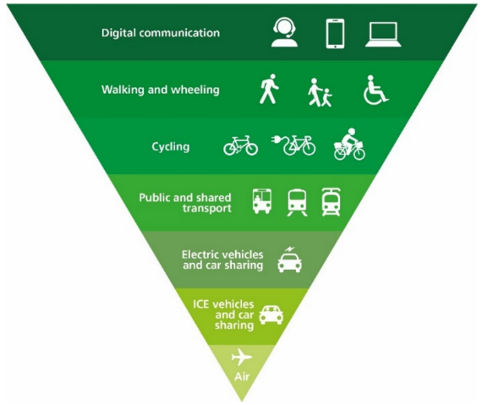
Now that you have identified the travel opportunities near to your site, and you have surveyed your staff and patients, you can now bring these together to recommend sustainable travel initiatives and future policies that work for your practice while considering the sustainable travel hierarchy.
A template Healthier Greener Travel action plan is overleaf to help you get started, followed in the Appendix by a list of ideas to consider.

Figure 1: Sustainable Travel Hierarchy

Share your progress
Share your progress and shout about your successes – both across Lancashire and South Cumbria and beyond!
The NHS LSC ICB Sustainability team and Lancashire/ Cumbria Active Travel teams can connect you with LSC-wide projects and offer support with developing case studies for national publication.
By sharing your travel plan and anonymised travel survey data with NHS LSC ICB, this also helps to paint the picture of how Primary Care staff and patients are travelling in Lancashire and South Cumbria which supports with ensuring LSC-wide changes meet your needs.
Contact Allison.Sathiyanathan@nhs.net Net Zero Project Manager, LSC ICB

Healthier Greener Travel Action Plan (Template)

Practice name: |  | Date:
Goal: | What is the overall travel goal? – this can be broad, e.g. "reduce car use" or "improve staff uptake of cycling”. It should communicate the vision for the travel plan.
Objectives: | These should be based on the results of steps 1 (Place) and 2 (People).  e.g. “Promote sustainable travel options”
No. | Action | Measurable | Progress | Required resource | Time-bound
 | Break down your objectives into manageable actions. Review the list of ideas for inspiration. | What/ how will you evidence the actions are delivered/ work/ opportunities for improvement identified. | When this action is complete, what should success look like? | These could include materials, resources, funding, partnerships, staff time, or other types of resources. | Identify key people and deadlines to keep actions accountable.
1
2
3

Appendix: Suggested actions for your Healthier Greener Travel Plan
 | Opportunities/ Ideas
General | - Share a commitment from senior management/partners on sustainable and active travel. Set up a group to work on this together.  - Join BetterPoints Lancashire. This App supported by Lancashire County Council rewards sustainable travel choices. Anyone studying, living or working in Lancashire can download the App and win points for traveling by public transport, cycling or walking. Points can be exchanged for drinks or vouchers.  - Sign up to the RCGP Active Practice Charter, and use their new Active Practice Toolkit  - Introduce no car days
Cycling | - The Active Travel team at Lancashire County Council can offer support and this may include funding to encourage active and sustainable travel. Previous funding has been used for secure bike storage, showers, drying room & lockers available. Contact Activetravel@lancashire.gov.uk with 'active travel support' in the subject line  - Purchasing a bicycle or e-bike for use with home visits – cargo bikes are able to carry equipment  - Save up to 42% on bikes/ accessories (inc. E-Bikes) via Cycle to work scheme  - Fair weather cyclist?: You can hire, for *free (funded by Lancashire County Council's Active Travel Team) a conventional or e-bike. Email Activetravel@lancashire.gov.uk with 'bike hire enquiry' and the district you live or work in, in the subject line  *Subject to funding being available  - Thinking of trying an e-bike or cargo e-bike before you buy? Contact I-Cycle Electric to take advantage of *free hire (funded by Lancashire County Council's Active Travel Team). Email hello@icycleelectric.co.uk *Subject to funding being available  - Claim business mileage: 20p/ mile re Agenda for Change cycling mileage rate  - Information & routes for cyclists can be found here and watch out for events or use 'The Complete National Cycle Network' app  - Cycle training to build confidence for adults available here.  - Sign up to Love to Ride to get incentives and rewards.
Car sharing | - FREE car sharing service for everyone living or working in and around Lancashire or for NHS staff NHS liftshare.  - Join an Electric Vehicle (EV) car salary sacrifice scheme such as NHS Fleet Solutions
Walking/ running | - Use the Living Streets workplace resources to help embed walking in your practice  - Running Sustrans ‘Workplace Travel Challenge’ to encourage employees to try active and sustainable travel
Public transport | - Promote the bus fare cap (currently £3 single bus trip, £1 after 7pm/ on Sundays) as per Bus tickets and fare offers - Lancashire County Council.  - Plan your route- download Google Maps for current train and bus times.  - For offers and Information for Lancashire, Information for Westmoreland & Furness

