LSC Integrated Care Board

Primary Care Contracts sub-committee

Date of meeting | 11 June 2026
Title of paper | Duddon Vallen Medical Practice – Reassignment of the main site Kirkby-in-Furness to Askam-in-Furness
Presented by | Amy Lepiorz, Associate Director Primary Care
Author | Louise Fazackerley, Primary Care Manager
Agenda item | Item 6
Confidential | Yes

Purpose of the paper
The purpose of this paper is to present to the Primary Care Contracts Sub-committee the application from Duddon Valley Medical Practice to reassign the Askam-in-Furness site as the main site and to close the Kirkby-in-Furness site following notice from the landlord to vacate the premises.

Executive summary
Duddon Valley Medical Practice has submitted an application to reassign the Askam-in-Furness site as the main site and to close the Kirkby-in-Furness site following notice from the landlord requiring vacation of the premises by 31 July 2026. The practice proposes to continue service delivery from its remaining sites in Askam-in-Furness and Broughton-in-Furness.

An options appraisal has been undertaken, which highlights that alternative estate solutions, including securing a new landlord or premises within Kirkby-in-Furness, present significant deliverability, financial and timing risks. These options are unlikely to be achievable within the required timeframe

While the closure will result in increased travel for some patients, particularly those in Kirkby-in-Furness, the practice has undertaken patient engagement and identified mitigating actions to support access, including continued home visiting and use of wider services.

Approval of the application represents the most practical and deliverable option, ensuring continuity of primary care services and operational stability within a constrained timeframe.

Recommendations
The Primary Care Contracts Sub-Committee is requested to approve Option One - the application from Duddon Valley Medical Practice to reassign Askam-in-Furness as the main Duddon Valley Medical Practice site and to close the Kirkby-in-Furness site. Service delivery will continue from the two remaining sites in Broughton-in-Furness and Askam-in-Furness.
Governance and reporting
Meeting | Date |  |  |  | Outcomes
Primary Medical Service Group | 3 June 2026 |  |  |  | Proceed to PCCSG for a decision following further exploration of the options and the rational for the proposed opening hours.
Conflicts of interest identified
not applicable

Implications
If yes, please provide a brief risk description and reference number | Yes | No | N/A | Comments
Quality impact assessment completed |  |  | X
Equality impact assessment completed |  |  | X
Privacy impact assessment completed |  |  | X
Financial impact assessment completed |  |  | X
Associated risks |  |  | X
Are associated risks detailed on the ICS Risk Register? |  |  | X

Report authorised by: | Amy Lepiorz, Associate Director of Primary Care

Primary Care Contracts Sub-committee

11 June 2026

Duddon Valley Medical Practice (A82651) – Application to reassign its Askam-in-Furness site as the main site and to close the Kirkby-in-Furness site.

1. Introduction

  - Duddon Valley Medical Practice holds a General Medical Service (GMS) contract for the provision of essential and enhanced primary medical services to 5,011 registered patients. The practice is a member of Mid Furness PCN.

  - The practice operates from three practice sites located in South Cumbria:

- Kirkby-in-Furness (Main Site)
- Broughton-in-Furness (Branch)
- Askam-in-Furness (Branch)

  - The landlord of the Kirkby-in-Furness site has served the provider notice on their lease and given the provider 3 months’ notice to vacate the building by the 31st July 2026.

  - The purpose of this paper is to present to the Primary Care Contracts Sub – committee the details of the application to reassign the Askam-in-Furness site as the main site, close the Kirkby-in-Furness site and outline the patient engagement feedback and available options.

- Background

  - On the 31st April 2026 the Practice Manager at Duddon Valley Medical Practice (DVMP) contacted the ICBs Primary and Community Care Team to advise the ICB that the landlord at the Kirkby-in-Furness site had served the practice 3 months’ notice on their lease as they intend to sell the property.

  - Legal advice has been sought by the practice which has concluded that the landlord is within their rights to only provide 3 months’ notice since the terms of the lease, which ended in 2021, did not include the two years opt out clause as is normally the case with such leases.

  - DVMP had considered purchasing the building from the landlord but has concluded that it wasn’t financially viable for the practice to do so.

  - DVMP have therefore applied to LSC ICB to close the Kirkby-in-Furness site and continue service delivery from the remaining sites in Broughton-in Furness (5.1miles) and Askam-in-Furness (5 miles) (see map in Appendix One).

  - The Kirkby-in-Furness site is listed as the main site on the DVMP contract. DVMP has proposed that the Askam-in-Furness site will become the main site and the Broughton-in-Furness site will remain a branch site.

  - The PCN Estates review completed in 2024 Identified that all DVMP were core estate which means that the buildings will remain in operation for at least 10 years.

  - The application to close the Kirkby-in-Furness site was considered by the Primary Medical Service Group (PMSG) on the 3 June 2026. PMSG concluded that following further exploration of the options that the application proceeded to Primary Care Contracts Sub-committee for a decision.

- Factors to consider

  - The group is asked to note the application from the practice to reassign the Askam-in-Furness site as the main site and to close the Kirkby-in-Furness site with effect from 31st July 2026 following the 3 months’ notice given by the landlord to vacate the premises, and to consider options for the future provision of primary medical care services for the Kirkby-in-Furness population. In determining the preferred option, the following factors should be considered:

Location

  - DVMP is the only medical practice located in the village of Kirkby-in-Furness. The next nearest practice is the DVMP branch in Askam-in-Furness which is approximately 5 miles or DVMP other branch site in Broughton-in-Furness which is approximately 5.1 miles.

  - Kirkby-in-Furness is a small rural village 9 miles from Barrow-in-Furness and 5 miles from Ulverston in the Lake District. The village is home to approximately 580 residents (census 2021).

  - The village is primarily accessed via the A595, the main coastal route through this area of Cumbria. The A595 connects Kirkby-in-Furness to Barrow-in-Furness passing through Askam-in-Furness or Ulverston can be accessed via a B Road (Stockbridge Lane).

  - Kirkby-in-Furness is served by a combination of rail and limited bus services. The local railway station provides connections to Barrow-in-Furness, Lancaster and Carlise; however, services are relatively limited. Bus provision is available but operates at a low frequency.

  - The practice has confirmed that there is unused space at both the Askam and Broughton sites providing enough room to absorb the extra capacity needed if the application is supported and there is no provision in Kirkby-in-Furness.

  - The table below provides the transport options to the other DVMP sites:

 | Car | Bus | Train
Askam-in-Furness | 7m  (5 miles) | 17m | 5m
Broughton-in-Furness | 11m  (5.1 miles) | 19m | 1h 12m

  - The practice has engaged with patients to understand their preferred alternative site and the preferred choice would be to attend the Askam-in-Furness site. Patients have stated that it would be a more convenient location due to the transport links.

  - Appendix two provides a breakdown of the percentage of patients registered at DVMP by post town. In summary:

- 37% patients live in Askam-in-Furness
- 22% live in Broughton-in-Furness
- 22% live in Kirkby-in-Furness
- 18% are located to the south of Askam-in-Furness which suggests that these patients would also attend the Askam-in-Furness site as this would be the closest of the two remaining practices.

  - DVMP is therefore proposing that the Askam-in-Furness site becomes the identified main site on the DVMP contract and that the Broughton-in-Furness site continues to operate as a branch practice.

Opening Times

  - Patient demand data reviewed by the practice has identified that the Askam-in-Furness site experiences higher levels of demand than the Broughton-in-Furness site. Askam-in-Furness also serves a comparatively younger population which would benefit from access to services outside of work and school commitments.

  - DVMP therefore proposes that the Askam-in-Furness site will operate during core hours, increasing the current opening times at the site to cover 8am - 6:30pm Monday to Friday.

  - DVMP proposes to extend opening hours at the Broughton-in-Furness site to provide access during core hours, 8am – 6:30pm Monday, Tuesday, Thursday and Friday. The site has not historically opened on Wednesdays or Fridays; however, the practice has requested that Wednesdays remain closed due to low demand. This reflects patient attendance patterns, with the local farming community typically accessing services on Mondays and Tuesdays to align with auction days in Broughton. Many local business in Broughton-in-Furness also maintain a traditional half a day closure on Wednesday which again encourages patients not to visit the village on that day.

  - A summary of the proposed operating hours are set out in the table below:

 | Askam in Furness  (proposed main site) | Broughton in Furness (branch site)
Monday | 8:00am – 6:30pm | 8:00am – 6:30pm
Tuesday | 8:00am – 6:30pm | 8:00am – 6:30pm
Wednesday | 8:00am – 6:30pm | Closed
Thursday | 8:00am – 6:30pm | 8:00am – 6:30pm
Friday | 8:00am – 6:30pm | 8:00am – 6:30pm

  - Patients registered at DVMP would be able to continue to access either site, subject to availability when booking appointments.

Number of registered patients

  - The current list size of DVMP is 5,011 patients (as at 1st May 2026).

  - The population profile of Kirkby-in-Furness is notably older, with around 30% of residents aged 65 and older, which is higher than the national averages and aligns with wider demographic trends across Westmorland and Furness.

  - Appendix three provides a map of the registered patients at DVMP and appendix two provides the percentage of patients registered by post town.

Alternative Premises

  - Kirkby-in-Furness is a small village with a small number of residential and commercial buildings.

  - The ICB Estates Lead has reviewed the available residential and commercial properties available in Kirkby-in-Furness and has not identified any available premises for lease.

  - Residential properties are available for purchase at values ranging from approximately £300k to over £1m. A commercial property, previously used as a public house, is also on the market for £350k. However, all identified options would require significant investment to make them suitable for clinical use.

  - There are two existing sites providing services as part of this contract, effectively either side of the Kirkby-in-Furness site. This means that strategically, capital investment in this area would not be a priority.

Patient Engagement

  - DVMP has provided the opportunity for patients to feedback their comments regarding the proposed changes via a patient engagement questionnaire. The patient engagement survey has received 132 responses, which is 3% of the registered patients.

  - The patient engagement was conducted using Microsoft Forms questionnaire which was sent to all patients via text, physically handed out at the practice and posted on the practice Facebook page.

  - The practice also engaged with the PPG extensively, the local Councilor and the Parish Council.

  - A summary of the responses to the patient survey are attached as Appendix Four. There was a mixed response with 52% of patients indicating that there would be no impact or minor impact if the site closed. 48% stated that there would be moderate or significant impact. The main concerns were access, increased travel, and repeat prescriptions.

  - The practice has responded to the issues raised by patients during the consultation and provided mitigations, and these are attached as Appendix Five.

  - The practice has notified local stakeholders including the Patient Participation Group, local councilors and their MP and also the local Parish Council.

  - At the time of writing this paper (08/06/26), the ICB has received one letter from the local MP regarding the proposed closure. The letter raises concerns about the impact on Kirkby-in-Furness residents, particularly older patients and those with limited mobility or transport access, while acknowledging the practice’s efforts to mitigate these challenges. No correspondence has been received from patients or other stakeholders.

Integrated Impact Assessment

  - DVMP, with support from the LMC, is currently completing an Integrated Impact Assessment, incorporating a Quality Impact Assessment and Equality Impact Assessment, to assess the impact of the proposed changes.

- Options Appraisal

Option 1 – Approve the application

  - Approve the application from DVMP to reassign the Askam-in-Furness site as the main site and to close the Kirkby-in-Furness site, with services continuing from Broughton-in-Furness and Askam-in-Furness.

Benefits:

    - Enables timely and practical response to the landlord’s notice, ensuring continuity of primary care service provision within the required timescales.

    - Avoids the reliance on uncertain estate solutions, removing the dependency on identifying a new landlord or alternative premises within a constrained timeframe which may not be achievable or affordable.

Risks:

    - Patients, particularly those in Kirkby-in-Furness (approximately 21.66% of the patients list, 1071 patients), will experience increased travel distances which may disproportionately impact older patients and those without access to private transport.

Option 2 - Support the identification of a prospective landlord

  - Support the identification of a prospective landlord to purchase the existing Kirkby-in-Furness site, enabling the continuation of primary care services from the current premises.

Benefits:

    - Enables the continued delivery of primary care services from Kirkby-in-Furness, preserving access for the local population, including those who may face challenges travelling to an alternative site.

Risks:

    - There is no guarantee that a suitable landlord will be identified within the limited timeframe, given the landlord’s intentions to sell the property.

    - The landlord may not be willing to sell the premises.

    - Delays confirming a solution which may create uncertainty for patients and staff.

Option 3 - Support the identification of alternative premises

  - Support the identification of alternative premises within Kirkby-in-Furness from which primary care services could continue to be delivered.

Benefits:

    - Enables the continued delivery of primary care services from Kirkby-in-Furness, preserving access for the local population, including those who may face challenges travelling to an alternative site.

Risks:

    - There are currently no suitable alternative premises available in the village that meet clinical and regulatory requirements.

    - The timeframe required to identify, secure, adapt and mobilise a new site is highly unlikely to align to the landlords notice period creating a risk of service disruption.

    - Significant capital investment may be required to bring any alternative premises up to the required clinical standards.

- Summary

  - DVMP has applied to reassign the Askam-in-Furness site as the main site and to close the Kirkby-in-Furness site following notice from the landlord requiring vacation of the premises within a constrained timeframe. Services will continue to be delivered from the Broughton-in-Furness and Askam-in-Furness sites located either side, 5 miles away from the site at Kirkby-in-Furness.

  - The options appraisal has identified that, while there are benefits associated with maintaining a primary care presence within Kirkby-in-Furness, both the identification of a prospective landlord or an alternative premises present significant deliverability, timing and financial risks. These options are unlikely to be achievable within the required timescales and carry a high risk of service disruption.

- Recommendations

  - Primary Care Contracts Sub-Committee is asked to approve in principle, subject to completion of the Impact Assessment, Option One: the application to reassign the Askam-in-Furness site as the main site and to close the Kirkby-in-Furness site. This option represents the most deliverable option.

This approach ensures continuity of primary care services, provides operational stability for patients and staff, and avoids reliance on uncertain estate solutions within a constrained timeframe.

Louise Fazackerley
Primary Care Manager
8th June 2026

.

Appendix One

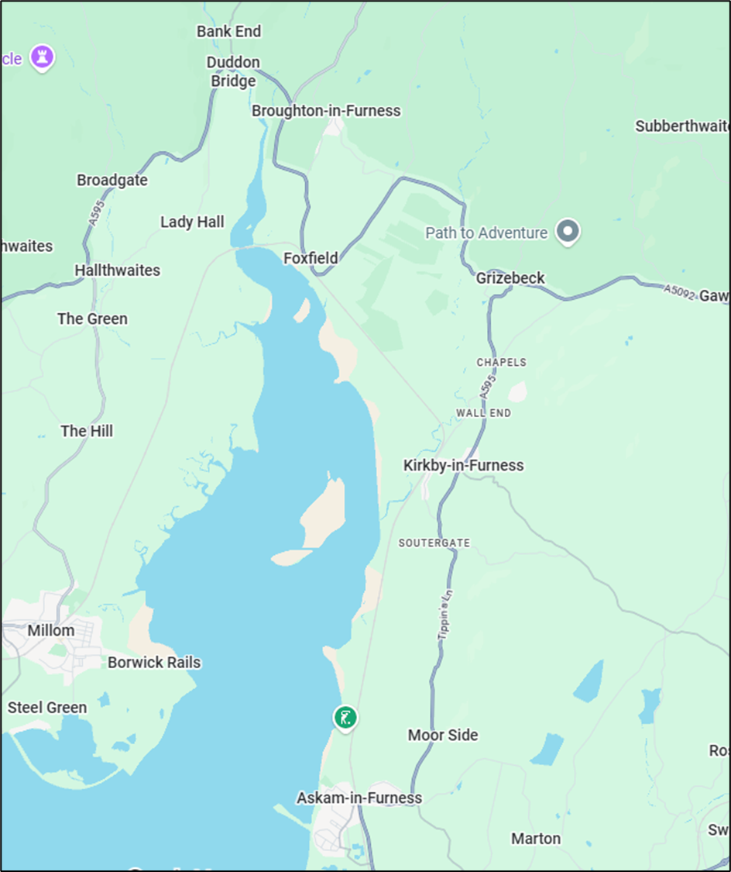

Appendix Two - Duddon Valley Medical Practice Registered Patient’s Postcodes

Partial Postcode | No Patients | Post Town | %
LA16 | 1853 | Askam-in-Furness | 37.47%
LA20 | 1090 | Broughton-in-Furness | 22.04%
LA17 | 1071 | Kirkby-in-Furness | 21.66%
LA12 | 427 | Ulverston | 8.63%
LA15 | 224 | Dalton-in-Furness | 4.53%
LA18 | 153 | Millom | 3.09%
LA14 | 54 | Barrow-in-Furness | 1.09%
LA13 | 43 | Barrow-in-Furness | 0.87%
LA21 | 20 | Coniston | 0.40%
CA19 | 3 | Holrook (Carlise) | 0.06%
LA11 | 3 | Grange Over Sands | 0.06%
LS1 | 2 | Leeds | 0.04%
W12 | 2 | Newton le Willows | 0.04%

Appendix Three - A82651 Duddon Valley Medical Practice Patient Plot May 2026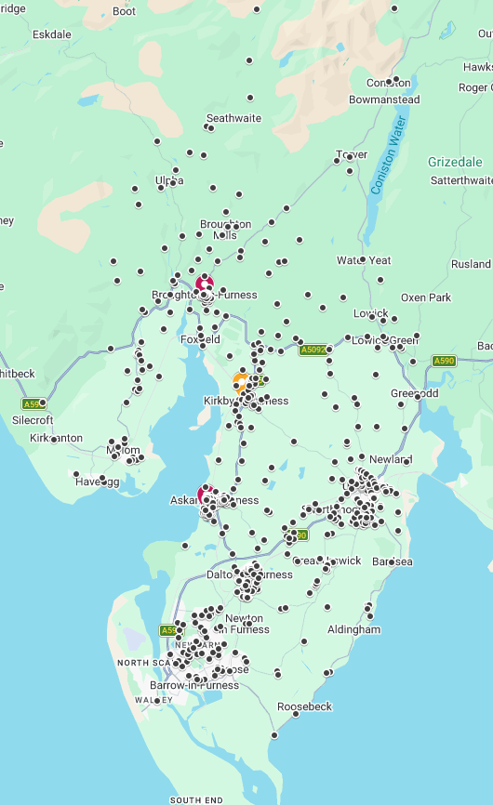

Appendix Four - Patient Engagement Summary

- Overall sentiment (support/oppose/undecided). The overall sentiment is even, between support and oppose. The percentage of responses reported there will be no impact to the closure was 20%. The percentage of responses that reported there will be a minor impact was 32%. The percentage of responses who reported there will be moderate impact was 30% and the percentage of responses who reported there will be significant impact was 18%. The percentage of responses aware of upcoming changes at Duddon Valley Medical Practice was 88%.

- Patient concerns/specific issues. The main concerns were in respect of collecting repeat prescriptions for patients living in Kirkby and having to travel to an alternative site. Concerns were raised in respect of access to the other practice sites at Broughton and Askam that are currently not open for 5 days a week. The most reported barriers that patients faced were transport, distance, and the weather. There were 54% of patients who reported it would be very easy to travel to other practice sites. It was reported by 4% of patients that it would not be possible to travel to other practice sites. There are 43% of patients who stated they travel by car to the practice. Attendance by walking to our practice is 64%. There were 50% of patients using our practice on a monthly basis. The percentage of patients that reported they have transport issues was 9%. There were 38% of responses that stated they had no issues with mobility/transport/long-term condition/regular care needs.

- Overall conclusion. The most important factor highlighted by patients when accessing GP services was that they were able to get an appointment quickly and the second most important factor was seeing a GP they were familiar with. It was obvious that there is disappointment due to the loss of the practice building in Kirkby village however, there were supportive views from patients who are very pleased that the practice will continue serving them from our other sites at Broughton and Askam and were grateful for the service we have provided over the years.

Due to the random distribution of the survey we would ask you to note that the responses are from patients who may or may not attend Kirkby practice building predominantly.

Appendix Five – Practice Response to Concerns and Mitigations

DVMP has always gone out of its way to support older patients, those with mobility issues, limited access to transport – whether they have long-term conditions etc. or not.

At DVMP our motto is - “if we can, we will” – so, unlike other practices, we routinely mitigate now for those very patients referred to.

Patient centered care is at the very centre of what we do, providing the best continuity of care across our large, geographical area to ensure the best patient outcomes achievable.

Dr Wilson and all the practice staff go over and above to provide the best services to our patients as possible. This attitude has determined our actions and is a genuine reflection of dedication to our patients.

Dr Wilson’s career has been his vocation, and he is hoping to continue to provide the best services to his patients despite the sale of the Kirkby building because the practice is the people, not just the building.

Access for patients who either require a home visit or who will struggle to travel

- The practice team carries out home visits to patients that need a home visit (genuinely need a home visit) or are then found to be NOT genuinely needing a visit or not considered as meeting the definition of housebound.
- Our GPs are planning to continue carrying out home visits without prejudice.
- Further mitigation for this, although limited provision is available - there is a Home Visiting Service (HVS) available for our patients from our Primary Care Network (PCN).
- We have provided lifts in our own transport and given life-saving support to patients attending appointments at hospital due to patients feeling stranded or being fearful of attending appointments on their own etc.

Access to prescriptions/repeat prescriptions

- We have personally delivered medication in many situations to our patients who state they have no friends or support network available at all to help them.
- We already provide GP and Practice Nurse support to our patients by delivering care to our patients in their own homes, as the patients have no friends or support network available and where district nurses cannot visit them due to the restrictions upon the district nurse service delivery criteria. We would continue to do this and travel from Broughton and Askam to carry out such services.
- We have personally administered medication to our patients who are not housebound, but who find it difficult to mobilise well. Mobilising to the Kirkby building has always been especially challenging for patients who struggle with their mobility as the Kirkby practice building is situated on a very steep hill.
- Our clinicians will continue to administer medication to our patients who are not only housebound but require this to be done as absolutely necessary due to the restrictions upon our district nurses to deliver such services.

Supporting self-care and living in a rural area

- We have always encouraged and educated our patients before emergency situations arise and will continue to do so to gather support from their friends, relatives, communities to provide as helpful a network as possible/feasible around them for their future days whilst living in their rural area.
- We also encourage our patients to consider putting in place power of attorney documents for health and welfare, as well as power of attorney documents for finances. This can begin the often difficult conversations involved in a timely manner that might help support our patients better psychologically whilst living in isolated areas and discover opportunities to improve their wellbeing and support systems since there are very limited services available in our large, geographical area.
- Services that we continue to offer patients include (not limited to);
  - Doppler services provided at all practice sites.
  - Complex wound care delivered at our practice sites.
  - Consultant requested blood tests and injections carried out at the practice sites to prevent patients from having to travel to the local hospital.

Workforce

- The most important mitigation therefore, for all the above, is that Dr. Wilson now has a new partner after searching for one for over 13 years, Dr. L. Gunasinghe. Dr. Gunasinghe also shares Dr. Wilson’s values and will hopefully enjoy a long and happy career serving our communities when Dr. Wilson can eventually retire.

Premises

- Wheelchair access and disabled access to a patient toilet has never been available at Kirkby but, this is already provided at Broughton and Askam practice buildings.

Other Considerations

- Please note that, following further discussions last week with members of the local parish council I also believe that they are putting energies into lobbying for better transport services from Kirkby to Broughton and from Kirkby to Askam to help patients access services at Broughton and Askam. For example, they are going to lobby for not just more frequent buses in operation for everyone in the village and surrounding areas but, for DVMP patients especially by lobbying for extra bus stops be placed nearer to the practice buildings in Broughton and Askam asap.

As far as I am aware, there has never been a bus stop outside the Kirkby practice building as far as I am aware, and patients have been brought to the practice by friends, relatives, voluntary transport services or by taxi currently.

Registered patients as at 1st May 2026

