

Dental Access Review and Service Delivery Recommendations for the Fylde Coast

Version: | 1.0
Purpose | The purpose of this report is to review dental access across the Fylde Coast within the context of the restoration of care to pre-COVID levels. One of the key objectives is to understand why dental access has not restored to pre-COVID levels. The report will consider the history and pattern of commissioning in terms of the number of contracts and units of dental activity (UDAs) delivered on the Fylde Coast. The needs of the population will be considered and recommendations made for the ICB to consider.
Authors (inc Job Title): | Deborah Moore, Consultant in Dental Public Health  Sarah Bloy, Head of Primary Care – Blackpool, North Lancashire and South Cumbria  Nick Barkworth, Senior Primary Care Manager  Dan Clough, Communications and Engagement Manager
Ratified by:  (Name of responsible Committee) | Dental Services Group
Cross reference to other Policies/Guidance | Fit for the Future, NHS Health Plan
Date Ratified: | TBC
Target audience: | ICB commissioners

Document control:
Date: | Version Number: | Section and Description of Change

Contents

Section No. | Section Heading | Page No.
 | Executive Summary | 4
1. | Introduction  - National Context  - National Drivers  - Local Context  - Local Drivers | 5
2. | Aims and Objectives | 7
3. | Scope of the report | 7
4. | Roles and Responsibilities | 8
5. | Oral Health and Disease Overview  - Local Context | 8
6. | Fylde Coast – Place and Population Overview | 12
7. | Review of dental service provision and access across the Fylde Coast  - (Primary) General Dental Service Provision  - Urgent Dental Service Provision  - Dental Access | 14
8. | Prioritisation Framework | 21
9. | Patient and Public Views | 22
10. | Barriers to Accessing Dental Care and Alternative Service Models | 23
11. | Service Model for the Fylde Coast | 24
12. | Finance | 25
13. | Conclusion | 25
14. | Recommendations | 26
15. | Appendices  - Access recovery trends  - Prioritisation framework indicator descriptions  - Patient and public engagement report  - Equality and health inequalities impact risk assessment (EHIIRA) | 27

Executive Summary

Access to NHS dental care across the Fylde Coast has not recovered to pre-COVID levels at the same pace as the rest of Lancashire and South Cumbria. This slower recovery is most pronounced in Blackpool and Wyre, where reductions in capacity, high levels of deprivation, and entrenched oral health needs have combined to create persistent and widening inequalities in access and outcomes.

Since the pandemic, the Fylde Coast has experienced a disproportionately high level of NHS dental contract hand-backs, resulting in significant disinvestment. Blackpool has incurred the greatest loss, equivalent to £12.88 per head of population, followed by Wyre at £10.67 per head. These reductions translate directly into fewer available appointments and a substantial fall in the number of patients able to access NHS dental care.

The impact of this disinvestment is reflected in access data. Child access in Blackpool is the worst in Lancashire and South Cumbria and remains so both pre- and post-pandemic. Wyre now has the lowest overall dental access rate across the ICB, despite having been one of the better-performing areas prior to COVID. Adult access recovery has also been markedly slower in Blackpool and Wyre than in comparator areas.

The report demonstrates that these access challenges sit alongside exceptionally high levels of oral disease and unmet need, strongly linked to deprivation. Blackpool and parts of Fleetwood experience some of the poorest oral health outcomes in England, including high rates of dental decay in children, hospital admissions for extractions under general anaesthetic, and higher oral cancer incidence and mortality. Evidence indicates that population need in deprived communities is 2–3.5 times higher than in more affluent areas, and while the dental access plan makes a commitment to focus on priority populations, the historic activity locked in dental contracts do not currently reflect this gradient.

Patient and public engagement reinforces the quantitative findings, presenting a consistent and stark picture. Many residents perceive NHS dentistry as effectively unavailable, particularly those who do not have routine access to a NHS practice. The dominant issues raised include the inability to find NHS dentists accepting new patients, the forced shift to private dentistry due to lack of alternatives, affordability barriers, limited awareness of urgent dental care pathways, and significant negative impacts on older people, low-income households, disabled people and those with dental anxiety or complex needs.

The report concludes that recovering activity to pre-COVID levels alone will not reduce inequalities. National funding allocations cover only 50–60% of the population, requiring the ICB to make explicit, evidence-based choices about where to invest limited resources. Using the ICB’s prioritisation framework, Blackpool is ranked second highest for future investment need, with Fleetwood identified as an outlier of deprivation within Wyre.

To address the scale of the challenge, the report sets out the early outline of a bespoke, place-based service model for the Fylde Coast, alongside the need for further clinical engagement, a robust investment case, and improved communication with the public. Without targeted intervention, there is a clear risk of continued deterioration in oral health outcomes and further escalation of demand for urgent and secondary care services.

Headline Recommendations

In summary, the report recommends that the ICB:

- Develop a coherent evidence-based and transparent rationale for allocation of the available investment.
- Seek feedback on the model from the profession, engage with clinical teams/local authority to co-design via focus groups.
- Strengthen a communication plan to increase access to information regarding urgent dental care to minimise the number of people in pain.

- Introduction and Background

  - All NHS organisations have a responsibility for reducing health inequalities and these responsibilities are enshrined in both primary and secondary legislation.

  - The purpose of this report is to detail why dental access has not recovered at the same rate across the Fylde Coast as other areas of Lancashire and South Cumbria and consider the impact that the disproportionate number of contract hand backs that have been received on the Fylde Coast has had. The report will consider the history and pattern of commissioning in terms of the number of contracts and units of dental activity (UDAs) delivered on the Fylde Coast, including benchmarking the Fylde Coast against other areas. The needs of the population will be considered and recommendations made, to support addressing inequalities for the geography that the ICB is responsible for.

  - The ‘Fit for the Future NHS 10-Year Health Plan’ describes how we will fix the foundations for dentistry, to ensure that by 2035 the NHS dental system will be transformed and that nobody will go without because they cannot afford it.

  - The 10-Year Health Plan provides some stark statistics, including that satisfaction with dental services has decreased from 85% to 69%. The British Dental Association estimates that 13 million adults (1 in 4 adults) have difficulty obtaining NHS dental care, often including the ones with the greatest clinical need that miss out.

  - Local Context

    - Lancashire and South Cumbria ICB developed a dental commissioning plan for the five years from 2025/26 to 2029/30. The national dental allocation received by the ICB funds dental access for approximately 50%-60% of the population, meaning that decisions regarding investment must focus on those with the greatest clinical need. A key aim of the programme is to provide priority access for patient groups based on the risk of adverse impact due to their oral health and offer care.

    - Dental access recovery has remained a focus in NHS England’s planning guidance for ICBs to follow with an ongoing expectation to recover dental access to pre-COVID levels. The ICB has been routinely monitoring dental access since September 2023 (appendix 1), and this data illustrates that restoration of dental access has been slower on the Fylde Coast and Blackpool, where there has also been a disproportionately higher number of contract hand backs.

    - In acknowledging the recovery position on the Fylde Coast, the ICB included in the initial business case, supporting the 5-year plan (February 2025), a project to understand what intervention is required (if any) to address dental access issues on the Fylde Coast and Blackpool in view of the slower rate of recovery.

- Aims and Objectives

  - The aim of this report is to review dental service provision across the Fylde Coast, and in considering any access recommendations, focus on the deprived wards in Blackpool and Fleetwood. This would also include recommending a dental service model to meet the needs of those populations.

  - The objectives of this report are:

    - To review the commissioned dental services across the Fylde Coast with a particular focus on the deprived wards in Blackpool and Fleetwood and seeking to understand how access has changed when comparing levels prior to COVID and now.

    - To provide detailed insight into the population including needs analysis.

    - To review dental access recovery data in the context of pre and post COVID pandemic levels and to provide any rationale for declining trend in this area.

    - To seek views from the public as to how they prefer to access dental care.

    - To review barriers to accessing care and alternative service models through published literature and case study analysis with a view to meeting the needs of the population.

    - To include the national and local context including reference to the local prioritisation framework.

    - To conclude with recommendations for service models and investment in the area.

- Scope of the review

  - This review is specifically focussed on the Fylde Coast area. Community dental care (special care adults/paediatrics) and secondary care dental provision are out of scope, and the focus of service provision is primary dental care and urgent dental care.

  - The ICB is funded to provide NHS primary dental services to 50-60% of the population only.

  - The scope of this review does not include geographic areas outside the Fylde Coast because the Fylde Coast has been identified as an outlier for dental access recovery.

- Roles and Responsibilities

  - This project is part of the Dental Access and Oral Health Improvement programme of work, which was agreed by the ICB Board in March 2025.

  - The project group reports to the Dental Access and Oral Health Improvement Steering Group, which in turn reports to the Primary and Community Care Transformation Programme Group. The project is supported clinically by the Local Dental Network as well as Dental Public Health Northwest.

  - While the clinical design of any access solutions will be developed by the Local Dental Network, securing the delivery of the service will be the responsibility of the Primary and Community Care team.

- Oral Health and Disease Overview

  - A detailed collation of recent population data on social determinants, general health and oral health within the ICB has been carried out. A summary of key highlights and takeaways of relevance for this project is provided in the following sections.

  - General Overview – patterns of dental disease at the population level

    - There is a broad evidence base to support the argument that patients living in more deprived areas have much worse oral health and their need is higher, often by a factor of 2 to 3 times, than those living in a more affluent area. At the same time, it is widely acknowledged that the current General Dental Services Contract is “unfit for purpose” (https://publications.parliament.uk/pa/cm5901/cmselect/cmpubacc/648/report.html ) and “it fails to incentivise practices to provide enough NHS care.”

    - Across the Fylde Coast there are areas of deprivation and relative affluence which brings a whole range of inequalities. The headline statistic is that the centre of the Fylde Coast has the lowest life expectancy in England (73.1 years for males and 78.9 years for females).

    - Blackpool is the most deprived local authority in England, Wyre has mixed affluence and deprivation, and Fylde is one of the least deprived areas in England. Blackpool and Wyre have aging populations with higher levels of multimorbidity, increasing both health and social care need. Where there is deprivation and poor health there are increased levels of poor oral health, and therefore increased need.

    - Commissioning equal levels of activity (UDA allocations) will not address inequalities. Commissioning must be targeted, flexible, and place‑based to address the hidden burden of disease in places like the Blackpool and the Fylde Coast.

  - Deprivation and Household Income

    - There is a linear relationship between increasing deprivation and increasing prevalence and severity of dental decay. In 2024 five-year-old children living in the most deprived areas of England were 3.4 times more likely to experience dentinal decay than those living in the least deprived areas (NDEP 2024).

    - Good oral health in adults also varies according to deprivation and household income (Adult Dental Health Survey (ADHS) 2023). The proportion of adults reporting ‘very good or good’ oral health ranges from 73% in the highest income quintile and 78% in the second highest quintile, to 53% in the lowest income quintile. Similarly, 49% of adults living in the most deprived areas reporting ‘very good or good’ oral health, compared with 77% of those living in the least deprived areas. These social gradients are also observed in relation to general health, such that dental treatment provision for adults in more deprived / lower income areas will be more complex both in terms of greater dental need, and greater medical complexity, due to higher prevalence of multi-morbidity and polypharmacy.

    - The ADHS 2023 survey found that 19% of adults in England had one or more potentially urgent dental conditions (ranging from 9% in the highest two income quintiles and 19% in the lowest income quintile).

    - Dental anxiety also varies by deprivation and household income (ADHS 2023). For example, 23% of those in the lowest income households felt very or extremely anxious about being in the waiting room, compared with 8% living in the highest income households. In another example 17% of adults living in the most deprived areas reported extreme dental anxiety, compared with 11% of those living in the least deprived areas.

  - Ethnicity

    - The prevalence of experience of dentinal decay in 5-year-old schoolchildren in the 2024 survey varied by ethnic group and was significantly higher in the Other ethnic group (45.4%) and the Asian or Asian British ethnic group (37.7%) than for other ethnic group (England average 26.7%).

    - Within the White ethnic group, children from the Gypsy and Irish Traveller ethnic group (58.9%), Roma ethnic group (46.8%) and Other White background (36.2%) had a significantly greater prevalence of experience of dentinal decay (England average, 26.7%).

    - Within the Asian or Asian British ethnic group, children from the Pakistani ethnic group (43.2%) and Other Asian background (41.4%) had a greater prevalence of experience of dentinal decay than the England average (26.7%).

    - There were no significant variations in prevalence of experience of dentinal decay within the Black, Black British, Caribbean or African ethnic group, the Mixed ethnic group and the Other ethnic group.

  - Age

    - The proportion of older adults retaining some natural teeth has increased significantly over the past 40 years. In the 2023 ADHS, 96% of those aged 65 to 74 years and 89% of those aged 75 years or older had some natural teeth. This is to be celebrated; however, it does mean there is a greater requirement for ongoing maintenance across the life course; 40% of adults have active tooth decay requiring treatment and 44% have moderate to severe periodontal (gum disease).

    - Negative oral impacts on quality of life (OHIP-14) appear to peak in middle age, with the highest negative impacts of oral health reported by adults aged between 45 and 54. The lowest reported impacts of oral health on quality of life are in the oldest age groups of 65-74 and 75+.

    - Dental pain is most common among adults aged 35 to 44 (20%) and is least common in adults aged 16 to 24 and adults aged 65 to 74 (both 10%) (ADHS 2023).

    - Reported dental attendance patterns varied by age, with regular attendance generally increasing with age, from 25 years onwards, up to 74. However, older adults (75 years and older) were more likely to report having difficulty in getting to or from a dentist.

    - Within LSC ICB (2024/25 data) the proportion of the population who has attended an NHS dental practice varies by age group, with 42-43% of adults aged 18-84 having attended within the previous 24-months, compared to 34% of those aged 85+.

  - Region

    - Dental epidemiological surveys consistently find that the oral health of children and adults within the North West region is poorer than the England average and is often amongst the poorest (OHID 2025).

  - Local Context

    - Recent local data is available on population oral health at age 5 and age 10-11 (year 6 survey). Local data on adults is more limited but child oral health data, alongside deprivation, can be used as a proxy for population adult oral health.

    - Survey data reveals stark geographic inequalities in child oral health across the ICB. Geographic areas which stand out as having higher need within the ICB across a range of population oral health metrics are Blackpool, Burnley, Preston, Blackburn with Darwen, Hyndburn and West Lancashire.

    - However, following triangulation across all metrics, Blackpool emerges as a clear priority for high and unmet oral health need using population data at Local Authority District (LAD) level. In summary, the indicators of need where Blackpool is highest or within the top 3 of all LADs across the ICB are:

- Blackpool has the highest score on Index of Multiple Deprivation (2019) of any of the lower tier local authority districts within the ICB.
- Blackpool has the highest prevalence of income deprivation affecting children (30% compared to next highest of 22.3% in BwD).
- Prevalence of tooth decay in five-year-olds was 3rd highest in Blackpool, after BwD, Preston and Pendle (2024 survey).
- Prevalence of clinical signs of severe untreated decay in five-year-olds was second highest in Blackpool, after Preston (2024 survey).
- The proportion of decayed permanent teeth at age 10-11 that have been filled is lowest in Blackpool, and significantly lower than other areas (14.6% compared to next lowest area of Lancaster, 24.9%) (2023 survey).
- The proportion of year 6 children with evidence of unmet need for dental care (either self-reported pain ‘often or very often’, or clinical signs of severe untreated decay (PUFA)) was highest in Blackpool, at 8% (2023 survey).
- The proportion of the general child population and Looked After Children who have attended an NHS dental practice within the previous 12 months (maximum recommended interval) is lowest in Blackpool at 50.1% and 50% respectively (2024/25 data).
- The rate of child hospital admissions for extraction of decayed teeth under general anaesthesia is highest in Blackpool at 756.4 episodes per 100,000 children. This is the highest rate in the NW and significantly higher than the next highest within the ICB; Burnley (574.7 / 100,000).
- The incidence of mouth and throat cancer (2017-2019) was highest in Blackpool (24.2 / 100,000) and Preston (20.6 / 100,000). Incidence was significantly higher than the England average in both areas.
- Mortality due to oral cancer is highest in Blackpool, and Blackpool is the only area within the ICB where mortality is statistically significantly higher than England (8.5 / 100,000) (2020-22).

- Fylde Coast – Place and population Overview

  - Deprivation MAP (IMD 2025) – the map below clearly illustrates the density of deprivation in Blackpool and Fleetwood.

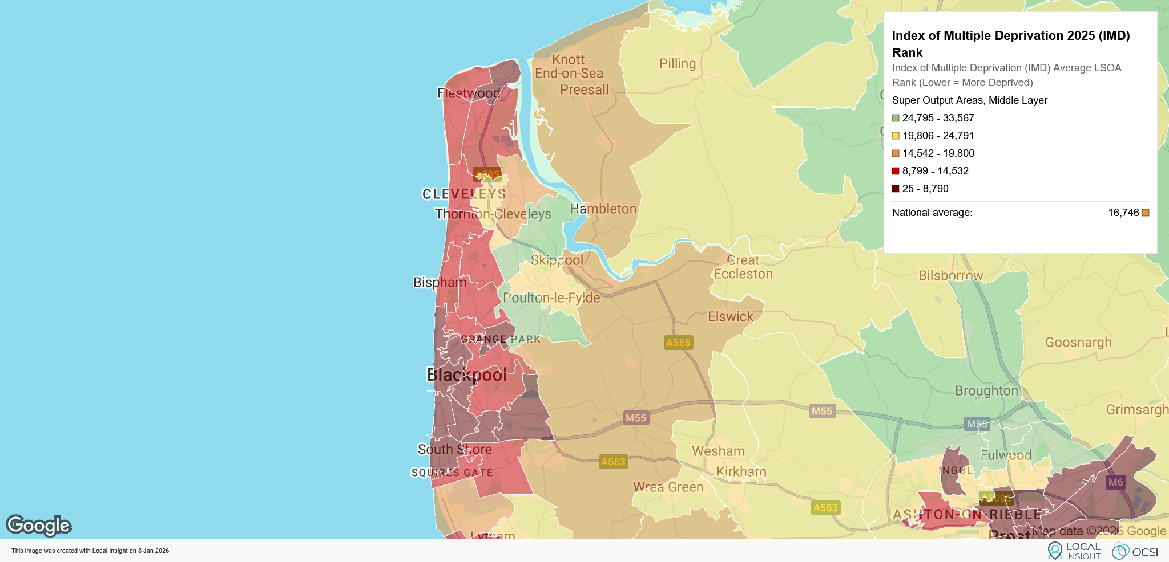
https://imd.localinsight.org/#/

  - Fleetwood Town small area profile (MSOA)

    - The profile below gives a summary of deprivation, housing, living environment and employment statistics for Fleetwood, which illustrates deprivation challenges in the town, as a sub-set of the overall Wyre area.

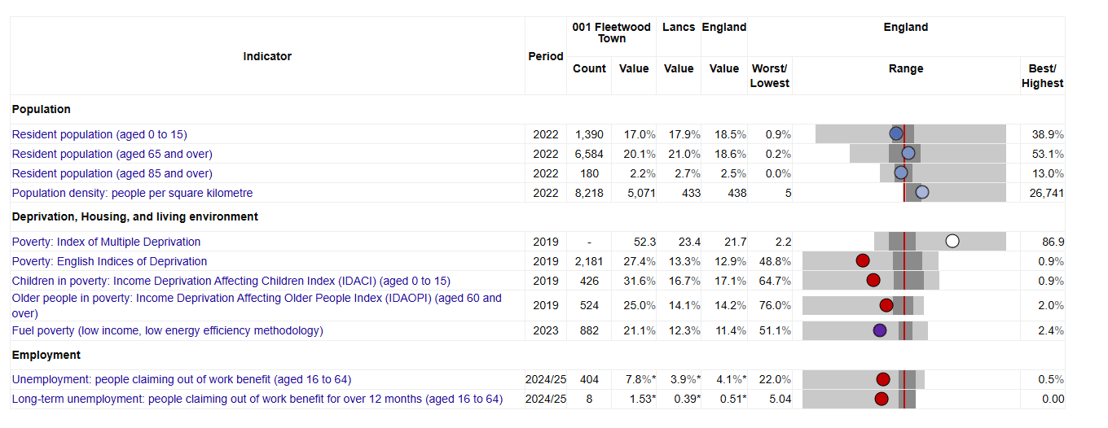

  - Blackpool central small area profile (MOSA)

    - The profile below gives a summary of deprivation, housing, living environment and employment statistics for Blackpool, highlighting many of the already well publicised challenges that impact on the town’s general and oral health.

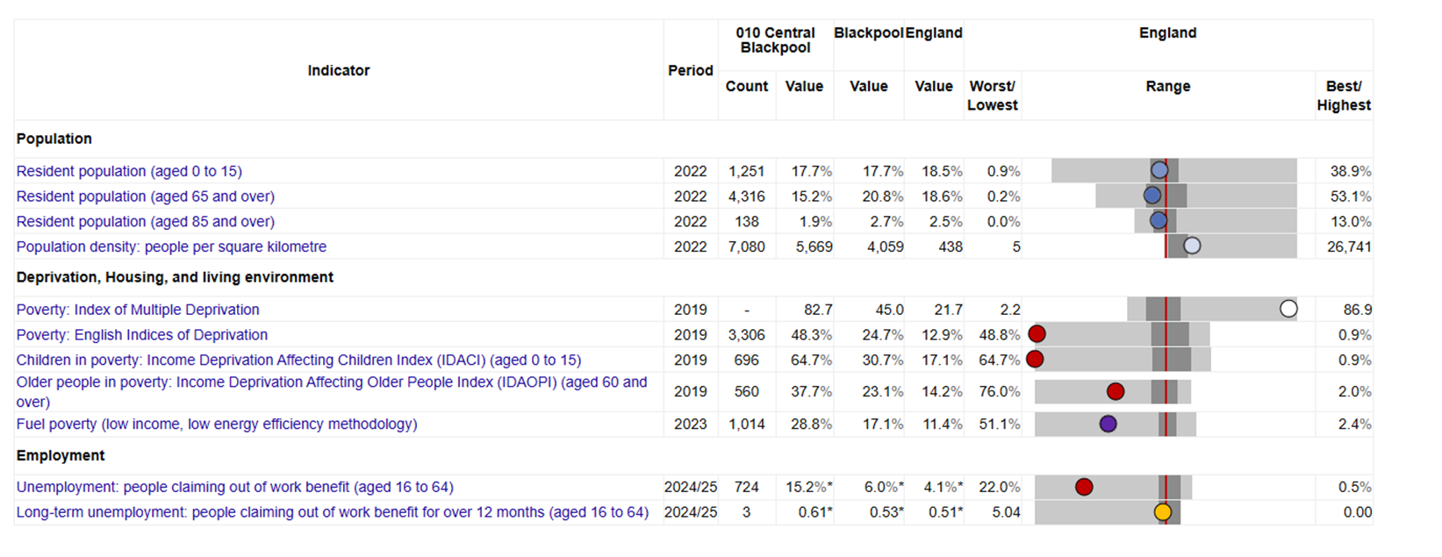

    - Populations in coastal areas experience lower life expectancy, high multimorbidity and major disease burdens and those factors correlate strongly with higher oral disease prevalence, including periodontal disease and dental decay. A higher oral disease burden is compounded by access inequalities, particularly where practices are not accepting new NHS patients.

    - Often deprivation is masked when surrounded by relative affluence “…deprivation and ill health at the coast is hidden by relative affluence just inland as the data is all lumped together” (Chief Medical Officer’s annual report 2021: health in coastal communities - GOV.UK), and the Fylde Coast has such pockets of deprivation (Fleetwood).

    - NHS dentistry suffers the same problem in that dentistry data (e.g., UDA delivery, access statistics) is not always meaningful when aggregated across mixed geographies. Small coastal towns with severe access issues are averaged out by larger inland areas.

    - There are also a higher number of older people living in coastal communities, who are more likely to have multimorbidity and polypharmacy, combined with heavily restored dentitions – meaning that their dental care is more complex and time consuming.

  - Transport Links

    - ‘Google Maps’ estimates that to drive from Fleetwood to central Blackpool would take 22 minutes. To travel by public transport is estimated to take 39 minutes by tram (Broad Water Station to North Station). To travel by bus is estimated to take 54 minutes.

    - Several areas within the ICB are visible as ‘hotspots’ where a large proportion of households in the Census 2021 reported they do not own a car or van (%). These include:

- Central Barrow in Furness (75.8%)
- Morecambe and Lancaster (65.4%)
- Central Blackpool (59.6%)
- Central Preston (53.3%)
- Central Blackburn (47.0%)
- Fleetwood Town (43%)
- Skelmersdale South East (40.2%)

- Review of dental service provision and access across the Fylde Coast

  - (Primary) General Dental Service Provision

    - The table below represents the recurrent contract hand backs received by the ICB, since the dental budget reset by NHS England in April 2022. The total figures for each area are then divided by the current populations size to calculate a £’s per head of population reduction in dental services for each area. The area that has had the largest amount of disinvestment in dental services is Blackpool, which is the equivalent of £12.88 per person living in the resort, followed by Wyre at £10.67 and then Fylde £9.33.

 | 2022 | 2023 | 2024 | 2025 | 2026 | Total | Reduction £ per head of Pop
Blackpool | £580,717 | £347,388 | £5,695 | £13,711 | £910,092 | £1,857,603 | £12.88
Burnley | £48,123 |  | £11,526 |  |  | £59,649 | £0.60
Chorley |  | £151,195 | £93,399 |  |  | £244,594 | £2.02
Fylde | £409,143 |  | £52,755 |  | £335,305 | £797,204 | £9.33
Ribble Valley |  |  | £9,940 |  |  | £9,940 | £0.15
Westmorland and Furness | £438,841 | £906,889 | £9,083 |  |  | £1,354,812 | £5.89
Wyre |  | £1,260,479 | £5,966 |  |  | £1,266,445 | £10.67
Total | £1,476,825 | £2,665,951 | £188,364 | £13,711 | £1,245,397 | £5,590,249
Table 1: Contract hand backs £s
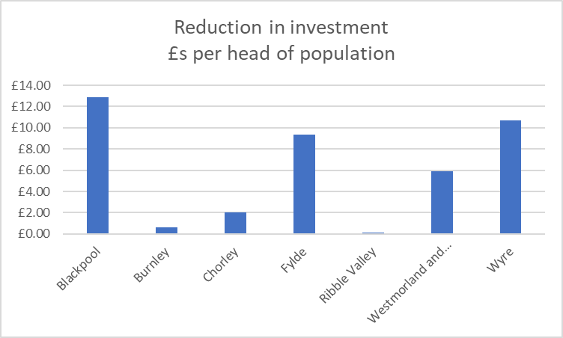
Table 3: Contract hand backs £s

    - Using a similar methodology, it is possible to equate the reduction in UDAs to illustrate what that means for each area in reduced dental access using a crude average of 3.5 UDAs per person. In this instance, again Blackpool has had the largest reduction in dental access by 15,718 patients followed by Wyre at 12,418 and then Westmorland and Furness at 12,215.

 | 2022 | 2023 | 2024 | 2025 | 2026 | Total | Equivalent in patient access
Blackpool | 15,170 | 11,194 | 200 | 450 | 28,000 | 55,014 | 15,718
Burnley | 1,830 |  | 400 |  |  | 2,230 | 637
Chorley |  | 4,334 | 2,504 |  |  | 6,838 | 1,954
Fylde | 6,000 |  | 1,850 |  | 7,034 | 14,884 | 4,253
Ribble Valley |  |  | 370 |  |  | 370 | 106
Westmorland and Furness | 14,450 | 28,003 | 300 |  |  | 42,753 | 12,215
Wyre |  | 43,312 | 150 |  |  | 43,462 | 12,418
Total | 37,450 | 86,843 | 5,774 | 450 | 35,034 | 165,551 | 47,300
Equivalent in patient access | 10,700 | 24,812 | 1,650 | 129 | 10,010 | 47,300
Table 2: Contract hand backs UDAs
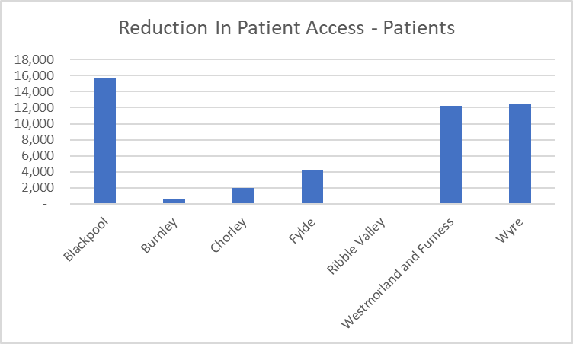
Table 4: Contract hand backs UDAs

    - For an area struggling with such chronic deprivation, reducing access to a core Primary Care NHS service will have a detrimental impact on the population. Blackpool is the only local authority area in Lancashire and South Cumbria where children’s oral health (as measured by the national epidemiology survey for 5-year-olds) has got worse instead of better, meaning unless an intervention is made a generation of children will grow up having poorer oral health than the previous.

  - Urgent Dental Service Provision

    - Call volumes received by the Lancashire and South Cumbria Call Handling Service for urgent presentations are detailed in the chart below (monthly average over a 12-month period). Blackpool and Preston are routinely the highest number of calls received, other areas on the Fylde Coast are highlighted as well.

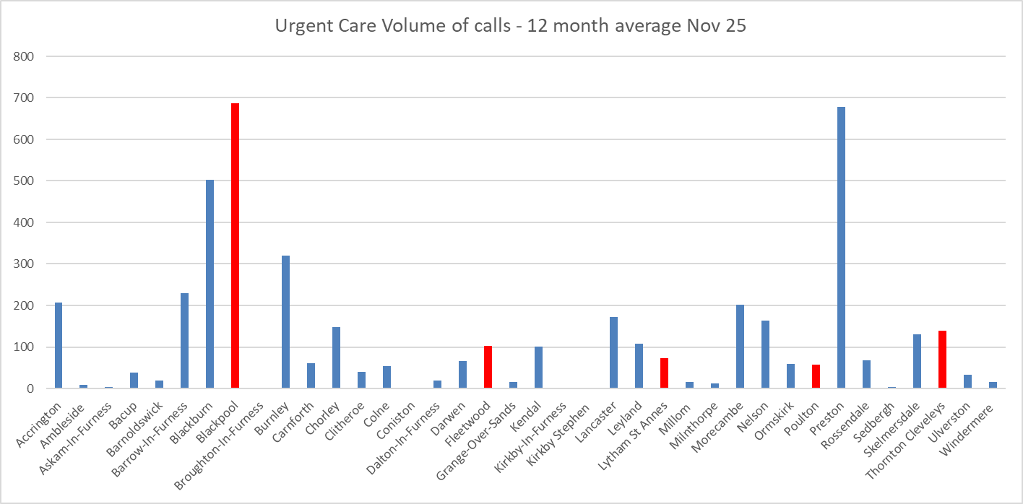
Table 5: Source FCMS Ltd
  - Dental Access

    - The source of the data below is NHSBSA’s dental data portal which is freely available and in the public domain. It covers data from 2019/20 to 2024/25, and the ICB has supplemented it with a bespoke data request bringing the access rates up to January 2026.

    - The figures represent the number of patients who access care expressed as a percentage of the population. The ‘recovery gap’ is the number of percentage points required to recover access to the 2019/20 access rate or pre-COVID figure.

    - Many of the areas have fully recovered child access, and for some access is now better than pre-COVID.

    - It is important to note that inequalities pre-date COVID and recovery to pre-COVID levels does not reduce those access inequalities.

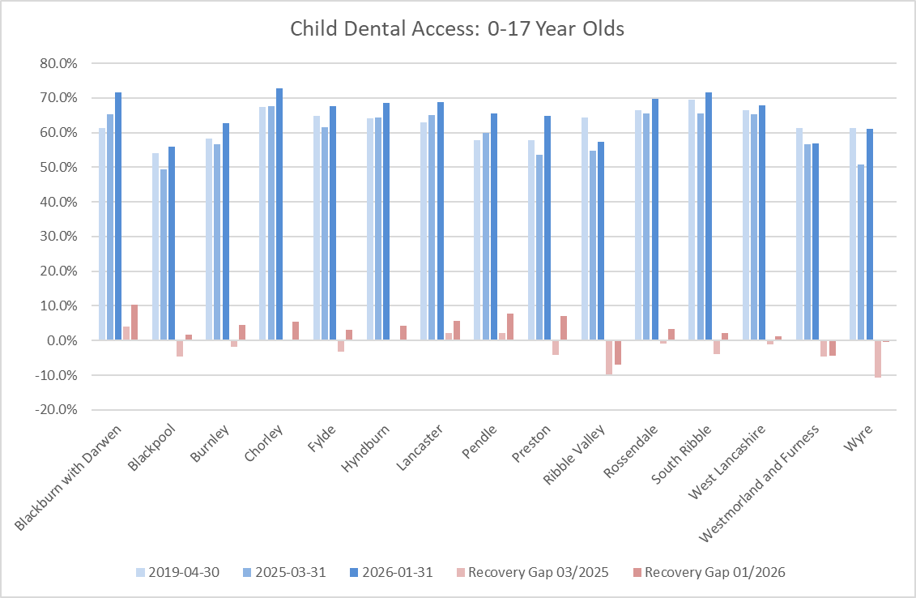
Table 6 Source NHSBSA

    - The table below is the data from which the above chart is derived and represents the % of 0–17-year-old child access.

 | 2019-04-30 | 2025-03-31 | 2026-01-31 | Recovery Gap 03/2025 | Recovery Gap 01/2026
Blackburn with Darwen | 61.4% | 65.4% | 71.6% | 4.0% | 10.2%
Blackpool | 54.1% | 49.5% | 55.9% | -4.6% | 1.7%
Burnley | 58.3% | 56.6% | 62.7% | -1.7% | 4.5%
Chorley | 67.3% | 67.6% | 72.7% | 0.3% | 5.4%
Fylde | 64.7% | 61.5% | 67.7% | -3.2% | 3.0%
Hyndburn | 64.2% | 64.4% | 68.6% | 0.2% | 4.3%
Lancaster | 62.9% | 65.0% | 68.7% | 2.1% | 5.8%
Pendle | 57.8% | 59.9% | 65.4% | 2.1% | 7.7%
Preston | 57.7% | 53.5% | 64.7% | -4.2% | 7.0%
Ribble Valley | 64.4% | 54.7% | 57.4% | -9.7% | -7.0%
Rossendale | 66.5% | 65.5% | 69.8% | -0.9% | 3.3%
South Ribble | 69.6% | 65.6% | 71.6% | -4.0% | 2.1%
West Lancashire | 66.5% | 65.4% | 67.8% | -1.2% | 1.3%
Westmorland and Furness | 61.3% | 56.6% | 56.9% | -4.7% | -4.3%
Wyre | 61.4% | 50.8% | 61.0% | -10.6% | -0.5%
Table 7: Source NHSBSA

    - Child access in Blackpool pre-COVID was the worst in Lancashire and South Cumbria and remains so today; even though access is higher than before COVID the figure remains lower than any of the other areas now or before COVID.

    - Adult access figures are drawn from the same source as the child data and have been calculated using the same methodology. They highlight a much slower recovery as well as the same inequalities in access. It is noticeable how the recovery gap is much bigger in Blackpool and Wyre compared with other areas (with the exception of the Ribble Valley).

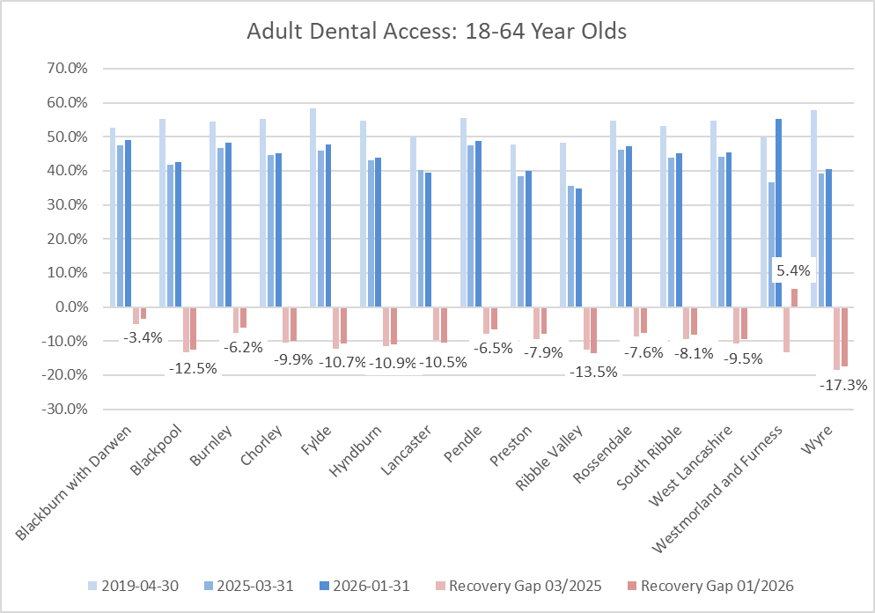
Table 8: Source NHSBSA

 | 2019-04-30 | 2025-03-31 | 2026-01-31 | Recovery Gap 03/2025 | Recovery Gap 01/2026
Blackburn with Darwen | 52.5% | 47.5% | 49.1% | -5.0% | -3.4%
Blackpool | 55.1% | 41.9% | 42.6% | -13.3% | -12.5%
Burnley | 54.5% | 46.8% | 48.3% | -7.7% | -6.2%
Chorley | 55.2% | 44.7% | 45.3% | -10.4% | -9.9%
Fylde | 58.3% | 46.0% | 47.7% | -12.4% | -10.7%
Hyndburn | 54.7% | 43.1% | 43.8% | -11.6% | -10.9%
Lancaster | 50.0% | 40.2% | 39.5% | -9.8% | -10.5%
Pendle | 55.4% | 47.5% | 48.9% | -7.9% | -6.5%
Preston | 47.8% | 38.4% | 39.9% | -9.4% | -7.9%
Ribble Valley | 48.2% | 35.6% | 34.8% | -12.6% | -13.5%
Rossendale | 54.7% | 46.1% | 47.1% | -8.7% | -7.6%
South Ribble | 53.2% | 43.8% | 45.1% | -9.4% | -8.1%
West Lancashire | 54.8% | 44.1% | 45.4% | -10.7% | -9.5%
Westmorland and Furness | 49.7% | 36.5% | 55.1% | -13.2% | 5.4%
Wyre | 57.9% | 39.3% | 40.5% | -18.6% | -17.3%
Table 9: Source NHSBSA
    - Wyre has the lowest access rate across Lancashire and South Cumbria, at 40.5%, prior to COVID it had the second highest access rate. Wyre’s recovery gap is 18.6%.

    - The final set of access data is for adults over 65 years of age, again drawn from the same source and calculated using the same methodology.

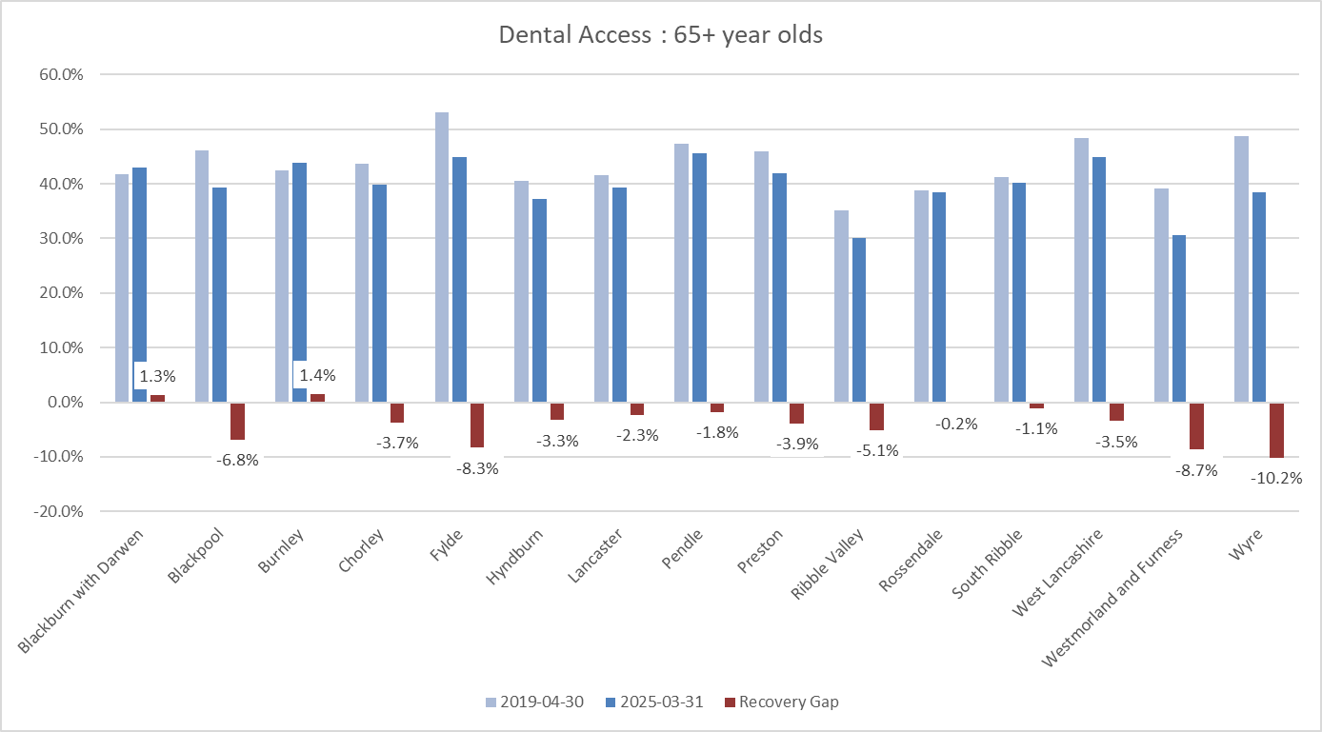

 | 2019-04-30 | 2025-03-31 | 2026-01-31 | Recovery Gap 03/2025 | Recovery Gap 01/2026
Blackburn with Darwen | 41.8% | 43.0% | 47.6% | 1.3% | 5.9%
Blackpool | 46.1% | 39.2% | 43.2% | -6.8% | -2.9%
Burnley | 42.4% | 43.8% | 50.1% | 1.4% | 7.7%
Chorley | 43.6% | 39.9% | 45.6% | -3.7% | 2.0%
Fylde | 53.2% | 44.9% | 51.7% | -8.3% | -1.5%
Hyndburn | 40.6% | 37.3% | 42.1% | -3.3% | 1.6%
Lancaster | 41.6% | 39.3% | 44.4% | -2.3% | 2.8%
Pendle | 47.3% | 45.5% | 50.7% | -1.8% | 3.4%
Preston | 45.9% | 41.9% | 47.8% | -3.9% | 1.9%
Ribble Valley | 35.2% | 30.0% | 35.0% | -5.1% | -0.1%
Rossendale | 38.7% | 38.5% | 45.2% | -0.2% | 6.4%
South Ribble | 41.3% | 40.2% | 46.1% | -1.1% | 4.8%
West Lancashire | 48.3% | 44.9% | 51.0% | -3.5% | 2.7%
Westmorland and Furness | 39.2% | 30.5% | 35.2% | -8.7% | -4.0%
Wyre | 48.6% | 38.5% | 43.1% | -10.2% | -5.5%

    - Dental access rates mirror the investment in geographies, and both sets of figures highlight significant inequity of resources available to populations. It is important to note that good dental access does not necessarily mean that residents will have good oral health. Child epidemiology data for 5-year-olds shows that poor oral health does not always correlate with poor access and vice versa.

    - NHS dental access for all residents, within the current regulatory and contractual framework is not possible with the resources available. There is also broad agreement across the dental profession that 100% access coverage would not lead to zero oral health problems. The ICB commissioning strategy is based on a hierarchy of patient clinical need.

    - Until there is greater investment and a change in the national contract, local commissioners will have to continue to decide which members of their respective populations will have access to NHS care and which will not.

- Prioritisation Framework

  - One of the projects within the Dental Access and Oral Health Improvement Programme was the development of a prioritisation of resources framework. The aim of the project was to outline how resources can be prioritised for specific geographies/patient groups based on objective measures or indicators. The project builds on the established Equident toolkit that was developed by dental public health consultants within the North West to support equitable commissioning of dental care services. This approach was shared nationally and published in the British Dental Journal In Practice. Thus, the preliminary stage of this project was to develop a set of indicators to populate the prioritisation framework.

  - The indicators are grouped into broad domains:
  - Access – expressed as a percentage of the population who access care using the national access metric.
  - Access Availability – the value and volume of primary care dental resources that are invested in an area to provide access to dental care.
  - Disease Prevalence – a set of data which gives an indication of the disease burden in a particular geography.
  - Deprivation – poor oral health, like many aspects of health are linked to deprivation.
  - Public Health: wider determinants – aspects of health which impact on oral health

  - A full list of indicators and their descriptions is provided in appendix 2.

  - The outcome of the project ranks areas within the Lancashire and South Cumbria footprint in terms of greatest need when considering resource allocation. The table below illustrates the rankings:

Area | Rank Based on All Indicators
Barrow-in-Furness** | 1
South Lakeland** | 11
Blackburn with Darwen | 8
Blackpool | 2
Burnley | 4
Chorley | 16
Fylde | 14
Hyndburn | 6
Lancaster | 3
Pendle | 7
Preston | 4
Ribble Valley | 12
Rossendale | 9
South Ribble | 13
West Lancashire | 15
Wyre | 10
Table 10: The current priority framework ranking of areas, refreshed in early 2025
  - This demonstrates that Blackpool is ranked 2 in terms of greatest need. Fleetwood is located within the Wyre area, and whilst this is ranked as 10, Fleetwood is an outlier within the Wyre area in terms of deprivation as outlined in section 6.
  - Please note that Cumbria Local Authorities changed and it is no longer possible to access public health data at the Local Authority District level for Barrow-in-Furness and South Lakeland (as they don’t exist as local government entities). However, when data was available at that level, Barrow was highlighted as a key priority area for investment.

  - The dental prioritisation framework attempts to define clinical need using proxy measures. While not perfect, it does reflect long established commissioning intentions and backs up the arguments for investing in higher need areas using objective measures to do so.

- Patient and Public Views

  - The Fylde Coast Dental Access Listening to Communities report is attached as appendix 3.

  - A summary of the findings is detailed below:

Public feedback shows a clear and consistent picture: access to NHS dental services is extremely limited and, for many people, effectively unavailable. The dominant concern is not the quality of care, but the absence of NHS dentists accepting new patients, particularly across Blackpool, Fylde and Wyre.

Many respondents described NHS dentistry as ‘non-existent’ or ‘impossible to access’, especially for new residents, people whose practices have closed, and those returning to the area after study or illness. Access is widely seen as a matter of luck or longstanding registration, rather than need. Those registered many years ago often continue to receive regular care, while others report trying unsuccessfully for years to find an NHS dentist.
There is strong perception of a shift from NHS to private dentistry, driven by poor NHS remuneration.

Respondents believe NHS trained dentists are moving into private practice, with NHS provision reduced to limited sessions or phased out altogether. This has left many people reluctantly paying for private care or going without dental treatment entirely.

Cost is a major barrier, particularly for pensioners, low-income households, disabled people, carers, and young adults. Many described delaying treatment due to affordability, resulting in worsening dental health, pain, extractions, and dentures. Where NHS dentists are available, they are often far from home, difficult to reach by public transport, and inaccessible for people with health conditions or disabilities.

People also reported poor information and communication, with no clear way to identify practices accepting NHS patients or to know when places become available. The impact on people with disabilities, anxiety, autism, or complex health needs was particularly stark, with inflexible systems, lack of reasonable adjustments, and distressing experiences reported.

Overall, the feedback is clear: availability must be addressed first. Respondents repeatedly state that service improvements are meaningless without sufficient NHS dental capacity, workforce, and access.

- Barriers to Accessing Dental Care and Alternative Service Models

  - A range of published literature is available on barriers and facilitators to dental attendance and dental service utilisation in high-need groups (PHE 2021, Harris et al 2017, Dyer et al 2023, Currie et al 2021, Raison et al 2018).

  - Identified barriers include:

- costs (direct, and indirect such as transport and time off work)
- dental anxiety / low confidence and self-esteem
- shame regarding condition of mouth and teeth
- physical, communication, or transport barriers
- lack of awareness of NHS dental charge exemptions and perceived lack of need (low health literacy)
- lack of social support to attend
- limited availability of suitable services designed for high-need groups
- lack of confidence and training of dental professionals in treating patients from vulnerable groups
- previous bad experiences with negative attitudes of dental staff / distrust
- difficulty taking time off from work or carer responsibilities
- lack of knowledge among carers and other health, social, education or community services about key oral health messages and ways to access dental services

  - Suggested ways of overcoming barriers to care included:

- provision of appropriate training to both service users and care providers
- policies to ensure dental services meet the needs of vulnerable people
- the use of appropriate skill-mix to deliver services (consider outreach / in-reach partnerships)
- integration between dental and other health, social, education or community, voluntary services e.g. dental team establishing relationships with other stakeholders/health professionals
- provision of information in a range of formats designed with health literacy in mind and Easy Read
- flexibility in appointment scheduling / drop-ins
- contractual arrangements to allow for additional time to accommodate needs
- making allowances for challenging lifestyles
- good interpersonal skills in the whole dental team to build trust
- involvement of service users and providers in service planning

  - In addition to published research, a request was made to colleagues in other areas of the country for recent experiences of designing dental services for high-need groups. In the West and East Midlands, a ‘Dental Equity premium’ is in place. In this programme, areas within the ICB were ranked in terms of ‘investment priority’ based on an equity audit (similar approach to Equident prioritisation framework described in section 8). Existing practices closest to the highest priority areas were invited to submit expressions of interest to deliver additional activity. An inequality premium of £5.52 was added to the average UDA price across the ICB, for this additional commissioned activity. Practices were expected to work with local Healthwatch, the dental triage line, and Local Authority services to receive patients with the highest needs (similar to the paediatric dental access pathway in LSC). West Midlands colleagues assigned £1.8m to the scheme across 10 providers, commissioning an additional 50,000 UDAs. Colleagues report the scheme as being successful in increasing access, reducing urgent care demand, and has been well received by providers and patients.

- Service Model for the Fylde Coast

  - As already mentioned, the current national General Dental Services contract disincentivises providing care for residents in areas of high deprivation.

  - If the outcome of this review results in agreement to invest resources into the Fylde Coast it is recognised that an alternative model of dental care and associated contracting should be explored. During the research and writing of this report considering factors such as the population of the Fylde Coast, barriers to accessing NHS dental care and seeking to ensure the service is viable for providers, a ‘hybrid’ model emerged.

  - The hybrid model would effectively offer any resident of the Fylde Coast the opportunity to access either a simple check-up, course of treatment or urgent care when they seek to do so without being ‘registered’ with a practice and without the usual recall intervals.

  - The contracting mechanism would flex and potentially include salaried sessions and a nominal UDA value for materials. Please note that the recommendations include establishing a small focus group with clinicians to seek views and develop this further.

- Finance

  - The table below illustrates the current investment into the different areas of Lancashire and South Cumbria. This is shown by the number of UDAs, the contract values and how that translates to ‘per head of population.’

2024/25 | UDAs | Contract Values | UDAs per head of population | £ per head of population | UDAs per patient treated
Blackburn with Darwen | 294370 | £9,810,959.51 | 1.90 | £63.32 | 3.48
Blackpool | 209489 | £6,486,836.81 | 1.49 | £46.01 | 3.35
Burnley | 142470 | £5,697,187.87 | 1.50 | £60.14 | 2.92
Chorley | 191515 | £6,279,610.02 | 1.62 | £53.26 | 3.22
Fylde | 132336 | £4,412,965.37 | 1.62 | £53.98 | 3.17
Hyndburn | 135882 | £4,319,459.60 | 1.65 | £52.50 | 3.32
Lancaster | 189107 | £5,589,833.27 | 1.33 | £39.27 | 2.88
Pendle | 179094 | £6,411,070.78 | 1.87 | £66.91 | 3.54
Preston | 236321 | £7,406,878.73 | 1.60 | £50.12 | 3.54
Ribble Valley | 56370 | £1,944,610.10 | 0.92 | £31.68 | 2.24
Rossendale | 81229 | £2,341,787.69 | 1.14 | £32.98 | 2.24
South Ribble | 129702 | £4,001,802.45 | 1.17 | £35.99 | 2.33
West Lancashire | 192758 | £7,022,877.15 | 1.65 | £59.97 | 3.23
Westmorland and Furness | 240526 | £8,113,642.94 | 1.06 | £35.75 | 2.68
Wyre | 197127 | £6,592,915.77 | 1.75 | £58.64 | 3.99
Table 11 Current commissioned routine dental access values and volumes.
  - Further work is required to better understand how NHS BSA is counting patients treated in Westmorland and Furness, due to the political boundary changes.

  - Accepting the affluence in the Ribble Valley (no ‘core20’ neighbourhoods) compared to Blackpool (65% of residents live in a ‘core20’ neighbourhood), the investment in terms of funding shows how significant the investment inequalities are. Also, considering Pendle has the highest £s per head of population and the largest number of UDAs, its children have the worst oral health in the North of England and the third worst in the country.

  - Reinvesting all of the contract hand backs from Blackpool into Blackpool would not bring its £s per head of population up to that of Wyre and would still leave it far short of Blackburn with Darwen, Pendle and Burnley. Considering the emerging evidence linking overall health and oral health, and the chronic health and mortality rates in Blackpool plus the evidence of need being 2 to 3 times greater in deprived areas, there is a compelling argument to invest a significant amount of resource into the Blackpool area.

- Conclusion

  - Access recovery remains a priority nationally and locally. The recovery gap is much greater in Blackpool and Wyre compared to other areas of the ICB. Child access to dental care is worse in Blackpool than any other area of Lancashire and South Cumbria and Wyre has the lowest access rate overall.

  - This report illustrates that Blackpool has suffered the largest disinvestment due to contract hand-backs since April 2022 equating to £12.88 per head of population. Wyre is the second highest at £10.67 per head of population. Nationally funding allocations for dental care only cover 50-60% of the population which means the ICB has a duty to ensure funding is invested in those areas of greatest need.

  - This report demonstrates that Blackpool and Fleetwood have some of the highest levels of deprivation and provides evidence that people living in these areas have worse oral health and higher need.

  - Patient and public engagement shows public experience and perception as negative, and demonstrates for many people living in those areas, dental care is simply unavailable.

  - The report outlines the start of a bespoke model of dental care for this area and cohort of patients.

  - Further work is required particularly around an evidence-based investment model, clinically informed model of delivery, improving communication around urgent care and further analysis of Westmorland and Furness data.

- Recommendations

  - Members of the Primary Care Contracts Sub-Committee are asked to:

    - Review the completed report that is circulated for comment
    - Accept the contents of the report
    - Agree the following pieces of follow-up work (April to June inclusive):
      - Develop a coherent evidence-based and transparent rationale for allocation of the available investment.
      - Seek feedback on the model from the profession, engage with clinical teams/local authority to co-design via focus groups.
      - Strengthen a communication plan to increase access to information regarding urgent dental care to minimise the number of people in pain.

- Appendices

Appendix
1 | Access recovery trends
2 | Prioritisation framework indicator descriptions
3 | Patient and public engagement report
4 | Equality and health inequalities impact risk assessment (EHIIRA)

Appendix 1 – Access Recovery Trends (Actual Attends)

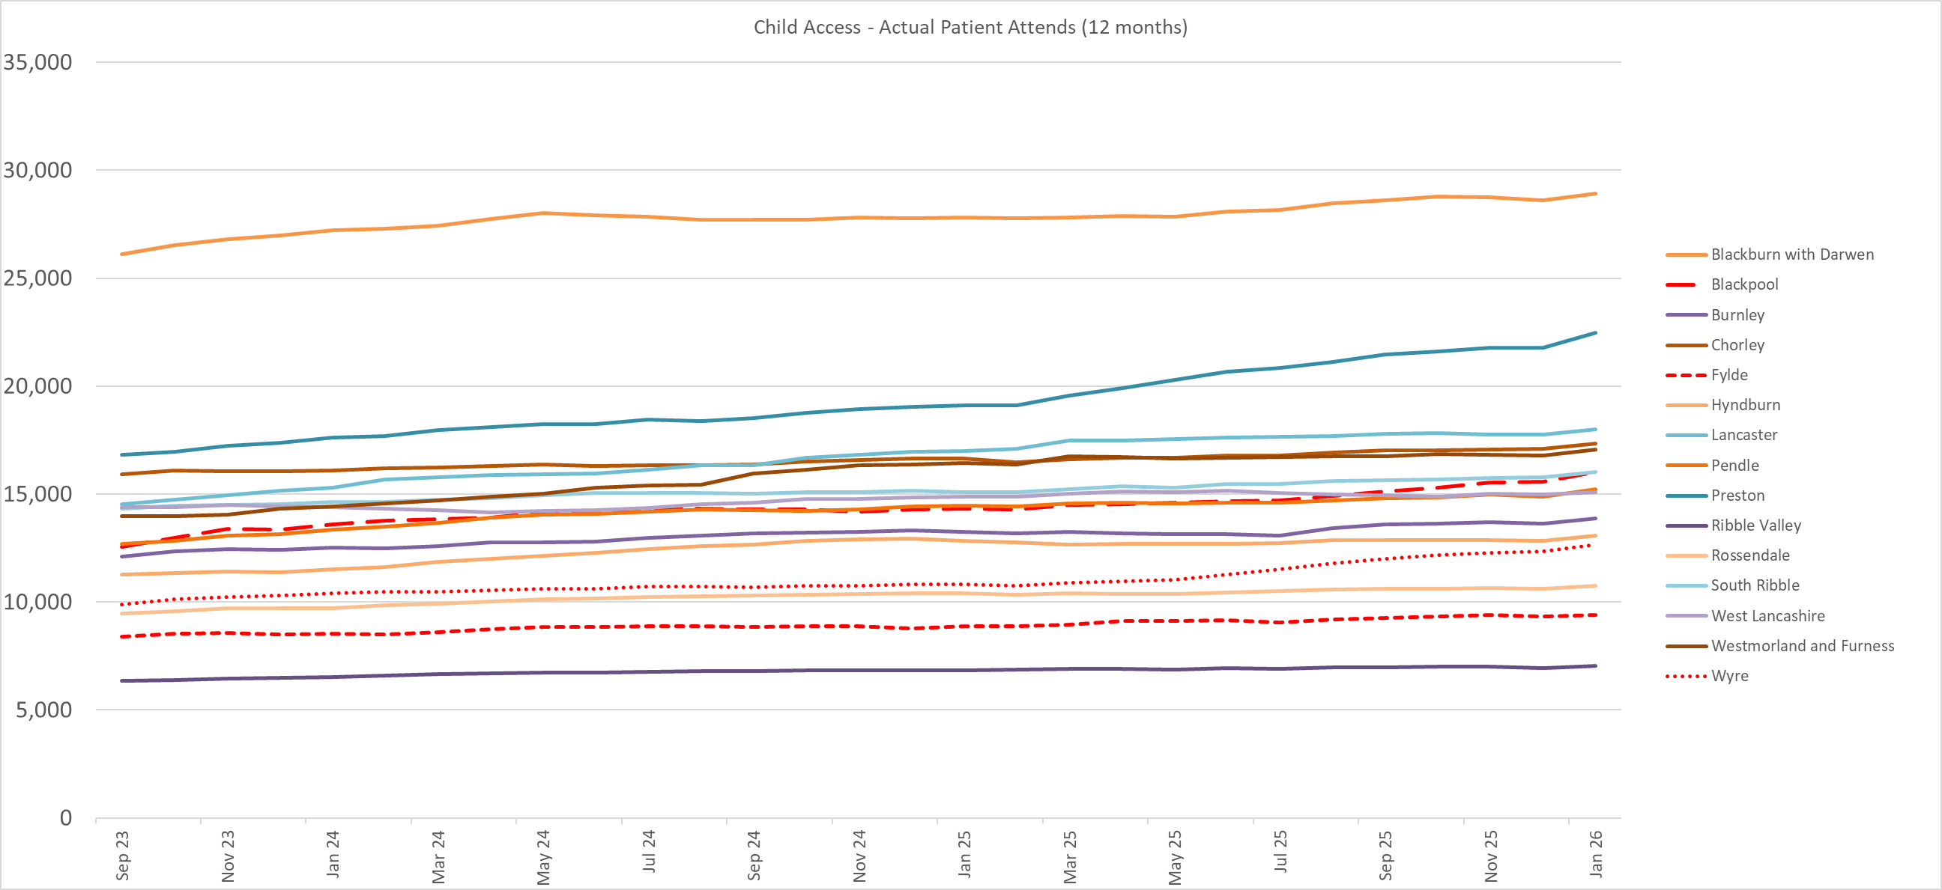

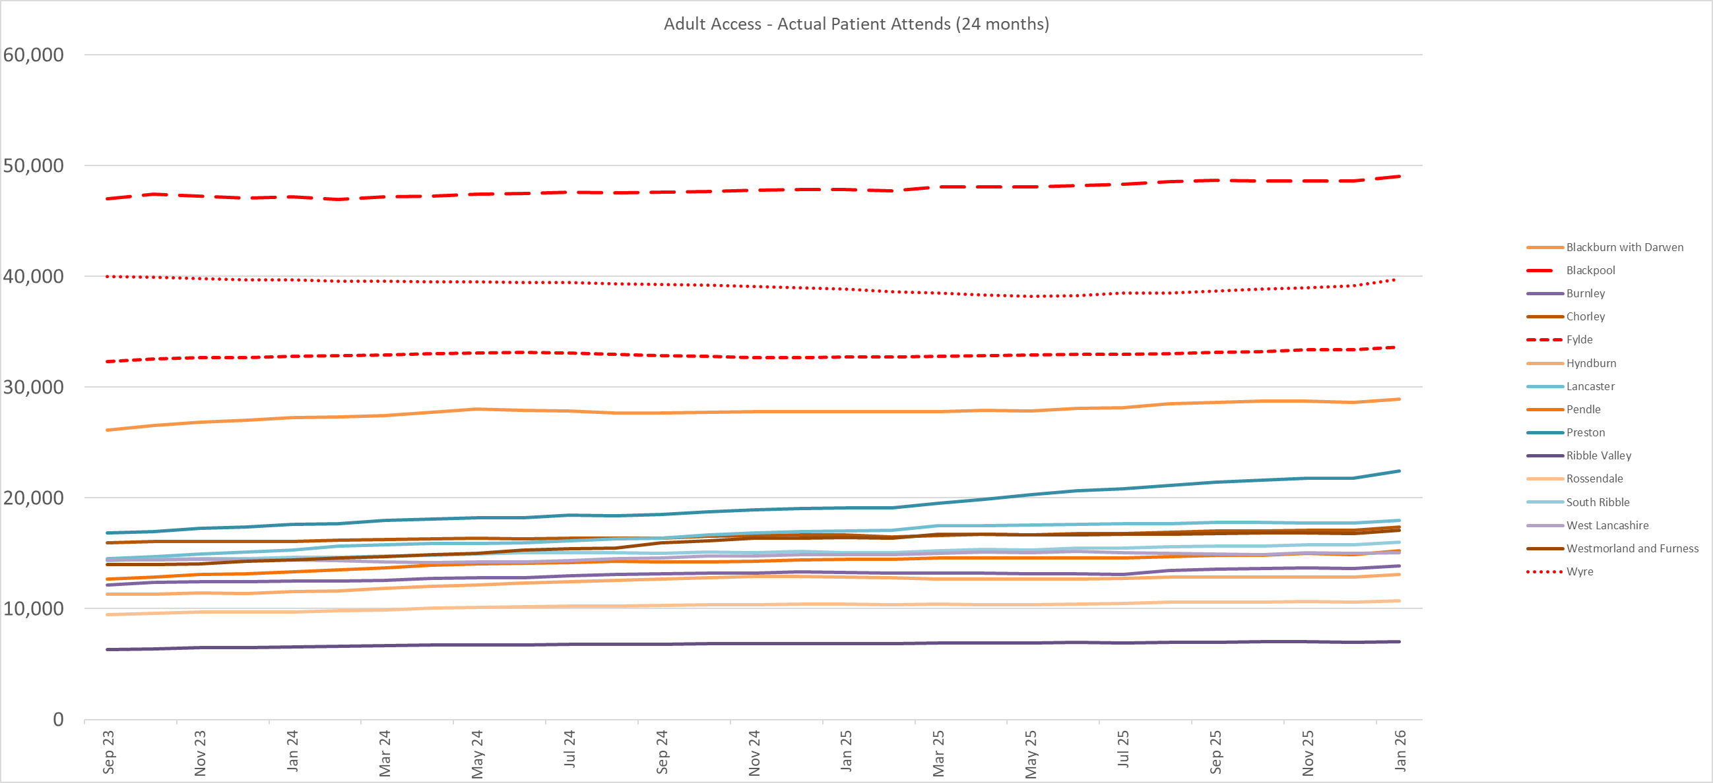

Appendix 2

Indicator Descriptions
Dental Access
The national measure for dental access is the number of patients resident in a geography who have attended a dental practice in the previous 24 months for adults or 12 months children. The figure is a unique count, which means that patients who have attended multiple times will only count once in the given time frame.

Child (0-18yrs)
The percentage of children who have attended a dental practice in the previous 12 months.
Adult (18+yrs)
The percentage of adults (18 years of age and over) who have attended a dental practice in the previous 24 months.
Adult (Over 65yrs)
The percentage of adults (65 years of age and over) who have attended a dental practice in the previous 24 months.

Access Availability
These two availability indicators are calculated by using the information that relates to ICB commissioned primary care dental services in each of localities. This is for routine dental care, and not any of the specialist commissioned pathways. Primary care dental service providers are commissioned to deliver a volume of activity measured in ‘Units of Dental Activity’ or ‘UDAs’ for a fixed contract value.
2022/2023 £s invested in routine dental services per head of resident population
The amount of funding in routine dental service contracts expressed as a £’s per head of population.
UDAs per head of resident population
The number of units of dental activity (UDAs) per head of resident population.

Disease Prevalence
Each of these indicators provide an indication of the level of disease present in each of the geographies.

Prevalence of dental decay in 5-year-olds (dmft)
The dmft (decayed, missing and filled primary teeth) and DMFT (decayed, missing, and filled permanent teeth) are commonly used and valuable indices for determining and monitoring the oral health status of a population. The proportion of a population affected by dental decay as measured by the dmft/DMFT index is used as a standard to compare dental health in many age groups, but is most used for children aged 5, 12, or 15yrs.
The prevalence of dental decay measured by the dmft for 5-year-olds is used within the prioritisation matrix, with data accessed from the sixth National Dental Epidemiology Programme survey of 5-year-old children in England, 2022.
Dental caries is the most common non-communicable disease worldwide, and these indices provide an indication of the levels of poor oral health in a specific area or population. Higher dmft indicates children with more experience of tooth decay and poorer oral health. The dmft index is also linked to levels of deprivation, with children in deprived areas experiencing three times the level of decay, than those in the least deprived areas.
Further details can be found at https://www.gov.uk/government/statistics/oral-health-survey-of-5-year-old-children-2022/national-dental-epidemiology-programme-ndep-for-england-oral-health-survey-of-5-year-old-children-2022

Urgent Care
Urgent dental care is defined as patients who are in immediate need of support for dental trauma, swelling, bleeding or pain relief. The majority of calls to the ICB urgent dental care phone line are patients who are symptomatic and in pain. Toothache comes in two main forms, a tooth problem relating to dental decay which can cause severe pain and/or swelling, or a gum problem causing infection pain and swelling. Both are an indicator that there is an incidence of disease in the callers mouth.
Urgent care calls (per 1,000 residents of population)
The ICB commissions a call handling service the books patients into appointments for urgent dental care. The service is available to patients who have an urgent need and cannot current access a dental practice of their own. Many of the callers do not have an ongoing relationship with a dental practice. The service interfaces with ‘111’ and the calls are triaged and mapped to specific geographies.
Urgent courses of dental care (as percentage of population)
When a dental practice treats a patient for an urgent intervention, unless there is follow up care required, they will normally submit a claim for the UDAs associated with a ‘Band 1 Urgent’ treatment. This data is made available to the ICB from NHSBSA and can be mapped to the patients post code.

Deprivation
Index of Multiple Deprivation (IMD)
This is the main Index of Multiple Deprivation (IMD) summary measure. It is presented as a score and is a weighted average of the seven IMD domains: Income Deprivation, Employment Deprivation, Health Deprivation and Disability, Education Skills and Training Deprivation, Barriers to Housing and Services, Living Environment Deprivation, and Crime. The more deprived an area, the higher the IMD score.
This data is from the Department of Levelling Up, Housing & Communities. Further detail on IMD can be found at the following link: https://www.gov.uk/government/collections/english-indices-of-deprivation
This indicator is included as there is clear evidence of the link between levels of deprivation and poor oral health in both adults and children. Those from deprived areas are disproportionately more affected by dental disease, have higher rates of hospital admissions for tooth decay in children aged 6-10, and poorer uptake of general dental services than those from less deprived areas.

Children in Poverty: Income Deprivation Affecting Children Index (IDACI)
This indicator is a measure of children living in poverty. The Income Deprivation Affecting Children Index (IDACI) measures the proportion of all children aged 0-15years living in income deprived families.
This data was published in 2019 and is sourced from the Ministry of Housing, Communities and Local Government. Further information regarding the IDACI can be found at: https://www.gov.uk/government/collections/english-indices-of-deprivation-2019
Growing up in poverty is harmful to children’s health and well-being, adversely affecting their future health and life chances. A considerable body of evidence links deprivation during childhood to both poor child oral health outcomes and future poor adult oral health.

Older people in poverty: Income deprivation affecting older people Index (IDAOPI)
This indicator is a measure of older people living in poverty. The Income Deprivation Affecting Older People Index (IDAOPI) measures the proportion of all those aged 60 or over who experience income deprivation. It is a subset of the Income Deprivation Domain which measures the proportion of the population in an area experiencing deprivation relating to low income.
This data was published in 2019 and is sourced from the Ministry of Housing, Communities and Local Government.
Although there are no national targets the Government aims to tackle poverty and promote greater independence and well-being in later life. People living in more deprived areas have a greater need for health services, with evidence identifying poorer oral health in areas of higher deprivation.

Public Health - wider determinants

Older adults with a limiting long-term health condition
This indicator is a measure of all older adults over the age of 65 years, with a limiting long-term health condition, which limits day to day activities. This is expressed as a proportion of the entire over 65 years population.
This data is from 2023 and is extracted from the POPPI database (Projecting Older People Population Information). Figures are taken from the Office for National Statistics (ONS) 2011 Census, with projections calculated by applying percentages of people with a limiting long-term illness in 2011 to projected population figures. More information can be found at: https://www.poppi.org.uk/

There is evidence to suggest a link between long-term health conditions in older adults and poorer levels of oral health. Furthermore, having a long-term health condition can also lead to limitations and barriers in accessing dental care services, in terms of mobility and the ability to attend dental appointments.
Older adults: need assistance with at least one self-care activity
This indicator is a proportional measure of the total population aged 65 and over who need help with at least one self-care activity. These include activities such as: dressing; washing hands and face; eating, including cutting up food; taking medicine; getting in and out of bed. Whilst toothbrushing is not specifically listed as one of the activities, it can be inferred that this population would likely demonstrate difficulties with oral self-care.
This data is from the POPPI database (Projecting Older People Population Information). Figures are taken from the Health Survey for England 2016: Social care for older adults (2017) NHS Digital. More information can be found at: https://www.poppi.org.uk/
Reduced ability to manage self-care tasks is linked to poorer oral health in older adults. This may be due to limited manual dexterity and mobility affecting toothbrushing activities leading to increased risk of tooth decay and gum disease, and/or a poorer diet, which predisposes to dental decay

Appendix 3
Dan Clough
dan.clough@nhs.net

Dan Clough
dan.clough@nhs.net

Contents

Introduction 2
Executive summary 2
Who have we heard from? 3
How many people got involved? 3
How did we speak to people? 3
Public engagement sessions 3
Survey 3
What did we hear? 7
Public drop-in sessions 7
Survey: Have you tried to access NHS dental services in the past two years? 8
Survey responses: (If answered ‘yes’) Which of the following best describes what happened? 9
Survey responses: (if answered ‘no’ to first question) Please tell us the reason you have not attempted to access NHS dental services 10
Survey responses: Have you previously attended an NHS dentist, but no longer do now? 11
Survey responses: (If answered ‘yes’ to previous question) Which of the following best describes why you no longer attend? 12
Survey responses: In the past two years, have you needed to access urgent dental care? 12
Survey responses: (If answered ‘yes’) On that occasion, what did you do? 13
Survey responses: Thinking about accessing NHS dental services, what would make it easier for you to attend? (Tick all that apply) 13
Survey responses: Please provide any comments you would like to make about access to NHS dental services on the Fylde Coast 15

Introduction

The Fylde Coast has historically been an area where dental services have faced challenges. The region has some of the most deprived areas in the country and getting support to people in those areas has often proved problematic.

During the COVID pandemic, access to dentistry services plummeted as many procedures became unavailable due to the risk of spreading the virus and practices had to close for many months. Since the pandemic came to an end, access figures have recovered across Lancashire and South Cumbria in all areas except for the Fylde Coast.

This issue has led to the ICB dental team looking to develop a programme of work to support dental access recovery across Blackpool, Fylde and Wyre.

To support this work, the communications and engagement team has led on a targeted engagement exercise to understand people’s experiences of access to NHS dental services across the Fylde Coast and to gain an insight into people’s perceptions of services as well as whether they feel able to access the support they need, when they need it.

Executive summary

Public feedback shows a clear and consistent picture: access to NHS dental services is extremely limited and, for many people, effectively unavailable. The dominant concern is not the quality of care, but the absence of NHS dentists accepting new patients, particularly across Blackpool, Fylde and Wyre.

Many respondents described NHS dentistry as ‘non-existent’ or ‘impossible to access’, especially for new residents, people whose practices have closed, and those returning to the area after study or illness. Access is widely seen as a matter of luck or long-standing registration, rather than need. Those registered many years ago often continue to receive regular care, while others report trying unsuccessfully for years to find an NHS dentist.
There is strong perception of a shift from NHS to private dentistry, driven by poor NHS remuneration.

Respondents believe NHS-trained dentists are moving into private practice, with NHS provision reduced to limited sessions or phased out altogether. This has left many people reluctantly paying for private care or going without dental treatment entirely.

Cost is a major barrier, particularly for pensioners, low-income households, disabled people, carers, and young adults. Many described delaying treatment due to affordability, resulting in worsening dental health, pain, extractions, and dentures. Where NHS dentists are available, they are often far from home, difficult to reach by public transport, and inaccessible for people with health conditions or disabilities.

People also reported poor information and communication, with no clear way to identify practices accepting NHS patients or to know when places become available. The impact on people with disabilities, anxiety, autism, or complex health needs was particularly stark, with inflexible systems, lack of reasonable adjustments, and distressing experiences reported.

Overall, the feedback is clear: availability must be addressed first. Respondents repeatedly state that service improvements are meaningless without sufficient NHS dental capacity, workforce, and access.


Who have we heard from?

How many people got involved?

Around 100 people were engaged face-to-face during events in Blackpool and Fleetwood.

164 completed responses to the survey were received, including online and paper copies.


How did we speak to people?

Public engagement sessions

In order to engage with people living in some of the more deprived areas of the Fylde Coast, the ICB team attended groups in Blackpool and Fleetwood to have face-to-face conversations with local residents. The team attended:
- 10 March 2026: Young at Heart friendship group, Fleetwood Library – around 15 attendees
- 10 March 2026: Harmony and Health singers, Marine Hall, Fleetwood, around 45 attendees
- 17 March 2026: SPARKS Network, Tarnside Community Centre, around 35 attendees

Survey

An online survey was developed and promoted via the ICB’s Citizens Panel and social media. The survey was live from Wednesday 4 to Tuesday 24 March 2026.

Respondents came from:

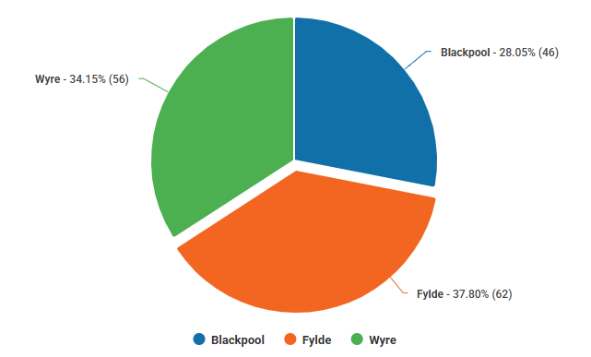

As part of the survey, demographic data was captured. Around 91 per cent (150) of respondents agreed to provide this data. The responses, detailing who responded to the survey, are below:

Age
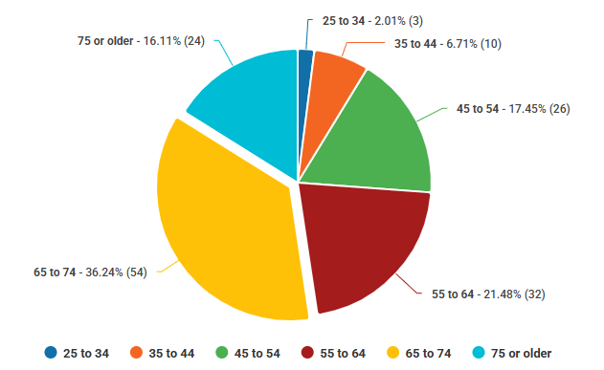
Gender
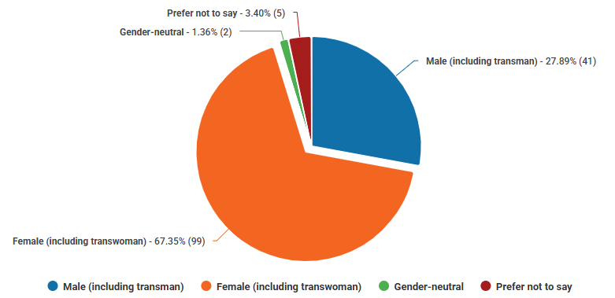

Ethnicity
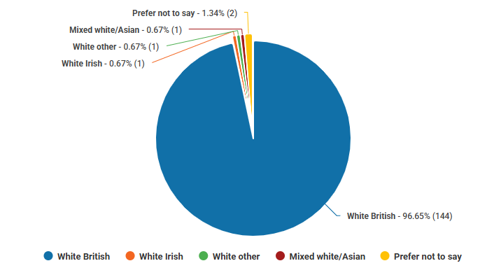
Disability
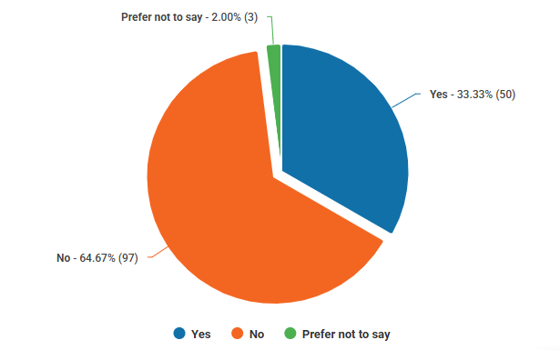

Carer
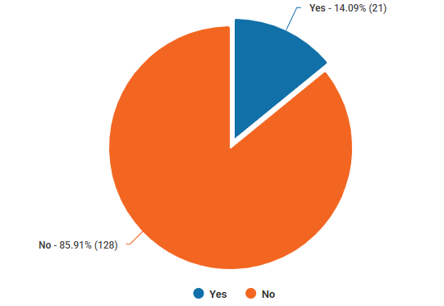


What did we hear?

Public drop-in sessions

Below is a summary of the comments made during face-to-face conversations:

Access to NHS dentistry
Many people reported significant difficulty accessing an NHS dentist, with a widespread perception that there is no NHS dentistry available. Some no longer try to register at all.
A common experience was being removed from NHS lists during the COVID pandemic and not being reaccepted or only being offered care if they paid privately.
Several people described practices advertising as NHS but then saying they were not accepting NHS patients, offering only private treatment.
Once people are removed from a list, they find it extremely hard to regain access, often leading to long gaps without care or reliance on emergency services only.
There were concerns about rigid appointment policies, with people feeling threatened with removal if they missed appointments, without consideration of barriers such as caring responsibilities, anxiety, transport or cost.

Cost as a major barrier
Cost emerged as one of the strongest and most consistent themes.
Many attendees are paying for private dental care, typically £40–£50 per month on dental plans or several hundred pounds per visit when treatment is needed.
Some people reported being unable to afford NHS charges, such as £300 for dentures or tooth extractions.
Pensioners, people on low incomes, and younger people on benefits highlighted as being particularly affected.
Several people described long-term consequences of unaffordable care, including missing teeth, reliance on dentures and impacts on confidence, wellbeing, and employment prospects.
There was limited understanding of financial support, exemptions and help with NHS dental charges.

Emergency and urgent dental care
Awareness of urgent dental services was very limited.
Some people knew about the Whitegate Drive service and reported good experiences when they did access it, particularly when they knew in advance where to go.
However, many:
- Did not realise they could access urgent care via NHS 111.
- Were confused by reports of a ‘rolling rota’ across Lancashire and South Cumbria, meaning care was not always available locally.
- Were turned away if they were not in pain, even where there was significant underlying need.
People felt unsupported when turned away, particularly when GPs stated they were ‘not insured to do anything with teeth’, leaving patients with no clear route for help.

Patient experience and anxiety
Anxiety and dental phobia were raised repeatedly as major barriers to accessing care, often compounded by cost.
Some people felt:
- Rushed during appointments.
- Judged or shamed by dentists for the condition of their teeth.
- That dentists sometimes blamed patients for issues beyond their control (eg tooth grinding).
There was strong feedback that:
- Dentists need more time to be careful and gentle, particularly for anxious patients.
- A more compassionate approach to missed appointments is needed, with practices exploring why someone didn’t attend rather than removing them automatically.

Prevention, oral cancer and education
Many people value regular check-ups as preventative care, not just treatment.
Concerns were raised about oral cancer, with questions about:
- How people would recognise symptoms.
- Whether the general public understands oral cancer risks at all.
There was strong support for:
- Education and prevention being built into any future model.
- Clearer public messaging about how and when to access dental services, and what a check-up actually includes (e.g. unexpected charges for cleaning).

Different experiences across groups
Experiences varied significantly. Some people reported excellent NHS dental care, with easy access, good communication, same-day denture repairs, and supportive staff.
People working with adults with learning disabilities and autism reported very good access to dental care for that group, including fast access in emergencies.
However, there was concern about widening inequalities, particularly for older people, young people in deprived areas and people who cannot afford private care but are not exempt from NHS charges.

Views on future service models
During the face-to-face engagement sessions, the team sought feedback on proposals to pilot alternative models of providing routine NHS dental care. This could include patients being responsible for initiating their own appointments, rather than waiting for their regular dentist to recall them once a year.
Feedback showed no single preferred model, There was strong support for traditional NHS dentistry with recall, particularly among older people.
Positive views were found for an ‘as and when’ patient-initiated model, especially among those who dislike frequent check-ups and repeated charges.
There was very limited support for urgent-care-only models.
Many people were receptive to a hybrid model, combining access to routine care when needed, preventative check-ups and clear urgent care pathways.
The idea of a waiting list system, where people could register in advance and be contacted when appointments become available, was well received.

Overall sentiment
There was a strong sense of resignation among many attendees, with a belief that NHS dentistry is largely unavailable.
People emphasised that small, practical interventions (eg denture repairs, extractions, preventative advice) could make a significant difference to quality of life.
There was clear appetite for better communication, greater transparency and more compassionate, preventative, and accessible dental services.

Survey: Have you tried to access NHS dental services in the past two years?

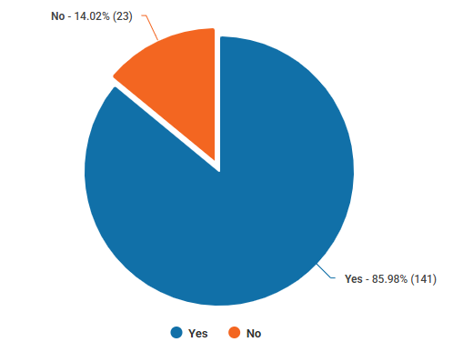

Survey responses: (If answered ‘yes’) Which of the following best describes what happened?

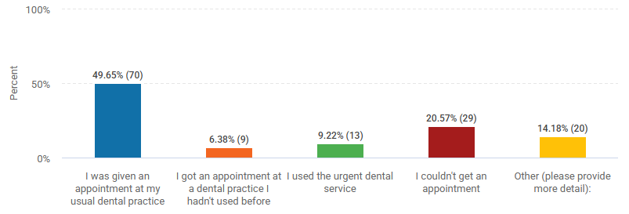

The majority of people who selected ‘other’ stated they had been unable to access an NHS dentist and been required to use a private service. One has been put on a waiting list, another said they had been supported to get NHS treatment through a family member.

Respondents were given an opportunity to add comments in response to this question. A summary of the comments made is below.

Inability to register with an NHS dentist
The most common experience was being unable to find any dental practice accepting new NHS patients, even after repeated attempts across wide geographic areas. Many respondents were told no NHS places were available locally, with some being advised to travel 30 to 60-plus miles, which was often unrealistic due to cost, mobility, or work commitments. Several people reported trying for years without success, leading to deterioration in oral health, tooth loss, or avoidance of care altogether.

Practices switching from NHS to private
A large number of respondents said their existing NHS dentist switched to private care, leaving them with little or no choice but to pay for treatment or to leave the practice and attempt (often unsuccessfully) to find another NHS dentist. Some people described having NHS appointments cancelled and replaced with private offers, sometimes with little notice. Pensioners and retired respondents frequently highlighted the financial strain of these changes.

Forced use of private dentistry
Many respondents reported being forced into private care, despite not being able to afford it. Several respondents said they had cut back on essentials or taken on financial stress to maintain access to dental care. Others said they had stopped seeking care altogether due to cost.

Long-distance travel to retain NHS access
Some respondents have remained registered with dentists near former homes because they could not access NHS dentistry after moving. Travel distances of 15 to 45 miles (or more) were commonly mentioned. This was described as inconvenient, costly, and unsustainable, but preferable to losing NHS access entirely.

Reliance on urgent or emergency care
Where routine NHS care was unavailable, respondents often used urgent dental services. Several people reported being turned away if their issue was not classed as an emergency, even when there was clear clinical need. This contributed to cycles of deterioration, pain, and repeated emergency access rather than preventative care.

Delays, cancellations and reduced routine care
Some respondents who were still registered reported long gaps between check-ups, routine appointments reduced from six-monthly to annual or longer and appointments cancelled or rescheduled repeatedly, sometimes after long waits. A few described confusion or poor communication around appointment dates and reminders.

Survey responses: (if answered ‘no’ to first question) Please tell us the reason you have not attempted to access NHS dental services

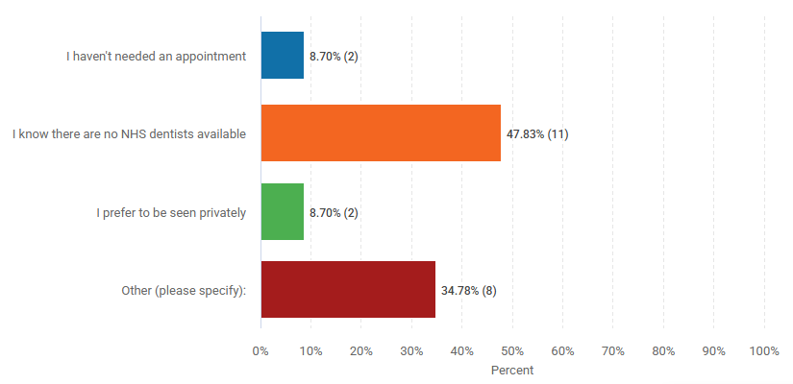
Of those who selected ‘other, the majority said they are registered with a private dentist. One said they were ‘housebound and petrified’ while another said they had retained their private dentist in Clitheroe having moved to the area, as they were concerned there are no dentists available in this area.

Respondents were given an opportunity to add comments in response to this question and there were 12 comments made. Most said they had not attempted to access NHS dental services because they believe there are no NHS dentists available locally, particularly those accepting new patients. As a result, many feel they have no real choice but to use private dental care, often reluctantly.

Several people described being forced into private dentistry after their former NHS dentist stopped providing NHS treatment. While some have stayed with the same practice for continuity or trust, they highlighted that private fees have risen while service quality has declined, adding to frustration.

Cost was a significant concern, especially for older people and those on fixed incomes, including state pensioners, who felt unfairly burdened by having to pay privately for what they believe should be an NHS-provided service.

Some respondents reported long-term access issues, saying they had lived in areas such as Wyre for many years without ever being able to register with an NHS dentist. This led to people either giving up trying altogether or travelling long distances to previous areas and paying high private fees.

There were also serious access and inequality issues raised. One respondent described complex health needs, severe anxiety, mobility issues, and being housebound, making dental access extremely difficult. Others expressed a preference to be properly registered as NHS patients, even where limited or semi-private arrangements exist.

Survey responses: Have you previously attended an NHS dentist, but no longer do now?
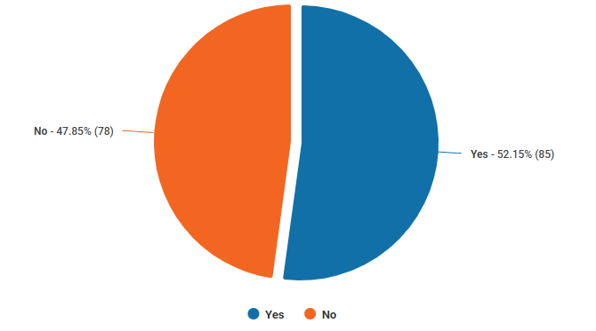

Survey responses: (If answered ‘yes’ to previous question) Which of the following best describes why you no longer attend?

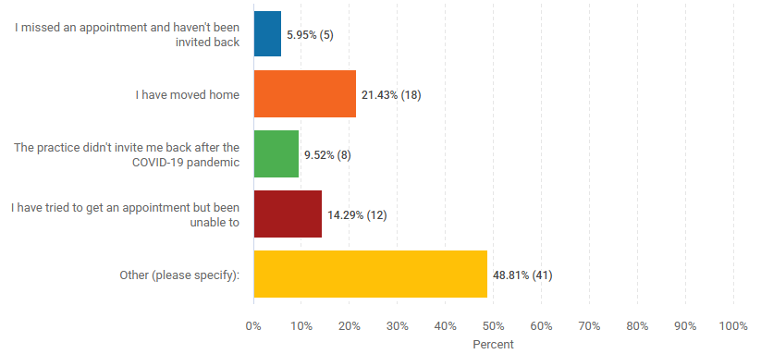
Of those who selected ‘other, the most common reason their dental practice withdrew from NHS dentistry. Many respondents said their dentist went fully private, resigned from the NHS, or switched all NHS patients on to private schemes such, often with little notice. In several cases, existing NHS patients were removed from practice lists, appointments were cancelled, or families were told they could no longer attend because they were NHS patients.

Practice closures and workforce changes were another major factor. Respondents reported dentists retiring, passing away, or surgeries closing altogether, leaving them without an NHS provider. Some were moved between multiple practice locations before losing access entirely.

A significant number of people said they could not find another NHS dentist after moving house or relocating to areas such as Blackpool, with no practices taking on new NHS patients. As a result, many felt they had no option but to register as private patients, even when this was not their preference.

Some respondents cited changes in the scope or quality of care, including practices limiting services to referrals or emergency-only care, or not offering necessary support such as sedation following surgery. A small number referred to poor or unsafe treatment experiences, which contributed to disengagement from NHS dentistry.

There were also personal and health-related barriers, including being housebound or having complex medical conditions, which made accessing alternative NHS dental services particularly difficult once their original practice stopped providing NHS care.

Survey responses: In the past two years, have you needed to access urgent dental care?

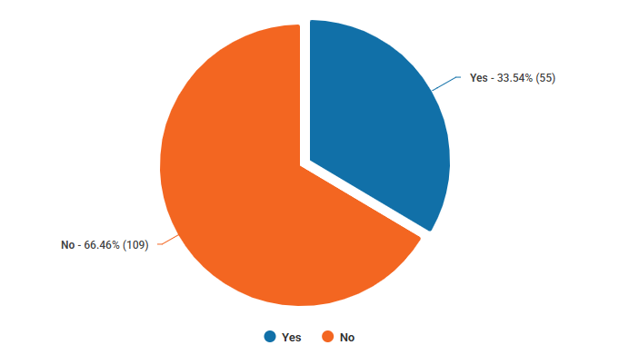

Survey responses: (If answered ‘yes’) On that occasion, what did you do?

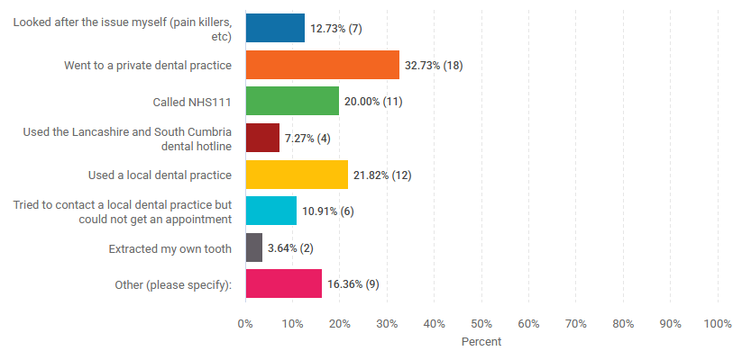
Of those who selected ‘other’, most stated that they attended an NHS urgent service or their regular dentist. One said they did nothing, another said ‘I have half a tooth and a hole still’.

Survey responses: Thinking about accessing NHS dental services, what would make it easier for you to attend? (Tick all that apply)

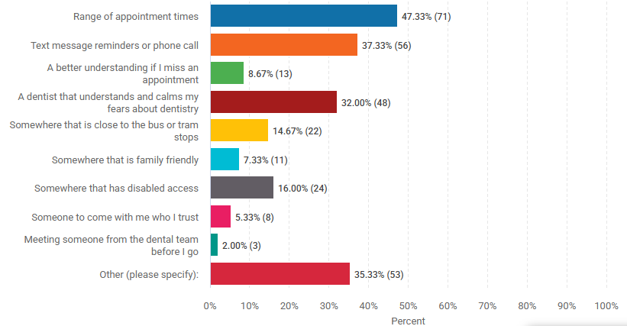
A summary of the responses from those who selected ‘other’ is below:

Availability of NHS dentists (dominant issue)
The overwhelming message is that people cannot find an NHS dentist at all, particularly one accepting new patients. Many respondents simply asked for any NHS dentist, describing repeated failed attempts to register and long-term lack of access. Several comments express frustration, desperation, and resignation about the current situation.

Local access and proximity
Many people said access would be easier if services were closer to home, highlighting long travel distances (often 20 to 45 miles) to reach an NHS dentist. Respondents frequently referenced wanting a dentist in their local community or neighbourhood.

Dentists accepting new NHS patients
Closely linked to availability, respondents repeatedly stressed the need for practices actively taking on NHS patients, rather than operating largely or entirely as private practices.

Appointment access and waiting times
Several comments focused on the difficulty of getting appointments, including long waits, limited NHS sessions (eg one day a week), and appointments being changed without notice.

Clearer information and guidance
Respondents said it would help to have clearer, more reliable information about which practices are accepting NHS patients, how to register and what options are available locally.

Continuity, trust, and respectful care
Some respondents highlighted the importance of seeing the same dentist consistently to build trust and being treated with understanding and respect, particularly for people with anxiety, autism, disabilities, or long-term illness. Concerns were raised about stigma, assumptions, and lack of flexibility for people whose health can fluctuate.

Reasonable adjustments and flexibility
People with disabilities described difficulties with last-minute cancellations due to illness and financial penalties that do not take health conditions into account. There was a strong call for greater understanding and reasonable adjustments.

Other practical improvements
Less frequently mentioned, but still important to some respondents were reminders for check-ups, access to sedation and community-based or outreach services.

Survey responses: Please provide any comments you would like to make about access to NHS dental services on the Fylde Coast

A summary of responses to this question is below:

Severe lack of NHS dental availability (overwhelming theme)
The dominant message is that NHS dental services are effectively non-existent for many people, particularly for anyone not already registered. Large numbers of respondents said it is impossible to find a practice accepting new NHS patients, often for years at a time. This was repeatedly described as ‘abysmal’, ‘appalling’, and a ‘national disgrace’. Many people feel access is determined by luck or long-standing registration, rather than need.

Two-tier system: existing patients vs new residents
A clear divide emerges between people who registered many years ago and generally still receive regular check-ups, and new residents, returning students, or those whose practices closed, who are completely locked out of NHS dentistry. Several long-term patients expressed anxiety that they may soon be pushed into private care as practices stop accepting NHS patients or reduce NHS provision.

Shift from NHS to private dentistry
Respondents widely believe that NHS-trained dentists are moving into private practice due to poor NHS remuneration and that practices now prioritise private patients, with NHS sessions limited to one day a week or one dentist. Some people reluctantly use private dentistry because it is the only realistic option, despite high costs, particularly during the cost-of-living crisis.

Cost and affordability
Cost was a major concern, especially for pensioners, people on low incomes or minimum wage, disabled people and carers and families unable to afford private fees. Several respondents described going without dental care entirely, or delaying treatment until problems became severe, resulting in extractions, dentures, or complex treatment.

Geographical and transport barriers
Where NHS dentists are available, they are often far from home (15–45 miles away), inaccessible by public transport and difficult to reach for people with disabilities. People described travelling out of area (including to Preston or South Ribble) or relying on taxis, adding financial and physical strain.

Reduced scope of NHS care
Some long-standing NHS patients noted a change in service quality, including no longer seeing a dentist for routine check-ups, only a hygienist, feeling NHS appointments are more rushed or limited and uncertainty about what is actually covered under NHS pricing. This created confusion and concern about long-term oral health.

Poor communication and lack of clear information
Many respondents said they do not know which practices (if any) are accepting NHS patients, how to register and whether waiting lists exist or how they are managed. There were strong calls for a clear, up-to-date, publicly available list of NHS dentists with spaces, and a better system for informing people when places become available.

Impact on people with disabilities, anxiety, and complex needs
Some of the most distressing comments came from people who are disabled, housebound, or have serious health conditions and those who experience dental anxiety, autism, learning disabilities, or trauma. Concerns included lack of reasonable adjustments, inflexible appointment systems, penalties for cancellations due to illness and feeling dismissed, stigmatised, or treated badly. Special care dentistry was highlighted as not meeting its intended purpose, particularly due to lack of reminder systems and inflexible re-booking processes.

Strong emotional impact
The comments reflect high levels of frustration, fear, anger, and distress. Some people described worsening dental health, severe pain, fear of emergency treatment and a sense of being abandoned by the system. Despite this, a small number of respondents reported excellent care and expressed relief at having secured an NHS dentist, fully aware that their experience is now unusual.

Appendix 4

Equality and Health Inequalities Impact Risk Assessment (EHIIRA)

If the recommendations of the final report include a proposal to invest in the Fylde Coast and an associated service model, and these recommendations are supported, an EHIIRA will be completed.

