**NHS Lancashire and South Cumbria Integrated Care Board**

**Equality, Diversity and Inclusion**

**Equality Delivery System (EDS) Grading Assessment Report 2024/2025**

**March 2025**

**Equality Delivery System Grading Assessment Report 2024/25**

1. **Introduction**

This report describes NHS Lancashire and South Cumbria (LSC) Integrated Care Boards (ICB) approach and performance for the Equality Delivery System (EDS) Grading Assessment for 2024/25.

The third version of the EDS was commissioned by NHS England and NHS Improvement as a simplified and easier-to-use version of EDS2.

EDS is an assessment tool designed to measure NHS equality performance with an aim to produce better outcomes for people using and working in the NHS and to gather equality evidence that demonstrates compliance with the Public Sector Equality Duty (PSED) and the Equality Act 2010.

The EDS comprises eleven outcomes spread across three Domains, which are:

1) Commissioned or provided services

2) Workforce health and well-being

3) Inclusive leadership.

The outcomes are evaluated, scored, and rated using available evidence and insight. It is these ratings that provide assurance or point to the need for improvement.

The outcomes that we measure against for each of the three EDS Domains are as follows:

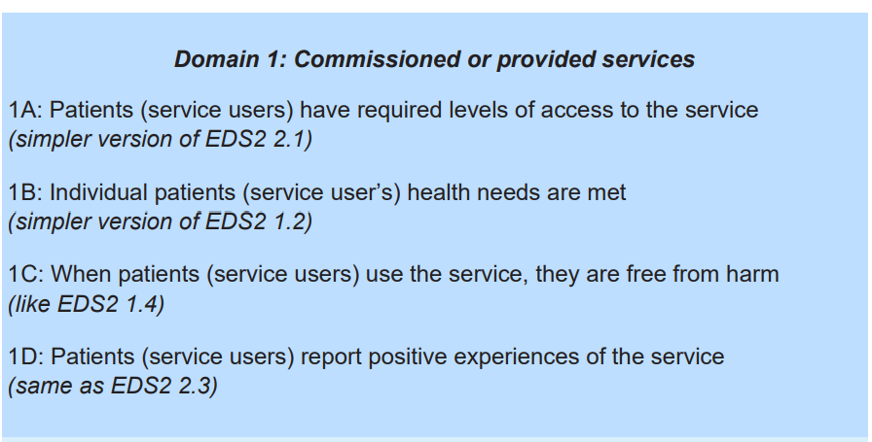

Please click on this [link](https://www.england.nhs.uk/wp-content/uploads/2022/08/NHS-Equality-Delivery-System-Technical-Guidance-v2-Revision-240423.pdf) to see the EDS 2022 Technical Guidance produced by NHS England.

1. **EDS Grading Assessment for 2024/2025**

**EDS Domain 1: Commissioned or Provided Services – LSC Maternity Services**

This year marks the first that EDS Domain 1 has been successfully completed as a collaborative assessment with NHS Provider Trusts with relevant evidence provided by the ICB via the Local Maternity and Neonatal Service. Provider Trusts who participated were:

* East Lancashire Hospitals Trust (ELHT)
* University Hospitals Morecambe Bay Trust (UHMBT)
* Blackpool Teaching Hospitals (BTH)
* Lancashire Teaching Hospitals (LTH)

Lancashire and South Cumbria Foundation Trust (LSCFT) were not in a position to contribute to this year’s assessment due to internal pressures and capacity issues.

A system working group was established and attended by a range of EDI and Public Health colleagues from across LSC. Regular meetings took place to plan the systems approach for the achievement of EDS Domain 1. Through the working group, a decision was made for the acute Provider Trusts to assess maternity services due to this being identified as an area requiring national improvement. The working group developed a formal evidence gathering and self-assessment template which was circulated to maternity leads across LSC for them to provide relevant evidence relating to the Domain 1 grading criteria.

On Tuesday 11 March 2025, LSC ICB hosted a virtual EDS Domain 1 grading event. The grading panel included independent representatives from Renaissance UK, Healthwatch, Local Maternity Voice Partnerships (LMVPs) and Patient Governors from Provider Trusts. Evidence packs were presented to graders at the grading event and the grading panel were asked to score EDS Domain 1 judging how well they felt Trusts had performed throughout 2024/25. Grading options were: **Undeveloped**, **Developing**, **Achieving** or **Excelling.**

Instead of scoring each Trust separately, graders collaboratively assigned a single system-wide grade for each Domain 1 subcategory (1A, 1B, 1C, and 1D) for maternity services in all acute provide Trusts in Lancashire and South Cumbria. Each Trust’s performance was analysed but, as per EDS 2022 technical guidance, graders assessed system-wide performance by aggregating evidence from all providers

For further information on EDS ratings and score card guidance, please click on this [link.](https://www.england.nhs.uk/wp-content/uploads/2022/08/EDS-2022-ratings-and-score-card-guidance-v2.pdf)

The overall grades received for each outcome in EDS Domain 1 (at an ICS level) are as follows:

|  |  |
| --- | --- |
| **EDS Domain 1: Commissioned or Provided Services** | **System 2024/2025 Grade** |
| 1A: Patients (service users) have required levels of access to the service | **Tied at Developing/Achieving** |
| 1B: Individual patients (service users) health needs are met | **Developing** |
| 1C: When patients (service users) use the service, they are free from harm | **Tied at Developing/Achieving** |
| 1D: Patients (service users) report positive experiences of the service | **Developing** |
| Overall Domain 1 grade | **Developing** |

The 2024-2025 EDS cycle will act as a baseline grade and form the basis of an action plan to improve our performance ahead of next year’s grading. The next steps for EDS Domain 1 for the 2025-2026 reporting cycle are:

* Using the results, the LSC EDS Domain 1 Working Group will develop an action plan to improve maternity services for patients from diverse backgrounds across all Trusts
* This report will be taken through relevant boards and committees across the ICB and Trusts for approval and publication
* Ongoing dialogue and collaboration with LSCFT to remain a priority to ensure full system alignment moving forward.
* In 2025-26, we will review progress made on the action plan and re-grade maternity services against the Domain 1 outcomes to monitor improvements and/or further opportunities.

**EDS Domain 1: Commissioned or Provided Services – North West Ambulance Service**

Further to the collaborative grading around maternity services, North West Ambulance Service undertook a standalone Domain 1 assessment examining the performance of NWAS Public Health, Cardiac Outcomes Project, Patient Safety and Friends and Family Test. This assessment took place on 9 January 2025 via MS Teams, with a panel consisting of Patient and Public Panel members and Community First Responders volunteers.

Graders were presented with a short summary of evidence at the event, which was then followed by questions and a group discussion before graders were asked to provide their scores for the respective outcomes. The results received for NWAS services were as follows:

|  |  |
| --- | --- |
| **EDS Domain 1: Commissioned or Provided Services** | **System 2024/2025 Grade** |
| 1A: Patients (service users) have required levels of access to the service | **Developing** |
| 1B: Individual patients (service users) health needs are met | **Achieving** |
| 1C: When patients (service users) use the service, they are free from harm | **Achieving** |
| 1D: Patients (service users) report positive experiences of the service | **Achieving** |
| Overall Domain 1 grade | **Achieving** |

1. **EDS Grading Assessment for 2024/2025**

**EDS Domain 2: Workforce Health and Wellbeing and EDS Domain 3: Inclusive Leadership**

EDS Domain 2 and EDS Domain 3 were completed at organisation level. Evidence relating to both Domains were collected from staff within LSC ICB and LSC ICB intranet.

This is the second year that the ICB has assessed against the new EDS 2022 Domains 2 & 3, therefore this is a comparator report for the ICB based on the 2023/2024 EDS results.

All LSC ICB employees were invited to a grading event on Tuesday 04 March 2025 which was attended by 8 employees. Evidence packs were circulated to LSC ICB colleagues prior to the grading event, the evidence packs provided in addition to colleague’s own experiences of working in the ICB would inform their grading. The grading event was facilitated by the Culture and Inclusion team. The facilitator used Mentimeter (an interactive presentation software facility) to collect the results. Real time scoring took place during the grading event with an online form circulated to collect further feedback following the grading event.

Grades received for EDS Domain 2 are as follows:

|  |  |  |
| --- | --- | --- |
| **EDS Domain 2: Workforce Health and Wellbeing** | **2023/2024 Grade** | **2024/2025 Grade** |
| 2A: When at work, staff are provided with support to manage obesity, diabetes, asthma, COPD and mental health conditions | **Achieving** | **Developing** |
| 2B: When at work, staff are free from abuse, harassment, bullying and physical violence from any source | **Achieving** | **Developing** |
| 2C: Staff have access to independent support and advice when suffering from stress, abuse, bullying harassment and physical violence from any source | **Achieving** | **Achieving** |
| 2D: Staff recommend the organisation as a place to work | **Developing** | **Undeveloped** |
| Overall Domain 2 grade | **Achieving** | **Developing** |

In comparison to the 2023-2024 EDS reporting cycle, there has been a deterioration in all the Outcomes in Domain 2 with the only exception being Outcome 2C where the grade has remained the same. It is worth noting that there has been a decline in Outcome 2D.

To caveat, there is currently significant work taking place at LSC ICB regarding the culture, values and behaviours of the organisation. It is also worth noting that low attendance at the grading event may have contributed to the significant variation in grades compared to last year’s assessment.

The graphs below show the number of the graders who attended the grading event and how they voted for each outcome.

**3.1 EDS Outcome 2A: When at work, staff are provided with support to manage obesity, diabetes, asthma, COPD and mental health conditions**

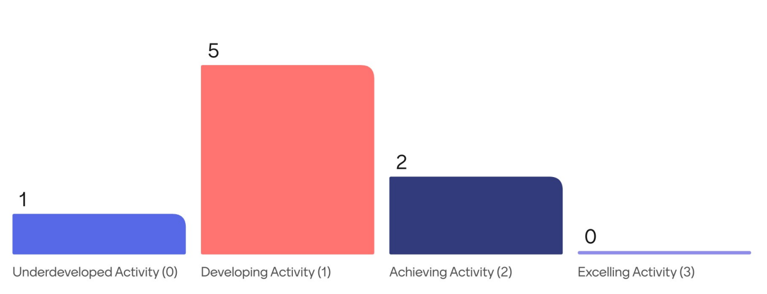

**Evidence provided for EDS Outcome 2A**

* Staff Policies (including but not limited to the ICB Flexible Working Policy)
* Health and Wellbeing hub resources
* Monthly check-ins (for ICB staff members)
* Display Screen Equipment assessment- Health and Safety at Work
* Employee Assistance Programme
* Wellbeing Conversations, including training for managers
* ICB Health and Wellbeing Guardians
* ICB Health and Wellbeing Champions
* Menopause support available
* ICB Wellbeing Passport
* Online Webinars that have been promoted by the ICB to support long term conditions
* Wellbeing Apps that are available to ICB staff
* ICB staff communications
* Sickness Absence Data
* Staff Survey Results 2024/2025 (Outcome 11A)

**3.2 EDS Outcome 2B: When at work, staff are free from abuse, harassment, bullying and physical violence from any source**

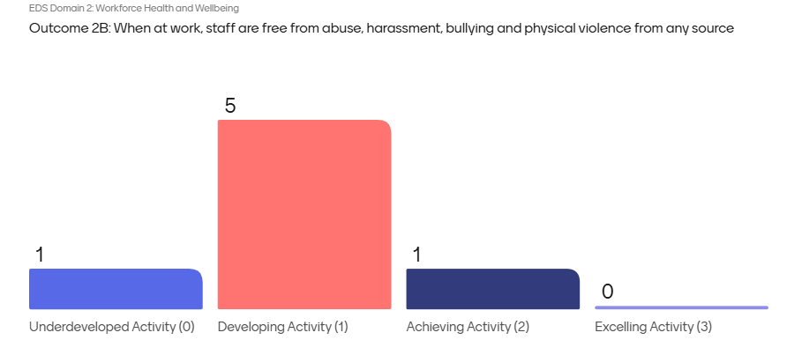

**Evidence provided for EDS Outcome 2B**

* ICB Harassment and Bullying at Work Policy
* ICB Culture and Development Plan (including the current culture and values reset)
* LSC Belonging Delivery Plan
* Freedom to Speak Up Policy
* Freedom to Speak Up Guardians
* Freedom to Speak Up Champions
* Promotion of the Civility and Respect Toolkit
* Staff comms
* Staff Survey related outcomes
* Workforce Race Equality Standard (WRES) results
* Workforce Disability Equality Standard (WDES) results

**3.3 EDS Outcome 2C: Staff have access to independent support and advice when suffering from stress, abuse, bullying harassment and physical violence from any source**

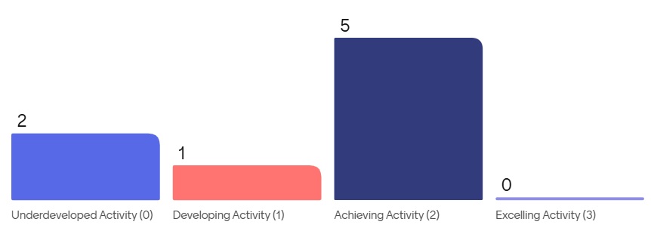

**Evidence provided for EDS Outcome 2C**

* Information about the ICBs Occupational Health offer – including Wellbeing Services and Employee Assistance Programme
* Freedom to Speak Up Policy
* How ICB colleagues can speak up in the organisation (including Staff Side representatives/Trade Unions)
* ICB Listening Rooms
* ICS LGBTQ+ Working Group
* ICS Network of Networks
* ICB Staff Networks
* National and Local support officers available to staff
* LSC Belonging Delivery Plan

**3.4. EDS Outcome 2D: Staff recommend the organisation as a place to work**

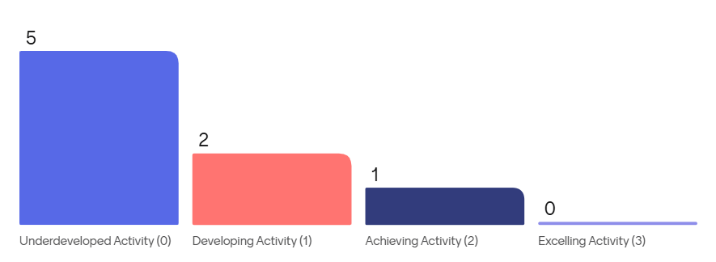

**Evidence provided for EDS Outcome 2D**

* ICB Policies (included but not limited to the ICB Grievance Policy)
* ICB Flexible Working Policy
* Outcomes from the 2023/2024 Staff Survey (Q23 – I would recommend my organisation as a place to work)
* NHS Staff Survey data (People Promise Outcomes 1 – 3)
* Monthly Health and Wellbeing check-in for ICB employees
* ICB Staff Networks
* WRES data
* WDES data
* Exit interview quotes

**3.5. Grades received for EDS Domain 3**

|  |  |  |
| --- | --- | --- |
| **EDS Domain 3: Inclusive Leadership** | **2023/2024 Grade** | **2024/2025 Grade** |
| 3A: Board members, system leaders (Band 9 and VSM) and those with line management responsibilities routinely demonstrate their understanding of, and commitment to, equality and health inequalities | **Achieving** | **Developing** |
| 3B: Board/Committee papers (including minutes) identify equality and health inequalities related impacts and risks and how they will be mitigated and managed | **Tied at Developing/Achieving** | **Developing** |
| 3C: Board members and system leaders (Band 9 and VSM) ensure levers are in place to manage performance and monitor progress with staff and patients | **Achieving** | **Developing** |
| Overall Domain 3 grade | **Achieving** | **Developing** |

In comparison to the 2023-2024 EDS reporting cycle, there has been a deterioration in all the Outcomes in Domain 3.

The graphs below show the number of the graders who attended the grading event and how they voted for each outcome.

**3.6. EDS Outcome 3A: Board members, system leaders (Band 9 and VSM) and those with line management responsibilities routinely demonstrate their understanding of, and commitment to, equality and health inequalities**

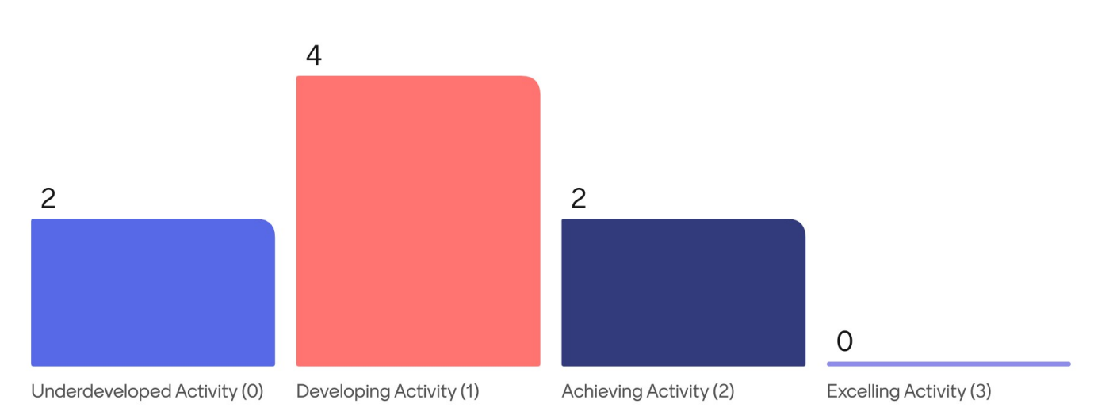

**Evidence provided for EDS Outcome 3A**

* ICB cover sheet for meeting papers includes a question which asks if an Equality Health Inequality Impact and Risk Assessment has been completed
* BAME Northwest Anti-Racist Framework
* Promotion/delivery of EDI History Month Events (Black, Disability and LGBT+ History Months)
* Development of an Equality and Inclusion calendar
* ICS/ICB Population Health Academy
* Information on how the ICB works in partnership with people and communities
* ICB Culture and Values reset (ongoing)
* ICB People and Culture Steering Group
* Support for staff following Southport Riots (including specific Listening Room and comms from Chief Exec)
* ICB Wellbeing Passport
* ICBs progress in reducing health inequalities

**3.7. EDS Outcome 3B: Board/Committee papers (including minutes) identify equality and health inequalities related impacts and risks and how they will be mitigated and managed**

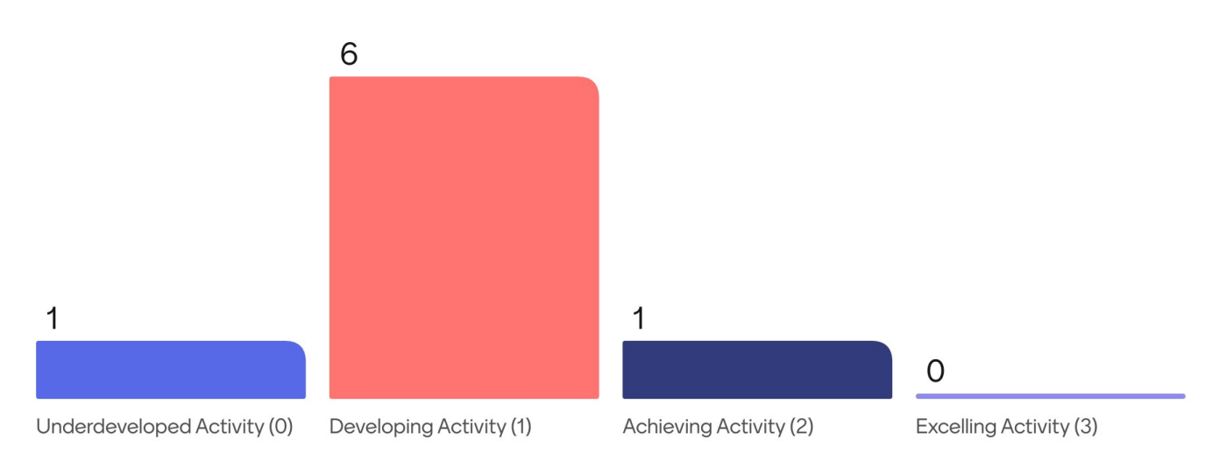

**Evidence provided for EDS Outcome 3B**

* Various ICB Board papers where equalities/health inequalities are referenced
* ICB People Board information
* ICB will address health inequalities and improve health outcomes
* ICB Population Health Management system
* LSC ICB is a Core20Plus5 accelerator site
* Equality and Health Inequalities Impact and Risk Assessments (EHIIRAs) and EHIIRA training that is provided to all ICB staff on an on-going basis

**3.8. EDS Outcome 3C: Board members and system leaders (Band 9 and VSM) ensure levers are in place to manage performance and monitor progress with staff and patients**

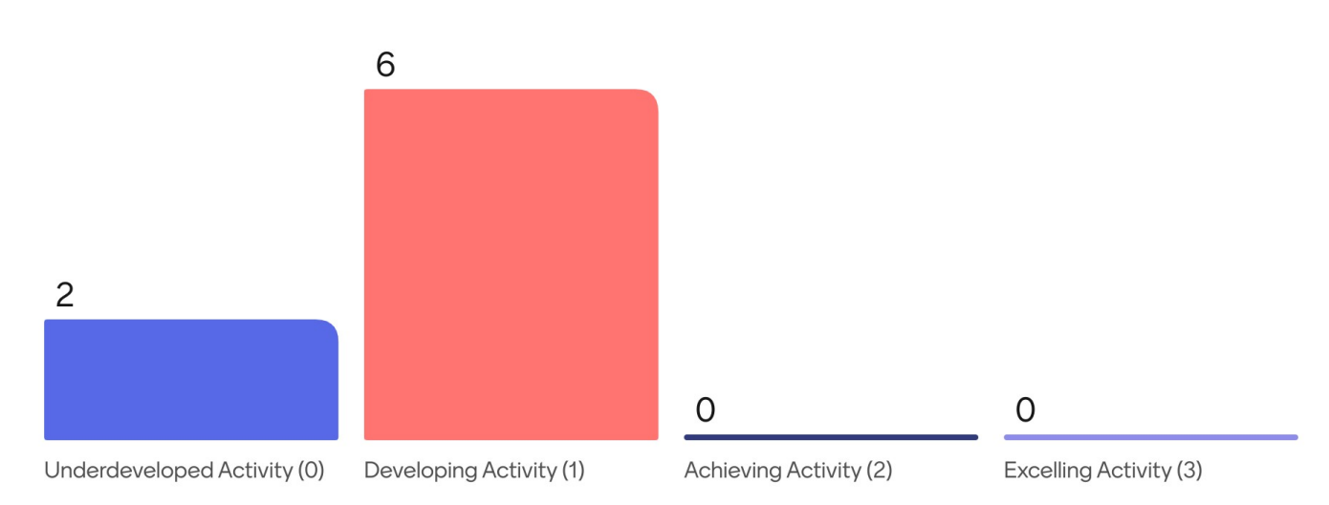

**Evidence provided for EDS Outcome 3C**

* System wide WRES & WDES reports for LSC
* Equality Health Inequality Impact and Risk Assessments (EHIIRAs)
* LSC Strategy for working in partnership with people and communities 2023-2026
* ICB Equality, Diversity and Inclusion strategy
* The Public Involvement and Engagement Advisory Committee information
* Patients Story/Citizens Voice – which are a standing agenda item on ICB Board meetings
* Listening Rooms
* Staff Comms

1. **EDS Grading Assessment - Feedback from graders**

The independent panel that participated in the EDS Domain 1 assessment and grading event acknowledged that the process was streamlined and easy to understand.

In relation to EDS Domains 2 and 3, which took place at ICB level. The graders reported that they enjoyed the grading assessment. Graders felt that that the session was informative and well-presented. Graders also felt that EDS was explained clearly with relevant and comprehensive evidence provided that enabled them to decide upon a suitable grade for each outcome. Anonymised feedback given by graders can be made available upon request.

1. **Monitoring and Reviewing**

NHS Lancashire and South Cumbria ICB will continue to monitor and review the progress of EDS on an annual basis with the support of the Culture and Inclusion team. The Executive Team, ICB employees and stakeholders will continue to be involved in ensuring improved better health outcomes for all the protected groups.

1. **Actions**

To build on the progress made in Domain 1 and address the challenges in Domains 2 and 3, the following recommendations are proposed:

1. **Enhance Evidence Collection and Stakeholder Engagement**
   * Initiate earlier evidence gathering to ensure a robust, comprehensive grading process.
   * Strengthen engagement with diverse stakeholder groups to provide a broader range of perspectives.
2. **Improve Workforce Experience and Culture**
   * Develop targeted interventions to address the decline in staff satisfaction (Outcome 2D).
   * Align organisational values and culture initiatives with staff feedback to create a more inclusive and supportive working environment.
   * Develop staff networks to support our people and address concerns being raised.
3. **Strengthen Inclusive Leadership**
   * Increase leadership accountability for equality, diversity, and inclusion outcomes.
   * Provide structured education, training and support to ensure leaders drive meaningful change.
   * Develop an organisational development plan, focusing on EDI, offering a range of interventions to build on the values and behaviour framework.
4. **Embed Continuous Improvement**
   * Regularly review grading processes to ensure alignment with best practices and evolving organisational needs.
   * Monitor the impact of ongoing culture and behaviour initiatives, using future assessments to track progress.

By implementing these actions, NHS Lancashire and South Cumbria ICB can reinforce its commitment to equity, diversity, and inclusion while improving outcomes for both staff and service users.

1. **Conclusion**

The 2024-2025 EDS grading assessment has highlighted both progress and areas for further development within NHS Lancashire and South Cumbria ICB. The collaborative approach to Domain 1 has resulted in a more structured and effective grading process, leading to improved outcomes. However, this process will continue to evolve, with a focus on earlier evidence gathering and stakeholder engagement to enhance future assessments.

Conversely, the decline in grades for Domains 2 and 3 underscores significant challenges in workforce well-being and inclusive leadership. The drop in Outcome 2D, where fewer employees recommend the organisation as a place to work, signals a need for targeted interventions to improve staff satisfaction and organisational culture. Similarly, the downward trend in Domain 3 suggests that despite a structured grading process, there is a need for improved inclusive leadership and tangible actions to address the knowledge, understanding and implementation of being an inclusive and compassionate leader.

Looking ahead, the ICB’s ongoing work on organisational culture, values, and behaviours will be critical in reversing the trend. The next assessment cycle provides an opportunity to measure the impact of these efforts, ensuring that equality, diversity, and inclusion remain a priority area of the ICB’s people plan.

By accepting the current grading and implementing the recommended actions, NHS Lancashire and South Cumbria ICB can build on existing strengths while addressing key areas for improvement, ultimately working towards better outcomes for both service users and staff.

1. **Recommendations**
2. Note the content of the report
3. To accept the grading of ‘Developing’ for the 2024-2025 EDS 2022 reporting cycle
4. Approve the actions contained within the report.