



Equality, Diversity & Inclusion

Annual Report

2024-25

Contents
Accessibility Statement 3
Foreword 4
Introduction 5
Legal Duties for Equality and Inclusion 6
NHS Mandated Equality Standards 13
Our ICB Workforce 18
Belonging in the ICS 31
Our Communities 37
Our Equality Objectives 2024 - 2027 53
Equality Monitoring 66
Contact Details and Alternative Formats 67
Appendix: Lancashire and South Cumbria ICB Workforce Demographic Report 71

Accessibility Statement

We want to ensure that the information we communicate is fair and accessible to all sections of our local communities. Patients, the public and staff can request reasonable adjustments such as information converted into other formats for easier reading.

To request information or any of our key documents in an alternative format such as braille, larger print, audio or other format please email lsc.icb@nhs.net quoting your address, telephone number along with the title and date of the publication, plus the format you require.



Foreword
I am pleased to present the Equality, Diversity and Inclusion Annual Report 2024-25 for NHS Lancashire and South Cumbria Integrated Care Board (ICB).
This year’s report reflects not only our continued commitment to equity and belonging, but also the resilience and dedication of our people in the face of ongoing challenges across the health and care system.

While 2024/25 has been a year marked by financial constraints and significant operational pressures across the NHS, our determination to embed inclusion and compassion into all areas of our work has not wavered. We know that inclusive cultures are essential to the wellbeing of our workforce, the quality of care we provide, and the outcomes we achieve for our diverse communities.

Throughout the year, we have deepened our commitment to fostering a workplace where everyone feels valued and heard. From enhancing the visibility and leadership of our staff networks, to progressing our system-wide Belonging Plan and driving forward actions to address workforce inequalities, we continue to take important steps to ensure that fairness and inclusion are at the heart of our strategy and everyday practice.

We also recognise that this work is ongoing. The evolving financial and policy landscape calls for even greater innovation and collaboration. Despite limitations, we remain committed to driving progress where it is most needed, particularly in the experiences of our workforce and in addressing the health inequalities that persist across Lancashire and South Cumbria.

As we look ahead, our focus will be on ensuring that our commitments to inclusion are sustained, embedded, and shared—supporting both our colleagues and our communities to thrive. Thank you to everyone—our staff, partners, and community members—who continue to champion inclusion across our system. Together, we are building a culture where everyone can belong, contribute, and succeed.


Sam Profitt – Acting Chief Executive Officer of Lancashire and South Cumbria ICB

Introduction

The Lancashire and South Cumbria Integrated Care Board (ICB) was established on 1 July 2022 under the Government’s Health and Care Act 2022. It is one of 42 ICBs in the country and replaces the eight clinical commissioning groups (or CCGs) that previously existed across the region. The ICB has since taken on responsibility for planning and buying NHS services for the 1.8 million people living in Lancashire and South Cumbria.

The equalities information presented in this report represents the ICB’s progress in incorporating equality, diversity, and inclusion into aspects of its work during 2024-25.

The publication of this report and the information contained within demonstrates not just compliance with the Public Sector Equality Duty, and the requirement to publish equality information annually, but also showcases the positive actions taken to address workforce inequalities beyond compliance.

This report sets out:

• Lancashire and South Cumbria ICB’s commitment to equality, diversity and inclusion
• Evidence of our ‘due regard’ to the Public Sector Equality Duty
• Progress made against the ICB’s equality objectives



Legal Duties for Equality and Inclusion

This section outlines the various legal requirements and NHS England Mandated Standards relating to equality and inclusion.

The Equality Act (2010)

The Equality Act (2010) came into force in October 2010. The Equality Act combines over 116 separate pieces of legislation into one single act. Combined, they make up an act that provides the legal framework to protect the rights of individuals and advance equality of opportunity for all. The act simplifies, strengthens and harmonises the current legislation to provide discrimination law which protects individuals from unfair treatment and promotes a fair and more equal society.

The Equality Act protects people from unfavourable treatment, and this refers particularly to people from the following categories known as ‘protected characteristics’:

- Age
- Disability
- Gender reassignment
- Marriage and civil partnership
- Pregnancy and maternity
- Race
- Religion and belief
- Sex (Gender)
- Sexual orientation

We also consider other inclusion health groups including carers, homelessness, military veterans, asylum seekers and refugees, rural and deprived communities.


The Protected Characteristics

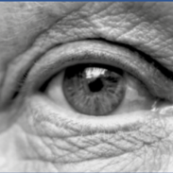

Age

This refers to a person of a specific age (e.g., 50 years old) or a range of ages (e.g., 18 to 30 years old). Age discrimination includes treating someone less favourably for reasons relating to their age (whether young or old).

Disability
A person has a disability if they have a physical impairment, mental impairment, sensory impairment or learning disability which has a substantial and long-term adverse effect on their ability to carry out normal day-to-day activities.

Gender reassignment

The process of transitioning from one gender to another. Gender identity refers to the way an individual identifies with their own gender, e.g., as being either a man or a woman or, in some cases, being neither, which can be different from biological sex.

Marriage and civil partnership

Marriage is an institution in which interpersonal relationships are acknowledged and can be between different sex and same-sex partners. Same-sex couples can have their relationships legally recognised as ‘civil partnerships’. In England and Wales, marriage is no longer restricted to a union between a man and a woman but now includes a marriage between a same-sex couple.

Pregnancy and maternity

Pregnancy is the condition of being pregnant or expecting a baby. Maternity refers to the period after the birth and is linked to maternity leave in the employment context. Protection against maternity discrimination is for 26 weeks after giving birth. This includes treating a person unfavourably because they are breastfeeding.

Race

Race refers to a group of people defined by their race, colour and nationality (including citizenship), ethnic or national origins.

Religion and belief

Religion has the meaning usually given to it, but belief includes religious convictions and beliefs, including philosophical belief and lack of belief. Generally, a belief should affect your life choices or the way you live for it to be included in the definition.

Sex (Gender)

A man or woman, but also includes men and women as groups. Treating a man or woman (or men and women) less favourably for reasons relating to their sex.

Sexual orientation

A person’s sexual attraction towards their own sex, the opposite sex or more than one sex. This includes people who are lesbian, gay, bisexual or heterosexual.

Inclusion Health Groups

Inclusion health groups are most likely to be affected by health inequalities and experience inequalities of access. They also tend to have poorer health outcomes compared to the general population. Poorer access to healthcare services and negative experiences can also exacerbate existing inequalities that may be faced by these groups. Inclusion health groups include (but are not limited to):

People experiencing deprivation


Deprivation underpins almost all inequalities. It is associated with poorer health, disability and often behaviours that can further impact on health, such as smoking. People living in deprived areas are consequently more likely to have poorer health outcomes, shorter life expectancy and shorter healthy life expectancy rates compared to individuals in less deprived areas.


Carers

Carers are not recognised under the Equality Act 2010 in their own right, however, carers may support individuals who possess a protected characteristic, such as an older relative, or someone with a disability, which may impact upon their own health and how they access health care services.

Asylum seekers and refugees

Asylum seekers and refugees often experience multiple disadvantage due to intersectionality of overlapping protected characteristics such as age, race, disability or sexual orientation. They may experience complex health-related needs relating to their individual experiences, and may also have less understanding of the UK health care system, resulting in barriers to accessing the services they need.

People experiencing homelessness

This inclusion health group is more likely to experience poorer health outcomes and health inequalities compared to the general population and may also face barriers to health care assess. When homelessness is intersected with other protected or inclusion group characteristics, barriers to accessing health care services may increase, resulting even poorer outcomes.

Veterans and service leavers


Veterans and military service leavers are recognised as a group that are more likely to experience poorer health outcomes and potential barriers to accessing healthcare services. Almost two thirds of military veterans in the UK are aged 65 and over, so there may be intersectionality in this group with age-related health conditions and related clinical needs.


Rural communities

Outward migration of younger people, and inward migration of older people, is resulting in a rural population that is increasingly older than the urban one, with accompanying health and social care needs. As with deprivation, rurality can be a factor that impacts upon access to healthcare services and may lead to health inequalities such as social isolation. Digital exclusion in rural areas may also impact upon a service user’s ability to access health care services.

Public Sector Equality Duty (2011)

Section 149 of the Equality Act (2010) requires us to demonstrate compliance with the Public Sector Equality Duty (PSED) which places a statutory duty on ICBs to address:

- Eliminating unlawful discrimination, harassment and any other conduct prohibited by the Equality Act.
- Advance equality of opportunity between people who share a protected characteristic and people who do not share it.
- Foster good relations between people who share a protected characteristic and people who do not.

The ICB also has a specific duty under the PSED to complete the following actions:

- Publish information to demonstrate their compliance with the Equality Duties, at least annually.
- Set equality objectives, at least every four years.

Human Rights Act (1998)

The Human Rights Act (1998) came into effect in the United Kingdom in October 2000.

The act requires ICBs to ensure that their commissioning decisions safeguard vulnerable people, and do not put people’s lives at risk or expose them to inhumane or degrading treatment.



Health and Social Care Act (2012)

The Health and Social Care Act (2012) states that each ICB must, in the exercise of its functions, have regard to the need to:


- Reduce inequalities between patients with respect to their ability to access health services.
- Reduce inequalities between patients with respect to the outcomes achieved for them by the provision of health services.
- Promote the involvement of patients and their carers, in decisions about provision of health services to them.
- Enable patients to make choices with respect to aspects of health services provided to them.

NHS Constitution (2015)
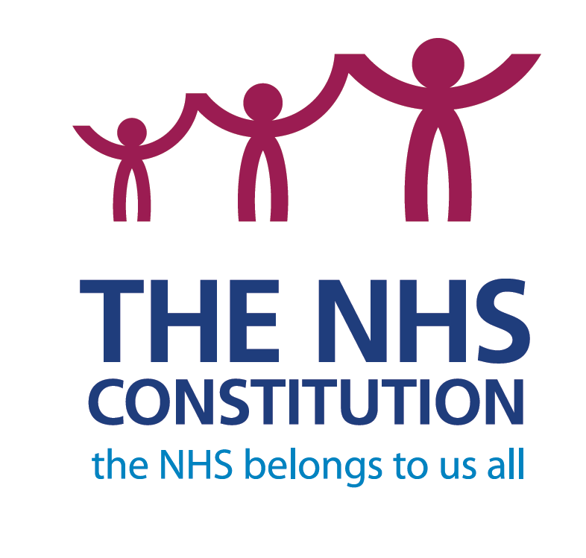

The NHS Constitution (2015) sets out rights for patients, the public and staff.

It outlines NHS commitments to patients and staff, and the responsibilities that the public, patients and staff owe to one another to ensure that the NHS operates fairly and effectively.

NHS Constitution targets are monitored via the ICB’s Quality Committee, and further assurances are provided to the Board.

NHS Mandated Equality Standards

Equality Delivery System (2022)

The Equality Delivery System (EDS) helps NHS organisations improve the services that they provide for their local communities and provide better working environments, free from discrimination, for those who work in the NHS, whilst meeting the requirements of the Equality Act (2010). EDS is an evidence-driven accountable improvement tool for NHS organisations in England – in active conversations with patients, public, staff, staff networks and trade unions – to review and develop their services, workforces, and leadership.

Accessible Information Standard (2016)

The aim of the Accessible Information Standard is to make sure that people who have a disability, impairment or sensory loss, receive information that they can access and understand, and receive any communication support that they need.

Commissioners of NHS services must have a regard to this standard, in so much as they must ensure that they enable and support compliance through their relationships with provider organisations. This standard is in the ICB’s NHS Standard Contract and is monitored by Quality and Performance Key Performance Indicators (KPIs).


Workforce Race Equality Standard (2015)


The NHS Workforce Race Equality Standard (WRES) is a useful tool to identify and reduce any disparities in experience and outcomes for NHS employees and job applicants of different ethnicities. The Standard is used by organisations to track progress in identifying and helping to eliminate discrimination in the treatment of Black and Minority Ethnic (BAME) employees.

Workforce Disability Equality Standard (2018)

The Workforce Disability Equality Standard (WDES) is a set of specific measures (metrics) that enables NHS organisations to compare the experiences of disabled and non-disabled staff and improve outcomes for NHS employees and job applicants with disabilities.

All NHS standard contracts set out that NHS Trusts and NHS Foundation Trusts are required to implement the WRES and the WDES.

Modern Slavery Act (2015)


All public authorities are required to co-operate with the Police Commissioner under the Modern Slavery Act (2015). This means that police and health care services, together with voluntary organisations, are legally required to work together to support people who have experienced slavery.

The ICB has a zero-tolerance policy for modern day slavery and breaches of human rights, and ensure this protection is built into the processes and business practices that we, our partners and our providers use.

Belonging in the NHS

The NHS is made up of approximately 1.3 million employees who care for the people of this country with skill, compassion, and dedication. People work in many different roles, in different settings, are employed in different ways, and across a wide range of organisations.

The NHS People Plan was published in July 2020. The plan sets out actions to support transformation across the whole NHS now and in the future. It focuses on how we must all continue to look after each other and foster a culture of inclusion and belonging, as well as action to grow our workforce, train people, and work together differently to deliver patient care.

The People Plan sets out what NHS staff can expect from leaders and each other and includes a focus on fostering a culture of inclusion and belonging. The NHS People Plan includes a People Promise, which outlines the actions and behaviors staff should expect from their employers and colleagues, as part of improving the experience of working in the NHS for everyone.
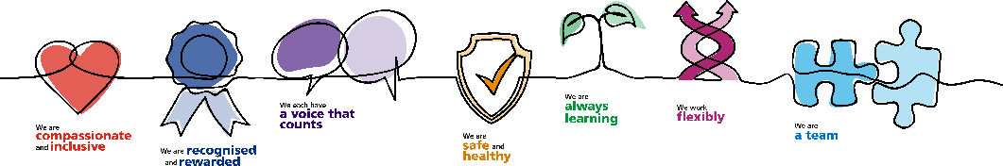

More recently, the NHS Long-Term Workforce Plan was published on 30 June 2023. This plan has been described as “a once in a generation opportunity to put staffing on a sustainable footing and improve patient care”. The 15-year plan focuses on training, retaining, and reforming the workforce, and places close attention on the way in which the NHS is organised to enable these ambitions. In particular, the plan places emphasis on retaining staff by improving culture and wellbeing.

Other recent national developments include the long-awaited publication of the NHS Equality, Diversity and Inclusion Improvement Plan published in early June 2023. This improvement plan sets out targeted actions to address bias and discrimination that exist in workplace experiences, policies and practices against specific groups and individuals within the NHS workforce.

The EDI Improvement Plan has set out six high impact actions, to which our LSC ICS Belonging Plan is aligned, addressing:

- EDI objectives for Chairs, Chief Executives and Board members
- The overhaul of recruitment and embedding of talent management
- The review of pay gaps for race, disability and gender
- Addressing health inequalities within the workforce
- The reduction of inequalities for internationally recruited staff
- The elimination of experiences of bullying and harassment

For more information about the LSC ICS Belonging Plan, see page 30 of this report.

Sexual Orientation Monitoring Information Standard (2017)

The Sexual Orientation Monitoring Information Standard (SOM) provides a mechanism for recording the sexual orientation of all patients/service users aged 16 years and over across all health services and local authorities with responsibilities for adult social care in England, and in all service areas where it may be relevant to record this data.

The ICB requires assurance from providers in the following areas:

- The ICB and its providers are able to demonstrate the provision of equitable access for LGB individuals.
- The ICB is monitoring its providers to determine if there is an improved understanding of the impact of inequalities on health and care outcomes for LGB populations in England.

We have ensured that business cases and clinical policies are subject to an Equality & Health Inequalities Impact and Risk Assessment (EHIIRA) and quality monitoring. This enables the ICB and its providers to identify health risks at a population level that support preventative and early intervention work to address health inequalities for LGB populations.


Our ICB Workforce

The ICB is committed to holding up to date information about its workforce, in line with current data protection legislation, to help ensure that strategic decisions affecting the workforce are based on accurate reporting and data.

Workforce Representation

As an ICB, we strongly recognise the need for our workforce to be representative of our resident population. Furthermore, we recognise that we need to do more to attract and retain a workforce that is representative of the communities we serve, retain the existing diversity within our workforce, and improve the experiences of our diverse staff.

Throughout 2024/25, our internal workforce has grown – rising from 842 people in March 2024 to 922 people as of 31 March 2025. However, while we have seen some improvements, there are still significant under-representation of specific protected characteristics and under-reporting of diversity monitoring data via the national NHS Electronic Staff Record (ESR). This means we need to make further efforts to ensure that our people are comfortable with, and understand the importance of, sharing their personal information with us so that we are better able to understand their needs and the challenges they may face, and improve the workplace experience for all employees regardless of their background or protected characteristics. This need is reflected in our refreshed Equality Objectives 2024-2027 (see page 50).

The following sections provide an overview of the demographics within our existing ICB workforce as of 31 March 2025. Please note – due to relatively low workforce numbers, we are unable to report on pregnancy and maternity, or marriage and civil partnership as there is a risk of identifying individual members of staff through the publication of this data. Furthermore, we are unable to report on gender reassignment as this data is not routinely collected via the national NHS Electronic Staff Record.

We have also published a detailed Workforce Demographic Report which demonstrates our understanding of the diversity within our workforce at a more granular level, including specific analysis by pay band and directorate. The Workforce Demographic Report can be found as an appendix to this report on page 68.

Sex (Gender) – In Lancashire and South Cumbria, the population has nearly the same number of males (49.2%) as females (50.8%). As of 31 March 2025, Lancashire and South Cumbria ICB’s full time equivalent (FTE) workforce comprises of 20.7% male staff and 79.3% female staff.

Gender | Full Time Equivalent (FTE) | Headcount | % of total workforce | Change from 31 March 2024
Female | 667.42 | 731 | 79.3% | +1.7%
Male | 170.56 | 191 | 20.7% | -1.7%
Total | 751.88 | 842 | 100.0% | -

Disability – Census 2021 data tells us that 19.7% of the total resident population of Lancashire and South Cumbria are disabled under the Equality Act, and 8.8% of those individuals, report that their disability limits their day-to-day activities.

In total, as of 31 March 2025, 7.3% of Lancashire and South Cumbria ICB’s combined workforce has declared that they have a disability. However, 42.3% of the workforce has not declared their disability status which means that the actual number of disabled staff is likely to be higher. This is further supported by the fact that there are a higher number of staff members who have required reasonable adjustments to be made in the workplace due to a disability or long-term condition.

Disability Status | % of workforce as of 31 March 2024 | % of workforce as of 31 March 2025 | % Change
Yes | 7.0% | 7.3% | +0.3%
No | 52.0% | 50.4% | -1.6%
Undeclared | 41.0% | 42.3% | +1.3%
Total | 100.0% | 100.0% | -

Ethnicity – The proportion of Lancashire and South Cumbria’s resident population who are from an ethnically diverse background (i.e., non-white British) is currently 12.3%. In comparison, 7.5% of Lancashire and South Cumbria ICB’s combined workforce self-reported as being from ethnically diverse backgrounds. However, it should be noted that 5.5% of the workforce have not stated their ethnicity.

Ethnicity | % of workforce as of 31 March 2024 | % of workforce as of 31 March 2025 | % Change
White British | 83.6% | 87.0% | 3.4%
Non-white British | 7.9% | 7.5% | -0.4%
Undeclared | 8.5% | 5.5% | -3.0%
Total | 100.0% | 100.0% | -

Religion and belief – The following table provides an overview of the most prevalent religions and beliefs within the ICB workforce compared to our resident populations in Lancashire and South Cumbria. Please note that it has not been possible to report on the religion of some of our people due to the risk of identifying individual members of staff*

 | % population of Lancashire and South Cumbria | % of workforce as of 31 March 2024 | % of workforce as of 31 March 2025 | % Change
Atheism | 32.0% | 8.8% | 11.0% | +2.2%
Christianity | 52.8% | 37.4% | 41.2% | +3.8%
Islam | 8.3% | 3.0% | 4.0% | +1.0%
Other | 1.4% | 4.0% | 5.1% | +1.1%
Not declared | 5.4% | 46.8% | 38.7% | -8.1%

Sexual orientation – The following table provides an overview of sexual orientation within our workforce compared to our resident populations in Lancashire and South Cumbria. Please note that it has not been possible to report on the sexual orientation of some of our people due to the risk of identifying individual members of staff*

 | % population of Lancashire and South Cumbria | % of workforce as of 31 March 2024 | % of workforce as of 31 March 2025 | % Change
Bisexual | 1.1% | 0.7% | 0.7% | -
Gay or Lesbian | 1.5% | 2.4% | 2.6% | 0.2%
Heterosexual / Straight | 90.2% | 53.9% | 62.3% | 8.4%
Other | 1.4% | 0.3% | 0.3% | -
Not declared | 6.9% | 42.7% | 34.2% | -8.5%

Disability and Sex (Gender) – The following table provides an intersectional view of disability and sex (gender) within our workforce:

Disability Status | Female | Male | Overall
Non-disabled | 50.9% | 48.7% | 50.4%
Disabled | 7.3% | 7.3% | 7.3%
Undeclared | 41.9% | 44.0% | 42.3%
Total | 100.0% | 100.0% | 100.0%

Ethnicity and Sex (Gender) – The following table provides an intersectional view of ethnicity and sex (gender) within our workforce:

Ethnicity Status | Female | Male | Overall
White British | 88.9% | 78.5% | 86.8%
Non-white British | 5.6% | 14.7% | 7.5%
Undeclared | 5.5% | 6.8% | 5.7%
Total | 100.0% | 100.0% | 100.0%

Gender Pay Gap Summary 2024

As of the snapshot date of 31 March 2024, NHS Lancashire and South Cumbria ICB employed 811 full-pay relevant employees—77.9% of whom were female and 22.1% male. This reflects a continued female-majority workforce in line with wider NHS trends.

Headline Gender Pay Gap Figures

- Mean hourly pay gap: 30.88% – with male employees earning an average of £11.26 more per hour than female employees

- Median hourly pay gap: 14.15% – with male employees earning £3.69 more per hour at the median

Both the mean and median pay gaps have narrowed since 2023, reflecting early signs of progress.

Gender representation by pay quartile

Pay quartile | % Female | % Male
Quartile 1 (lowest) | 82.97% | 17.03%
Quartile 2 | 85.97% | 14.03%
Quartile 3 | 81.54% | 18.46%
Quartile 4 (highest) | 62.09% | 37.91%

While women remain well represented across the workforce, there is still an imbalance in the upper pay quartile, where men occupy a disproportionately high number of the most senior, highest-paid roles. However, the proportion of women in the highest pay quartile has increased by approximately 10% compared to 2023.

Pay Gap by quartile

Pay quartile | Female Avg. Hourly Rate | Male Avg. Hourly Rate | Gap (%)
Quartile 1 (lowest) | £13.70 | £13.43 | -2.01% (favours women)
Quartile 2 | £20.16 | £20.67 | 2.46%
Quartile 3 | £26.13 | £26.03 | -0.38% (favours women)
Quartile 4 (highest) | £44.68 | £56.46 | 20.86%

The largest gap exists in the highest pay quartile, which significantly impacts the overall pay gap. Quartiles 1–3 show minimal or reversed disparities.

Actions to address the Gender Pay Gap
To reduce the gender pay gap, the ICB is committed to the following strategic priorities:

- Enhanced workforce data analysis at senior levels, disaggregated by additional protected characteristics
- Targeted support for women’s career progression, especially into Very Senior Manager (VSM) roles, through mentoring, sponsorship, and inclusive recruitment practices
- Promotion of flexible working and shared parental leave, to support equity in caring responsibilities
- Increased support for women’s health, particularly through menopause awareness and wellbeing initiatives

These actions form part of a long-term strategy to build a more equitable and inclusive organisation, ensuring fair representation and opportunity across all pay levels. Additionally, in 2025/26, the ICB intends to publish its first combined pay gap report, encompassing gender, ethnicity and disability pay gap data.

Training and Development Opportunities


Staff are encouraged to discuss and agree learning and development opportunities with their managers at regular intervals during one-to-ones and through the appraisal process. These opportunities may include undertaking specific courses, attending conferences and events, or identifying areas for ‘on-the-job’ development.

The ICB is committed to the active promotion of targeted learning and development programmes such as the NHS Ready Now programme, access to opportunities via the Apprenticeship Levy, and activities delivered through the NHS Leadership Academy which are aimed at colleagues from protected characteristic groups who are less likely to access non-mandatory training, who feel that there are fewer opportunities for career progression or who are under-represented in senior roles and leadership positions.

Through the ICS Belonging Plan, the ICS Five Year Workforce Strategy and Education and Training Plan, the ICB is committed to increasing learning and development opportunities and improving career development opportunities for individuals who are from groups who are currently under-represented within our ICB workforce and those of our wider ICS system partners.

Equality, Diversity and Human Rights Training

Mandatory training for staff is monitored via Electronic Staff Records (ESR). Online Equality, Diversity and Human Rights training is mandatory for all ICB employees and is completed every three years.

As of 31 March 2024, the compliance rate for Equality, Diversity and Human Rights training amongst ICB employees is 93.4%.

Reasons for not reaching 100% compliance may include employees currently on secondment, maternity leave and long-term absence.

In addition to mandatory equality, diversity and inclusion (EDI) training, the ICB has continued to provide a programme of non-mandatory learning opportunities to support the development of an inclusive workforce culture. Throughout 2024/25, staff were able to access training on key topics including Unconscious Bias, Invisible Disabilities, and Equality and Health Inequalities Impact and Risk Assessment (EHIIRA). These sessions were designed to deepen understanding of the barriers faced by marginalised groups, promote reflective practice, and equip staff with the knowledge and tools to embed inclusive thinking into decision-making, service planning, and everyday interactions. Attendance and feedback have demonstrated a strong appetite among colleagues to further their learning in this space and actively contribute to creating an equitable and compassionate working environment.

Communicating with our staff

The ICB strives for a high standard of engagement and communication to keep staff well informed and involved in key decisions and priorities for the organisation. This has remained important during the ICB’s third operational year as leadership, structures, and ways of working have continued to evolve against the backdrop of financial recovery across the organisation and the wider system. The following methods are used to communicate, engage and involve staff:

- Regular staff newsletters including important organisational and financial updates, in addition to information about local, regional and national equality and inclusion events and awareness days.
- Social media posts (LinkedIn, Facebook and Twitter)
- Regular newsletters for staff in primary care organisations
- Regular all-staff virtual briefings
- Regular corporate induction sessions for new starters which include specific information around culture, EDI, and the health and wellbeing measures in place for staff.
- Staff intranet which includes a wide range of information around equality, diversity and inclusion, health and wellbeing, latest news, staff surveys/consultations, policies, contact information and upcoming events.
- Regular listening rooms focused on a range of health and wellbeing-related topics.
- Inclusion calendar which outlines a wide range of EDI-focused awareness days and celebrations including specific campaigns and areas of focus for each month.

Belonging Series – Webinars, Spotlight Sessions and Listening Rooms

As part of the ICB’s commitment to Belonging which includes listening to our people and understanding their needs, the Culture and Inclusion Team regularly collaborates with our Health and Wellbeing Champions and our Staff Networks to deliver a programme of EDI-specific activities aimed at giving our people the opportunity to share their lived experiences, their workplace experiences and help the ICB to identify and explore opportunities to better support our workforce.

In 2024-25, the ICB hosted themed webinars, spotlight sessions and listening rooms focused on the following topics:

- Stress Awareness Month
- Equality, Diversity and Human Rights Week
- Mental Health Awareness Week
- Carers’ Week
- Windrush Day
- South Asian Heritage Month
- Black History Month
- International Men’s Day
- UK Disability History Month
- LGBT+ History Month
- Freedom To Speak Up
- Time To Talk Day
- Ramadan

Through these activities, we were able to create opportunities for staff to engage with diverse perspectives and explore the challenges faced by colleagues from underrepresented groups. These efforts continue to play a key role in cultivating an inclusive workplace by encouraging reflection, building empathy, and supporting a deeper appreciation of the barriers that can exist within the workplace.

ICB Values and Behaviours Framework

At the ICB, we are committed to fostering a culture that is ambitious, appreciative and resilient. We believe in a “can do” attitude, where every challenge is an opportunity for growth and improvement. Our intent is to deliver our plans effectively and efficiently, ensuring that we become an organisation that serves our communities with excellence.

Throughout 2024/25, we undertook work to launch our new Lancashire and South Cumbria ICB values and behaviours framework which sets out how we will collectively create the culture to achieve our vision and purpose. Between October 2024 and February 2025, we held a range of workshops and session to listen to our people about what values and behaviours they felt we were important to them. Based on this feedback, we established a set of core values and behaviours based on Compassion, Integrity, Respect and Inclusion to foster a positive organisational culture as a great place to work, delivering high quality, safe and effective health and care. This framework outlines:

- How we do things.
- How we can all contribute to the success of our teams, our organisation and our system.
- How we treat others and work in partnership and collaboration.
- How we can expect to be treated.
- How we can achieve our organisation’s purpose and develop a culture which makes our organisation a great place to work.

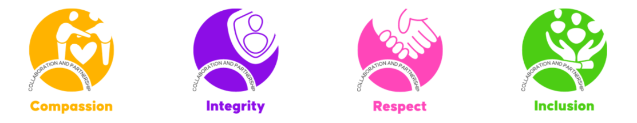
Each of our core values are underpinned by a range of principles and behaviours that describe what is expected from everyone to be successful in their roles and how we will work together in our teams and collaborate across our organisation to create high performance and a positive culture in the ICB.

Equality and Inclusion Awareness Briefings

Each month, the Culture and Inclusion Team compiles and circulates a monthly Equality and Inclusion Awareness Briefing for inclusion in ICB staff newsletters. The regular publication of these briefings allows the Culture and Inclusion Team to not only raise the profile of national awareness days, it also helps to draw attention to local awareness and celebration events and encourages staff to show their support.

Some examples of awareness campaigns featured in these briefings are displayed below:

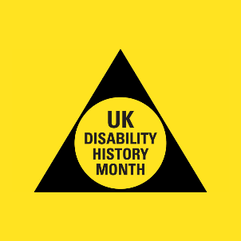
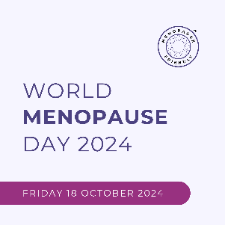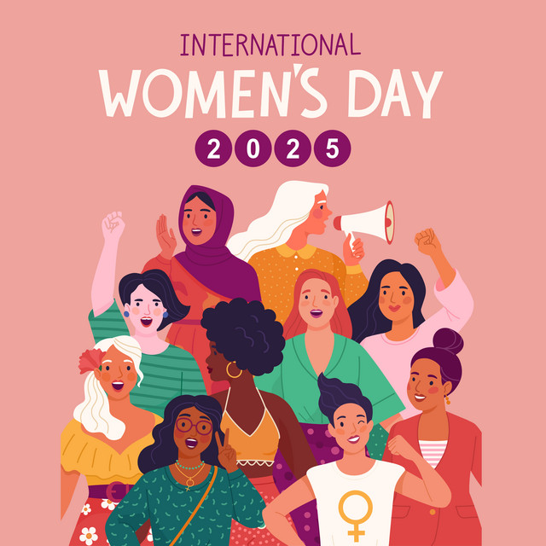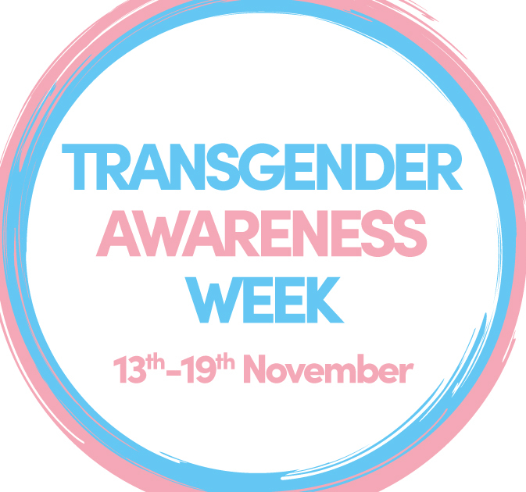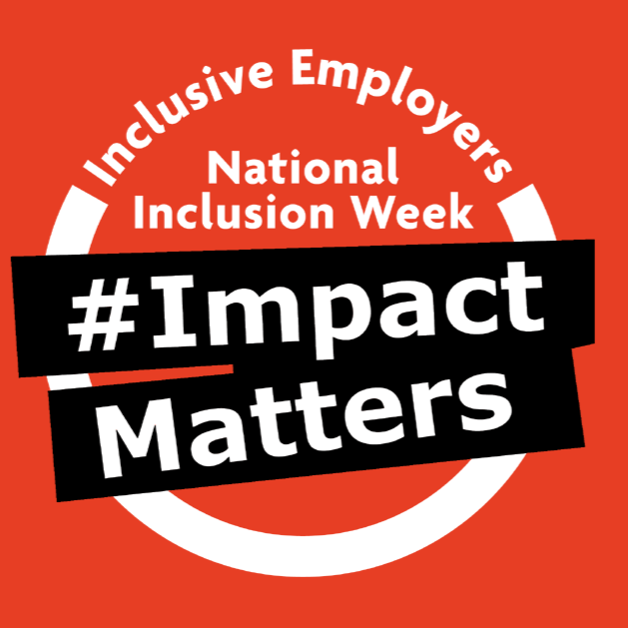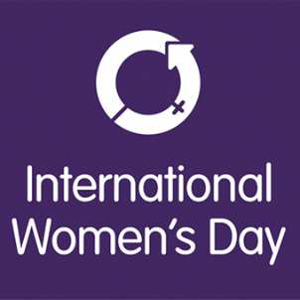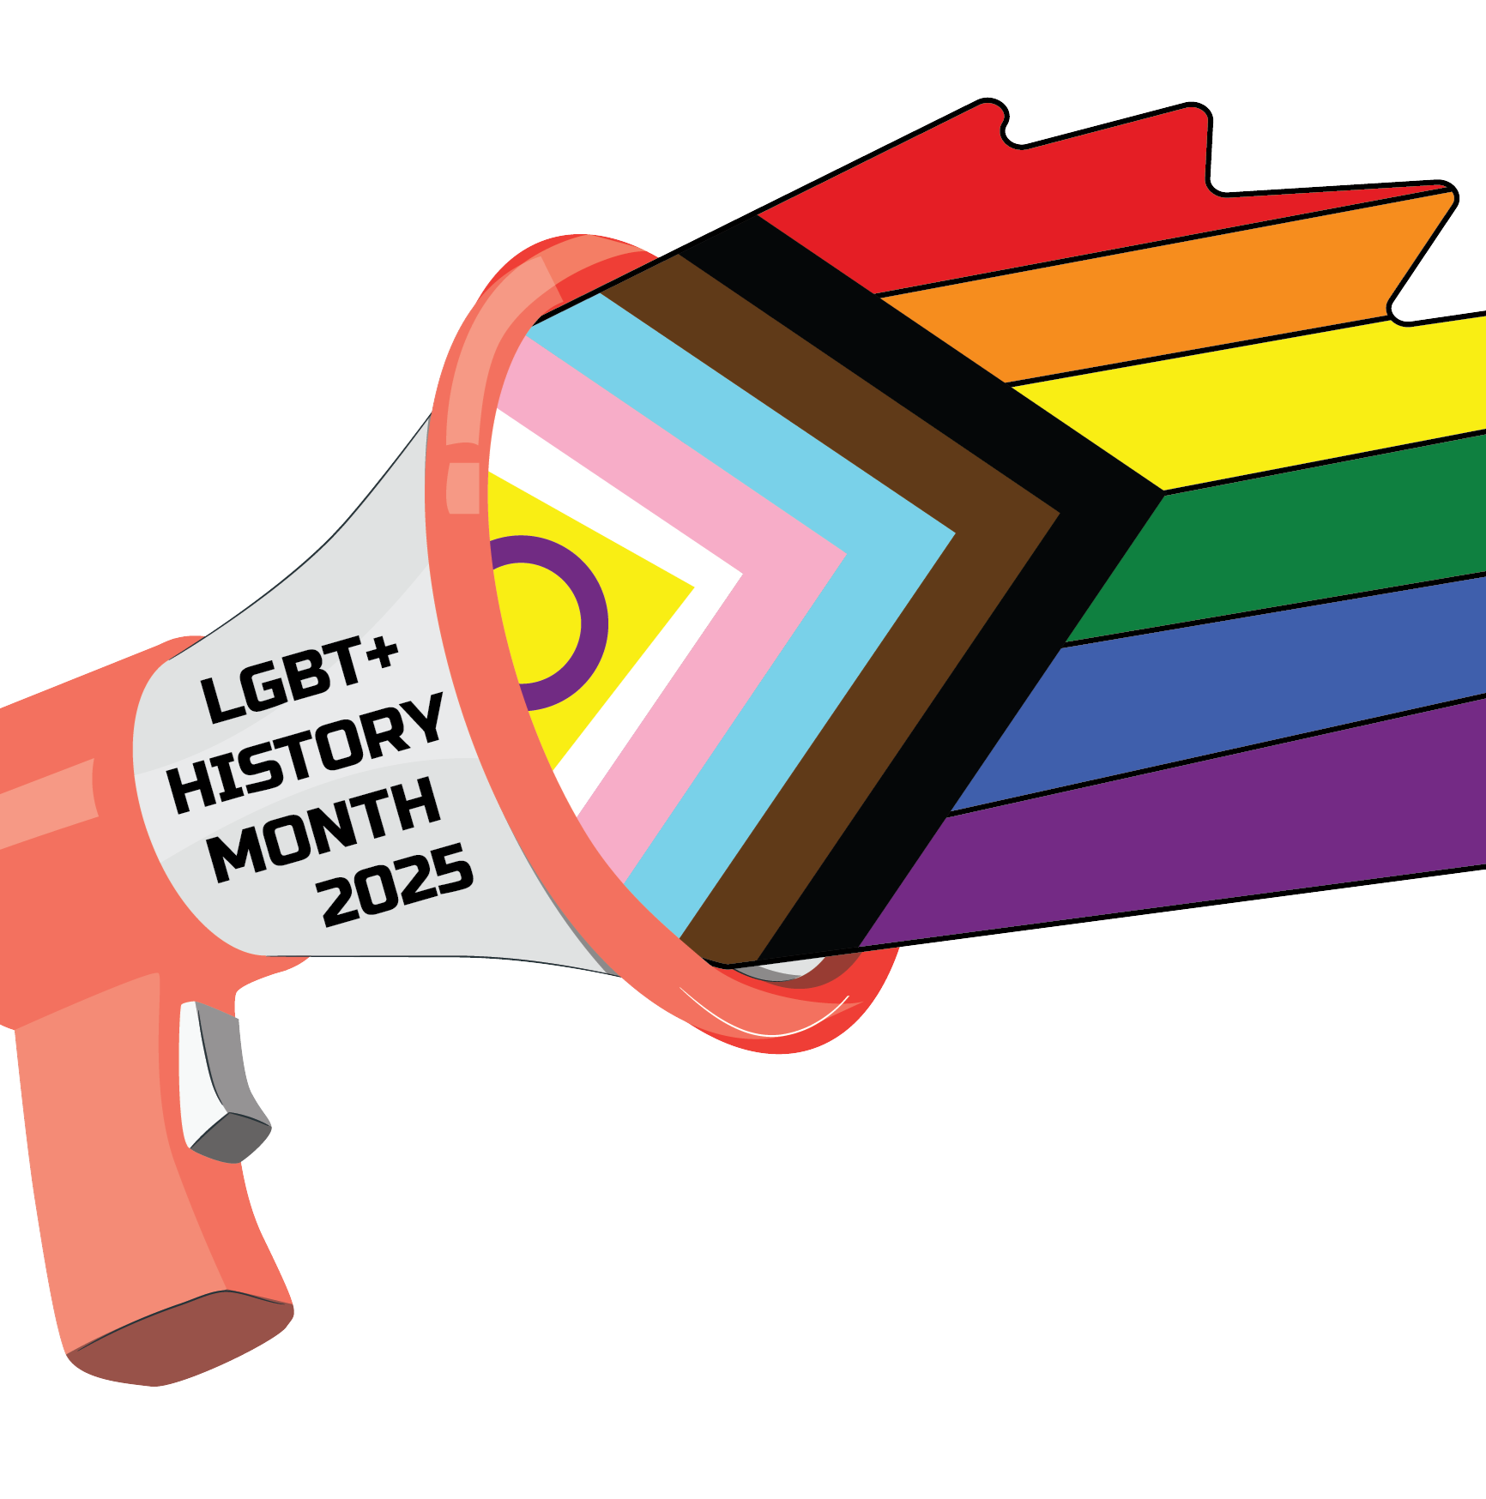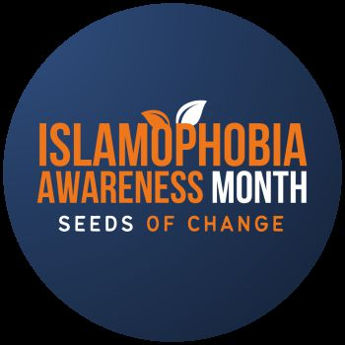


ICB Staff Networks

The ICB has established four internal staff networks, with a view to extending these to include wider protected characteristics in the future:

• Race Equality Network
• LGBTQ+ Network
• Disability Network
• Women’s Network

Throughout 2024/25, we have made good progress in the development and visibility of our staff networks. Each network now has an appointed Chair and an Executive Sponsor, ensuring strong leadership, guidance, and advocacy at a senior level. The networks continue to hold regular virtual meetings and remain open to all staff, regardless of their protected characteristics. Allies are welcomed and encouraged to participate, helping to foster inclusive and collaborative environments.

The staff networks are a key mechanism for driving meaningful change within the ICB and continue to influence both our culture and decision-making processes. Monthly cross-network Chair meetings have been introduced, providing a platform for collaboration, mutual support, and strategic planning to strengthen the visibility and impact of the networks across the organisation.

Over the past year, the staff networks have played an important role in coordinating awareness-raising activities aligned with national observances, including Black History Month, LGBTQ+ History Month, and Disability History Month. The Women’s Network has also led valuable work on menopause in the workplace, contributing to more inclusive and supportive workplace practices.

In addition to our formal staff networks, we have established an informal Carers’ Support Group. While not a formal network, this group provides a peer support space for staff with caring responsibilities, further reflecting our commitment to inclusion and wellbeing.

The functions of the staff networks remain integral to our EDI ambitions. These include:

  - Providing safe and supportive spaces for staff to discuss concerns, share experiences, and engage with key organisational workstreams and policies
  - Raising awareness of issues impacting staff and promoting inclusive practices
  - Offering support for staff navigating workplace challenges
  - Acting as a collective voice to inform and influence senior leadership and executive decision-making

The staff networks continue to provide valuable insight and expertise on equality, diversity, and inclusion, which is embedded into the ICB’s wider work on workforce development, staff experience, wellbeing, and inclusive policy.

The Culture and Inclusion team continues to support the networks, having established a Staff Network Operating Model and supported each group in developing a Terms of Reference. Now fully established, the networks are contributing feedback and insight to senior leaders and formal committees, helping to shape organisational policies, procedures, and the day-to-day experience of our workforce.

ICS Staff Network Chairs’ Development Programme

In 2024/25, the ICB undertook engagement with our ICS Belonging Strategic Group and the ICS Network of Networks Forum, which identified the development of an ICS Staff Network Chairs’ Development Programme as a key priority across the system. It was widely recognised that the effectiveness and sustainability of our staff networks across Lancashire and South Cumbria depends on having confident, well-equipped Chairs and Co-Chairs. Investing in their skills and leadership capabilities is essential to enabling them to champion inclusion, lead with impact, and support staff from all backgrounds in meaningful and transformative ways.

A skills gap analysis was circulated to all staff network chairs and co-chairs across the LSC ICS. The purpose of the skills gap analysis was to identify any areas of strengths and weaknesses that chairs and co-chairs felt that they had. Subsequently, the results of the skills gap analysis were analysed, and the following development areas were identified:

- Leading without authority and influencing leaders
- Effective chairing of meetings, including setting agendas and minute taking
- Marketing and engagement, in terms of getting financial support for Staff
- Collaborative leadership
- General Equality, Diversity and Inclusion (EDI) training
- Time management skills
- How to challenge senior leaders constructively

The results of the skills gap analysis determined what support or training the ICB could offer in the future and as part of the ICBs commitment to the ICS chairs development programme, the ICB delivered three development sessions throughout 2024-2025 to address the identified training needs. The development sessions delivered were: Collaborative Leadership (facilitated by the Associate Director of Population Health from the ICB Population Health team), an Unconscious Bias training session (delivered by the ICB Culture and Inclusion Team) and a Facilitating Great Network Experiences session (delivered and organised in partnership with the North West Leadership Academy) Additionally, an online training brochure was produced in collaboration with the North West Leadership Academy. The training brochure provides chairs and co-chairs with practical tips and guidance on convening and facilitating staff network spaces.

All development sessions were interactive and explored a collaborative approach for staff network chairs and co-chairs. The sessions offered attendees the opportunity to celebrate what they were proud of in their respective networks, what challenges they faced and gave the opportunity to share their staff network experiences with fellow colleagues. Sessions were well attended, and positive feedback was received, the key theme arising from the feedback was that chairs and co-chairs felt empowered to effectively organise facilitate safe spaces for their network members following the development sessions.

Belonging in the ICS

Belonging Operating Model

The ICB is committed to ensuring that all of our ICS partners are modern employers of choice whereby our workplaces reflect a compassionate and inclusive culture, and that our collective workforce is diversely representative at all levels. In support of this approach, the ICB’s Belonging Operating Model enables us to highlight clear accountability and governance routes to meet our priorities around culture and inclusion.

The Belonging Operating Model adopts an outcomes-led approach with a focus on three domains within the Belonging programme:

- Equality and diversity – ensuring that there is equal representation at all levels of the workforce, transparency in our decision-making processes, and fairness in our people processes and practices.

- Culture of belonging – ensuring that people at all levels display inclusive behaviours, senior leaders hold accountability for adopting good practice, our organisations are committed to learning, and that our people feel valued, feel safe to speak up and feel able to bring their whole selves to work.

- Employer commitment – ensuring that we work together to deliver high quality healthcare for underserved communities and that the diverse needs of patients are reflected in service design and delivery through robust Equality and Health Inequality Impact and Risk Assessments (EHIIRAs).

In 2024/25, the ICB has refreshed and re-established the roles of sub-committees attended by system colleagues designed to provide accountability and assurance around EDI, Culture and Belonging in Lancashire and South Cumbria.

The ICS Belonging Strategic Group provides strategic leadership, guidance and accountability for the delivery of EDI activities and belonging initiatives across the ICS. This sub-committee oversees the implementation of the ICS Belonging Plan and its goals, overseeing progress and ensuring the successful implementation of strategic EDI activities across the ICS. In turn, the ICS Belonging Strategic Group feeds into and provides assurance to the ICS People Committee.

Subsequently, the ICS Belonging Delivery Group has been established as the operational sub-group of the ICS Belonging Strategic Group. The Belonging Delivery Group is responsible for operationalising the actions and priorities defined by the Belonging Strategic Group. It acts as a key forum for the co-ordination, implementation, and monitoring of EDI and belonging initiatives across Lancashire and South Cumbria.

ICS Belonging Plan

The Lancashire and South Cumbria ICS Belonging Plan underpins the Belonging workstream and sets out a system-wide commitment to collaboratively create inclusive workplaces that enable our people to do their best work and create opportunities for our communities to thrive.

From a compliance perspective, the ICS Belonging Plan is also a key document in evidencing that the ICB and wider system partners are meeting their obligations to the Equality Act (2010) and routinely demonstrating due regard to the main aims of the Public Sector Equality Duty.

Development on the ICS Belonging Plan began in October 2022 when the ICB Culture and Inclusion Team engaged with representatives from each of the NHS Provider Trusts within the system to assess their current progress and priorities within their own EDI functions, and their EDI-related successes and challenges.

Throughout Q1 and Q2 of 2023/24, the draft Belonging Plan was socialised for suggestions and feedback with a range of colleagues and stakeholders from across the LSC system. This provided the ICB with a wealth of insightful and practical feedback which was incorporated into the final version of the Belonging Plan. The Belonging Plan was approved for publication by the ICB in November 2023 and can be accessed here.

Since the development of the Belonging Plan, the EDI, Culture and Belonging landscape has changed due to the publication of key strategic documents such as the national NHS EDI Improvement Plan and the regional Anti-Racist Framework, along with the heavy focus on financial recovery across our system. This is likely to impact on how we are able deliver upon the objectives and actions included in the Belonging Plan.

With this in mind, the Culture and Inclusion Team will continue to work with the ICS Belonging Strategic Group and Belonging Delivery Group throughout 2025/26 to develop specific priorities and actions for EDI, Culture and Belonging that can be effectively delivered in collaboration across the system within the confines of the current financial pressures we face.

North West BAME Assembly Anti-Racist Framework

Published in 2023, the NHS North West BAME Assembly Anti-Racist Framework aims to support organisations on the journey to becoming intentionally and unapologetically anti-racist. The framework encourages the tackling of structural racism and discrimination through collaboration, reflective practice, accountability and action. Through the embedding of the themes, deliverables and actions outlined into structures, processes, policies and culture, organisations will create meaningful change within their workforce and service delivery.

The framework is organised into three levels of achievement: Bronze, Silver and Gold. Each level builds on the next, encouraging organisations to make incremental changes and take consistent actions towards eliminating racial discrimination in their organisations.

Back in 2023/24, the ICB made a commitment to achieving the initial Bronze award under the Anti-Racist Framework. Additionally, as the lead organisation for the ICS, the ICB also committed to supporting and directing our NHS system partners to drive progress in these areas.

In May 2024, the ICB submitted its initial application for the Bronze Award from the North West BAME Assembly. While the submission was not successful, the feedback received acknowledged several areas of good practice and notable progress. However, the panel concluded that, as the ICB was still in its second year of operation, there was not yet sufficient evidence of measurable impact from its anti-racism initiatives.

Since then, the ICB has continued to strengthen its internal work in this area and is preparing to resubmit its application in the final quarter of 2025/26. This will follow the appointment of an Executive Sponsor for Anti-Racism in Q1 2025/26, which is expected to further support and drive progress.

Throughout 2024/25, the ICB has continued to support NHS system partners to achieve against the Anti-Racist Framework by hosting webinars and regularly discussing progress at our ICS Belonging Delivery Group meetings. Subsequently, East Lancashire Hospitals Trust, Lancashire and South Cumbria Foundation Trust and University Hospitals of Morecambe Bay both achieved their Bronze award in 2024/25.

More information about the North West Anti-Racist Framework can be found here.

Workforce Race Equality Standard (WRES) and Workforce Disability Equality Standard (WDES)

Following the introduction of the Workforce Race Equality Standard (WRES) in 2015, every NHS organisation has been required to submit individual annual WRES data returns to NHS England on an annual basis. Similarly, since 2018, NHS Trusts have been required to submit Workforce Race Disability Standard (WDES) data returns to NHS England.

Since the establishment of ICBs in July 2022, NHS England have not yet requested formal WRES and WDES data returns from Integrated Care Boards. However, as part of as our collaborative activities across the system, the ICB compiled an internal WRES and WDES data analysis report in 2024 to provide data about the workforce across these underrepresented groups. In turn, this has informed our current WRES and WDES action plan (approved in September 2024) which consists of the following actions:

- Focus on fair and equal representation across all pay bands to level out the bulge at band 7 and increase BME representation at more senior levels from band 8a and above.
- Provide targeted opportunities for BME people to progress and develop through the talent management route into more senior roles.
- Develop and implement a programme of work on ‘becoming an anti-racist organisation’
- Focus on improving the disability declaration rates across the workforce, including Board level.
- Focus on fair and equal representation across all pay bands to level out the bulge at band 7 and increase disabled representation at more senior levels from band 8a and above.
- Review sickness absence policy for disabled people and provide enhanced support for disabled people to feel supported during periods of ill health to return to work, ensuring our new reasonable adjustments process is effective.

WRES & WDES System Report 2024

In August 2024, the ICB Culture and Inclusion Team worked with NHS Provider Trusts within the ICS to produce our annual collated WRES and WDES System Report. The aim of the report was to analyse performance and progress against each of the WRES and WDES indicators across ICS Provider Trusts and to identify any priority areas for improvement and opportunities for targeted and collaborative action based on WRES and WDES submission data provided by each of the Trusts.

The report demonstrated that there are pockets of good performance against the WRES and WDES indicators – both as a system and as individual Trusts when compared to national and regional averages – and identified some areas of progress compared to the WRES & WDES System Report 2023.

NHS EDI Improvement Plan

The national NHS Equality, Diversity and Inclusion (EDI) Improvement Plan, published in June 2023, sets out a strategic framework to tackle bias, discrimination, and inequality across the NHS workforce. Its purpose is to ensure a consistently inclusive and equitable experience for all NHS staff, particularly those from underrepresented or disadvantaged groups. The plan outlines six High Impact Actions that must be implemented by all NHS organisations—including Integrated Care Boards (ICBs) and NHS Trusts—with a focus on leadership accountability, equitable recruitment and talent management, reducing pay gaps, improving experiences for internationally recruited staff, addressing health inequalities within the workforce, and eliminating bullying and harassment. The plan provides a clear and measurable set of expectations that hold NHS organisations accountable for creating inclusive cultures where all staff can thrive.

In 2024/25, Lancashire and South Cumbria ICB aligned its Belonging Plan and broader EDI programme with the NHS EDI Improvement Plan to support consistent implementation of the six High Impact Actions across the system. Notable progress includes:

- Ongoing development of an inclusive recruitment toolkit to address diverse under-representation across all pay bands.
- Publication of the Gender Pay Gap report and groundwork laid for an upcoming combined pay gap report (gender, race, disability) in 2025.
- Improved data collection and declaration rates, especially for disability and sexual orientation, enabling more accurate monitoring of workforce inequalities.
- Delivery of a broad programme of Belonging webinars and training sessions.

As part of its responsibilities under the NHS EDI Improvement Plan, Lancashire and South Cumbria ICB submits quarterly assurance returns to NHS England’s regional EDI team. These submissions provide structured evidence of the ICB’s progress against the six High Impact Actions, alongside insights into system-wide delivery and collaboration. The LEAF framework enables NHS England to monitor both the ICB’s internal EDI performance and the support it provides to its system partners. In 2024/25, the ICB coordinated the collation of provider trust returns across Lancashire and South Cumbria, ensuring a consistent approach and shared learning across the ICS. The assurance process has strengthened accountability, supported local alignment with national priorities, and enabled targeted action in areas such as inclusive recruitment, leadership diversity, and cultural transformation.

Our Communities

Lancashire and South Cumbria is an area in the North West of England, covering the southern parts of the Lake District in the north, rural areas of the Ribble Valley in the east, coastal towns such as Blackpool and Morecambe in the west, the urban cities and towns of Lancaster, Preston, Blackburn and Burnley, and market towns such as Ormskirk and Chorley in the south.


The total population of Lancashire and South Cumbria as of April 2024, is nearly 1.8 million residents.

Census 2021 results show that the resident population is evenly split between males and females. 20.6% are aged 65 and over, 28.6% are aged 24 and under, and 50.7% are aged between 25 and 64.

While the majority of Lancashire and South Cumbria residents are White, 12.3% of the population are from an ethnically diverse group (including non-white British).

2.9% of Lancashire and South Cumbria residents aged 16 and over identify as having a sexual orientation other than heterosexual or straight.

19.7% of residents in Lancashire and South Cumbria categorise themselves as being disabled under the Equality Act 2010, and 8.8% of those individuals feel that their day-to-day activities are limited a lot.

The average life expectancy rates for residents in Lancashire and South Cumbria are estimated to be 77.9 years for males, and 81.8 years for females. These figures are lower than the respective England averages of 79.4 and 83.1.

Population Profile of Blackburn with Darwen

The total population of the place-based partnership area of Blackburn with Darwen, as of April 2024 is approximately 149,700 residents.

The majority of the area’s residents live in the towns of Blackburn and Darwen with the remainder living in the rural villages and hamlets that surround the two major urban centres.

Census 2021 results show that the resident population is evenly split between males and females, and 14.3% are aged 65 or over, 34% are aged 24 or under, and 51% are aged between 25 and 64. 28.3% of its population is aged under 20, which is the 6th highest proportion in England.

The Blackburn with Darwen population is more diverse compared to other areas in Lancashire and South Cumbria, and while the majority of residents are White, 39.7% of the population are from an ethnically diverse group (including non-white British).

2.1% of Blackburn with Darwen residents aged 16 and over identify as having a sexual orientation other than heterosexual or straight. This is lower than the England rate of 3.1%.

18.5% of residents in Blackburn with Darwen categorise themselves as being disabled under the Equality Act, and 9.1% of those individuals feel that their day-to-day activities are limited a lot.

Life expectancy rates for residents in Blackburn with Darwen are lower than national averages. Life expectancy for males in the area is estimated to be 76.3 years compared to the England figure of 79.4, while life expectancy for females in the area is approximately 80.3 years compared to the England figure of 83.1.


Population Profile of Blackpool

As of April 2024, the total population of the place-based partnership area of Blackpool is approximately 142,708 residents.

Census 2021 results show that the resident population is evenly split between males and females, and that 20.6% are aged 65 or over, 26.9% are aged 24 or under, and 52% are aged between 25 and 64.

The majority of residents in Blackpool are White, with approximately 5.3% of the population coming from an ethnically diverse group (including non-white British).

5% of Blackpool residents aged 16 and over identify as having a sexual orientation
other than heterosexual or straight. This is higher than the England rate of 3.1%.

25.1% of residents in Blackpool categorise themselves as being disabled under the Equality Act, and 12.3% of those individuals feel that their day-to-day activities are limited a lot.

Life expectancy rates for residents in Blackpool are significantly lower than national averages. Life expectancy for males in Blackpool is estimated to be 74.1 years compared to the England figure of 79.4, while life expectancy for females in the area is approximately 79.0 years compared to the England figure of 83.1.



Population Profile of Lancashire

The place-based partnership area of Lancashire consists of the following twelve Local Authority districts: Burnley, Chorley, Fylde, Hyndburn, Lancaster, Pendle, Preston, Ribble Valley, Rossendale, South Ribble, West Lancashire and Wyre.

The total population of this area as of April 2024 is approximately 1.2 million residents.

Census 2021 results show that the resident population is evenly split between males and females, and 20.7% are aged 65 or over, 28.7% are aged 24 or under, and 50.5% are aged between 25 and 64.

The majority of Lancashire residents are White, with 11% of the population coming from an ethnically diverse group (including non-white British).

2.9% of Lancashire residents aged 16 and over identify as having a sexual orientation other than heterosexual or straight. This is similar to the England rate of 3.1%

19.3% of residents in Lancashire categorise themselves as being disabled under the Equality Act, with 8.5% of those individuals detailing that their day-to-day activities are limited a lot.

The average life expectancy from birth across all twelve Lancashire districts is 78.3 for males and 82.0 for females. Both of these figures are lower than the England statistics of 79.4 for males and 83.1 for females respectively.

Ribble Valley has the highest average life expectancy for males across Lancashire and South Cumbria as a whole, at 81.0. Whereas Burnley and Preston have some of the lowest life expectancy rates for females across Lancashire and South Cumbria at 80.3 and 80.5 respectively.


Population Profile of South Cumbria

The place-based partnership of South Cumbria consists of the Barrow-in-Furness and South Lakeland areas from within Westmorland and Furness Council, the Millom areas from within Cumberland Council, and the Craven area from within North Yorkshire Council.

The total population of this area as of April 2024 is approximately 186,478 residents.

Census 2021 results show that the population is evenly split between males (49%) and females (51%), and 25.7% are aged 65 or over, 23.8% are aged 24 or under, and 50.5% are aged between 25 and 64.

The majority of residents in South Cumbria are White British 94.7% (English, Welsh, Scottish, Northern Irish or British), with only 5.3% of the registered population coming from an ethnically diverse group (including non-white British).

Approximately 2.3% of South Cumbria residents aged 16 and over identify as having a sexual orientation other than heterosexual or straight. This is lower than the England rate of 3.1%

19.3% of residents in South Cumbria categorise themselves as being disabled under the Equality Act, with 8.1% of those individuals detailing that their day-to-day activities are limited a lot.

The average life expectancy from birth in Barrow-in-Furness is 77.1 for males and 80.6 for females. Both of these figures are lower than the England statistics of for males and 83.1 for females respectively. In contrast, South Lakeland, has the second highest average life expectancy in males across Lancashire and South Cumbria as a whole at 80.3, and the highest life expectancy for females across all Lancashire and South Cumbria districts at 84.8.


Deprivation in Lancashire and South Cumbria

People may be considered to be living in poverty if they lack the financial resources to meet their needs, whereas people can be regarded as deprived if they lack any kind of resources, not just financial income. There is a recognised link between deprivation and poorer health outcomes.

The Index of Multiple Deprivation (IMD) is the official measure of relative deprivation in England and is calculated by the Ministry of Housing, Communities and Local Government. The IMD follows an established methodological framework in broadly defining deprivation to encompass a wide range of an individual’s living conditions, and in general, the higher an area’s score is, the more deprived it is likely to be.

The table below details the IMD scores for each Local Authority district in Lancashire and South Cumbria as of 2019, and the difference compared to the national average. It also includes the IMD rank for each district, which summarises the average level of deprivation across all Local Authorities in England, with 1 being the most deprived and 317 being the least deprived.

Area | IMD Rank 2019 | IMD Score 2019 | ↑/↓ compared to national average
Blackburn with Darwen | 14th | 36.0 | ↑ 14.3
Blackpool | 1st | 45.0 | ↑ 23.3
Burnley | 11th | 37.8 | ↑ 16.1
Chorley | 192nd | 16.9 | ↓ 4.8
Craven | 239th | 12.8 | ↓ 8.9
Eden | 7th | 41.7 | ↑ 20.0
Fylde | 198th | 15.9 | ↓ 5.8
Hyndburn | 18th | 34.3 | ↑ 12.6
Lancaster | 112th | 24.2 | ↑ 2.5
Pendle | 36th | 30.7 | ↑ 9.0
Preston | 46th | 29.5 | ↑ 7.8
Ribble Valley | 282nd | 10.6 | ↓ 11.1
Rossendale | 91st | 24.1 | ↑ 2.4
South Ribble | 210th | 15.3 | ↓ 6.4
West Lancashire | 178th | 18.6 | ↓ 3.1
Wyre | 147th | 20.9 | ↓ 0.8
Barrow-in-Furness | 44th | 31.1 | ↑ 9.4
South Lakeland | 242nd | 12.5 | ↓ 9.2
England | - | 21.7 | -

Of the 18 Local Authorities in Lancashire and South Cumbria in 2019*, 8 rank amongst the 50 most deprived districts in England (with Blackpool being ranked as the most deprived), and five rank between 192-282 at the least deprived end of the IMD.

The IMD 2019 scores show that rates of deprivation are indeed variable across Lancashire and South Cumbria, with ten Local Authorities having higher levels of deprivation than the national average, six having lower levels, and one lone district having a similar score to the England average.

However, it should be noted that while the IMD scores and ranks in the table above give a useful broad insight into deprivation in each Local Authority (and place-based partnership area), there will be variations in deprivation at local levels that may relate to a range of socio-economic and population factors.

*Please note that since the 2019 IMD index was published, local authority boundaries in South Cumbria have been reconfigured and replaced with Westmorland and Furness Council, Cumberland Council and North Yorkshire Council. The figures included in the above table reflect the previous local authority districts that now form part of the South Cumbria footprint of the ICS.

Deprivation at LSOA level

Differences in relative deprivation are not just regional but can also occur between neighbourhoods too. Lower-Layer Super Output Areas (LSOAs) are small areas designed to be of a similar population size, with an average of approximately 1,500 residents or 650 households.

Each LSOA in England is ranked into 10 deprivation deciles, with the LSOAs in decile 1 being deemed to be the most deprived 10% nationally, and LSOAs in decile 10 being the least deprived 10% nationally. There are currently 1,049 LSOAs in Lancashire and South Cumbria in total, and 198 (18.9%) of those are in decile 1, meaning that they are considered to be amongst the most deprived 10% in the country.

The majority of the LSOAs that are in the most deprived decile across Lancashire and South Cumbria are located in the Local Authorities of Blackpool, Burnley, Blackburn with Darwen, Eden and Pendle, and these particular districts also rank amongst the top 20 Local Authorities in England in regard to the proportion of such neighbourhoods. However, these districts do also have small proportions of LSOAs in the least deprived deciles, illustrating how levels of deprivation can look very different across a particular patch.

Core20PLUS5 – An approach to reducing health inequalities

Introduced in 2021-22, Core20PLUS5 is a national NHS England and NHS Improvement approach to support the reduction of health inequalities at both national and system level. The approach defines a target population cohort – the ‘Core20PLUS’ – and identifies ‘5’ focus clinical areas requiring accelerated improvement on a national level.

Core20:

The most deprived 20% of the national population as identified by the national Index of Multiple Deprivation (IMD). The IMD has seven domains with indicators accounting for a wide range of social determinants of health.

PLUS:
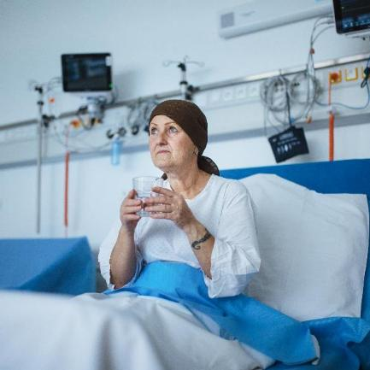
Locally determined population groups experiencing poorer than average health access, experience and/or outcomes, but not captured in the ‘Core20’ alone. This should be based on local population health data.

Such population groups may include ethnic minority communities, coastal communities, people with multi-morbidities, protected characteristic groups, people experiencing homelessness, drug and alcohol dependence, vulnerable migrants, Gypsy, Roma and Traveller communities, sex workers, people in contact with the justice system, victims of modern slavery and other socially excluded groups.

Lancashire and South Cumbria Integrated Care System will continue its work on identifying local priorities and inclusion groups relating to Core20PLUS5 throughout 2024-25.

5:

The final part sets out five clinical areas of focus where a need has been identified for improvements on a national level:

- Maternity: ensuring continuity of care for 75% of women from Black, Asian and minority ethnic communities and from the most deprived groups.

- Severe mental illness (SMI): ensuring annual health checks for 60% of those living with SMI (bringing SMI in line with the success seen in learning disabilities).

- Chronic respiratory disease: a clear focus on Chronic Obstructive Pulmonary Disease (COPD) driving up uptake of COVID, flu and pneumonia vaccines.

- Early cancer diagnosis: 75% of cases diagnosed at stage 1 or 2 by 2028.

5. Hypertension case finding: to allow for interventions to optimise blood pressure and minimise the risk of myocardial infection and stroke.

Lancashire and South Cumbria Integrated Care Strategy:

The Lancashire and South Cumbria Integrated Care Strategy describes how organisations in the Lancashire and South Cumbria Integrated Care Partnership will work together to reduce inequalities identified as part of Core20PLUS5, improve the health and wellbeing of our residents, and achieve our vision of longer, healthier, happier lives. The strategy sets a number of priorities focused on the life course of our residents:

Starting Well – Giving our children the best start in life, supporting them and their families with problems that affect their health and wellbeing, and getting them ready to start school.

Living Well – Reducing ill health and tackling inequalities across mental and physical health for people of all ages by understanding the cause of these unfair differences.

Working Well – Increasing ambition, aspiration and employment, with businesses supporting a health and stable workforce and employing people who live in the local area.

Ageing Well – Supporting people to stay well in their own home, with connections to their communities and more joined up care.

Dying Well – Encouraging all of our residents to feel comfortable in talking about planning for dying, and to be well-supported when a loved one dies.

Some of the themes that will help us deliver on these priorities include:

- ‘One workforce’ across health and care, helping services be more joined up for our residents.
- Supporting unpaid carers with their own health and wellbeing as well as the people they are looking after.
- Using digital resources and making better use of information about our population.
- Using our buildings as collective resources across communities.
- Committing to sustainability in health and care services to reduce our environmental impact.

For more information about our Integrated Care Strategy, please visit the following link - https://lscintegratedcare.co.uk/our-work/our-strategy

Good Practice in Engagement and Service Delivery

Male suicide prevention campaign challenges barriers to seeking help
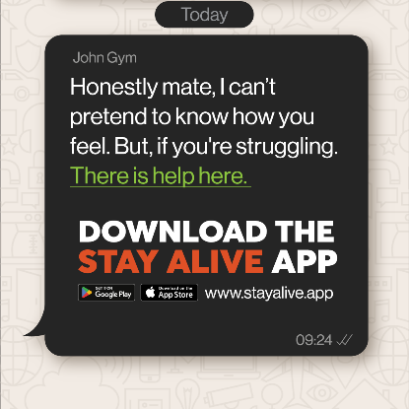

Lancashire and South Cumbria Integrated Care Board launched a new campaign in March 2025 which is dedicated to tackling the issue of male suicide in the region.
Suicide is the single biggest killer of men under the age of 49, and rates in the North West are now the highest in the UK. The Let’s Keep Talking campaign aims to help males in the region understand that reaching out and seeking help isn’t a weakness, and that there is support available.
Helen Parry, suicide prevention lead for Lancashire and South Cumbria Integrated Care Board, said: “Male suicide is a big issue that can't be ignored any longer. It's unacceptable that so many men are dying, yet there is still so much stigma surrounding this subject. We are hopeful that this campaign will raise awareness of male suicide, reducing the stigma attached to mental health, and get people talking.”
The campaign seeks to extend suicide prevention beyond its focus on individual mental health, to understand the social and cultural context which contributes to people feeling suicidal. For example, men may compare themselves against what is termed the masculine ‘gold standard’ that represents the man as the breadwinner who looks after his family, and when they cannot do this, some men may feel a sense of shame and defeat, which can lead them to suicide.
Helen continued: “Men are also generally less likely to seek formal emotional support for their problems and will often reach crisis point before they do, as unhelpful stoic beliefs that emotional expression is weak and unmasculine still persist today. We need to challenge the stigma of that image so future generations of males can seek out the support they need, when they need it the most.”

Targeted Lung Health Checks in Lancashire and South Cumbria reach cancer diagnosis milestone

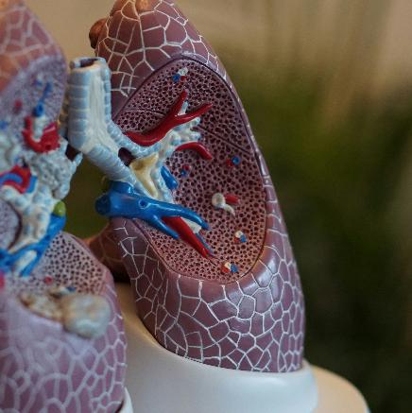
More than 300 people in Lancashire and South Cumbria have had cancers diagnosed early because of Targeted Lung Health Checks.
The national initiative, which had its first pilot in the region in 2021, invites people considered to be at risk of lung cancer for health checks with the aims of finding cancer before symptoms appear and improving patient outcomes as a result.

A 15-minute telephone assessment is offered to those aged 55-74 who are known by their GP as having ever smoked, where a health professional then assesses their risk of developing lung cancer over the next five years, and anyone found to be at high risk is offered a CT scan.

Lancashire and South Cumbria Cancer Alliance Senior Programme Manager Anne Turner said: “Across our region, more than 45,000 people have participated in the Targeted Lung Health Check programme, and 300 have benefitted from potentially lifesaving treatment and have a better chance of recovery thanks to an earlier diagnosis.”

The large majority of people who participate in this initiative will receive the all-clear, giving them peace of mind, and those who are scanned are offered follow-up CT scans every two years.

Finding cancer early and starting curative treatment can be the difference between life and death. Lung cancer traditionally presents late as there are no symptoms of disease in its early stages, so the lung screening programme presents a real opportunity to increase early diagnosis and save lives.

Due to the success of this programme, Targeted Lung Health Checks are now being rolled out across the country and will become part of the national screening remit by 2029, and become known as ‘Lung Cancer Screening’. It is currently being offered to patients that meet the criteria in Fylde and Wyre and will be rolled out across other areas of Lancashire and South Cumbria in the coming months.
Lancashire and South Cumbria football CCOs unite for cancer ‘prehab’

Football club community organisations (CCOs) across Lancashire and South Cumbria have come together to help people with cancer to prepare for treatment.
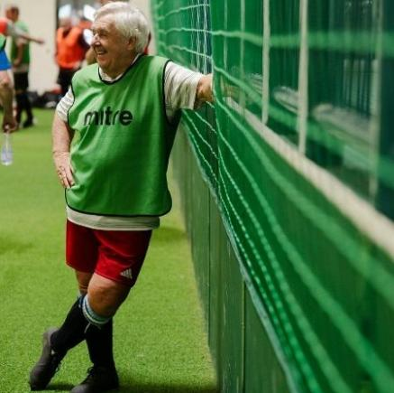
The CCOs of the region’s eight English Football League sides are now all offering free ‘prehab’ training sessions to adult cancer patients with the goal of improving their health and fitness ahead of oncological care or surgery.

The one-year pilot programme, launched in collaboration with the Lancashire and South Cumbria Integrated Care Board Cancer Alliance, sees the community organisations from Accrington Stanley, Barrow AFC, Blackburn Rovers, Blackpool FC, Burnley FC, Fleetwood Town, Morecambe FC, and Preston North End hosting two-hour sessions aimed at encouraging patients to be more active as well as offering a chance for social and mental wellbeing support.

Faye Bennett, cancer quality improvement lead for the Cancer Alliance, said: “Prehabilitation, or preventative rehabilitation is well documented to improve quality of life for cancer patients and patient outcomes.”

Susan Saul, clinical lead physiotherapist for prehabilitation agreed, adding: “Proven benefits of increasing fitness and optimising health ahead of surgery can include reduced side effects of treatment, a reduced risk of complications, shorter length of stay and a quicker recovery.”

The sessions consist of a group exercise tailored to suit the individuals in attendance, followed by a chance to sit down for a cup of tea and a chat with support staff and fellow patients.

Patients aged 18 and over are able to self-refer onto the sessions, and oncologists, clinical nurse specialists, multi-disciplinary teams and Macmillan staff also have the details of the sessions taking place at their local clubs. Football club community organisations (CCOs) across Lancashire and South Cumbria have come together to help people with cancer to prepare for treatment.

Lancashire and South Cumbria Integrated Care Board signs Armed Forces Covenant

Representatives of Lancashire and South Cumbria Integrated Care Board signed the Armed Forces Covenant in November 2024, reaffirming local NHS support, and the ICBs commitment to the Armed Forces community (which includes those with serving partners or spouses, military families, veterans, reservists, and voluntary leaders in military cadet organisations).

Of the 1.8 million people living in Lancashire and South Cumbria, approximately 65,500 are veterans, and this group are significantly more likely to have a long-term illness, disability, or suffer with poor mental health, when compared to the general population. A recent survey of veterans also found that more than half found it difficult to speak up about mental health issues and are often unsure how to access help when they need it.

The ICB has a statutory duty under The Armed Forces Act (2021) to show ‘due regard’ to the unique obligations of and sacrifices made by the Armed Forces, which it plans to achieve through the pledges outlined in the Covenant, as both a major employer in the region and a planner and commissioner of services.

ICB Chair Emma Woollett said: “It is important for us to look after our veterans from a health and wellbeing point of view, removing barriers to accessing the help and support that is available. The ICB commissions dedicated physical and mental health services for veterans and service leavers across Lancashire and South Cumbria, such as specialist mental health support, designed specifically for those due to leave the military, reservists, armed forces veterans and their families.”

The next major milestone will be to secure the Defence Employer Recognition Scheme (ERS) Bronze award and build on this foundation as an ‘anchor’ health organisation, by creating opportunities for colleagues to share learning, knowledge and best practice.

Workshops and exhibition held as part of a Lancashire and South Cumbria menopause project


Stories and artwork created by participants expressing their journeys through menopause went on display in Lancaster in October and November 2024.

The Venus Revisited project, which was conducted by Kath McDonald from King Street Arts in Lancaster and supported by the Lancashire and South Cumbria Integrated Care Board, explored how women discuss their personal experiences of menopause, and held workshops between 2022 and 2024 to enable women to express their thoughts about the changes to their bodies and mind through clay sculpture.

An exhibition featuring drawings, photos and other artwork from the workshops was also on display to the public as part of the project.

Although the menopause is now a hot topic, the study found that many participants had never discussed their personal experiences of menopause with anyone else, and as a result, often felt socially isolated and had no context to know if the symptoms and changes they were experiencing were normal.

Kath said: “The Venus Revisited project created a safe space for women to come together and compare notes with others in a similar position, explore their new sense of self and body in clay and drawing, and to celebrate the discovery of their older selves.”

Dr Jennifer Horrocks is a GP from Bay Medical, who facilitated one of the workshop sessions, and says it is something that she would like to see rolled out across Lancashire and South Cumbria: “This has been a great, innovative arts project and has added tremendous value to our local community, truly enhancing these women's experience of their menopause journey.”

A publication compiled by the participants including information about local support services, will soon be available in GP surgeries, libraries and community hubs in the region.

Funding awarded to project aiming to give people in care medication independence


Lancashire and South Cumbria Integrated Care Board, Lancaster University, and partners are set to receive £1.2m in funding from the Department of Health and Social Care’s Adult Social Care Technology Fund to deliver a project that explores the potential of ‘smart medication’ devices with the aim of helping people manage their prescription medication schedules, symptoms, and changes.

Medication administration is a major task for care services, with social care workers increasingly given the responsibility of both assisting with and administering medication in domiciliary care settings. Digital medication devices could lessen the need for in-person care visits and help patients by giving them the independence to manage their medication in their own homes.

The project (which will be independently assessed by the University of Lancaster) will evaluate whether using a technology-enabled smart medication device (or a digital dosage monitoring system) as part of domiciliary care, will provide an effective and time-saving solution that will benefit the person receiving prescription medication, the domiciliary care market, the NHS and local authorities.

Andrew White, chief pharmacist for the ICB, said: “As we introduce digital medication management and it becomes more routinely used and accepted by local people and providers, we will begin to see if these devices can empower people to take full responsibility for their medication, free capacity in the domiciliary care market, and automate the process of medication delivery to ensure safety and quality of care."

The project is set to run for three months, with the teams involved supporting participants to replace their in-person medication-only visits with medication monitoring from a distance via use of the smart devices, to assist them to move towards the ultimate aim of complete medication independence.
COVID-19 vaccination programme team shortlisted for Nursing Times Award

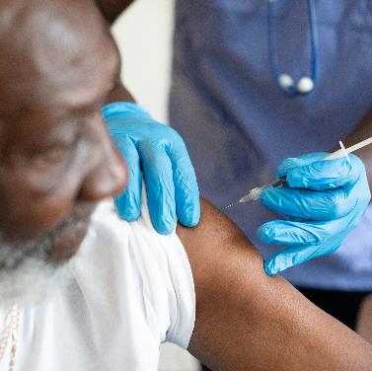
The Lancashire and South Cumbria Integrated Care Board COVID-19 vaccination team’s care home vaccinations project was shortlisted in the ‘Care of Older People’ category as part of the 2024 Nursing Times Awards.

Since the pandemic began, people living and working in care homes have been disproportionately affected by COVID-19. The Integrated Care Board’s vaccination team led a new model of delivery during the autumn/winter 2023 COVID-19 and flu vaccination campaign, that aimed to improve vaccine uptake and the overall vaccination experience amongst residents and staff of nursing homes at Risedale Care Homes in Barrow.

This approach to the winter vaccination campaign used the unique bond between residents and care home staff by training and supporting the registered nurses working in the care homes to administer vaccinations. The team developed and delivered a practical, in-person training programme which enhanced the NHS standard online vaccination training and incorporated peer support for registered nursing staff.

The project led to an increase in vaccine uptake amongst residents and staff alike, an improved vaccination experience for all, and a reduced level of staff sickness with absences dropping from 130 to three in a twelve-month period.

The model was highlighted as being easily scalable across the region and beyond, and could be applied to other vaccinations for this eligible group. It also provides an opportunity to develop professional connections and enhance clinical skills amongst care home staff.

Our Equality Objectives 2024 - 2027

As required by the Public Sector Equality Duty (PSED) of the Equality Act (2010), public sector organisations are required to prepare and publish one or more equality objectives at least every four years. These objectives must be specific and measurable, address one or more of the three equality aims in the Public Sector Equality Duty and one or more of the protected characteristics set out in the Equality Act (2010).

By setting equality objectives and targets, the ICB aims to meet its legal obligations while driving strategic and demonstrable equality improvements and improve health outcomes relating to relevant protected characteristics within our resident populations and our workforce.

In 2024/25, the ICB developed a set of refreshed equality objectives for the ICB to work towards between 2024 and 2027. These objectives are focussed on both service delivery and our workforce.

Service delivery focused equality objectives

Objective 1: By March 2025, to demonstrate that maternity and neonatal insight, co-production and engagement (ICE) activity is focused on service users and their families who are representative of the diversity of the local (maternity) population.

This objective was developed to support the delivery of “Intervention 6: ensure the Maternity Voice Partnerships in your Local Maternity Services reflect the ethnic diversity of the local population, in line with NICE QS167”. It was agreed that this objective would be progressed via the following actions:

ACTION: Development and implementation of a robust, system-wide data collection tool for ICE activity

PROGRESS: Significant progress has been made in standardising and improving data collection on ICE activity across the maternity system. During 2024/25, the ICB supported the implementation of a structured “Activity Monitoring Spreadsheet” across all four Maternity and Neonatal Voices Partnerships (MNVPs). This tool records detailed demographic data and themed feedback from service users, which is reported monthly to the LMNS board and disseminated at the Trust level. It has enabled more consistent tracking of engagement, particularly with seldom-heard groups, and allows better alignment of MNVP activities with strategic objectives.
Enhancements are planned for 2025/26 to improve data accuracy and reduce the number of unknown demographic entries. Tablets and access to Smart Survey platforms have also been distributed to all MNVPs to support real-time data collection during community engagement.
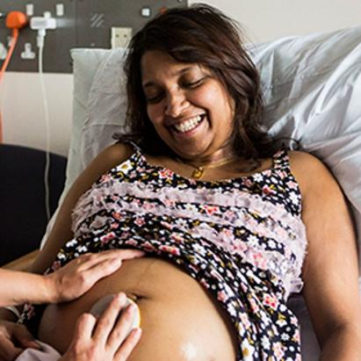
ACTION: Produce an updated population health needs analysis of the maternity population which will include population demographics

PROGRESS: As part of the ongoing commitment to understanding and responding to population health needs, the ICB has worked with Healthwatch Lancashire and the MNVPs to gather a richer set of demographic data through community engagement and structured survey tools. The 2024/25 MNVP engagement data shows a strong reach into diverse populations, including:

- 46% of known service users from the lowest quintile of deprivation
- Increased engagement with refugees, Eastern European populations, and asylum seekers
- Targeted work with ethnic minority women experiencing specific health issues, such as postpartum haemorrhage
- Quarterly sessions with asylum-seeking populations and co-production with community organisations

This evolving dataset is informing the refresh of the maternity population health needs analysis, to be completed in 2025. This analysis will guide more equitable service delivery and ensure the LMNS is responsive to changing local demographics.

ACTION: Delivery of targeted ICE activity with identified cohorts and communities:

PROGRESS: ICE-focused activity has been embedded across MNVP workstreams, demonstrating a clear shift towards targeted engagement and co-production. Examples include:

- Bay-wide MNVP: Developed bereavement suite plans with input from bereaved families and established a user group for sustained work on induction of labour.
- Blackpool, Fylde and Wyre MNVP: Engaged asylum seekers through quarterly sessions at the Metropole Hotel and co-produced local resources with Blackpool Family Hub to support postnatal care.
- East Lancashire MNVP: Created an Engagement Lead role to improve reach among hard-to-reach groups and improve access to translation and communication support.
- PCSR MNVP: Focused on engagement with ethnic minority mothers, particularly around infant feeding and the use of donor milk, and collaborated with the Race & Health Observatory on PPH.

The ICB has also increased support to MNVPs through additional roles, including a dedicated Team Leader to support coordination and communication. Volunteers and new roles have strengthened local capacity, with models being evaluated for wider rollout.

Objective 2: To improve completeness and accuracy of ethnicity coding in primary care for patients assessed as having mild-moderate frailty.

This objective was developed to enable us to better understand frailty in different ethnic groups, to map need and to tailor services to better reflect needs. In order progress this objective, the following actions were agreed

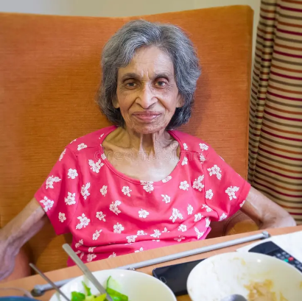
ACTION: Completed an audit of completeness and accuracy by December 2024, to provide a baseline for future improvement for patients within the assessed frailty cohorts with an aspiration of 80% having up to date and accurate ethnicity coding for those patients who have received a frailty review by March 2025

PROGRESS: We have completed the NHS General Practice Quality and Outcomes Framework for 2024/25 incorporating the assessments of individuals with mild-moderate frailty. 78,736 assessments were undertaken during this period using a template to assess unmet need and enable the General Practice workforce to improve the coding of ethnicity. We are currently undertaking a post-hoc analysis (beyond activity monitoring for assurance and payment purposes) to assess impact on quality of care delivered and system activity. The process to focus on ethnicity (amongst other items) has been delayed due to capacity and priority challenges but is expected to complete by July 2025.

Objective 3: By March 2025 to have used the 2021 census data to map the LGBTQ population for Lancashire and South Cumbria and to understand the correlation with Core20plus populations

PROGRESS: In 2024/25, the ICB’s Population Health Team successfully completed the mapping of the LGBTQ population across Lancashire and South Cumbria using data from the 2021 Census. This work involved detailed analysis and cross-referencing of demographic data to identify geographical distribution patterns of LGBTQ communities within the region. As a result, a dynamic and user-friendly dashboard has been developed, which enables us to visualise LGBTQ population clusters at a local level. The dashboard also integrates Core20PLUS data, allowing for a deeper understanding of where LGBTQ populations intersect with other priority or underserved groups. This tool is now informing targeted planning and resource allocation to address health inequalities more effectively.

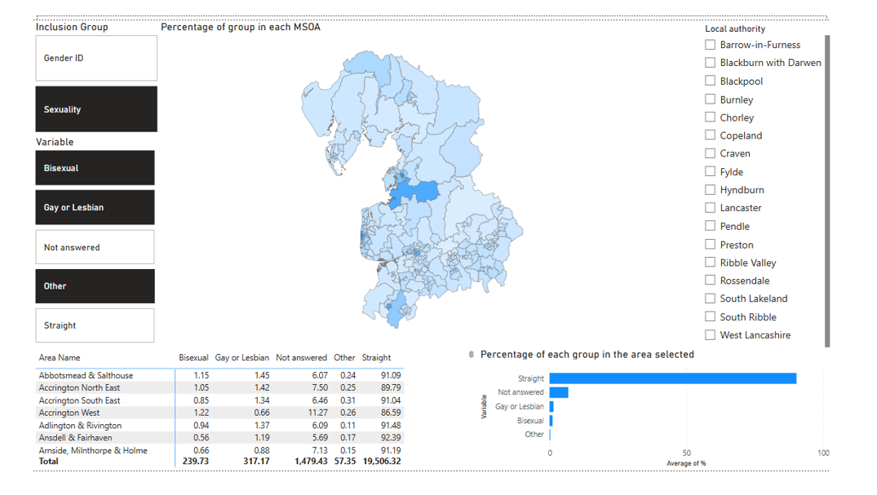

Workforce focused equality objectives

Objective 1: Increase the proportion of staff declaring their diversity monitoring information via ESR to enable a better understanding of the diverse composition of the ICB workforce

ACTION: Increase ethnicity sharing rates across the overall workforce from 91.9% to 98% by the end of 2026/27. This will include a particular focus on increasing ethnicity declaration rates at Band 8b and above where declaration rates are currently lowest, and with an aspiration for 100% declaration rates at Band 9 and VSM levels by the end of 2025/26.

PROGRESS: Throughout March 2025, the ICB Culture and Inclusion Team launched a campaign to encourage employees to self-report their diversity monitoring information via the Electronic Staff Record (ESR). As a result, we have seen ethnicity reporting rates rise from 91.9% (as of 31 March 2024) to 94.5% (as of 31 March 2025) which suggests that we are on course to reach our target of 98% by the end of 2026/27.

As of 31 March 2025, ethnicity declaration rates at Bands 8A to 9 sit at 93.4% with non-AfC declaration rates sitting at 83.8%. This demonstrates a need for targeted activities to ensure that senior leaders update their diversity monitoring data in order to achieve 100% declaration rates at Band 8B and above by the end of 2025/26.

ACTION: Increase disability sharing rates across the overall workforce from 59.9% to 75% by the end of 2025/26, increasing to 85% by the end of 2026/27. This will include a particular focus on increasing disability declaration rates at Band 8a and above where declaration rates are currently lowest, and with an aspiration for 100% declaration rates at Band 9 and VSM levels by the end of 2025/26.

PROGRESS: Throughout March 2025, the ICB Culture and Inclusion Team launched a campaign to encourage employees to self-report their diversity monitoring information via the Electronic Staff Record (ESR). However, we have seen a slight decrease in disability reporting rates from 59.0% (as of 31 March 2024) to 57.7% (as of 31 March 2025) which suggests that there are still significant actual or perceived barriers to staff feeling confident enough to formally record their disability status. We have seen a slight increase in the number of staff declaring that they have a disability on ESR – rising from 7.0% (2024) to 7.3% (2025). It should also be noted that the overall workforce has seen a headcount increase of 80 people between 31 March 2024 and 31 March 2025 which may have some bearing on the overall decrease in declaration rates.

As of 31 March 2025, disability declaration rates at Bands 8A to 9 sit at 62.9% with non-AfC declaration rates sitting at 35.5%. This demonstrates a need for targeted activities to ensure that senior leaders update their diversity monitoring data in order to achieve 100% declaration rates at Band 8B and above by the end of 2025/26.

ACTION: Increase sexual orientation sharing rates across the overall workforce from 56.6% to 70% by the end of 2025/26, increasing to 80% by the end of 2026/27, with an aspiration for 100% declaration rates at Band 9 and VSM levels by the end of 2025/26.

PROGRESS: Throughout March 2025, the ICB Culture and Inclusion Team launched a campaign to encourage employees to self-report their sexual orientation monitoring information via the Electronic Staff Record (ESR). As a result, we have seen sexual orientation reporting rates rise from 57.3% (as of 31 March 2024) to 65.8% (as of 31 March 2025) which suggests that we are on course to reach our target of 80% by the end of 2026/27.

As of 31 March 2025, sexual orientation declaration rates at Bands 8A to 9 sit at 67.9% with non-AfC declaration rates sitting at 37.1%. This demonstrates a need for targeted activities to ensure that senior leaders update their diversity monitoring data in order to achieve 100% declaration rates at Band 8B and above by the end of 2025/26.

Objective 2: Increase diverse representation across all levels of the workforce

ACTION: Increase BME workforce representation from the current position of 7.1% by the end of 2026/27

PROGRESS: As of 31 March 2025, overall BME workforce representation currently sits at 7.5% demonstrating a slight increase since our refreshed equality objectives were agreed. However, it should be noted that the current financial landscape has led to limited opportunities to recruit and promote staff into new/existing roles.

ACTION: Increase disability workforce representation from the current position of 6.3% by the end of 2026/27.

PROGRESS: As of 31 March 2025, overall disabled workforce representation currently sits at 7.3% demonstrating a slight increase since our refreshed equality objectives were agreed. However, it should be noted that the current financial landscape has led to limited opportunities to recruit staff into new roles.

ACTION: Increase LGBQ+ workforce representation from the current position of 3.2% by the end of 2026/27.

PROGRESS: As of 31 March 2025, overall LGBQ+ workforce representation currently sits at 3.6% demonstrating a slight increase since our refreshed equality objectives were agreed. However, it should be noted that the current financial landscape has led to limited opportunities to recruit staff into new roles.

Objective 3: Improve the experiences of our diverse workforce and reducing instances of diverse staff reporting incidents of discrimination, bullying and harassment

ACTION: Undertake a full reset of organisational values and behaviours by the end of 2024/25.

PROGRESS: Throughout 2024/25, we undertook work to launch our new Lancashire and South Cumbria ICB values and behaviour framework which sets out how we will collectively create the culture to achieve our vision and purpose. Between October 2024 and February 2025, we held a range of workshops and session to listen to our people about what the values and behaviours they felt we were important to them. Based on this feedback, we established a set of core values and behaviours based on Compassion, Integrity, Respect and Inclusion to foster a positive organisational culture as a great place to work, delivering high quality, safe and effective health and care. For more information, please see page 21 of this report.

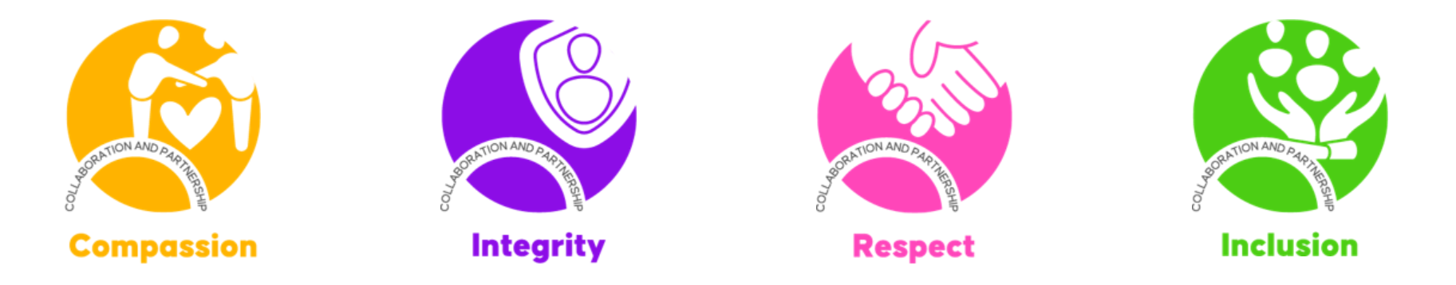

ACTION: Achieve the NW Anti-Racist Framework Bronze award by the end of 2025/26 with an aspiration to achieve the Silver award by the end of 2026/27

PROGRESS: In May 2025, the ICB submitted its initial application for the Bronze Award from the North West BAME Assembly. While the submission was not successful on this occasion, the feedback received acknowledged several areas of good practice and notable progress. However, the panel concluded that, as the ICB was still in its second year of operation, there was not yet sufficient evidence of measurable impact from its anti-racism initiatives.

Since then, the ICB has continued to strengthen its internal work in this area and is preparing to resubmit its application in the final quarter of 2025/26. This will follow the appointment of an Executive Sponsor for Anti-Racism in Q1 2025/26, which is expected to further support and drive progress. For more information, please see page 27 of this report.

ACTION: Deliver a programme of cultural learning opportunities (e.g. webinars and listening rooms) via our Belonging workstream.

PROGRESS: As part of the ICB’s commitment to Belonging which includes listening to our people and understanding their needs, the Culture and Inclusion Team regularly collaborate with our Health and Wellbeing Champions and our Staff Networks to deliver a programme of EDI-specific activities aimed at giving our people the opportunity to share their lived experiences, their workplace experiences and help the ICB to identify and explore opportunities to better support our workforce.

In 2024-25, the ICB hosted themed webinars, spotlight sessions and listening rooms focused on the following topics:

- Stress Awareness Month
- Equality, Diversity and Human Rights Week
- Mental Health Awareness Week
- Carers’ Week
- Windrush Day
- South Asian Heritage Month
- Black History Month
- International Men’s Day
- UK Disability History Month
- LGBT+ History Month
- Freedom To Speak Up
- Time To Talk Day
- Ramadan

Through these activities, we were able to create opportunities for staff to engage with diverse perspectives and explore the challenges faced by colleagues from underrepresented groups. These efforts continue to play a key role in cultivating an inclusive workplace by encouraging reflection, building empathy, and supporting a deeper appreciation of the barriers that can exist within the workplace.

ACTION: Strengthening and amplifying the voices of our Staff Networks

PROGRESS: In 2024/25, we took targeted steps to strengthen and amplify the voices of our Staff Networks, embedding them more firmly within the fabric of our organisation. With the appointment of Executive Sponsors for each network and the introduction of monthly Chairs’ meetings, we have created stronger lines of communication between the networks and senior leadership. This structure has enabled more direct influence on organisational priorities, greater visibility of network-led initiatives, and improved responsiveness to the concerns raised by network members. By elevating their role in awareness campaigns, decision-making forums, and policy development, our Staff Networks are now more empowered than ever to shape an inclusive and representative workplace culture

Objective 4: Provide targeted progression and development opportunities to under-represented, diverse groups within our workforce

ACTION: Implement a refreshed Inclusive Recruitment Toolkit to be fully rolled out throughout 2025/26.

PROGRESS: During 2024/25, we continued the development of an Inclusive Recruitment Toolkit, with the intention of implementing it across the organisation to support equitable and inclusive hiring practices. It is important to acknowledge, however, that this objective was established prior to the announcement of revised national financial priorities for the NHS, which are expected to significantly limit recruitment activity during 2025/26. In light of this, our focus has shifted towards identifying opportunities to embed inclusive principles within Management of Change processes that may be initiated in the forthcoming year.

ACTION: Implement a Reciprocal Mentoring Scheme to be fully rolled out throughout 2025/26

PROGRESS: Plans to launch a Reciprocal Mentoring scheme in 2025/26 were developed as part of our broader commitment to fostering inclusive leadership and addressing disparities in staff experience. However, the introduction of new national financial priorities within the NHS has placed constraints on programme delivery across the system. As a result, the implementation of the scheme has been paused. We remain committed to the value of reciprocal mentoring and will revisit opportunities to progress this initiative when circumstances allow.

ACTION: Utilise the Apprenticeship Levy to provide targeted development opportunities for under-represented, diverse groups within our workforce.

PROGRESS: Our ambition to leverage the Apprenticeship Levy to create targeted development opportunities for under-represented and diverse groups within our workforce remains a key strategic priority. However, in the context of ongoing financial pressures and national workforce constraints, opportunities for formal development may be limited during this period of change. Despite these challenges, we remain committed to advancing equity in access to career development and will continue to explore alternative approaches to support the progression of diverse talent within the organisation.

Equality and Health Inequalities Impact and Risk Assessments

Lancashire and South Cumbria ICB utilises an Equality and Health Inequalities Impact and Risk Assessment (EHIIRA) toolkit from the Equality and Inclusion Team at NHS MLCSU. The EHIIRA toolkit provides a framework for undertaking Equality and Health Inequalities Impact and Risk Assessments in all aspects of ICB decision-making.

This tool combines two assessments consisting of Equality and Human Rights. This enables the ICB to show ‘due regard’ to the Public Sector Equality Duty and ensures that consideration is given prior to any policy or commissioning decision being made by ICB committees that may affect equality and human rights. The toolkit was updated in 2022 to ensure a wider range of inclusion health groups (as defined by NHS England) and to ensure that Core20PLUS5 priority areas were routinely considered within the completion of EHIIRAs.

By considering ‘due regard’, the ICB aims to ensure that people from protected characteristic groups and inclusion health groups can expect the same high standards of access, care and experience compared to the general population. The ICB is committed to embedding the use of EHIIRAs in every aspect of service development, policy development and workforce development. Throughout 2024/25, work was undertaken to more closely align our EHIIRA processes with other key impact assessment processes (such as Quality Impact Assessments) by building monitoring processes for EHIIRAs into the ICB’s Project Management Office framework. This provides further assurances that EHIIRAs are completed routinely in all aspects of decision making.

Between April 2024 and March 2025, 65 EHIIRAs relating to a wide range of service design and workforce decisions were completed or are currently in progress.

Equality Delivery System 2022

The Equality Delivery System (EDS) is a national NHS framework designed to help NHS organisations assess their performance on equality, diversity and inclusion (EDI). It focuses on improving access, experience and outcomes for both service users and staff, especially those from protected and underserved groups.

In 2024/25, the ICB undertook its second year of assessments using the updated EDS 2022 framework. This provided a structured opportunity to review our performance across three domains:

1) Commissioned or provided services
2) Workforce health and well-being
3) Inclusive leadership.

Each domain includes specific outcomes that are scored against four grading levels:
Undeveloped, Developing, Achieving, or Excelling.

Domain 1: Commissioned or provided services

Domain 1 was delivered collaboratively in partnership with our four acute Provider Trusts: East Lancashire Hospitals Trust, University Hospitals of Morecambe Bay Trust, Blackpool Teaching Hospitals, and Lancashire Teaching Hospitals. Recognising maternity services as a national priority for improvement, the ICB established a cross-organisational working group involving EDI and Public Health colleagues to coordinate a consistent, system-wide assessment approach.

Each Trust submitted evidence using a shared self-assessment template, which was developed to align with EDS 2022 grading criteria. The evidence was reviewed at a dedicated virtual grading event held on 11 March 2025. This session was attended by a diverse panel of independent representatives, including voices from Healthwatch, Local Maternity Voice Partnerships, Renaissance, and Patient Governors. Rather than evaluating each Trust individually, the grading panel considered the collective evidence and agreed a single grade for each outcome, reflecting system-wide performance across Lancashire and South Cumbria.

The grading outcomes indicated that while some progress had been made, there remains significant scope for improvement. Overall, maternity services in the region received a grade of ‘Developing’, which now provides a benchmark to inform targeted improvement work throughout 2025/26. The grades for each Domain 1 outcome were as follows:

EDS Domain 1: Commissioned or Provided Services | System 2024/2025 Grade
1A: Patients (service users) have required levels of access to the service | Tied at Developing/Achieving
1B: Individual patients (service users) health needs are met | Developing
1C: When patients (service users) use the service, they are free from harm | Tied at Developing/Achieving
1D: Patients (service users) report positive experiences of the service | Developing
Overall Domain 1 grade | Developing

Separately, North West Ambulance Service (NWAS) undertook its own EDS Domain 1 assessment, focusing on public health programmes, patient safety work, and user feedback mechanisms. Their grading event, held on 9 January 2025, included input from Community First Responders and Patient and Public Panel members. The evidence presented was positively received, with NWAS achieving three ‘Achieving’ grades and one ‘Developing’ grade, resulting in an overall Domain 1 rating of ‘Achieving’. This reflects strong and effective practice across NWAS service areas.

Domain 2: Workforce health and wellbeing

The assessment of Domain 2, covering the health and wellbeing of our workforce, was carried out internally by the ICB. On 4 March 2025, a grading session was held for all staff, supported by the Culture and Inclusion Team. Evidence packs were distributed ahead of the event, allowing staff to review policies, data and organisational initiatives before casting their votes on each outcome. The session itself was facilitated using Mentimeter, an interactive tool enabling anonymous, real-time voting and feedback.

The results showed a marked decline in perceived staff wellbeing and satisfaction compared to the previous year. In 2023/24, Domain 2 had been graded as ‘Achieving’. This year, however, participants gave an overall grade of ‘Developing’. The grades for each Domain 2 outcome were as follows:

EDS Domain 2: Workforce health and wellbeing | 2024/2025 Grade
2A: When at work, staff are provided with support to manage obesity, diabetes, asthma, COPD and mental health conditions | Developing
2B: When at work, staff are free from abuse, harassment, bullying and physical violence from any source | Developing
2C: Staff have access to independent support and advice when suffering from stress, abuse, bullying harassment and physical violence from any source | Achieving
2D: Staff recommend the organisation as a place to work | Undeveloped
Overall Domain 2 grade | Developing

It is worth noting that work is continuing to take place in the ICB to reset the culture, values and behaviours of the organisation. While it is possible that the low attendance at the grading session affected the outcome, the feedback indicates that further work is needed to rebuild trust and improve staff experiences.

Domain 3: Inclusive leadership

Domain 3 focuses on leadership’s role in promoting and embedding equality throughout the organisation. This domain was also assessed internally during the same staff grading session. The evidence considered included board papers, equality impact assessments, training initiatives, and examples of senior engagement with staff networks and community groups.

In comparison to the previous year, where this domain had been rated ‘Achieving’, all three outcomes for 2024/25 were graded as ‘Developing’. The grade for each Domain 3 outcomes were as follows:

EDS Domain 3: Inclusive leadership | 2024/2025 Grade
3A: Board members, system leaders (Band 9 and VSM) and those with line management responsibilities routinely demonstrate their understanding of, and commitment to, equality and health inequalities | Developing
3B: Board/Committee papers (including minutes) identify equality and health inequalities related impacts and risks and how they will be mitigated and managed | Developing
3C: Board members and system leaders (Band 9 and VSM) ensure levers are in place to manage performance and monitor progress with staff and patients | Developing
Overall Domain 3 grade | Developing

EDS - next steps for 2025/26:

The 2024/25 EDS assessment has offered both a clearer picture of where progress is being made and a candid reflection of where we need to do better. The collaborative grading of maternity services represents a step forward in system-wide accountability and provides a strong foundation for future cross-organisational improvement.

However, the internal findings from Domains 2 and 3 highlight the need for greater focus on staff wellbeing, engagement, and inclusive leadership. These findings will inform our next phase of improvement activity.

Throughout 2025/26, our priorities will include delivering a co-produced improvement plan for maternity services, strengthening staff wellbeing support during the upcoming period of organisational change, addressing concerns about workplace culture through our refreshed Values and Behaviours Framework, and increasing leadership visibility and accountability. We also aim to begin the evidence-gathering process earlier in the next cycle and to involve a broader, more representative group of staff and stakeholders in future grading events.

Equality Monitoring

All NHS Providers that Lancashire and South Cumbria ICB contracts with undertake an annual equality compliance review. The table below provides a snapshot of the current position of each of the main NHS Providers in Lancashire and South Cumbria following a review of their websites. For reference, a green tick signifies that the trust is compliant in that area, and an amber tick signifies partial compliance in that area.

Commissioned Provider | Equality Objectives | Published Equality Information | Undertaken EDS in 2023/24 | Published WRES report | Published WDES report | AIS | Modern Slavery Act
Blackpool Teaching Hospitals NHS Foundation Trust | - | - |  |  |  |  | 
East Lancashire Hospitals NHS Foundation Trust
Lancashire and South Cumbria NHS Foundation Trust |  |  |  |  |  |  | -
Lancashire Teaching Hospitals NHS Foundation Trust
North West Ambulance Service NHS Trust
University Hospitals of Morecambe Bay NHS Foundation Trust

Contact Details and Alternative Formats
For a copy of this document in an alternative format, including other languages, large print or audio, please contact us using the following telephone number or e-mail addresses:

Tel: 01772 214 232
lsc.icb@nhs.net

---------------------------------------------
Arabic/العربية

للحصول على نسخة من هذه الوثيقة في صيغة بديلة، بما في ذلك لغات أخرى، بالطباعة الكبيرة أو بالأجهزة الصوتية، يرجى الاتصال بنا باستخدام التفاصيل التالية:

01772 214 232 الهاتف:
lsc.icb@nhs.net

---------------------------------------------

Bengali/বাংলা

অন্যান্য ভাষা, বড় ছাপার হরফ বা অডিও সহ, বিকল্প কোনো ফরম্যাটে এই নথির একটি প্রতিলিপির জন্য অনুগ্রহ করে নীচের বিবরণ ব্যবহার করে আমাদের সঙ্গে যোগাযোগ করুন:

টেলি: 01772 214 232
lsc.icb@nhs.net

---------------------------------------------

Cantonese/香港中文

如需本文件的其他格式（包含其他語言、大型列印或音訊格式）複本，請透過下列詳細資料聯絡我們：

電話： 01772 214 232
lsc.icb@nhs.net

---------------------------------------------

French/Français

Si vous voulez un exemplaire de ce document dans un autre format, y compris dans une autre langue, en gros caractères ou au format audio, contactez-nous aux coordonnées suivantes :

Tél. : 01772 214 232
lsc.icb@nhs.net

---------------------------------------------
Gujarati/ગુજરાતી

અન્ય ભાષાઓ, મોટા અક્ષરો અથવા ઑડિયો સહિત વૈકલ્પિક સ્વરૂપમાં આ દસ્તાવેજની નકલ માટે કૃપા કરીને નીચેની વિગતોનો ઉપયોગ કરીને અમારો સંપર્ક કરો:
ટેલિફોન: 01772 214 232
lsc.icb@nhs.net

---------------------------------------------
Hindi/हिन्दी

इस दस्तावेज़ की कॉपी किसी अन्य फ़ॉर्मेट, जैसे अन्य भाषा, बड़े अक्षरों या ऑडियो में प्राप्त करने के लिये कृपया निम्नलिखित पर हमसे संपर्क करें:

फ़ोन: 01772 214 200
lsc.icb@nhs.net

---------------------------------------------
Mandarin/简体中文

如需本文档的其他格式（包括其他语言、大字印刷或音频格式）副本，请通过以下方式与我们联系：

电话： 01772 214 232
lsc.icb@nhs.net

---------------------------------------------

Polish/Polski

Aby uzyskać kopię tego dokumentu w innym formacie, w tym między innymi w innym języku, w wersji dużym drukiem lub w formie audio, należy skontaktować się z nami korzystając z następujących danych:

Tel: 01772 214 232
lsc.icb@nhs.net

---------------------------------------------
Punjabi/ ਪੰਜਾਬੀ

ਦੂਜੀਆਂ ਭਾਸ਼ਾਵਾਂ, ਵੱਡੇ ਅੱਖਰਾਂ ਜਾਂ ਆਡੀਓ ਸਮੇਤ, ਵਿਕਲਪਕ ਰੂਪਾਂਤਰ ਵਿੱਚ ਇਸ ਦਸਤਾਵੇਜ਼ ਦੀ ਕਾਪੀ ਲੈਣ ਲਈ, ਕਿਰਪਾ ਕਰਕੇ ਹੇਠਾਂ ਦਿੱਤੇ ਵੇਰਵੇ ਦੀ ਵਰਤੋ ਕਰਦੇ ਹੋਏ ਸਾਡੇ ਨਾਲ ਸੰਪਰਕ ਕਰੋ:

ਟੈਲੀਫੋਨ: 01772 214 232
lsc.icb@nhs.net

--------------------------------------------
Romanian/Limba română

Pentru a primi un exemplar al acestui document într-un format alternativ, inclusiv în alte limbi, în format mare sau audio, vă rugăm să ne contactați folosind următoarele detalii:

Tel: 01772 214 232
lsc.icb@nhs.net

--------------------------------------------
Urdu/ اردو

اس دستاویز کی کاپی کسی دیگر فارمیٹ جیسے دیگر زبانوں، بڑے حروف یا آڈیو میں حاصل کرنے کے لیے برائے مہربانی مندرجہ ذیل پر ہم سے رابطہ کریں :

فون : 01772 214 232
lsc.icb@nhs.net

--------------------------------------------
A glossary of our most used terms is available at the ICB website at the following link - https://www.lancashireandsouthcumbria.icb.nhs.uk/about-us/glossary

Appendix: Lancashire and South Cumbria ICB Workforce Demographic Report

Introduction:

This is Lancashire and South Cumbria Integrated Care Board’s (ICB) first workforce demographic profile report since transitioning from Clinical Commissioning Boards in July 2022. Public authorities with over 150 employees must consider how their activities as employers affect staff and publish information on the outcomes for staff. As good practice, this should include publishing disaggregated data by each protected characteristic including the following areas:

  - The overall workforce composition including the seniority/pay grade of staff
  - Recruitment outcomes for staff in respect of protected characteristics

This report will focus on the two above areas with other workforce related activities e.g., training, inclusion, experience and wellbeing being captured and published in the ICB’s Equality and Inclusion Annual Report 2024/25.

This year's report serves as a baseline to measure the diversity of staff across the full range of NHS pay grades. This report will be presented to the ICB People and Culture Committee and the ICB Executives Committee who as part of their role have delegated responsibilities to ensure the ICB, as an employer, demonstrates due regard to the Equality Acts, Public Sector Equality Duties (PSED), implementation, oversight and monitoring of the ICB’s EDI strategy, training, and associated action plans. The report will also be shared with the ICB’s Staff Networks and Staff Engagement Group.

The staff figures and data within this report are taken from the NHS Electronic Staff Record (ESR) database. Lancashire and Cumbria demographic profile data is taken from the L&SC ICB Equality, Diversity and Inclusion Annual Report. Where other data is used it will be sourced.

The report provides a profile of the Lancashire and South Cumbria ICB staff in post as of 31st March 2025 which, at that point, was 922 people (headcount). To be able to produce staff data that maintains confidentiality we have replaced staff numbers with percentages to make it difficult to identify staff members with a specific protected characteristic. It is worth considering that when working with relatively small figures, small changes in staff numbers can substantially alter the demographic profile of a workforce.

At a Lancashire and South Cumbria system level, the ICB continues to work with NHS and wider partners to make the local area a better place to work in a movement towards a ‘one workforce’ approach where the greatest impact can be had by affecting change across the whole local workforce collaboratively.

Summary of findings:

The reasons for over or under representation of the ICB workforce by protected characteristics across all pay bands can be attributed to a range of cultural, social and economic factors which could include:

  - Conscious and/or unconscious bias within the recruitment process.
  - Roles which have historically been taken up by a specific characteristic profile.
  - The nature of the work and size of the organization.
  - Demographics of the local communities.
  - Organisational culture.

This is not an exhaustive list, and further understanding may be gained through continual monitoring, staff surveys, and through assessing policies, processes, and functions for bias towards one characteristic over another. As we start the journey working collaboratively across the system, there will be opportunities to further our understanding and reduce inequality in the workforce.

Age: Age range under 20 years is not represented in the L&SC ICB workforce and age 21-25 years are under-represented in the ICB Workforce when compared to the NHS as a whole.

Disability: People with a disability are not represented within the ICB workforce as a proportion of the population of Lancashire & South Cumbria. The highest percentage staff band not declaring whether they have a disability or not, is Non-AfC (Very Senior Managers & medical staff) at 45.2% of that group of staff​.

Gender Re-assignment: Data is not collected for this characteristic. No National agreement on the collection of data or what question/s to ask currently in place.

Marriage & Civil Partnership: Civil relationships were reported to be at 1.0% which is slightly higher than the national figure of 0.5%. 61.7% of the ICB workforce reports as being married which is higher than the Lancashire 14 rate of 46.9% (Lancashire County Council Lancashire-12 report on Census 2021 estimates at 45.1% married or same-sex civil partnership).

Pregnancy & Maternity: Data is not collected for this characteristic.

Ethnicity: 86.8% of the workforce identifies as White. BME at 7.5% of staff is lower than the general population of 12.3%. BME staff are positively represented in the Non-AfC pay bands which is made up of VSM and non-Agenda for Change staff however this pay group also has the highest level of ethnicity being not stated. The highest percentage staff band not stating their ethnicity, was Non-AfC (Very Senior Managers/other non-AfC)​.

Religion & Belief: 41.2% of staff identify as Christian which is less than the Lancashire & South Cumbria population figure of 52.8%. In the ICB, 38.7% of staff have either not declared or their religion/belief is unspecified compared to the general population figure of 5.4%. Islam at 4.0% of ICB staff is below that of the population. The proportion of ICB staff reporting their religion/belief as Atheism at 11.0% is significantly below the population figure of 32%.

Sex (Female–Male): The NHS National workforce figure of 74% being female and 26% being male differs slightly to the ICB staff figure of 79.3% female and 20.7% male. When looking at the most senior (non-AfC) roles, male staff are significantly overrepresented as a proportion of the ICB workforce at 50.0%. Males are also underrepresented at both pay band groupings 1-4 and 5-7 when measured against their overall workforce size of 20.7%.

Sexual Orientation: In the ICB, 2.6% of staff identified as gay or lesbian and 0.7% identified as bisexual which is in line the population figure of 3.3%. These staff are found predominantly in pay band range 1-4 (6.1%) and 8a-9 (3.4%). A total of 62.3 % staff identified as Heterosexual or Straight. 29.2% were asked but declined to provide a response and a further 5.0% of staff reported as unspecified.

Full Time and Part Time Participation: Age, Disability Religion and Belief, Ethnicity, Pregnancy and Maternity are all determining factors to consider in better understanding the dynamics of full and part time working arrangements. While ensuring organisational operating needs are met, assuring due regard to equality of opportunity between the protected characteristics must also given. In the ICB there are just over 28% of staff working part-time and there is a higher proportion of females working part-time than males.

Age

The ICB’s workforce profile by age varies across the pay band groups. The highest proportion of staff are aged 51-55 years and sit within the pay band grouping AfC Bands 5-7 and this age grouping has the second highest proportion of the total in Bands 8a-9. There are no staff on Non-AfC pay bands under the age of 36 years in L&SC ICB.
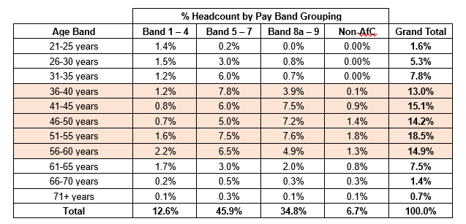

Despite being one of the biggest employers in England, only 6 per cent of the NHS workforce is under 25 (https://www.kingsfund.org.uk/blog/2022/02). For LSC ICB this 1.6% is aged up to 25 years, however the workforce dynamics of an ICB differs when compared with NHS Provider Trusts and there are proportionately higher numbers of senior non-clinical positions. This may be one reason why there are lower numbers of staff in the up to 25 years age range. 75.7% of staff are aged between 36 and 60 years, 24.4% are aged 56 years and over with 6.9 % of staff aged up to and including 30 years. There are no gaps in age declaration.

Disability

Census 2021 data tells us that 19.7% of the total resident population of Lancashire and South Cumbria are disabled under the Equality Act, and 8.8% of those individuals, report that their disability limits their day-to-day activities a lot.

During this reporting period, 7.3% of ICB staff reported as having a disability. 29.4% of ICB staff have not declared their disability status information, with a further 0.4% preferring not to answer the question. 11.5% are recorded as unspecified.

If we take the % of staff who chose to ‘not declare’, ‘preferred not to answer’ or checked ‘unspecified’ and added these together, we have 42.3% of staff where we do not know their disability status - however, we can assume that of that 42.3%, there will be staff who have a disability, therefore our figure could be higher and, as an organisation, we should work to ensure that staff always feel confident and safe to declare their disability without fear.
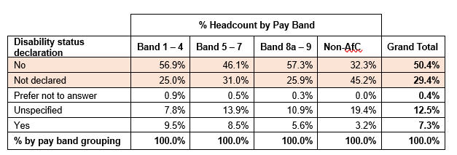

Where 7.3% of the ICB workforce has a declared disability, the table above demonstrates that disabled staff are over-represented in pay band grouping 1-4 and 5-7 and under-represented in pay band grouping 8a-9 and Non-AfC.

Marriage and Civil Partnership

The percentage figure of ICB staff reporting as being in a civil partnership for this reporting period is 1.0% which is slightly higher than the 0.5% across the whole population of adults aged 16 or over in same-sex marriage and all civil partnerships (ONS Census 2021).

61.7% of the ICB workforce identified as being married and 24.6% of the workforce report themselves as single, making up over 85% of the workforce from these two groups. The marital status of 2.1% of ICB staff is unknown and less than 1% are shown as blank.

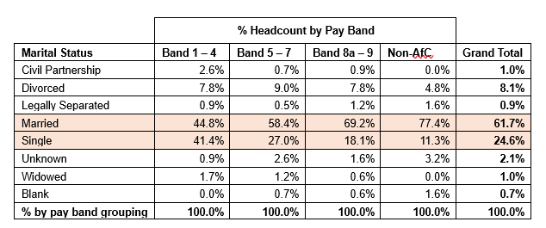

The table above demonstrates that there is a higher representation of people who are married in pay band grouping 8a-9 and Non-AfC and a lower representation of people in pay band groupings 1-4 and 5-7. This is the opposite for those reporting as single where the higher proportion are in pay band group 1-4.

Ethnicity

The proportion of Lancashire and South Cumbria’s resident population who are from an ethnically diverse background (i.e., non-white British) is currently 12.3%. The report provides a profile of ICB workforce based on broad ethnicity types whereby 86.4% of the workforce identifies as White and 6.7% of the workforce identifying as BME. Over 7% have either not stated or not specified their ethnicity. The proportion of BME staff in the ICB is lower (at 6.7%) than that of the resident population by 5.6%.

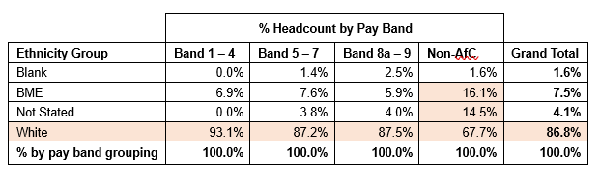

Looking at the table above, in relation to the distribution of staff from different ethnicity across pay band groupings, the shaded boxes show where there is under or over representation.

Staff with an unspecified ethnicity are over-represented in the Band 8a-9 pay band grouping, BME staff are under-represented in the Band 8a-9 pay band grouping and over-represented in the Non-AfC grouping.

Those staff who have not stated their ethnicity are under-represented in Band 1-4 grouping and over-represented in the Non-AfC pay band grouping. and overall are slightly underrepresented when compared to their population.

Religion and Belief

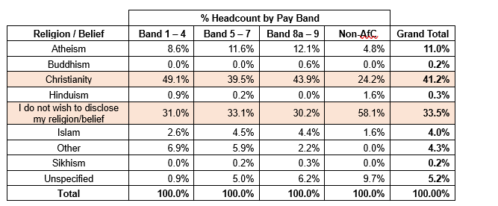

Of the population of Lancashire & South Cumbria, 52.8% identify as Christian. The next highest percentage are people who identify has having no religion (Atheism 32%). This is followed by 8.3% stating their religion as Islam and 5.4% of the population who did not state their religion. 1.4% of the population stated Other as their religion/belief.

When looking at religion and belief across the ICB workforce, 41.2% of staff report their religion as Christianity. 4.0% of staff report their religion as Islam which is 4.3% below that of the population. 11% of the ICB workforce report that they are Atheist which is significantly below the population figure of 32%. A significant figure in relation to religion and belief is the percentage of staff who did not wish to disclose this information at 33.5%% of the workforce. As an organisation, we are working to ensure that staff always feel confident and safe to declare their religion or belief without fear.

Looking at the table above, we can see that those reporting as Christian are over-represented in pay band grouping 1-4 and 8a-9 and under-represented in Non-AfC staff. In terms of those who do not wish to disclose their religion or belief there is over representation in Non-AfC.

Buddhism, Islam, Other and Sikhism are all showing as under-represented from the Non-AfC staff whereas Unspecified is over-represented which might indicate that there is a gap in reporting in this group of staff of religion/belief.

Sex (Female/Male)

In Lancashire and South Cumbria, the population has nearly the same number of males (49.2%) as females (50.8%).

Health and Social Care is one of the public sectors where women thrive in terms of representation. The NHS workforce totals 1.5 million staff (headcount, June 2024 NHS Digital workforce statistics), of which approximately 74% are women (The Kings Fund, May 2024). The ICB has a higher proportion of female workers at 79.3% of the workforce being female and 20.7% being male. While the NHS has traditionally been a female dominated sector these figures are not represented at the senior levels.

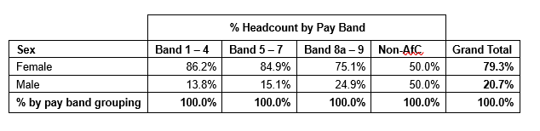

When we compare the ICB workforce figure of 79.3% female 20.7% male, it is less than representative at Pay Band levels 8a-9. When looking at the most senior (Non-AfC) roles, male staff are significantly overrepresented as a proportion of the ICB workforce at almost 50%. Males are also underrepresented at both pay band groupings 1-4 and 5-7.

When looking at the representation of females and males in bands 8a and above (incl. non-AfC) as a % of the total female/male workforce, females are again under-represented by around 8%.

Sexual Orientation

The proportion of the UK population aged 16 years and over identifying as heterosexual or straight was 89.4% in ONS Census 2021. An estimated 3.3% of the UK population aged 16 years and over identified as lesbian, gay or bisexual (LGB).

In the ICB, 2.6% of staff identified as LGB and 0.7% identified as bisexual which is in line with the population figure of 3.3%. These staff are found predominantly in pay band range 1-4 (5.2%) and 8a-9 (2.8%). A total of 62.3 % staff identified as Heterosexual or Straight. 29.2% were asked but declined to provide a response and a further 5.0% of staff reported as unspecified. Over half of the staff in non-AfC pay bands declined to provide a response.

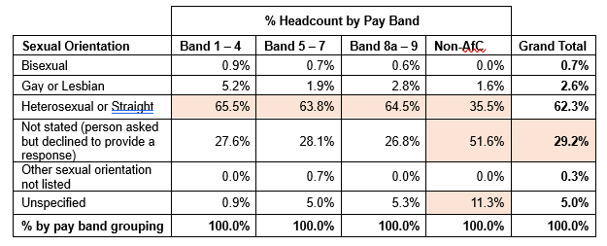

The table above demonstrates that heterosexual or straight staff are over-represented in pay band grouping 8a-9 and under-represented in Non-AfC. Non-AfC staff were more likely to not state their sexual orientation or leave as unspecified. Gay or lesbian staff are slightly over-represented in pay band grouping 1-4 compared to the total of staff in this group and under-represented in band 1-5 and Non-AfC groupings.

Full-time and part-time participation

When analysing this data, it is important to consider the demographics of participation. Disaggregating this data for example by sex (female/male), can provide a range of meaningful data around working habits that can be attributed to historical factors such as:
  - The organisations operating structures
  - Preferred part-time working arrangements for women with families or who have carer commitments.

Age, Disability and Religion and Belief may also be determining factors to consider in better understanding the dynamics of full and part time working arrangements to ensure due regard to equality of opportunity between the protected characteristics.
In the ICB, just over 28% of staff work part-time, there are more female part-time workers than males working part-time.

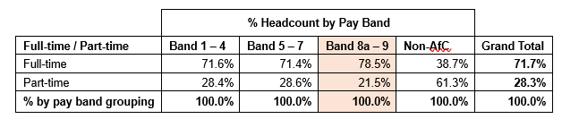

In the L&SC ICB, the split of full-time and part-time workers in band 1-4 and band 5-7 reflects that of the split of the workforce as a whole. However, for bands 8a-9, there is a higher proportion of full-time staff working in these bands compared to the full-time-part-time split of the workforce.

It is important to consider the various types and roles available as well as other considerations within the organisation, alongside the different gender profiles that occur within specific roles.

A higher proportion of female staff work part-time compared to males when comparing to the overall split of full-time to part-time for all staff.

Recruitment process data by protected characteristic

There were 1720 applicants for jobs in the Lancashire and South Cumbria ICB during the reporting period (1st April 2024 to 31st March 2025). 861 applicants were shortlisted and of those 387 were interviewed. Following this process there were 97 appointments made with people recruited into post.

Data is collected from applicants and the following pages present a view against a range of areas (age, sex (female/male), disability, ethnicity group, marriage or civil partnership (marital status), sexual orientation and religion or belief.

Each area is presented to provide a view of the number of applicants, the number shortlisted, the number interviewed, and the number recruited. A view on the source of job advertisement of the 1720 applications is also included.

Age

All 1720 applicants submitted their age. The highest percentage of applicants were in the 25-29, 30-34 and 35-39 age groups all at 17.0% or slightly above. 68% of applicants were aged between 25 and 44 years. Applicants under 25 years equated to 7.4% of all applications and those aged 60+ years equated to 1.6%.

Shortlisting (861 applicants) and interviewed (387 candidates) pretty much followed the above in terms of the proportions of people being shortlisted and interviewed from the different age ranges.

In terms of recruitment (97 recruits), 77.3% of those recruited were aged between 30 and 54 years which suggests that older applicants are being recruited to a larger degree. 23.0% of applicants were aged 45 to 59 years, whereas 38.1% of this age range were recruited. 13.3% of applicants were aged 50 to 59 with 22.7% recruited. 4.1% of those recruited were aged under 25 and 4.1% were aged 60+ years.

Sex (Female/Male)

Of the 1720 applicants, 64.0% were female, 34.9% were male and 1.0% were recorded as ‘do not wish to disclose’.

In terms of shortlisting (861), 62.3% of those shortlisted were female with 36.8% being male and 0.9% ‘do not wish to disclose’. Of the 387 candidates that were interviewed, 76.2% were female, 23.3% were male and 0.5% were from those who did not wish to disclose their sex.

When looking at the 97 people recruited, 85.6% were female (83), 13.4% were male (13) and 1.0% did not wish to disclose their sex (1).

Disability status

Of the 1720 applicants 96.6% disclosed their disability status with 86.5% stating that they do not have a disability (1487) and 10.1% declaring that they do (174). 3.0% of applicants (51 people) did not wish to disclose their disability status.

In terms of shortlisting (861 applicants) and interviewing (387 candidates) there were slightly higher proportions of those with a disability or those choosing not to declare being shortlisted and interviewed than those stating that they do not have a disability.

Of the 97 people recruited, 84.5% (82 people) do not have a disability, 6.2% of those recruited do have a disability (6 people) and 4.1% (4 people) of those recruited did not wish to disclose their disability status. 5.2% (5) of those recruited were recorded as ‘not stated’.

There were 174 applicants that declared they have a disability, and the table below provides more detail of the specific disability of those applicants.

Ethnicity

Of the 1720 applicants, 45.8% were BME, 51.7% were white and 2.1% did not wish to disclose their ethnicity group. For 0.5% of applicants, their ethnicity group was not stated.

In terms of shortlisting (861 applicants) 56.3% were white (485), 41.5% were BME (357) and 2.2% (19) were from those applicants who did not wish to disclose. There were 387 candidates interviewed and of those 74.9% were white (290), 23.8% were BME (92) and 1.3% were candidates who did not wish to disclose (5).

97 people were recruited and of those, 87.6% were white (85), 6.2% were BME (6) and 1.0% were from those who did not wish to disclose their ethnic origin (1). For 5.2% of those recruited (5), their ethnicity group was not stated.

Religion and belief

Of the 1720 applicants, 52.3% declared their religion as Christianity (900), 13.0% Atheism (224), 11.6% Islam (200), 7.4% Hinduism (128), and 6.8% other religions/beliefs (117). 8.3% of applicants did not wish to disclose their religion/belief (143 people) and 0.5% (8) were ‘not stated’.

In terms of shortlisting (861) 50.4% were Christian (434), 15.1% Atheism (130), 12.7% Islam (109), 5.3% Hinduism (46) and 7.9% other religious/beliefs (68). Of those shortlisted, 8.6% did not wish to declare their religion of belief which was 74 candidates. Of the 387 people interviewed, 52.5% were Christian (203), 16.5% Atheism (64), 10.3% Islam (40), 2.6% Hinduism (10) and 7.5% other religions/beliefs (29). 10.6% of those interviewed did not disclose their religion or belief (41).

55.7% of the people recruited were Christian (54), 19.6% were Atheist (19), 8.2% did not disclose (8), 3.1% Islam (3) and 7.2% other religions/beliefs (7).

Marriage and Civil Partnership

Of the 1720 applicants, 49.6% were married (853), 39.1% single (673), 3.8% divorced (66), 3.2% other (55), 1.3% in a civil partnership (22), 0.4% legally separated (7) and 0.4% widowed (7). 1.7% did not wish to disclose (29).

In terms of shortlisting (861 applicants), the proportions fell closely in line with the marital status of all applications listed above. At interview stage (387 candidates), 52.7% were married (204), 31.8% single (123), 5.7% divorced (22), 5.9% other (23), 1.8% in a civil partnership (7), 0.8% legally separated (3) and 0.3% widowed (1). 1.0% of interview candidates did not disclose their marital status (4).

Of those recruited (97), 52.6% were married (51), 23.7% single (23), 7.2% other (7), 8.2% divorced (8) and 1.0% in a civil partnership (1). 2.1% of people recruited did not wish to disclose (2). 5.2% of those recruited had ‘not stated’ their marital status and there were no recruits from those who are widowed.

Sexual Orientation

Of the 1720 applicants, 89.5% (1539) stated they are heterosexual or straight, 3.4% (59) gay or lesbian, 2.2% bisexual (37) and 0.2% other or undecided (3). 3.4% of applicants did not wish to disclose their sexual orientation which was 74 people. 0.5% were recorded as ‘not stated’ (8).

In terms of shortlisting (861 applicants), 89.4% were heterosexual or straight (760), 4.2% gay or lesbian (38), 2.1% bisexual (25) and 0.5% other or undecided (3). 4.3% of those shortlisted did not wish to disclose (35).
At interview stage, 89.1% of candidates were heterosexual or straight (345), 2.8% gay or lesbian (11), 2.3% bisexual (9). 5.7% of those interviewed did not wish to disclose (22).

Of the 97 people recruited, 83.5% were heterosexual or straight (81), 6.2% gay or lesbian (6). 5.2% of those recruited did not disclose their sexual orientation and 5.2% were not stated.

