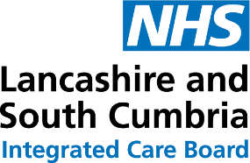
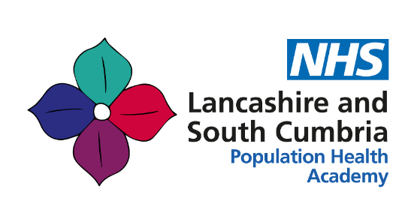

Leadership for Population Health (for Executive and Non-Executive Leaders)

Population Health Leadership Development Programme (for Senior Leaders)

Do you have an interest or passion in reducing health inequalities, improving population health and empowering communities?

Are you a professional in a leadership role in the health and care system and want to enhance your leadership for health equity?

Are you a Primary Care Network Clinical Director or Primary Care Network Manager?

Do you want to take part in an exciting population health leadership programme that will help develop your population health, health equity and leadership knowledge and skills and give you the tools to help deliver change in your community, organisation or setting?
Would you value protected time for learning and reflection to shape targeted approaches that enable effective delivery of the primary care LES, address inequalities in service access and outcomes and/or tackle inequalities in urgent care?

The Lancashire and South Cumbria Population Health Academy are currently recruiting participants for the 25/26 Population Health Leadership Programmes starting in September 2025;

- Leadership for Population Health for Executive and Non-Executive Leaders
- Population Health Leadership Development Programme for Senior Leaders

Population health is an increasingly important focus for health and care systems, as organisations start to work together and with their communities to improve health and tackle health inequalities for the people they collectively serve. It offers real opportunity for positively impacting health outcomes and contributing to financial sustainability.
“I was thrilled to be accepted on to the programme – and it absolutely hasn’t disappointed! I can’t recommend it highly enough for anyone who genuinely wants to develop leadership skills in the context of our local communities and workforce. It is varied and rounded in content, exploring how we deploy our own skills and work to each other’s personal strengths to improve outcomes for some of our most disadvantaged communities. This programme could not have gained momentum at a better time for our ICB. I look forward to the monthly session seeing it as a salvation during the current climate of financial challenge. It also serves to remind us of why we are leaders in the public sector. It should be mandated for every executive director on our patch!”
Catriona Logan, Divisional Director of Operations ELHT
Current participant on 2024/25 programme

"Anybody thinking of doing the course I would 100% say do it. Even if you're not sure what you're going to get out of it, even if you're not sure what you're going to learn, the learning is incredible. The skills that you can build on, the confidence that you'll get, but more importantly just having that time out to think and breathe and meet people and talk things through it really has it made me love my job again. It’s an amazing opportunity and I would say everyone should be doing it really."

Dr Jo Magapu, GP Partner at The Chorley Surgery and
Health Inequalities Clinical Lead for the Chorley Central PCN
A graduate of the Population Health Leadership Development Programme 2022/23

"The leadership development programme has been fabulous, thought provoking and uncomfortable at times. The facilitators have created the prefect environment padded with safety to allow exploration of self and how ‘I’ show up as a leader. The journey has led to some personal discovery . . . but the support is there to wade through and develop to be a leader that understands what collaborative leadership means with our communities."
Candace Bedu-Mensah, Head of Diversity and Inclusion
Lancashire and South Cumbria NHS Foundation Trust
A graduate of the Population Health Leadership Development Programme 2023/24

"This programme is excellent! It is targeted at developing leadership skills in diverse, collaborative work environments. It’s a motivating opportunity to enhance your ability to communicate effectively with professionals and communities from various backgrounds, lead interdisciplinary teams whilst navigating the complexity of building the health inequality agenda into your practice. The programme creates valuable time to develop yourself whilst exploring important ethical perspectives and motivations for doing this work. The quality and experience of the speakers on the programme has been outstanding."
Sarah Cullen, Chief Nursing Officer, Lancashire Teaching Hospitals NHS Foundation Trust
A graduate of the Population Health Leadership Development Programme 2023/24

The programme is designed to support you to develop your own leadership skills by exploring themes of who we are in leadership roles and how we can nurture our strengths whilst understanding the opportunities for continued personal and professional development. It will help refine your skills for working with partners from across health and care systems to improve the health and wellbeing of your local population and the communities within it that you have responsibility for.

The programme aims to support you to appreciate the impact of the social determinants of health and to develop an understanding of the health inequalities facing your own local population and/or service users. It will further expand on the methods and techniques within the population health “toolbox” that can help us as we collectively work towards achieving improved health equity. This programme includes the opportunity to test out your ideas and new learning, with support to initiate your own project within your area of work or setting. This will be enabled by using Action Learning Sets – Action learning sets | Knowledge and Library Services (hee.nhs.uk).
You will learn from local, national and international leaders and from each other. Importantly you will also learn from the voice of lived experience. The tools and techniques embedded within the programme are ones that facilitate real depth in discussion and understanding when applied to our work with communities and ourselves. This can be enlightening and empowering but also challenging and emotive. The same can be said of some of the stories we will hear both directly within the programme and perhaps through some of the work you will apply the tools to. To support this, the programme therefore is facilitated within a highly supportive and nurturing environment.

If you are interested in finding out more then please read the attached Information Pack and consider completing the appropriate Expression of Interest form (attached), submitting by noon on Friday 30th May 2025. Details of how to submit can be found within the Expression of Interest forms.

This programme is innovative, invigorating, evocative and stimulating.

If you feel this is the programme for you, we look forward to hearing from you!

