Consent: Saying Yes or No
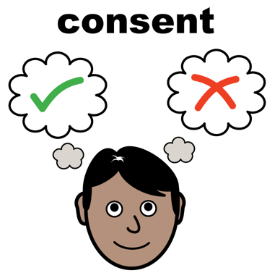 | What is consent? Giving consent means saying yes or no to something.  When you don’t feel well you might need to see a doctor or nurse.  They want to find out what’s wrong – to examine or assess you  Or want to help – treat you  Before they do anything they must ask you if this is OK. This is consent
 | They might ask you to consent by:  Doing something  Signing something
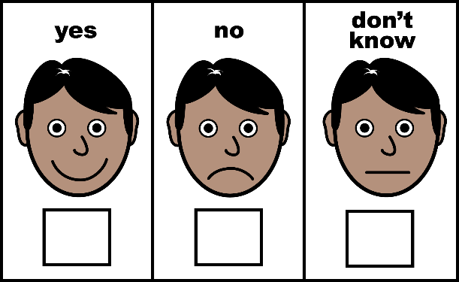   | You can say YES  You can say NO  It is up to you.  Are you 16 or over?  You can give consent for yourself.  Are you under 16?  You can give consent for some things.
 | Before you decide you will be given information about:  What they want to do – the treatment  Why they think it is good for you  What the treatment will feel like  What might go wrong  How much better it will make you  You can ask more questions if you don’t understand or feel you want more facts.
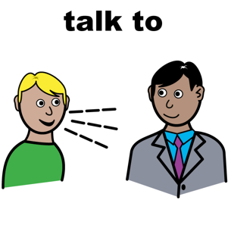 | Do you need help?  Talk it over with your friend, relative, carer or advocate.  They might like to ask questions too.  Take time to think about it.
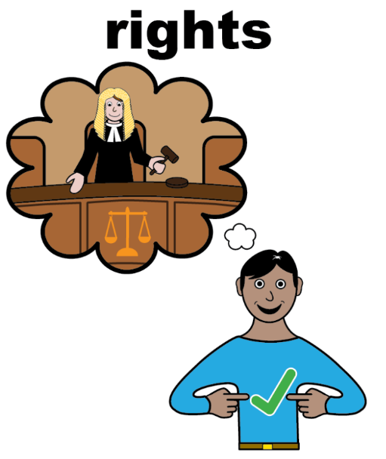 | Your rights:  - You can have someone with you when you see a doctor or a nurse  - You have the right to say what you feel and want about your care  - You have the right to say no  - You have the right to see a different doctor or nurse  - You do not have to see a student  - No-one can assume you cannot make a decision just because of your age, your disability or how you look
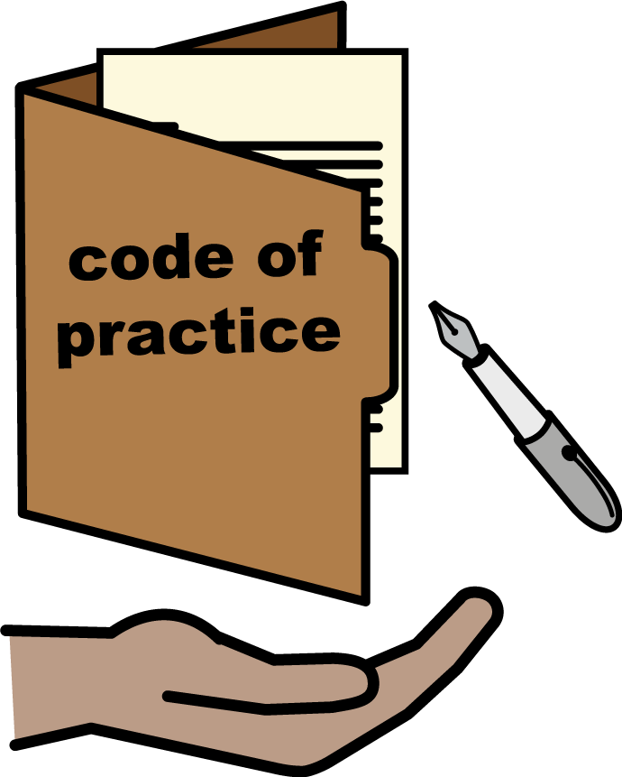 | If someone thinks you do not have capacity to make a decision they have to use a Law called The Mental Capacity Act 2005. They have to do what the code of Practice says. It is the Law.  You can find out more information about this from your doctor or nurse.  Remember: giving consent is up to you.

