Your Flu & Covid vaccination
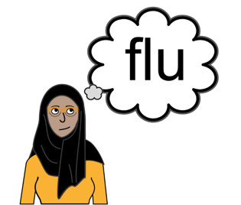 | Flu and covid is an infection that can make people feel really poorly
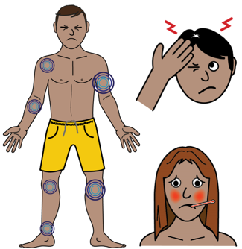 | The symptoms can be:  High temperature – feeling hot  Aching body  Headache  Sneezing
 | The vaccination is available to you now  If you are vaccinated it will protect you and keep you safe  It will also stop you from  spreading it to your family and friends
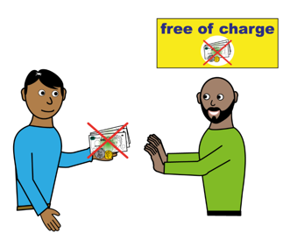 | The vaccination is free
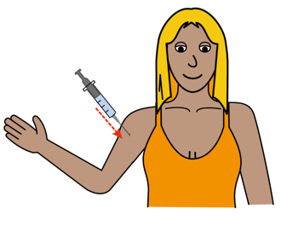 | The vaccination is given as an injection that goes into your arm
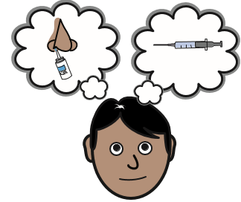 | If you do not like needles and are scared then you can have a nasal spray instead for the flu vaccine  It is up to you so don’t worry
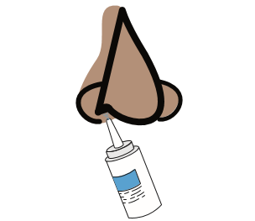 | The nasal spray goes into the nose and is easy and very quick to have
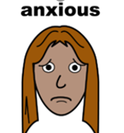 | If you are anxious or worried it is very important that you tell your Doctor
 | Ring your Doctors surgery and tell them you are worried  Or you can ask a friend or carer to ring for you
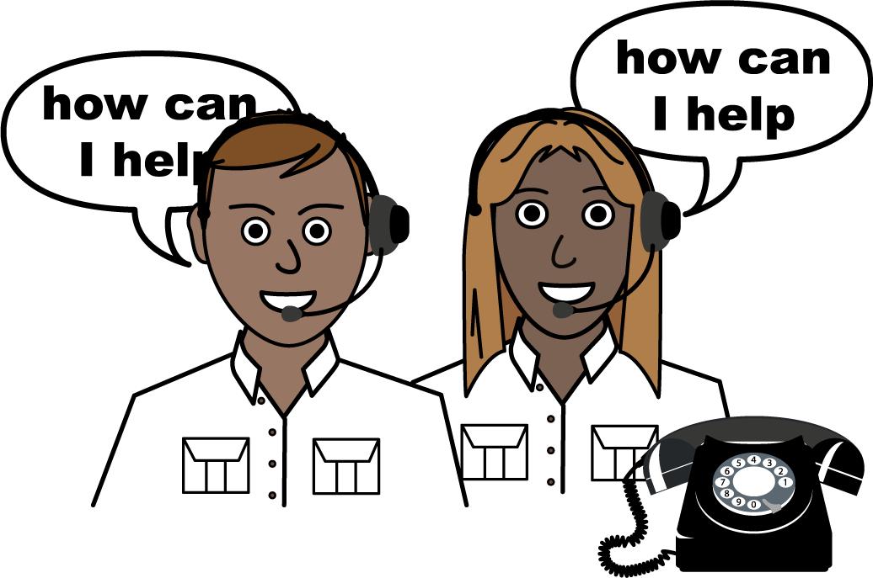 | The Receptionist will talk to you to find out what they can do to help you  This may mean you can have your injection or nasal spray at a special clinic  Or the Doctor or Nurse may come to your house

